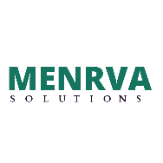MENRVA SOLUTIONS  
ABC BUILDING, MNP ROAD, NEAR XYZ TEMPLE, SANDHURST ROAD, MUMBAI – 400 009

Dear Name_is,

This is to inform you that in this appraisal cycle you have been promoted to Position_is.

Your Revised Salary is going to be Salry_is.All the very best for your future.

Kindly contact HR department and get your details updated with them.

Thanks & Regards

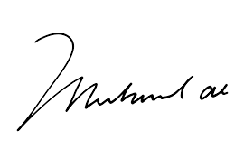

Appraisal Team,

