Mini Project Report on

**EPPO – Service Management System**

Submitted in partial fulfillment of the requirements of the degree of Bachelor in Engineering

By

|  |  |  |
| --- | --- | --- |
| **Khushboo Rathod** | **SE4** | **64** |
| **Vinay Savla** | **SE4** | **65** |
| **Amey Sawant** | **SE4** | **66** |

Under the guidance of

**MS. SARITHA. K**



**DEPARTMENT OF COMPUTER ENGINEERING SHAH AND ANCHOR KUTCHHI ENGINEERING COLLEGE**

**CHEMBUR, MUMBAI – 400088.**

**University of Mumbai (AY 2022-23)**

**CERTIFICATE**

This is to certify that the Mini Project entitled **“EPPO – Service Management System”** is a bonafide work of **Khushboo Rathod, Vinay Savla, Amey Sawant** submitted to the University of Mumbai in partial fulfillment of the requirement for the award of the degree of **“Bachelor of Engineering”** in **“Computer Engineering”.**

###### (MS. SARITHA. K)

Guide

###### (Prof. UDAY BHAVE) (Prof. BHAVESH PATEL)

Head of Department Principal

# Mini Project Approval

This Mini Project entitled “**EPPO – Service Management System”** by **Khushboo Rathod, Vinay Savla, Amey Sawant** is approved for the degree of **Bachelor of Engineering** in **Computer Engineering.**

##### Examiners

**1………………………………………**

(Internal Examiner Name & Sign)

###### 2…………………………………………

(External Examiner Name & Sign)

Date:

Place:

**Declaration**

We declare that this written submission represents our ideas in our own words and where others' ideas or words have been included, we have adequately cited and referenced the original sources. We also declare that we have adhered to all principles of academic honesty and integrity and have not misrepresented or fabricated or falsified any idea/data/fact/source in our submission. We understand that any violation of the above will be cause for disciplinary action by the Institute and can also evoke penal action from the sources which have thus not been properly cited or from whom proper permission has not been taken when needed.

|  |  |  |  |
| --- | --- | --- | --- |
| **Name of student** | **Class** | **Roll No.** | **Signature** |
| **Khushboo Rathod** | **SE4** | **64** |  |
| **Vinay Savla** | **SE4** | **65** |  |
| **Amey Sawant** | **SE4** | **66** |  |
| Date:  Place: |  |  |  |

**Abstract**

The project EPPO, this project is based on a Service Management System. Eppo is a platform that aims to provide a contactless solution for booking appointments with professionals such as doctors, lawyers, therapists, and barbers. The platform's goal is to streamline the appointment booking process, making it easy for clients to book appointments and for professionals to manage their schedules. The platform has developed a web application using ReactJS and NodeJS. The web application is designed to help professionals manage their appointments and customers, with the aim of streamlining business operations and efficiently managing customer appointments. The tool is user-friendly and intuitive, making it easy for both customers and professionals to use.

**Table of Contents**

### Page Number

Chapter 1: Introduction 1

* 1. Introduction
  2. Motivation

Chapter 2: Literature Review 2

2.1 Literature survey

Chapter 3: Problem Definition and Objectives 3

* 1. Proposed System
  2. Features
  3. Database Design
  4. Outputs

### Chapter 4: Future Scope and Conclusion 8

**Chapter 5: References 9**

**List of tables:**

|  |  |  |  |
| --- | --- | --- | --- |
| **Chapter** | **Table** | **Table Name** | **Page Number** |
| Chapter 2 | 2.1 | Literature Survey | 2 |

**List of Figures:**

|  |  |  |  |
| --- | --- | --- | --- |
| **Chapter** | **Table** | **Table Name** | **Page Number** |
| Chapter 3 | 3.4 | Outputs | 5 |

**Chapter 1**

## Introduction:

This project is based on a Service Management System. Eppo is a platform that aims to provide a contactless solution for booking appointments with professionals such as doctors, lawyers, therapists, and barbers. The platform's goal is to streamline the appointment booking process, making it easy for clients to book appointments and for professionals to manage their schedules. The platform has developed a web application using ReactJS and NodeJS.

The web application is designed to help professionals manage their appointments and customers, with the aim of streamlining business operations and efficiently managing customer appointments. The tool is user-friendly and intuitive, making it easy for both customers and professionals to use. It offers a range of features that improve appointment management, such as an intelligent scheduling system that analyzes the availability of the professional and suggests appointment times that are most convenient for both the professional and the client. This feature automates the booking process, making it more efficient and reducing the risk of scheduling conflicts.

The application also incorporates a recommendation system that suggests professionals to clients based on standard parameters. This feature helps clients find the right professional for their needs, improving the overall quality of the appointment experience.

By using a web application, Eppo hopes to enhance the user experience and address the challenges faced by the platform. The application's design and features are tailored to improve appointment management, making it easier for professionals to manage their schedules and for clients to book appointments. The user-friendly interface ensures that both clients and professionals can use the platform with ease, improving their overall experience.

One of the most significant benefits of the web application is its ability to streamline business operations. The application simplifies the appointment booking process, reducing the time and effort required by professionals. This streamlining of operations can improve the overall efficiency of the business, resulting in higher productivity and increased profitability.

Another benefit of the web application is its ability to improve customer satisfaction. Clients can easily find the right professional for their needs, reducing the likelihood of dissatisfaction due to mismatched expectations. Additionally, the intelligent scheduling system reduces wait times and scheduling conflicts, creating a more positive appointment experience for clients.

In conclusion, Eppo is a platform that offers a contactless solution for booking appointments with professionals. The platform faces challenges such as long wait times, scheduling conflicts, and inefficient appointment management. To address these challenges, the platform has developed a web application using ReactJS and NodeJS. The application is designed to help professionals manage their appointments and customers, streamlining business operations and improving customer satisfaction. The intelligent scheduling system and recommendation system are some of the features that enhance the platform's user experience. With these features, Eppo hopes to create a more efficient and satisfying appointment booking process for both clients and professionals.

## Motivation:

There should be a platform that offers a contactless solution for booking physical appointments with professionals such as doctors, lawyers, therapists, barbers, and more. However, long wait times, scheduling conflicts, and inefficient service management can create frustration for clients and professionals alike. So we tried to implement this into our EPPO web app.

1

## Chapter 2 Literature Review

### Literature Survey:

We had searched about this type of application on the internet but got one which was not so user-friendly, more efficient and easier so the features added in this project is our own idea. We took the help of the below-mentioned article to build this project.

### Literature Review

|  |  |  |  |
| --- | --- | --- | --- |
| **Sr. No.** | **Author/Title/Year** | **Work done/ Algorithm/ Concept/ Idea presented in the paper** | **Remarks** |
| 1 | Appointy Software Inc. | https://www.appointy.com/online-booking-software/ | It is a technology company that provides online scheduling software for businesses of various sizes and industries and also enables businesses to manage their appointments, staff schedules, and customer information all in one place. |
| 2 | Building a Service Management System with Node.js and React" by Kirill Konshin | https://itnext.io/building-a-service-management-system-with-node-js-and-react-part-1-setting-up-the-project-5d7c0f0be23f | This article provides a detailed tutorial on how to build a service management system and also covers the entire development process, from setting up the development environment to implementing features such as user authentication, client management, and appointment scheduling. |
| 3 | Building a Service Management System with Node.js and React" by Sarthak Sharma | https://sarthaksharma657.medium.com/building-a-service-management-system-with-node-js-and-react-6c39a2b98a7c | This tutorial covers how to use React.js to build the front end of the application, including the use of components, routing, and form handling, and provides detailed code snippets and explanations to help readers follow along. |
| 4 | Service Management System using React and Node.js" by Hasib Al Rashid | https://medium.com/@hasibrahman390/service-management-system-using-react-and-node-js-28a2018f90b5 | This tutorial starts by explaining what a service management system is and why it is useful for businesses. The tutorial then goes on to cover the entire development process, including setting up the development environment, creating the back end using Node.js, and building the front end using React. |
| 5 | "Building a Service Management System with React and Node.js" by Krunal Vyas | https://medium.com/javascript-in-plain-english/building-a-service-management-system-with-react-and-node-js-51b53d506f64 | This tutorial covers how to deploy the application to a cloud-based platform using Heroku. The article provides code snippets and detailed explanations throughout the tutorial to help readers follow along and build their own service management system. |

**Chapter 3**

**Proposed System**

* 1. **Proposed System:**

To create a platform that offers a contactless solution for booking physical appointments with professionals such as doctors, lawyers, therapists, barbers, and more. However, long wait times, scheduling conflicts, and inefficient appointment management can create frustration for clients and professionals alike.

### Features:

* Customizable appointment types: This will give them more control over the scheduling process and make the app more flexible.
* Automatic reminders: Send automatic reminders to users via email or SMS to reduce no-shows and missed appointments.
* User reviews and ratings: Allow users to leave reviews and ratings for service providers. This will help other users to make informed decisions when booking appointments
* Automatic rescheduling: If a service provider needs to reschedule an appointment, offer an automatic rescheduling option that suggests alternative dates and times.

### Database design

### The data stored in the system has to be stored and retrieved from the database. Designing the database is the main part of system design because a system is nothing without a database. Data elements and data structures to be stored have been identified at the analysis stage and are structured to be put together to design the database.

### A database is a collection of interrelated data stored with less redundancy to serve users quickly and efficiently. The general objective behind this is to make database access easy, quick, inexpensive, and flexible. Normalization is done to get an internal consistency of data and to have minimum redundancy. This ensures minimal data storage required, fewer chances of data inconsistencies, and optimization for updates. The MySQL database has been chosen for developing the relevant database for our system.

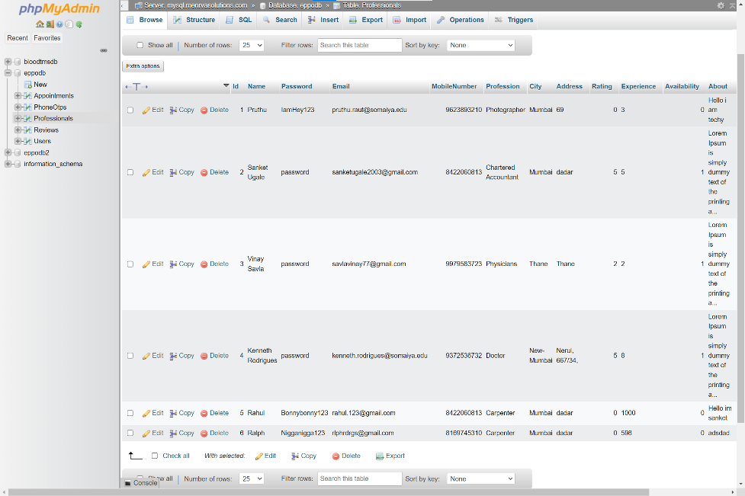

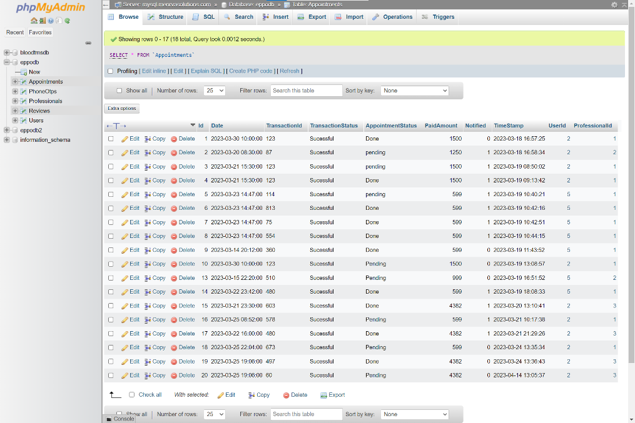

Figure 3.3. 1: Professionals Table

Figure 3.3. 2: Appointments Table

## Output

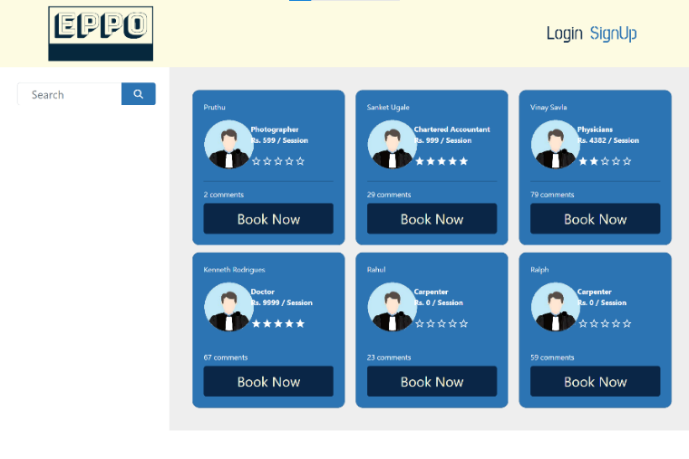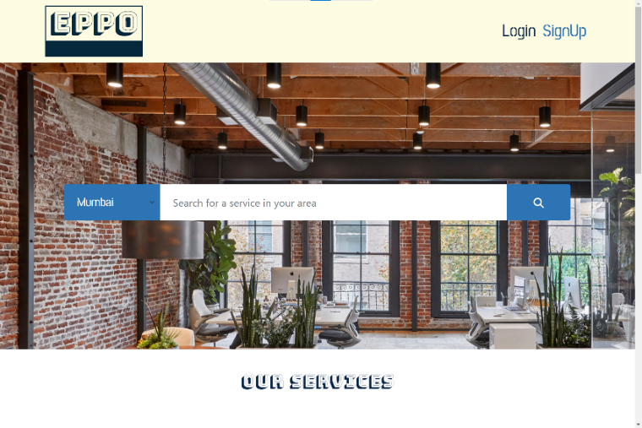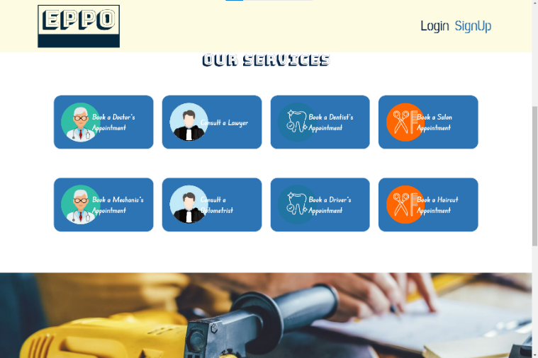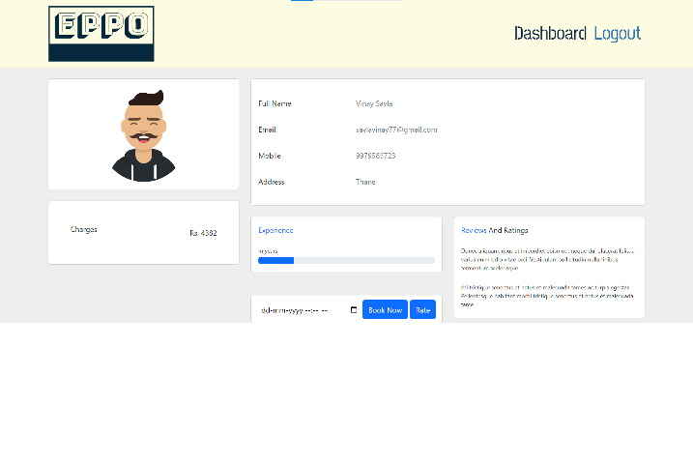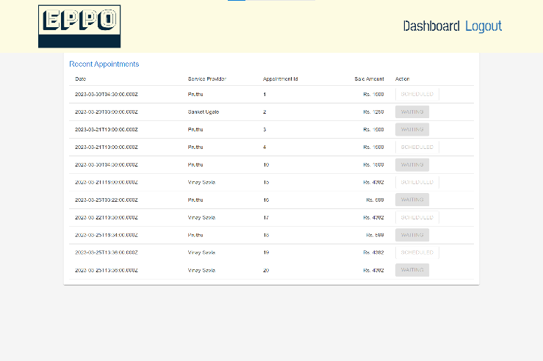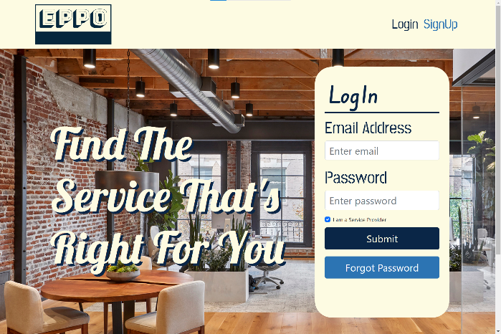

Figure 3.4.2: Landing Page

Figure 3.4.2: Landing Page

Figure 3.4.3: Service Provider’s List

Figure 3.4.4: Login Page

Figure 3.4.6: User Dashboard

Figure 3.4.5: Appointment Booking Page

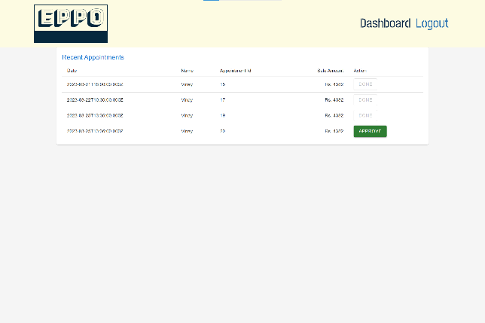

Figure 3.4.7: Service Provider’s Dashboard

**Chapter 4**

**Future Scope:**

The future scope for the above web app can include the integration of more advanced features that cater to the changing needs of businesses and customers. One potential area of expansion could be the inclusion of artificial intelligence and machine learning algorithms that can optimize the scheduling process by analyzing past appointment data and customer behavior.

This can improve the efficiency of the platform and provide a more personalized experience for customers. Another potential area of expansion could be the integration of video conferencing and virtual appointment options, which can provide an alternative to in-person appointments and offer greater flexibility for both customers and businesses.

Additionally, the platform can expand to cater to a wider range of businesses and industries, including healthcare, salons and spas, and other service-based businesses. Overall, the future scope for the above web app is vast, and with continuous innovation and improvement, it can become a go-to solution for appointment management needs for businesses of all sizes and industries.

**Conclusion**

An appointment booking web app made using React.js in the front end and node.js in the back end provides a smooth and efficient user experience. It is designed to be user-friendly and intuitive, making it easy to use for both customers and Professionals.

The web app also provides a range of features designed to help Professionals manage their customers and appointments. It provides an intuitive dashboard for Professionals to manage their appointments, customers, and payments, as well as a range of other features designed to make managing appointments and customers easier.

**Chapter 4**

## References

## [1] Appointy Software Inc.

## [2] “Building a Service Management System with Node.js and React” by Kirill Konshin

## [3] “Building a Service Management System with Node.js and React” by Sarthak Sharma

## [4] “Service Management System using React and Node.js” by Hasib Al Rashid

## [5] “Building a Service Management System with React and Node.js” by Krunal Vyas