Clustering
Clustering is an unsupervised machine learning technique that groups similar data points into clusters based on their similarity or distance, without using predefined labels.
Example
Fruit | Weight (g) | Sweetness
Apple | 160 | 7
Apple | 170 | 8
Apple | 180 | 8
Orange | 140 | 5
Orange | 150 | 5
Orange | 145 | 6
Watermelon | 4500 | 9
Watermelon | 4700 | 8
Watermelon | 4300 | 9

In Clustering, the algorithm does not know the fruit names.
It only receives the features.
The algorithm has no idea which row is Apple, Orange, or Watermelon.
Weight (g) | Sweetness
160 | 7
170 | 8
180 | 8
140 | 5
150 | 5
145 | 6
4500 | 9
4700 | 8
4300 | 9

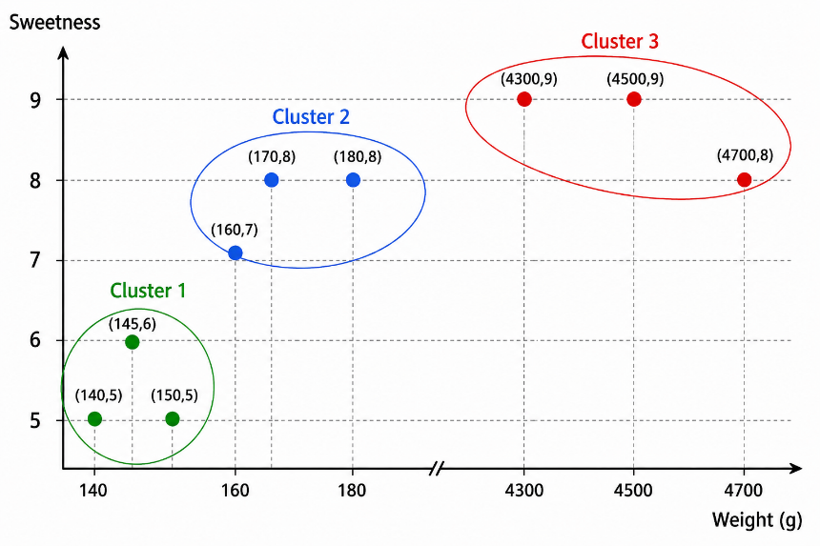
Add the Original Labels
Cluster 1
Weight | Sweetness | Fruit
140 | 5 | Orange
145 | 6 | Orange
150 | 5 | Orange

Cluster 2
Weight | Sweetness | Fruit
160 | 7 | Apple
170 | 8 | Apple
180 | 8 | Apple
Cluster 3
Weight | Sweetness | Fruit
4300 | 9 | Watermelon
4500 | 9 | Watermelon
4700 | 8 | Watermelon

Clustering does not use the Fruit column.
It discovers groups only from Weight and Sweetness
After clustering, humans may look at the groups and realize that
Cluster 1 = Orange,
Cluster 2 = Apple,
Cluster 3 = Watermelon.

Types of Clustering
- Partitiona Based
  - K-Means
  - K-Medoids
  - Fuzzy C-Means
- Hierarchical
  - Agglomerative
  - Divisive
- Density-Based
  - DBSCAN
  - OPTICS
- Distribution-Based
  - Gaussian Mixture Model (GMM)
- Grid-Based
  - STING
  - CLIQUE
- Graph-Based
  - Spectral Clustering
  - Affinity Propagation

K – Means
Given only the weight and sweetness of fruits, group similar fruits into K clusters without knowing their names.

Weight (g) | Sweetness
160 | 7
170 | 8
180 | 8
140 | 5
150 | 5
145 | 6
4300 | 9
4500 | 9
4700 | 8

Use the K-Means Clustering algorithm with K = 3 to group similar fruits into three clusters based on their Weight and Sweetness.

Since the fruit names are unknown, the algorithm must automatically discover the groups by calculating the distance between the data points and the cluster centroids

Weight | Sweetness
160 | 7
170 | 8
180 | 8
140 | 5
150 | 5
145 | 6
4300 | 9
4500 | 9
4700 | 8

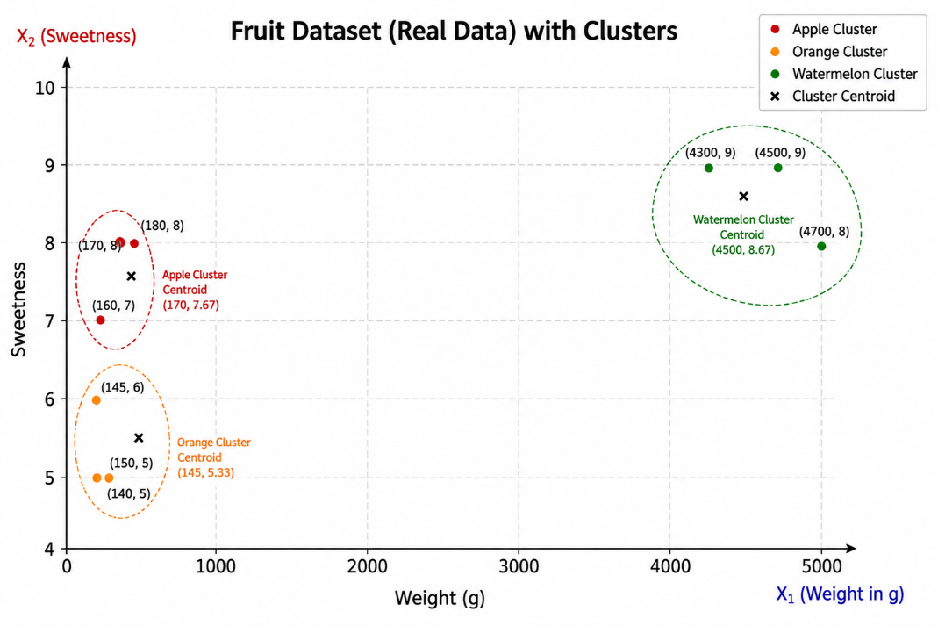

Number of Clusters K=3
Suppose we choose
Centroid | Weight | Sweetness
C1 | 160 | 7
C2 | 145 | 6
C3 | 4500 | 9

Calculate the distance of Every fruit and from every centroid
We use the Euclidean Distance Formula
$$d=\sqrt{{\left(x_{2}-x_{1}\right)}^{2}+{\left(y_{2}-y_{1}\right)}^{2}}$$

Distance Calculations for the First Data Point (160, 7)
Distance From Centroid 1
$$\text{Distance to }C_{1}$$
$$X_{1}=160, Y_{1}=7$$
$$X_{2}=160, Y_{2}=7$$
$$\text{Distance}=$$
$$\sqrt{{\left(X_{1}-X_{2}\right)}^{2}+{\left(Y_{1}-Y_{2}\right)}^{2}}$$
$$\sqrt{{\left(160-160\right)}^{2}+{\left(7-7\right)}^{2}}$$
$$\sqrt{0^{2}+0^{2}}$$
$$\sqrt{0}$$
$$0$$
Distance From Centroid 2
$$DistancetoC_{2}$$
$$X_{1}=160, Y_{1}=7$$
$$X_{2}=145, Y_{2}=6$$
$$\text{Distance}=$$
$$Distance=\sqrt{{\left(X_{1}-X_{2}\right)}^{2}+{\left(Y_{1}-Y_{2}\right)}^{2}}$$
$$\sqrt{{\left(160-145\right)}^{2}+{\left(7-6\right)}^{2}}$$
$$\sqrt{{15}^{2}+1^{2}}$$
$$\sqrt{225+1}$$
$$\sqrt{226}$$
$$≈15.03$$

Distance From Centroid 3
$$DistancetoC_{3}$$
$$X_{1}=160, Y_{1}=7$$
$$X_{2}=4500, Y_{2}=9$$
$$\text{Distance}=$$
$$Distance=\sqrt{{\left(X_{1}-X_{2}\right)}^{2}+{\left(Y_{1}-Y_{2}\right)}^{2}}$$
$$\sqrt{{\left(160-4500\right)}^{2}+{\left(7-9\right)}^{2}}$$
$$\sqrt{{\left(-4340\right)}^{2}+{\left(-2\right)}^{2}}$$
$$\sqrt{{4340}^{2}+2^{2}}$$
$$\sqrt{18,!835,!600+4}$$
$$\sqrt{18,!835,!604}$$
$$≈4340.00$$

Weight | Sweetness | Distance to C1 | Distance to C2 | Distance to C3 | Allocated  Centroid
160 | 7 | 0.00 | 15.03 | 4340.00 | C1

Similarly table data is
Weight | Sweetness | Distance to C1 | Distance to C2 | Distance to C3 | Allocated Centroid
160 | 7 | 0.00 | 15.03 | 4340.00 | C1
170 | 8 | 10.05 | 25.08 | 4330.00 | C1
180 | 8 | 20.02 | 35.06 | 4320.00 | C1
140 | 5 | 20.10 | 5.10 | 4360.00 | C2
150 | 5 | 10.20 | 5.10 | 4350.00 | C2
145 | 6 | 15.03 | 0.00 | 4355.00 | C2
4300 | 9 | 4140.00 | 4155.00 | 200.00 | C3
4500 | 9 | 4340.00 | 4355.00 | 0.00 | C3
4700 | 8 | 4540.00 | 4555.00 | 200.00 | C3

Cluster 1 |  | Cluster 2 |  | Cluster 3
Weight (g) | Sweetness | Weight (g) | Sweetness | Weight (g) | Sweetness
160 | 7 | 140 | 5 | 4300 | 9
170 | 8 | 150 | 5 | 4500 | 9
180 | 8 | 145 | 6 | 4700 | 8

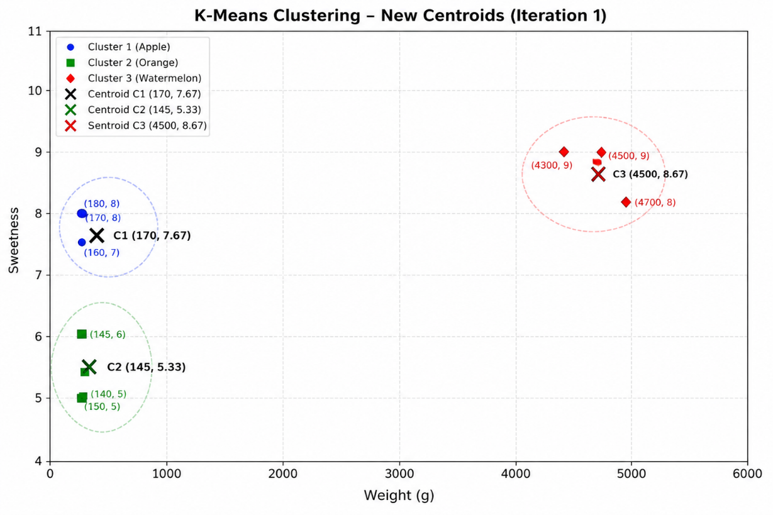
$$Step 1: Calculate the New Centroid for Cluster 1$$
$$\text{Weight}$$
$$=\frac{160+170+180}{3}$$
$$=\frac{510}{3}$$
$$= 170$$
$$\text{Sweetness}$$
$$=\frac{7+8+8}{3}$$
$$=\frac{23}{3}$$
$$≈7.67$$
$$\text{New Centroid }C_{1}=\left(170, 7.67\right)$$

$$Step 2: Calculate the New Centroid for Cluster 2$$
$$\text{Weight}=\frac{140+150+145}{3}$$
$$=\frac{435}{3}$$
$$= 145$$
$$\text{Sweetness}=\frac{5+5+6}{3}$$
$$=\frac{16}{3}$$
$$≈5.33$$
$$\text{New Centroid }C_{2}=\left(145, 5.33\right)$$

$$Step 3: Calculate the New Centroid for Cluster 3$$
$$\text{Weight}=\frac{4300+4500+4700}{3}$$
$$=\frac{13500}{3}$$
$$= 4500$$
$$\text{Sweetness}=\frac{9+9+8}{3}$$
$$=\frac{26}{3}$$
$$≈8.67$$
$$\text{New Centroid }C_{3}=\left(4500, 8.67\right)$$
New Centroids
Centroid | Weight | Sweetness
C1 | 170 | 7.67
C2 | 145 | 5.33
C3 | 4500 | 8.67

The Euclidean distance calculations are:
Weight | Sweetness | Distance to C1 | Distance to C2 | Distance to C3 | Allocated Centroid
160 | 7 | 10.02 | 15.15 | 4340.00 | C1
170 | 8 | 0.33 | 25.14 | 4330.00 | C1
180 | 8 | 10.01 | 35.11 | 4320.00 | C1
140 | 5 | 30.09 | 5.03 | 4360.00 | C2
150 | 5 | 20.11 | 5.03 | 4350.00 | C2
145 | 6 | 25.02 | 0.67 | 4355.00 | C2
4300 | 9 | 4130.00 | 4155.00 | 200.00 | C3
4500 | 9 | 4330.00 | 4355.00 | 0.33 | C3
4700 | 8 | 4530.00 | 4555.00 | 200.00 | C3

Observation
The allocated centroids are exactly the same as in the previous iteration:
- Cluster 1: (160,7), (170,8), (180,8)
- Cluster 2: (140,5), (150,5), (145,6)
- Cluster 3: (4300,9), (4500,9), (4700,8)
Since no data point changes its cluster, the K-Means algorithm has converged, and these are the final clusters.
The K-Means algorithm stopped because no data point changed its assigned cluster after recalculating the centroids. Since the cluster assignments remained the same, the centroids also became stable. This indicates that the algorithm has converged, and the current clusters are the final clusters.
Final Clusters:
- C1 → Apples
- C2 → Oranges
- C3 → Watermelons
At this point, no further iterations are needed because the optimal grouping has been found.

