

Before Docker

A developer sends code to a tester but it doesn’t run on the tester’s system due to
various dependency issues, however it works fine on the developer’s end.

After Docker

As the tester and developer now have the same system running on Docker
container, they both are able to run the application in the Docker environment
without having to face differences in dependencies issue as before.

Docker

Docker is a software development tool and a virtualization technology that makes it
easy to develop, deploy, and manage applications by the use of containers.

Container

Container refers to a lightweight, stand-alone, executable package of a piece of
software that contains all the libraries, configuration files, dependencies, and other
necessary parts to operate the application.

VM vs Containers

Virtual Machine Docker Container

1. Hardware-level process isolation. 1. OS level process Isolation.
2. Each VM has a separate OS . 2. Each container can share OS.
3. Boots in minutes. 3. Boots in seconds.
4. VMs can move to new host easily. 4. Containers are destroyed and re-created
rather than moving.
5. Creating VM takes a relatively longer time . 5. Containers can be created in seconds.
6. More resource usage . 6. Less resource usage.

Docker Architecture

- Docker uses a client-server architecture.
- Docker client talks to the Docker daemon, which does the heavy lifting of building, running, and distributing your Docker containers.
- Docker client and daemon can run on the same system, or you can connect a Docker client to a remote Docker daemon
- For a virtual communication between CLI client and Docker daemon, a REST API is used

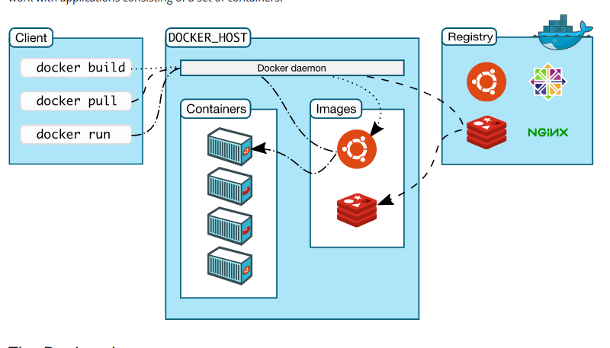

we interact with docker using Docker-client through CLI commands

Basic Work flow of Docker Architecture:

when provide commands to docker-client it communicates with docker-daemon using Rest-API
and docker-daemon process our reqiurements based on the given commands

For example:

--- $ docker pull ubuntu

docker-client sends the context to daemon
now Daemon process the given command with help of Docker-Registry

firstly docker-daemon search for ubuntu image on our local system if it doesn’t finds on local system then it goes to Docker-Registry and brings it from there.

Docker Registry URL (hub.docker.com)

Docker registry is a storage and distribution system for Docker Images.

It is organized into Docker repositories , where a repository holds all the versions
of a specific image.

By default, the Docker engine interacts with DockerHub , Docker's public
registry instance.

Docker Commands

1. docker version
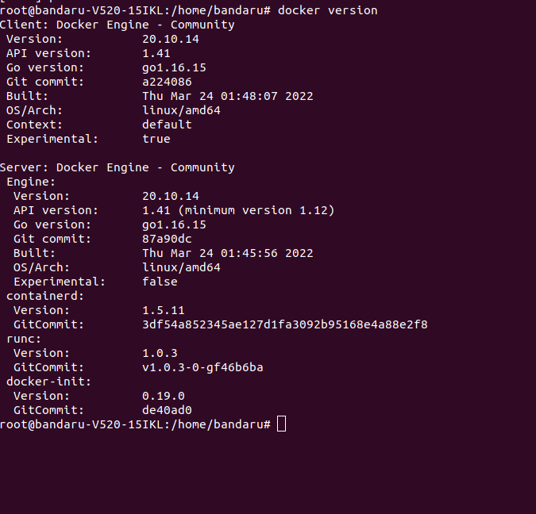

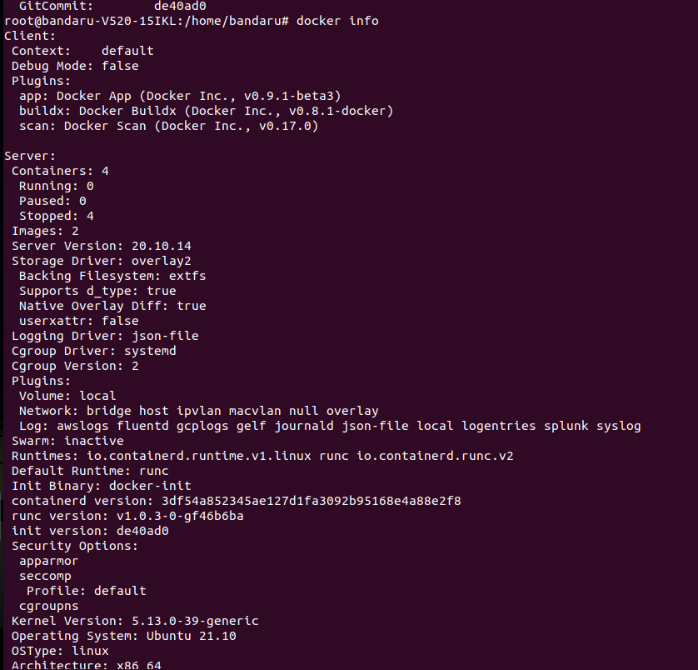
2. docker info

What is a Docker Image?

Docker image can be compared to a template that is used to
create Docker containers. These are read-only templates that contains application binaries and dependencies. Docker images are stored in the Docker Registry.

What is Docker Container?

Docker container is a running instance of a Docker image as
they hold the entire package needed to run the application.

run
Docker Image --------> Docker Container

we can run multiple docker containers using single docker image
but we need to ensure that none of containers name should be same as another Container.

The changes we made inside running container doesn’t reflect the image we ran
unless you you export the contianer as a new image.

An Docker Image is a Read-only-Template
so, when we run containers docker creates a writeable layer where we can make our modifications as per our requirements to the running containers.

Docker home directory

/var/lib/docker

where docker stores all its docker images, containers, networks, volumes
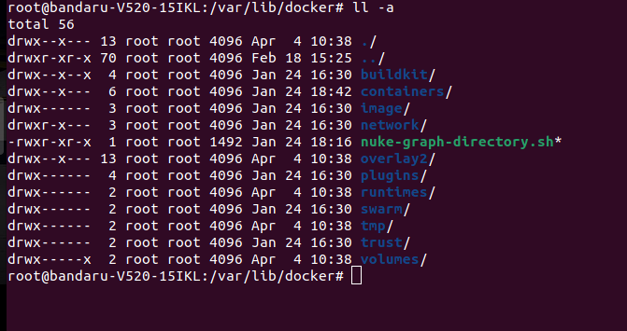

Docker basic commands

Format: docker <command> <sub-command>
eg: ----$ docker image ls

Docker Container basics

Running a container

--- $ docker container run nginx

What happens in 'docker container run'

1. Docker looks for that image name nginx locally in image cache.

2. If it doesn't find anything, it looks in remote image repository(docker hub)

3. Downloads the latest version (nginx:latest by default)

4. Creates new container based on that image and prepares to start

5. Container gets attached to a network and gets a virtual IP
inside the private network, typically default bridge network

6. Opens up ports to serve the requests

7. Starts process mentioned in the CMD of image’s Dockerfile

---> When we run nginx, a container is created and it runs in the foreground
and terminal is attached to its process

• When we exit out of the terminal, the container will be killed

• To avoid this we need to run the container in detached(background) mode

using –detach

--- $ docker run --detach nginx

--- $ docker ps
list all running containers

---- $ docker ps -a
list all running and Exited Containers

---$ docker container inspect <container-id>
gives the config and meta data used to start this container; returns JSON array

---$ docker run --detach –p 8080:80 --name webhost nginx
Naming a container

---$ docker container stop <unique container id>
Stop a container

---$ docker start < unique container id>
Start a stopped container

---$ docker container kill <unique container id>
Kill a container

---$ docker container logs <container name>
To see logs of contianer

---$ docker container rm <container name>
Remove a container

---$ docker top <container>
Lists specific processes in a specific container

---$ docker container stats <container>
Get CPU, Mem usage of the container

Docker Container: Provide shell access

Importance of -i -t flags

Any image that has shell as its starting process expects a terminal(-t)
and standard input(-i) to be attached when starting the container.
If the container doesn’t find the terminal, it simply exits.

Interacting with the running container

Use exec to interact with a running container

--- $ docker run -it -d --name centos centos
---$ docker exec -it centos bash

Commit changes in container to a image

• By default changes made to container are
lost once container is deleted, to preserve the

changes, commit to an image

----$ docker commit <container-id> <new-image-name>

Docker Networking:

• Docker gives 3 default networks: bridge, none and host
• When you start Docker, a default bridge network (also called bridge) is
created automatically, and newly-started containers connect to it unless
otherwise specified.

---$ docker network ls
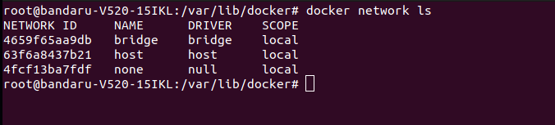

----$ docker network inspect bridge
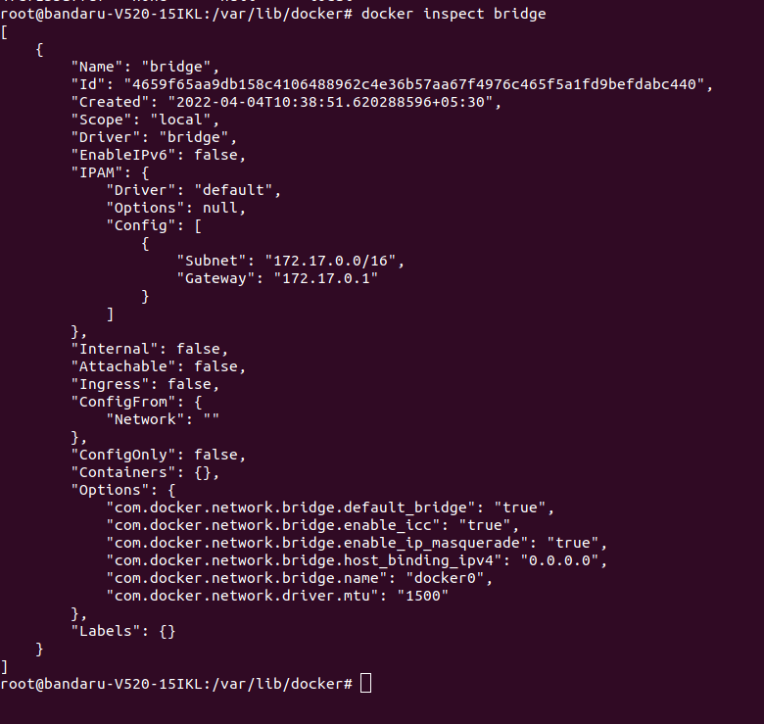

Docker Networking: Bridge

In Bridge network, all containers get private internal IPs
and they are isolated from host.

Port forwarding forwards outside traffic to the containers.

Containers on the default bridge network can only access
each other by IP addresses, unless you use the --link
option, which is considered legacy.

You can also create user-defined custom bridge network
User-defined bridge networks are superior to the default
bridge network.

On a user-defined bridge network, containers can resolve
each other by name or alias(DNS)

Creation of Network

Create a bridge network:

----$ docker network create --driver bridge <network-name>

Attach a container to it:

----$ docker run -d --name web --net <network-name> nginx

When containers are run in default bridge network they cannot find
each other using their container names.

For example:

when 2 containers are created under the default bridge network
Note that ping to second container from the first container using the second container’s name will not provide any results( i.e there is communication between them)

Now a new bridge network is created and containers are attached to
that network.

In this case, containers find each other using their container
names

Docker Networking: Port Mapping

Port forwarding enables access to
applications running inside containers from
outside world

----$ docker run -it -p 5000:80 nginx

Docker Networking: Host

• In host network, all containers directly get connected to
host.
• Multiple containers cannot run on same hosts because of
port conflicts on host side.

To run container on host network.

---- $ docker run -d --name web -net host nginx

Docker Networking: None

• This network doesn’t have any IP address for running Container.

• Containers run in pure isolation.

• when you inspect this container, it shows null or none for IP address.

Docker Volumes

Images are a series of read-only layers

A container is merely an instantiation of those read-only layers with a single read-write layer on top.

Any file changes that are made within a container are reflected as a copy of modified data from the read-only layer.

The version in the read-write layer hides the underlying file
but does not remove it.

When deleting a container, the read-write layer
containing the changes are destroyed and gone forever!

In order to persist these changes we use docker volumes.

Advantages:

1. To keep data safe when a container is removed.

2. To share data between the host filesystem
and the Docker container.

Docker Volumes

Two types of volume mounts: Named(Mount) and Bind

Named Volume: Mounting a volume created using ‘docker volume create’
command and mounting it from default volume location /var/lib/docker/volumes
The Volumes we create are stored in home directory of Docker /var/lib/docker/volumes

-----$ docker volume create <volume-name>

-----$ docker run -d --name nginx -v volume-name:/app nginx

-----$ docker run -d --mount source=volume-name,target=/app nginx

Bind Volume:

External mounting(external hard disks etc.)

Bind mounts may be stored anywhere on the host system. They usually start with
‘/’
----$ docker run –name web -v /root/html:/var/www/html/ nginx

Docker volumes commands:

----$ docker volume create <volume_name>
To create a volume
----$ docker volume ls
To list total volumes

----$ docker volume inspect <volume_name>
To see metadata and other information of volume

----$ docker volume rm <volume_name>
To delete or remove volume

----$ docker volume prune
To delete unused volumes

Building Images:

Hosting a webapplication was easier as base image nginx has all dependencies to host.

What if we are required to host an application which requires lot of dependencies

which base image do we need to provide?

Then We build our own required image!!! Using Dockerfile

Dockerfile

• Dockerfile is used as build instructions to build your image

• It is a text document that contains all the commands a user could call on the
command line to assemble the image

• Using docker build users can create an automated build that executes several
command-line instructions in succession

Name of the file should be Dockerfile without any extentsion

build run
Dockerfile -------> Docker Image -------> Docker Container

Dockerfile Commands:

FROM defines the base image used to start the build process

USER defines which user to use while building image

MAINTAINER defines a full name and email address of the image creator

COPY copies one or more files from the Docker host into the Docker image

EXPOSE exposes a specific port to enable networking between the container and the outside
world

RUN runs commands while image is being built from the dockerfile and saves result as a new
layer

VOLUME is used to enable access from the container to a directory on the host machine

WORKDIR used to set default working directory for the container

CMD command that runs when the container starts

ENTRYPOINT command that runs when the container starts

Simple Dockerfile

FROM ubuntu
USER root
COPY */* /opt
MAINTAINER linux-admin
RUN apt-get update
WORKDIR /opt
CMD bin/bash

----$ docker build -t imagename:tagname -f dockerfilename dockerfilepath
you can we use below command if your Dockerfile name is same as Dockerfile

----$ docker build -t imagename:tagname .

To Push Locally built Imges to our DockerHub Registry

----$ docker tag <imagename> <username-of-dockerhub/repositary-name:tagname>

----$ docker login -u username -p password (credentials of DockerHub)

----$ docker push imagename here imagename is the name which you have tagged earlier
To Push Images to our localsystem Internal Registry

first to have a internal-registry in our localsystem we need run contianer of registry offical image

----$ docker pull registry

----$ docker run -itd -- name internal-registry -p 5000:5000 registry

By default internal registry has 5000 port

To push image to internal registry

---$ docker tag <imagename> localhost:5000/repositoryname:tagname

---$ docker push localhost:5000/repositoryname:tagname

images pushed to internal-registry are stored at /var/lib/docker/volumes/

To push images to internal registry of other machine

Repeat the same above steps

make sure while tagging provide IP address of machine and port number of running container

need to add some lines in daemon.json file
that is “insecure-registries”: [“IP address:port”]
location of daemon.json file /etc/docker/daemon.json

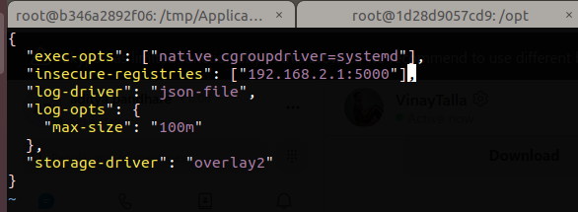

while you are pushing image to other machine make sure that “registry” container is running on that machine

----$ docker tag <imagename> <192.168.x.x:5000/repositoryname:tagname

----$ docker push 192.168.x.x:5000/repositoryname:tagname

DockerFile for IBM-APP CONNECT

FROM ubuntu
WORKDIR /opt/ibm
COPY IBM_ACE_12.0.1.0_LNX_x005F_X8664_INCTK.tar.gz /opt/ibm
RUN tar -xvf IBM_ACE_12.0.1.0_LNX_x005F_X8664_INCTK.tar.gz
RUN /opt/ibm/ace-12.0.1.0/ace make registry global accept license silently
RUN useradd --create-home --home-dir /home/aceuser --shell /bin/bash -G mqbrkrs,sudo aceuser
RUN su - aceuser -c ‘. /opt/ibm/ace-12.0.1.0/server/bin/mqsiprofile’
RUN echo "./opt/ibm/ace-12.0.1.0/server/bin/mqsiprofile" >> /home/aceuser/.bashrc'

RUN above DockerFile

go inside the running container and run bash profile
or “ . /opt/ibm/ace-12.0.1.0/server/bin/mqsiprofile”

Dockerfile for IBM-MQ

FROM oraclelinux:7.9
USER root
RUN useradd mqm
RUN cat /etc/passwd
COPY IBM_MQ_9.0.0.0_LINUX_X86-64.tar.gz /opt
RUN cd /opt && tar zxvf IBM_MQ_9.0.0.0_LINUX_X86-64.tar.gz
RUN cd /opt/MQServer/ && ./mqlicense.sh -accept
RUN yum update -y
RUN cd /opt/MQServer && rpm -ivh MQSeries*
RUN cd /opt/mqm/bin/ && ./setmqinst -i -p /opt/mqm/
RUN usermod -s /bin/bash mqm
RUN su mqm
RUN cd /opt/mqm/bin ./mqconfig
RUN dspmqver

MQ server and client connnection

