Python Oracle DB Connection:

Snapshots:

1. Establishing connection and creating a table.

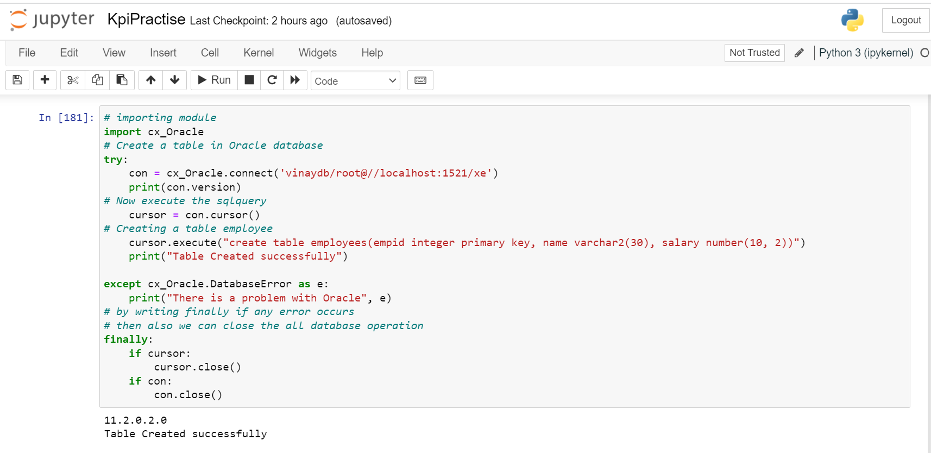

2. Inserting the records into the created table .

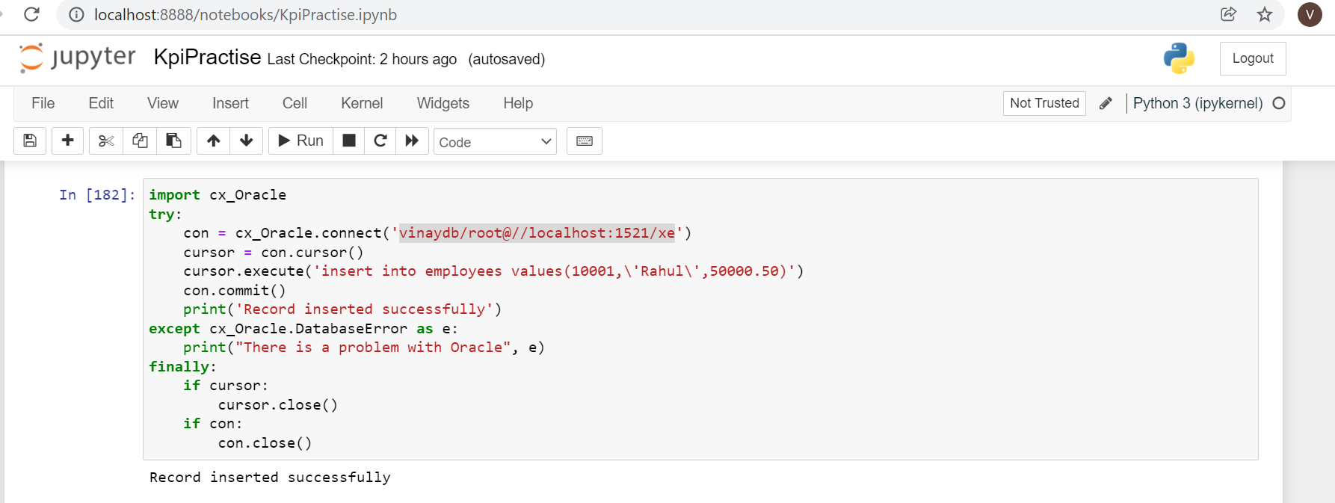

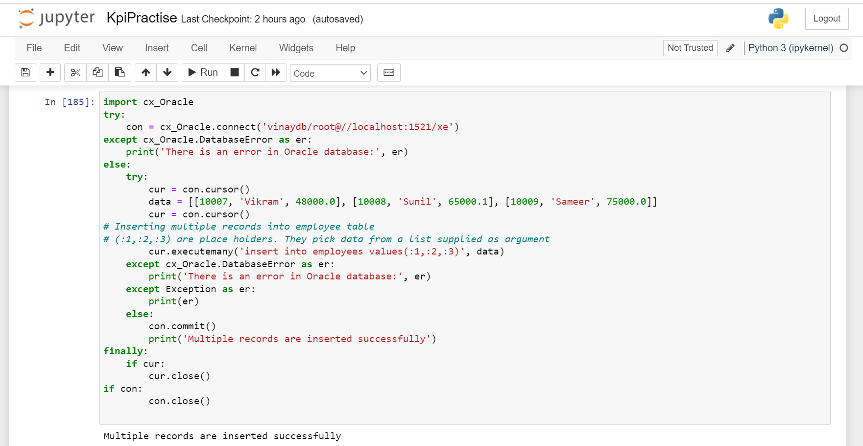

3. Inserting multiple records into the table.

4.Using fetchall() , fetchmany() and fetchone() to reterive the data present in the table.

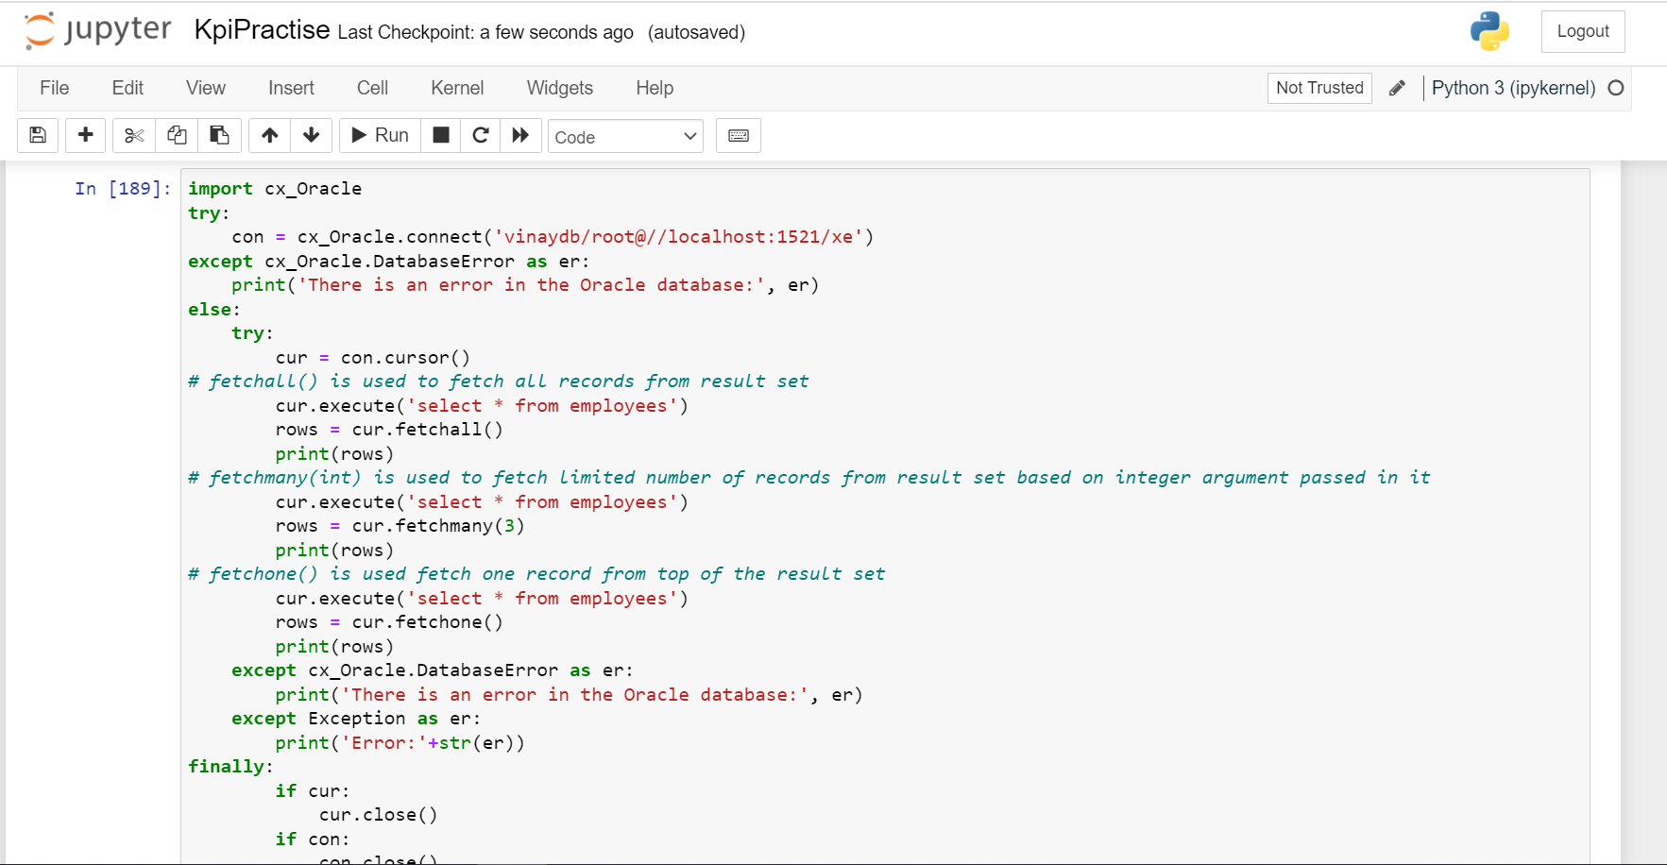

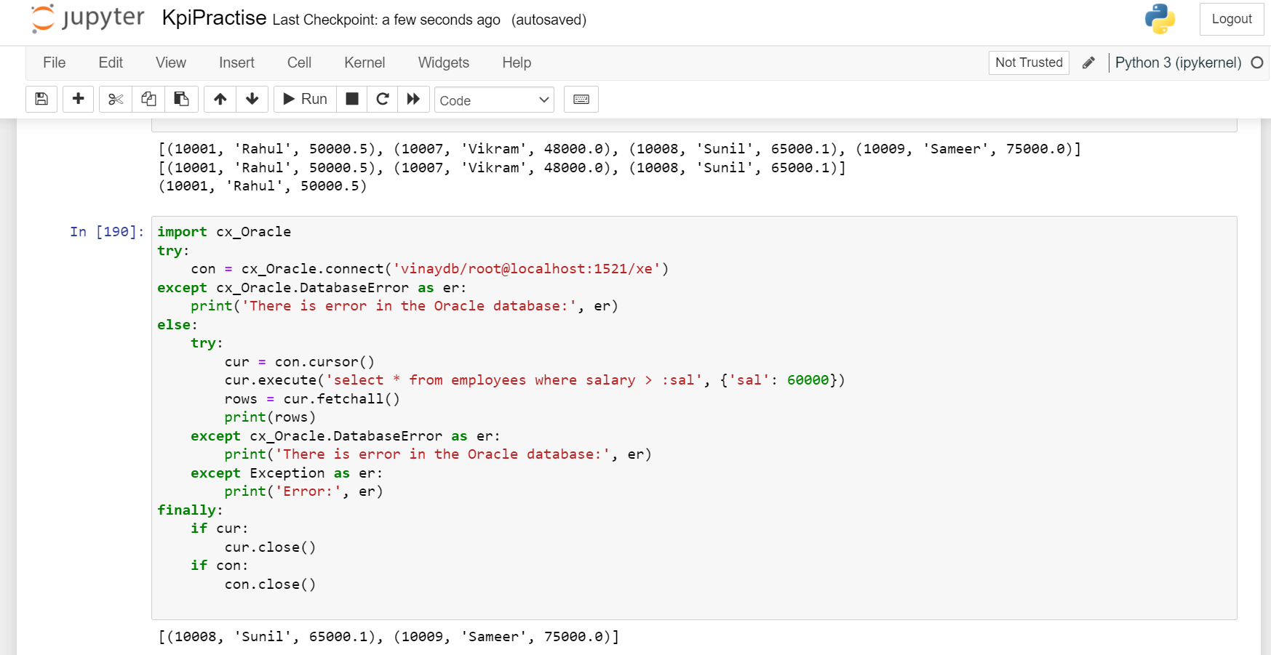

5. Condition to check the employee with sal>60000 and printing it.