6. Find the issue that occurred mostly.

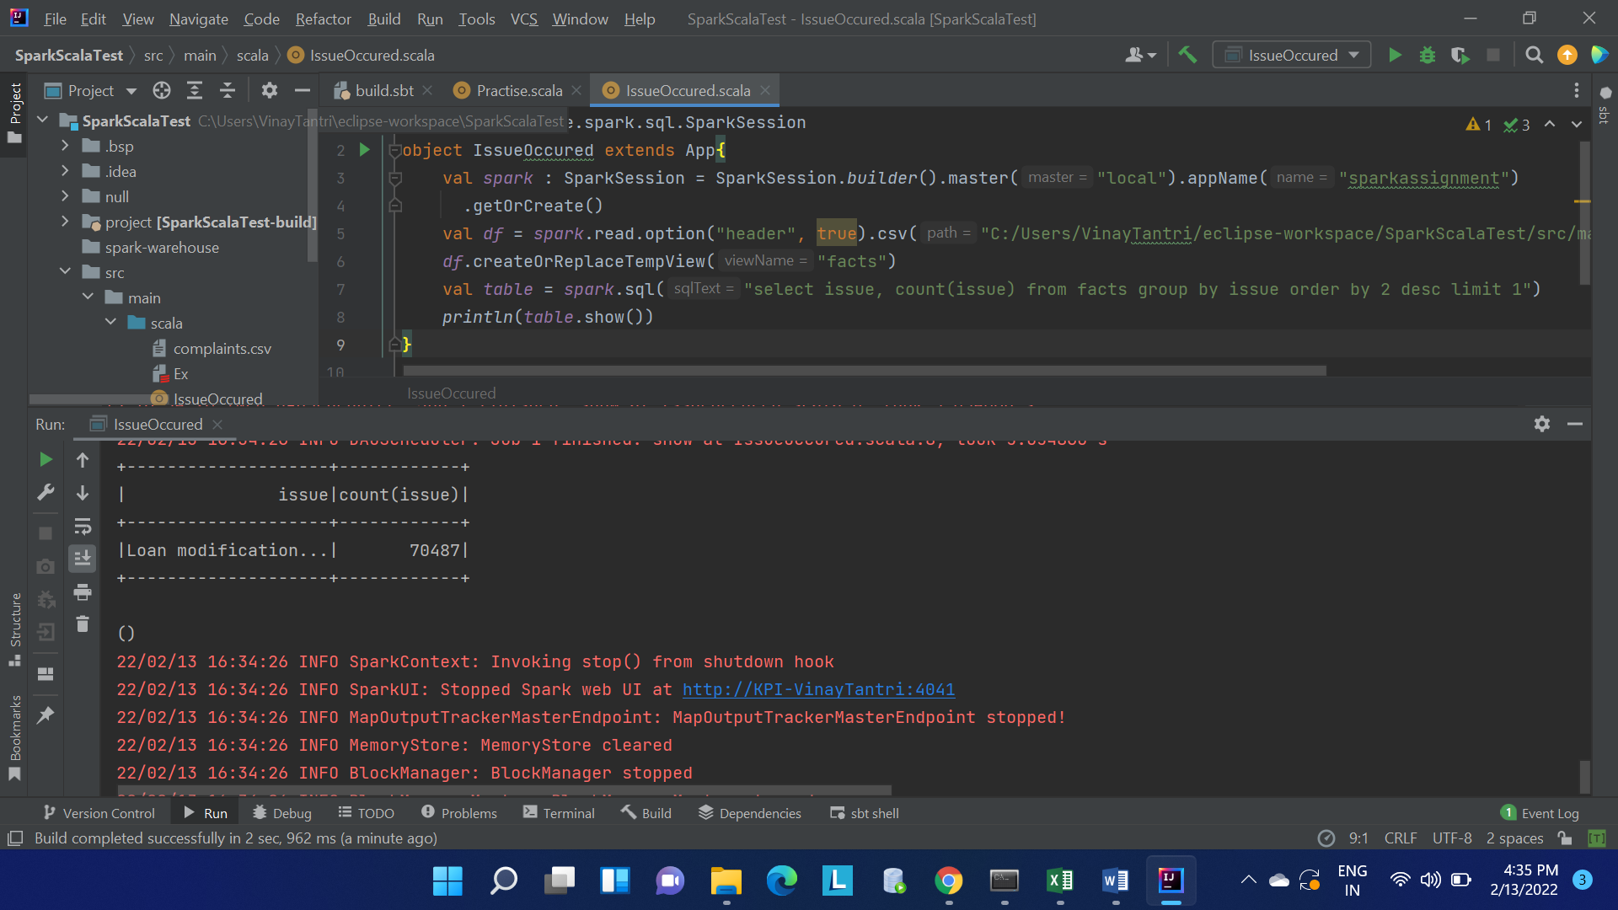

7. Which are the Top 5 states having the highest volume of complaints coming.

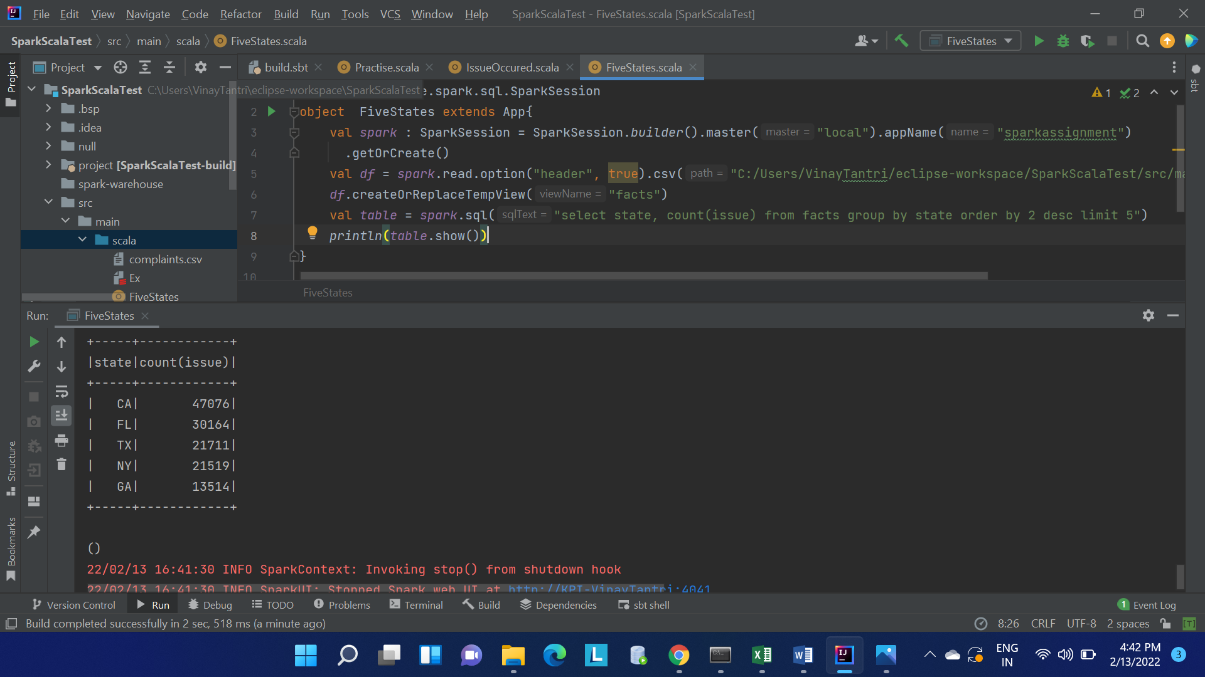

8. Which are the Top 5 companies people complaining the most.

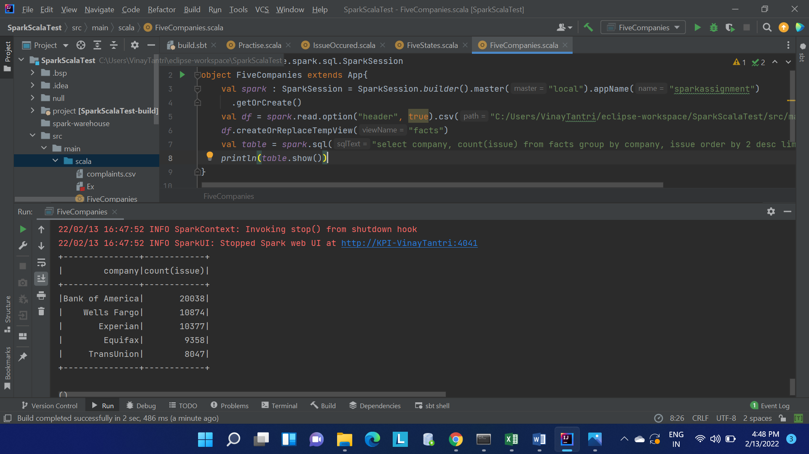9. Which product has the most number of complaints.

