**DataBricks Activity:**

Reading a cluster for checking the file path

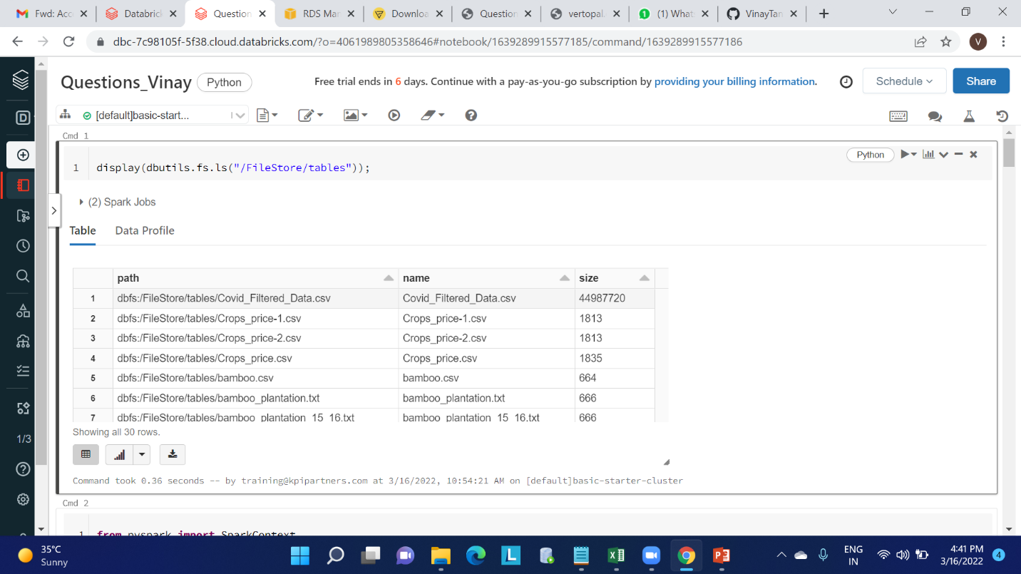

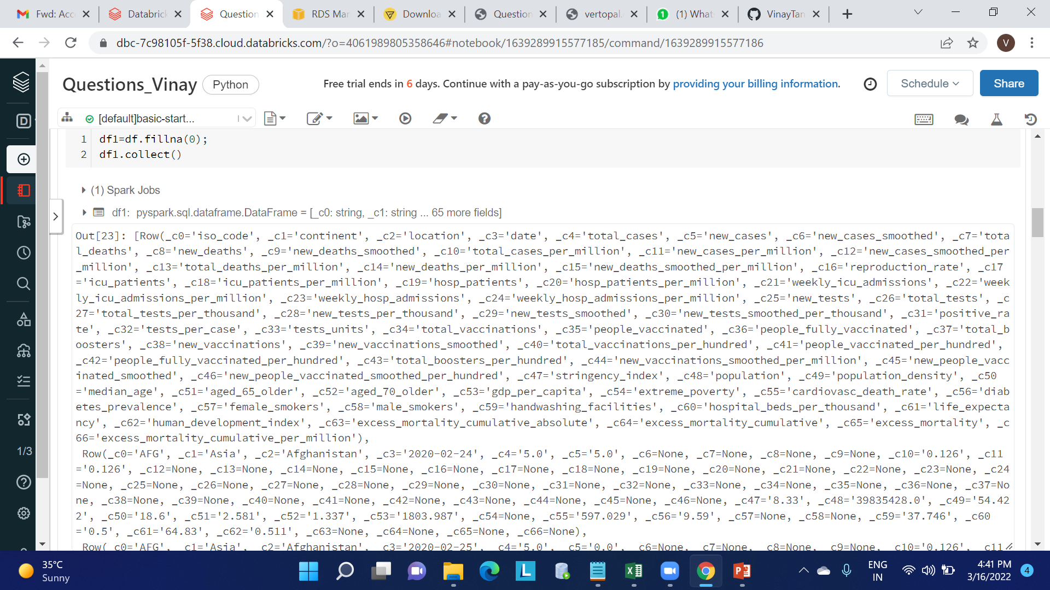

Using header for table name Creating a View

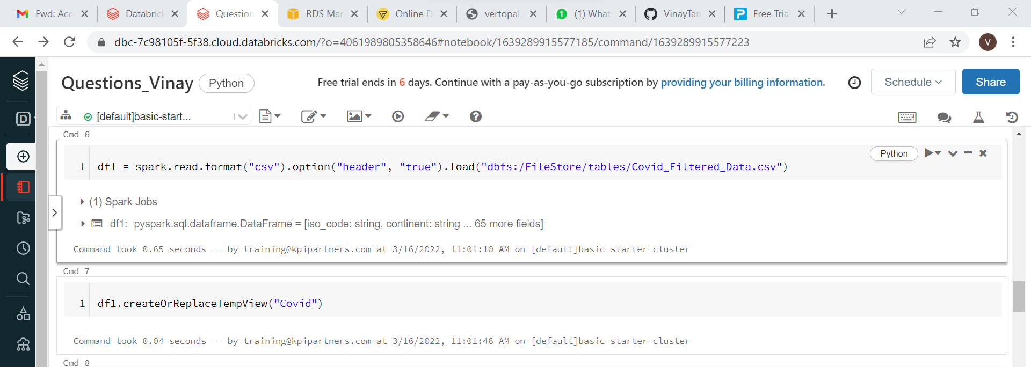

Fetching the data using select * from Covid;

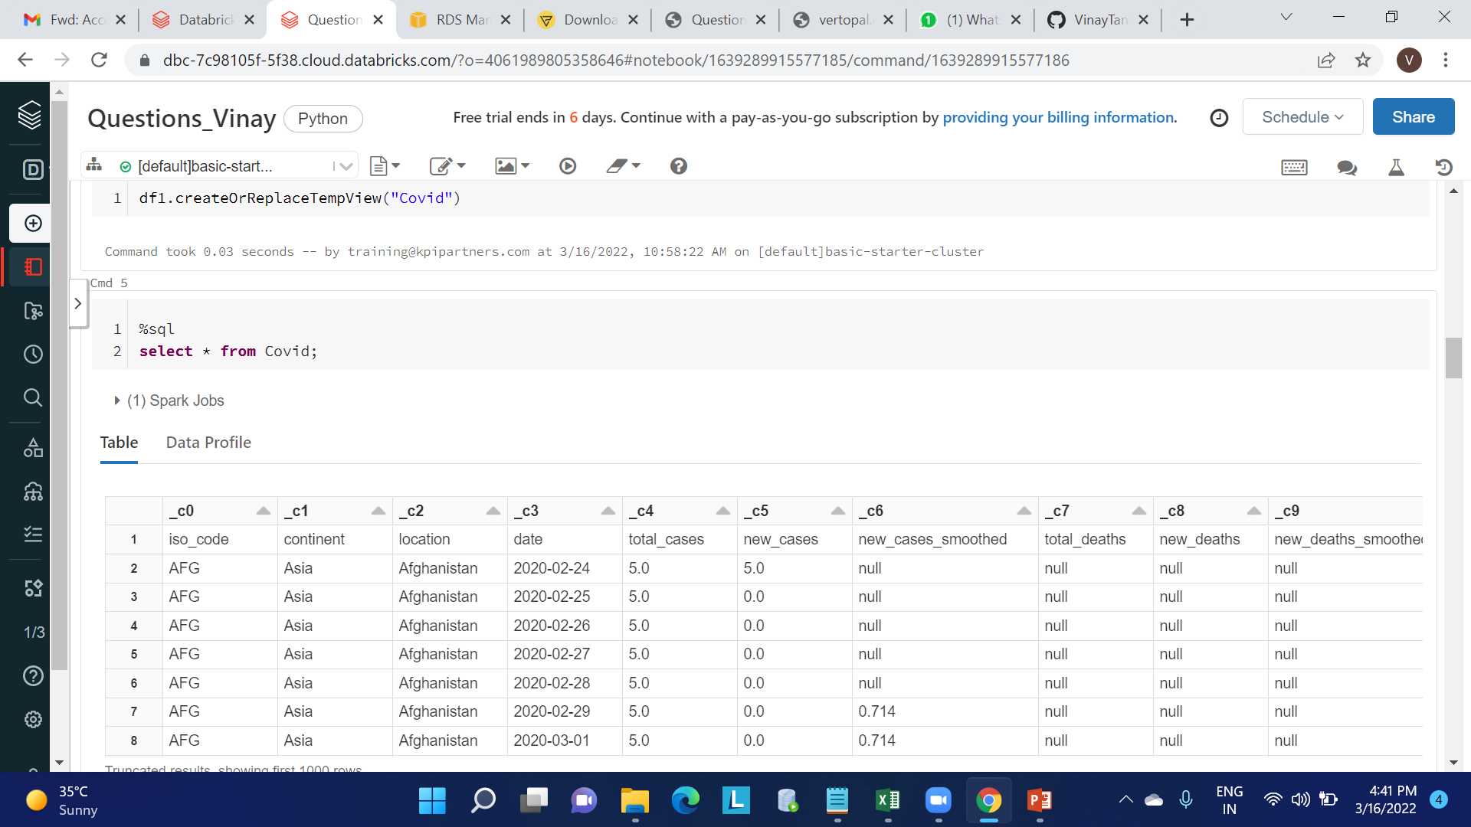

3. Display the continent, positivity rate where the stringency index is maximum

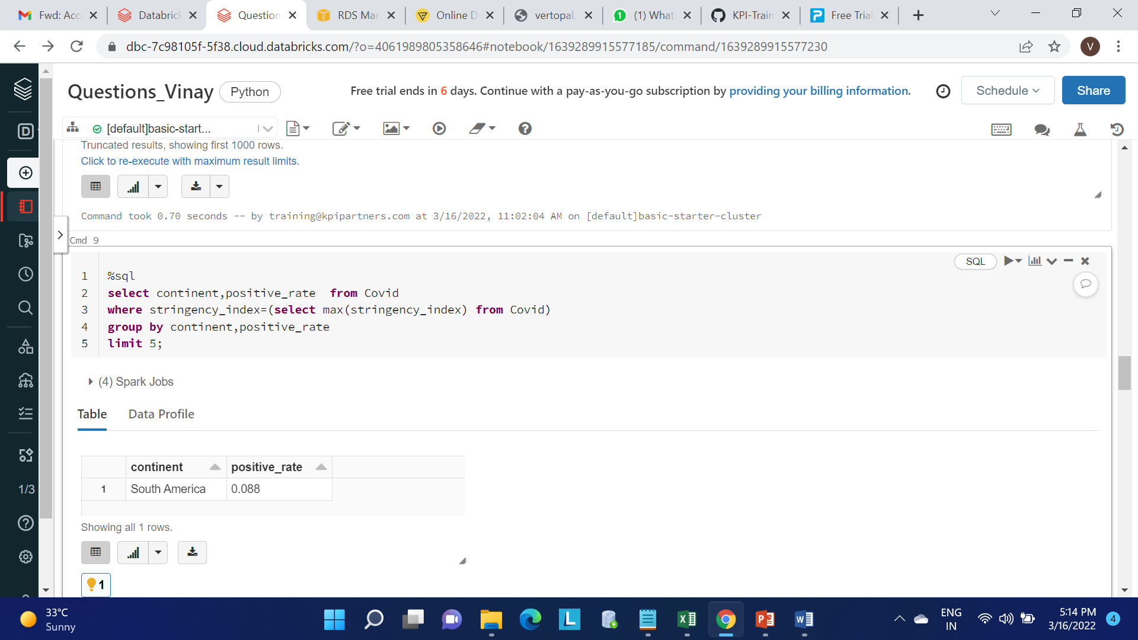

4. Which continent and location having max no.of deaths and male smokers

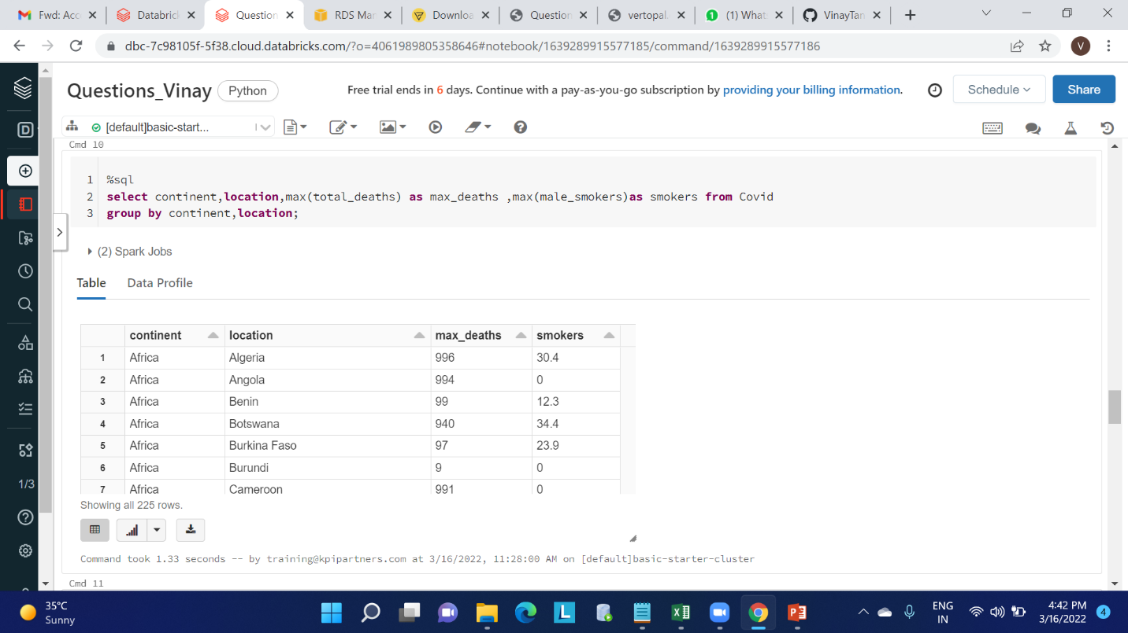

5. Which year having the highest number of deaths

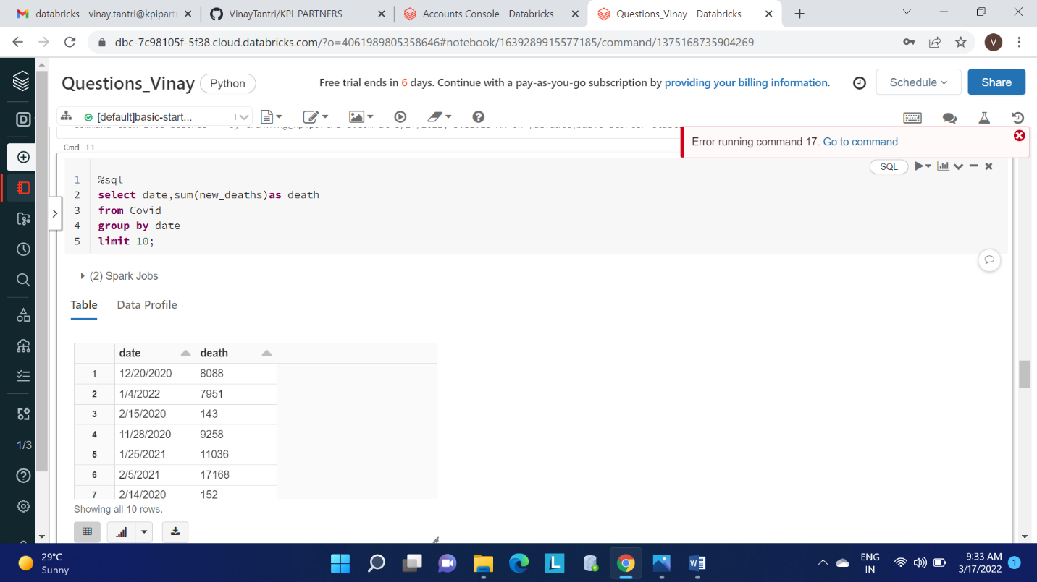

6. Which location having lowest recovery rate for each continent

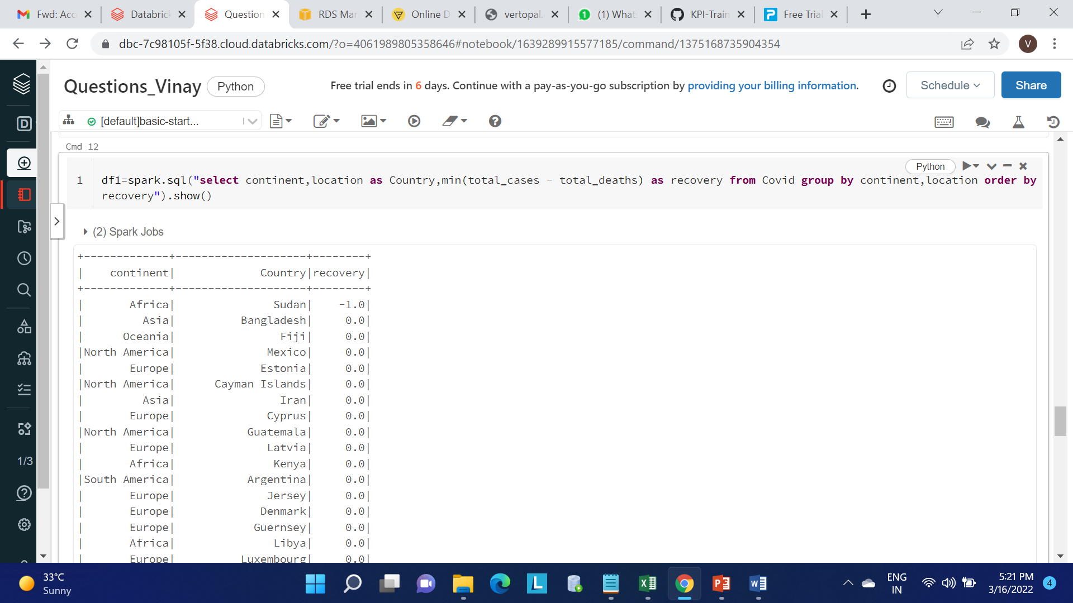

7. Countries with max cardiovascular death rate and diabetes prevalence greater than 10

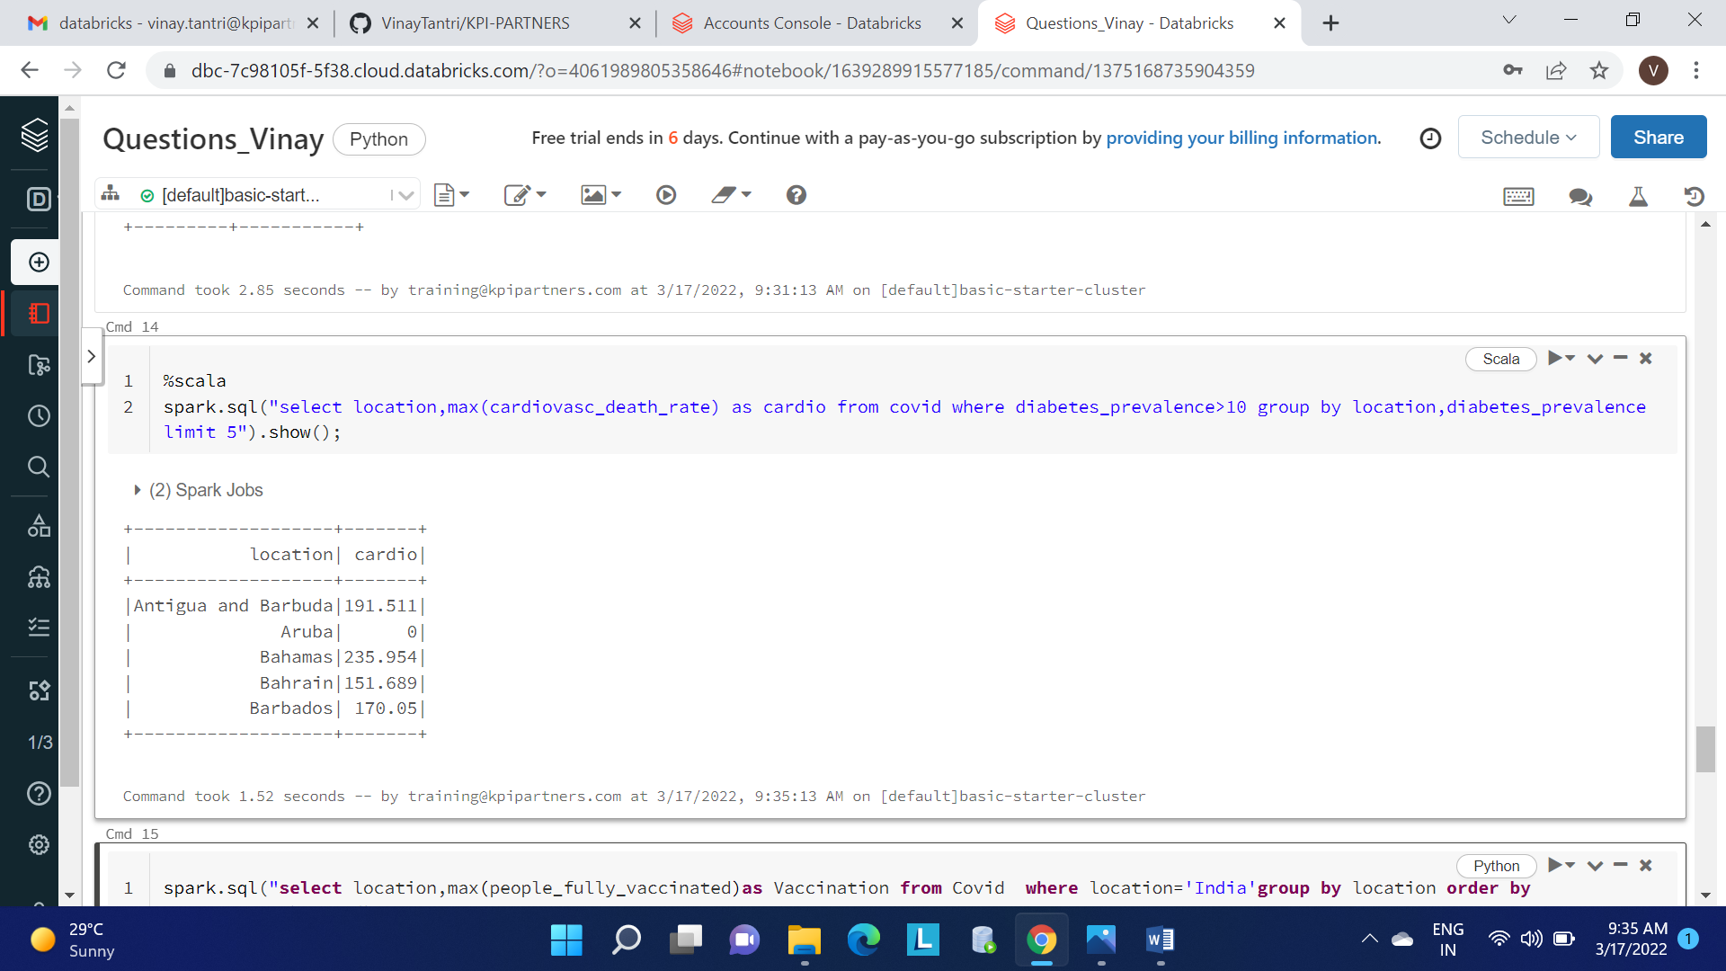

8. Which location has highest number of vaccinated people in each continent

