**Design and Simulation of Four Element Yagi - Uda Antenna Using CST**

**Submitted to:**

**Dr. Paritosh Peshwe**

**ECE Department**

**Submitted by:**

**M Vinay Teja**

**BT20ECE008**

**ECE Department**

**Abstract**:

This report presents the design of 4 element Yagi Uda antenna at 1800 MHz frequency. The antenna has one active element (dipole antenna), one reflector and 2 directors (parasitic elements). The antenna design is modelled and simulated in CST microwave studio.

Index Terms— Yagi-Uda, S-Parameter, Gain, Directivity, Reflector, Dipole, Director and CST studio.

**Introduction:**

Yagi - Uda antenna was invented by Shintaro Uda and Hidetsugu Yagi in 1920. It is widely used in applications where high gain and directivity is required. Usually Yagi - Uda consists of an active element, reflector and directors. Reflector is placed rare side of the dipole and directors are placed in front side of the dipole. Feeding is provided at the centre of the dipole, so that maximum power is transmitted from transmitter to antenna. No feeding is provided to reflector and directors. Director length is a bit shorter than the active element and the director length vary with respect to spacing between director elements. Director length and spacing between director elements has significant effect on gain and band width. The length and spacing of a reflector also affect the gain and input impedance of an antenna. A low-cost Yagi - Uda antenna operating at 1800Mhz is designed in this report.

**Antenna Design Parameters:**

The basic structure of 4 element Yagi Uda antenna is shown in the figure. A port is provided at the centre of the dipole and is fed by a voltage source of 50 ohms impedance. The proposed antenna is designed at a resonant frequency of 1800Mhz the antenna design parameters at 1800Mhz is given by:

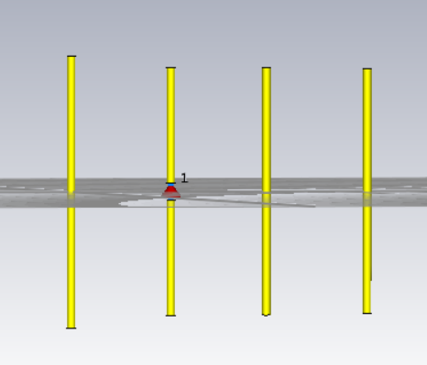

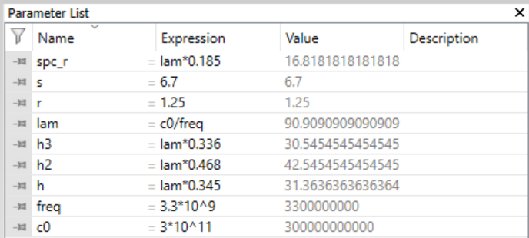

Directors

Dipole

Reflector

**Parameters List:**

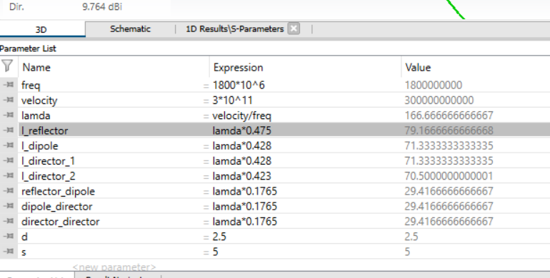

Where d is the diameter of elements used.

Lamda is the wavelength

Velocity is the speed of light in milli meters

S is length of slot for active element

Freq is the resonant frequency at which the antenna is supposed to work

L_reflector is the length of reflector element

L_dipole is the length of active element

L_director_1 is the length of first director

L_director_2 is the length of second director

Reflector_dipole is the distance between reflector and dipole

Dipole_director is the distance between director and dipole

Director_director is the distance between directors

L_director_2 is the length of second director

**Variations:**

## **Varying the spacing between the directors:**

The dip in S-Parameters is moving towards higher frequencies with decrease in spacing between directors. The dip is not sharp which indicates all the elements in the antenna are not resonating together. Let’s try further variations.

The following shift is observed by decreasing spacing from lambda*0.2 to lambda*1765.

This came at the loss of gain from 10dBi to 9.923dBi.

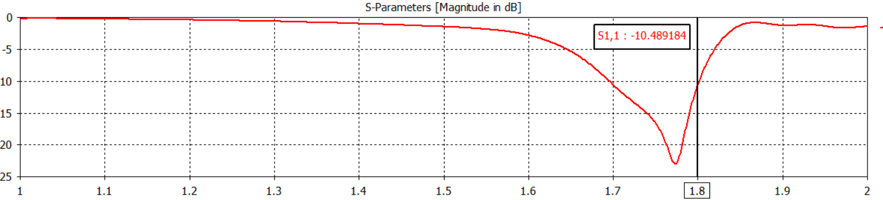

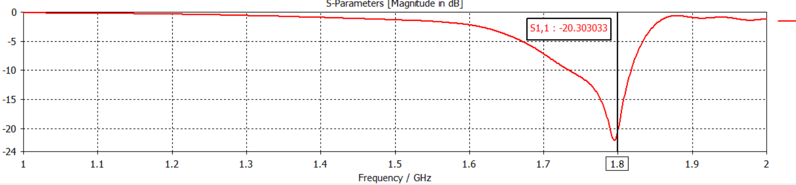

## **Varying the length of dipole:**

As the dipole is the excited element in the antenna, profound changes are observed on varying its length. The irregularity we’ve seen earlier is now uniform and we have a sharp dip. The dip in S-Parameters is getting deep with the decrease in length of dipole at the desired frequency.

The following variation is observed by decreasing length from lambda*0.438 to lambda*428.

This came at a slight loss of gain.

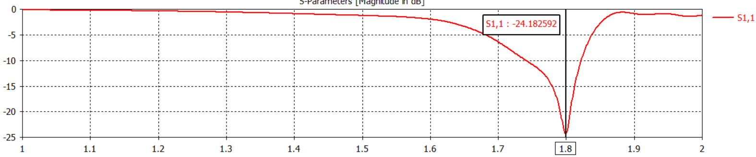

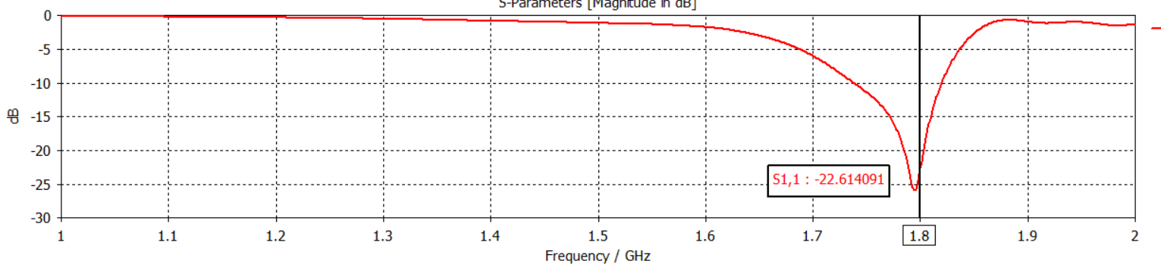

## **Varying the length of reflector:**

Reflector is the longest element in the antenna. Increasing the length increased the bandwidth of antenna. Axis markers are placed at -10dBi to measure bandwidth. The dip in S-Parameters is getting deep with the decrease in length of dipole at the desired frequency like earlier.

The following variation is observed by increasing length from lambda*0.480 to lambda*486.

This came at a significant loss of gain.

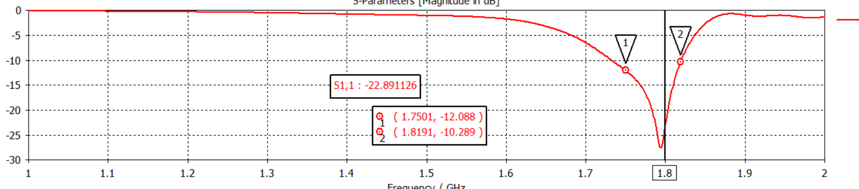

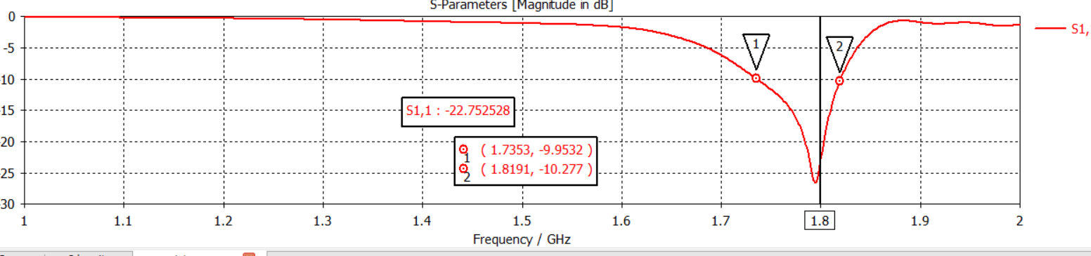

**Final Simulated Results:**

**Parameter List:**

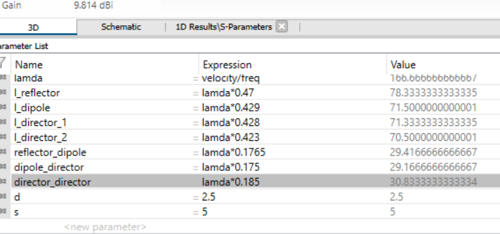

**Far Field and Gain:**

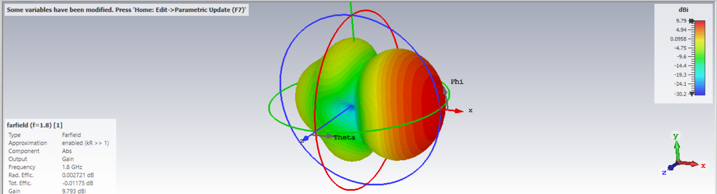

**S-Parameters:**

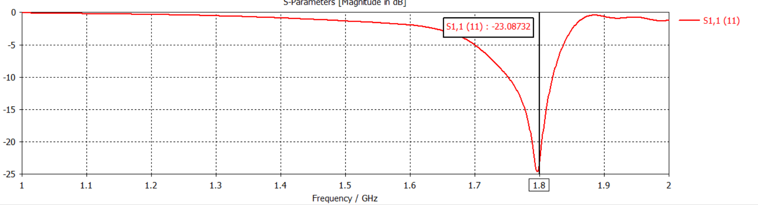

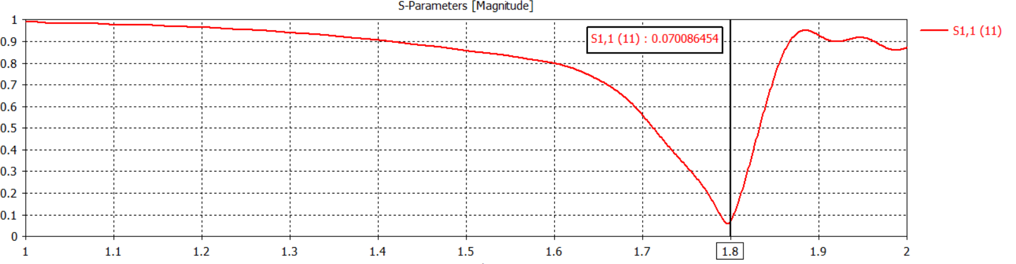

**Other Parameters:**

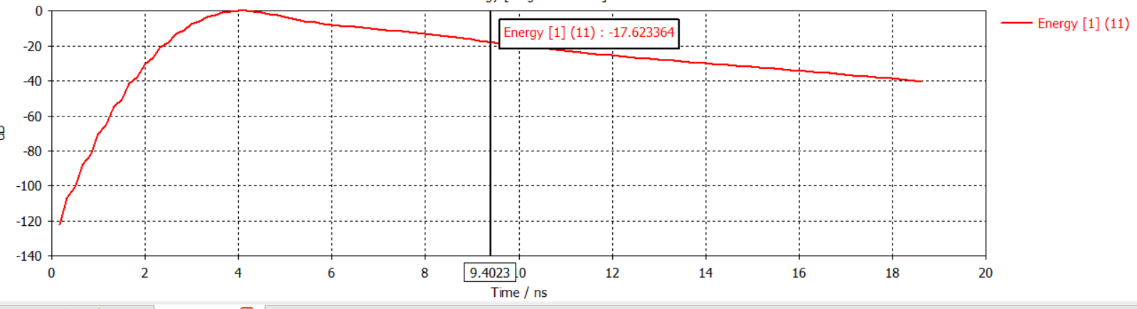

The Yagi Uda antenna is simulated in CST Microwave studio. After observing change in parameters and the trends, the optimized antenna design parameters have achieved improved gain and directivity.

**Fabricated Antenna:**

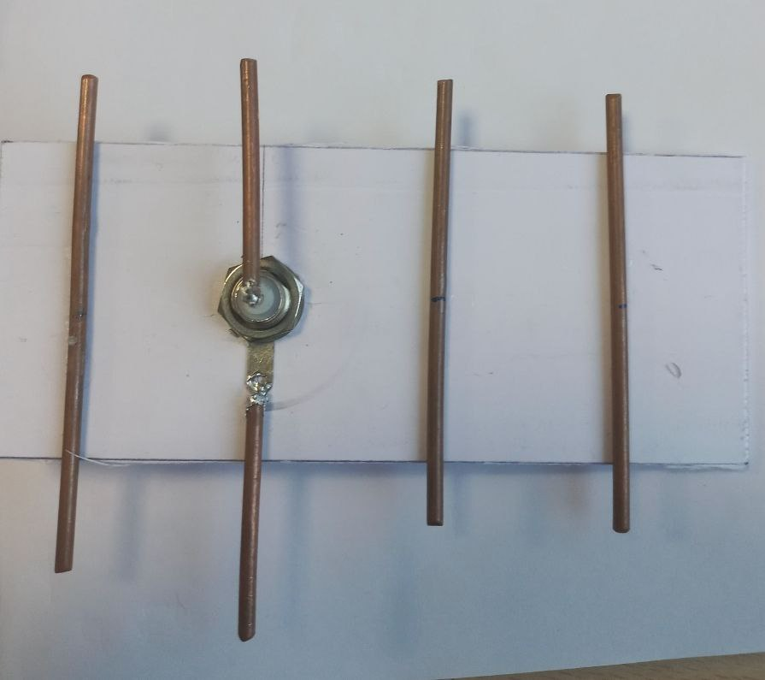

**Performance of fabricated antenna:**

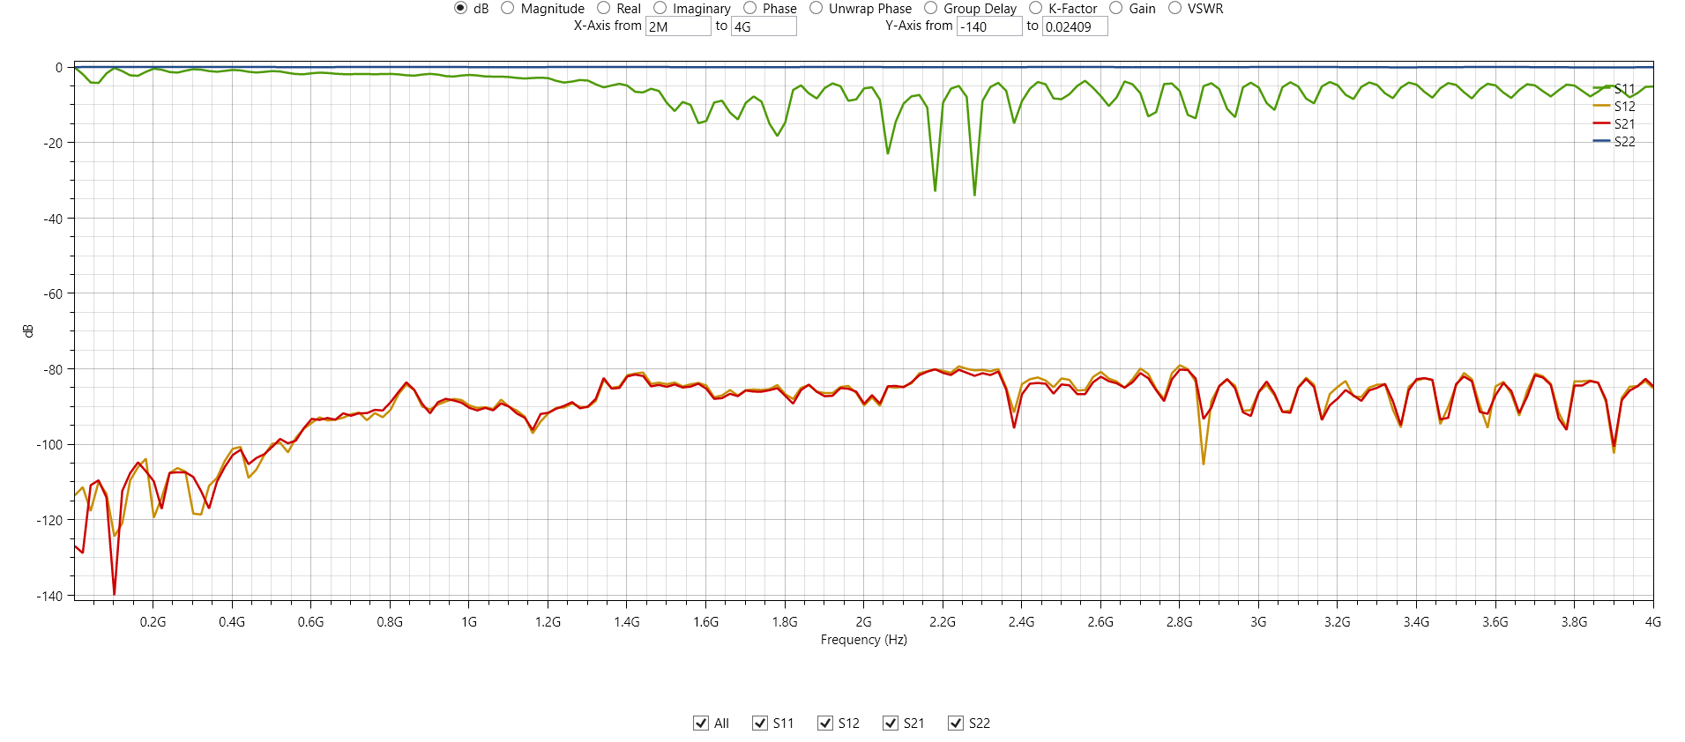

**Conclusion:**

In this report a Yagi Uda antenna is designed and simulated using CST Microwave studio. The antenna is operated in UHF band. This antenna is well suited for RFID applications in UHF band. In this report the length of reflector, dipole and directors and spacing between elements are varied and S-Parameter and gain is gain is observed after every change in parameter. Total of 7 parameters can be varied. In the future work by altering both length of the elements and spacing between elements high gain and band width can be achieved without increasing the number of directors

**References:**

1. "Yagi Antenna Design" by P Viezbicke from the National Bureau of Standards, 1968

Dipole

Reflector

Director