XAVIER INSTITUTE OF ENGINEERING
Department of Computer Engineering | Mumbai
SOFTWARE ENGINEERING LAB
Mini Project Report
Vehicle Showroom Management System
A web application for vehicle inventory, test-drive booking, online purchase and service management

Submitted by | Vinay P. Tirkey
Class / Branch | Second Year B.Tech, Computer Engineering
Roll No. / Division
Faculty guide
Version / Date | Release v1.0.0 | 4 October 2026

Source code: Git repository "vehicle-showroom-management-system" (release tag v1.0.0)

Abstract
The Vehicle Showroom Management System (VSMS) is a web application that digitises the day-to-day work of a car showroom. Customers can register, search the inventory by brand, model, category and price range, see live availability, book and manage test drives, buy a vehicle with an online payment and download an invoice, and review their booking, purchase and service history. Administrators, sales staff and service staff use role-restricted screens to manage inventory and pricing, customers and staff accounts, test-drive bookings, tax and handling configuration, service records and sales reports.
This project turns the artefacts produced in the Software Engineering lab into a working system. The process model and plan (Experiment 1), the IEEE-format SRS (Experiment 2), the function-point estimate (Experiment 3), the UML models (Experiment 4), the data flow diagrams (Experiment 5), the risk plan (Experiment 6), the configuration management practice (Experiment 7), the white-box testing approach (Experiment 8) and the Jira/Trello planning (Experiment 9) each map directly onto a part of the delivered code, tests or repository history.
The system is implemented in Python with the Flask framework and SQLAlchemy. It is verified by 120 automated tests (unit, integration, system, white-box, security and non-functional) that reach about 91% statement coverage. Business rules from the SRS, such as preventing double-booked test drives and ensuring a vehicle cannot be sold twice, are enforced in code and proved by tests, including a multi-threaded race test.

Table of Contents
Abstract 2
1. Introduction 4
2. Software Process Model 5
3. Requirements Analysis 6
4. Project Estimation 7
5. System Design 8
6. Implementation 12
7. Testing 14
8. Software Configuration Management 16
9. Risk Management 17
10. Project Tracking with Jira and Trello 18
11. Results: Application Screens 19
12. Limitations and Future Scope 30
13. Conclusion 30
References 30
Appendix A: Running the System 31

1. Introduction

1.1 Background and problem statement
A traditional showroom keeps its inventory, test-drive schedule and sales records on paper or in disconnected spreadsheets. This leads to well-known problems: a vehicle is promised to a customer after it has already been sold, two customers are given the same test-drive slot, quotations contain inconsistent taxes, and nobody can easily see how the business is performing. The SRS (Experiment 2) describes a web-based system that replaces this manual process with a single, secure, always-available application.

1.2 Objectives
- Let customers register, log in, search vehicles and check availability.
- Let customers book, reschedule and cancel test drives without double-booking.
- Let customers purchase a vehicle with a correctly calculated price, pay online and receive an invoice.
- Let administrators manage vehicle inventory, pricing, customers, staff and configuration.
- Let service staff maintain service records and let customers see their service history.
- Protect customer and payment data and restrict each screen by role.
- Prove the behaviour with structured testing and keep the work under version control.

1.3 Scope
In scope are all features listed in section 4 of the SRS. Out of scope for this release, and flagged as "to be determined" in the SRS, are a real third-party payment provider, real e-mail delivery, peak-load targets and a data-retention policy. The payment gateway and e-mail are therefore simulated behind clean interfaces so that real providers can be plugged in later.

2. Software Process Model
Experiment 1 compared the Waterfall, V, Incremental, Iterative, RAD, Spiral and Agile models. The Agile model was selected because showroom requirements can change, continuous testing finds defects early, and each sprint delivers a working increment. The same choice is recorded in section 6 of the SRS.

2.1 Eight-week sprint plan and what was delivered
Week | Planned work (Experiment 1) | Git tag | Delivered in the repository
1 | Requirements gathering and analysis | - | SRS, scope, estimation, risk plan
2 | System design: use case, DFD, ER, schema | v0.2.0 | Models, app factory, base layout
3 | User / customer management | v0.3.0 | Register, login, profile, RBAC
4 | Vehicle inventory module | v0.4.0 | Search, detail, pricing, seed data
5 | Test drive booking module | v0.5.0 | Book, reschedule, cancel, overlap rule
5-6 | Sales, billing and service modules | v0.6.0 | Purchase, payment, invoice, service
7 | Integration, admin module and reports | v0.7.0 | Dashboard, users, tax config, reports
8 | Final testing, defect fixing, deployment | v0.8.0, v1.0.0 | Security / white-box / NFR tests, docs
Table 1: Sprint plan mapped to repository tags

3. Requirements Analysis
The requirements come from the IEEE-format SRS written in Experiment 2 (version 1.0, 16 July 2026). Requirements are identified as REQ-<feature>-<number>, and every one is traced to code and to at least one automated test in the traceability matrix kept in the repository (docs/TRACEABILITY.md).

3.1 User classes
User class | Responsibilities in the implementation
Customer | Registers, searches, books and manages test drives, buys vehicles, views history and invoices.
Sales staff | Views and completes test-drive bookings, sees sales report (subset of administrator functions).
Administrator | Manages inventory, pricing, tax configuration, customers and staff, password resets, reports.
Service staff | Creates and updates service records for sold vehicles.
Table 2: User classes

3.2 Functional requirements
ID | Requirement (summary) | Priority
REQ-REG-1..4 | Register with name, email, phone, password; unique valid email; login; error on bad credentials | High
REQ-SRCH-1..3 | Search by brand, model, price range; show availability; show vehicle details | High
REQ-TD-1..4 | Book, view, reschedule, cancel test drives; e-mail confirmation; no double booking | High
REQ-PUR-1..5 | Purchase, price with tax and charges, payment gateway, mark sold, e-mail invoice | High
REQ-HIST-1..2 | View booking history, purchase and service history | Medium
REQ-ADM-1..4 | Manage inventory, pricing, customer records; admin-only access | High
REQ-SVC-1..3 | Auto-generate invoice; service records; sales and service reports | Medium
Table 3: Functional requirements from the SRS

3.3 Non-functional requirements and business rules
- Performance: vehicle search results within 3 seconds; many users at once without degradation.
- Safety: test drives never double-book a vehicle; inventory status always reflects reality.
- Security: authenticated access, role-based control, salted password hashing, customer and payment data protected.
- Quality: usable first time, reliable, portable across browsers and devices, modular and maintainable.
- Business rules: only authenticated customers book or buy; only administrators change inventory, prices and customer records; a sold vehicle can no longer be booked or bought.

4. Project Estimation
Experiment 3 used Function Point Analysis. The counts and the value adjustment factor are reproduced here as the planning baseline.
Information domain value | Count | Weight | Complexity | Result
External inputs (EI) | 7 | 4 | Average | 28
External outputs (EO) | 4 | 5 | Average | 20
External inquiries (EQ) | 4 | 3 | Simple | 12
Internal logical files (ILF) | 5 | 10 | Average | 50
External interface files (EIF) | 1 | 7 | Average | 7
Unadjusted function points (UFP) |  |  |  | 117
Table 4: Unadjusted function points (Experiment 3)
Value adjustment. The 14 general system characteristics were rated and summed to 40, so VAF = 0.65 + 0.01 x 40 = 1.05. Adjusted FP = 117 x 1.05 = 122.85, rounded to 123 function points.

4.1 Estimate versus delivered system
The five internal files of the estimate correspond to the users, vehicles, test drives, sales/invoices and service records tables, and the single external interface file corresponds to the payment gateway. The delivered system contains about 1,090 non-blank lines of Python application code, 440 lines of HTML templates, about 50 lines of CSS and about 600 lines of test code. Basic COCOMO in organic mode (effort = 2.4 x KLOC^1.05) applied to the Python code gives roughly 2.6 person-months and a schedule of about 3.6 months. Function-point estimates are language-neutral and generally run higher than the line count of a compact Python/Flask implementation, which is why the two figures differ.

5. System Design
The models from Experiments 4 and 5 were refined into the design below. Where the lab diagrams used earlier working names (for example Dealer and Driver), the implementation uses the roles that appear in the SRS (administrator, sales staff, service staff).

5.1 Use case diagram
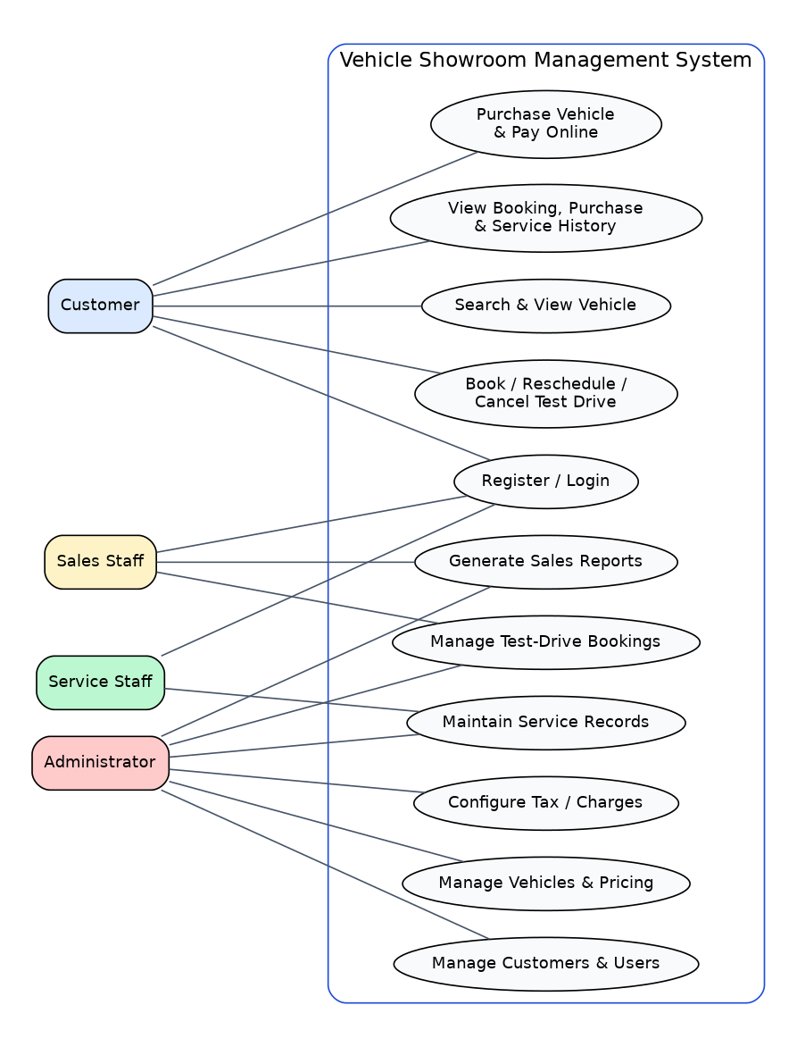
Fig. 1: Use case diagram

5.2 Class diagram
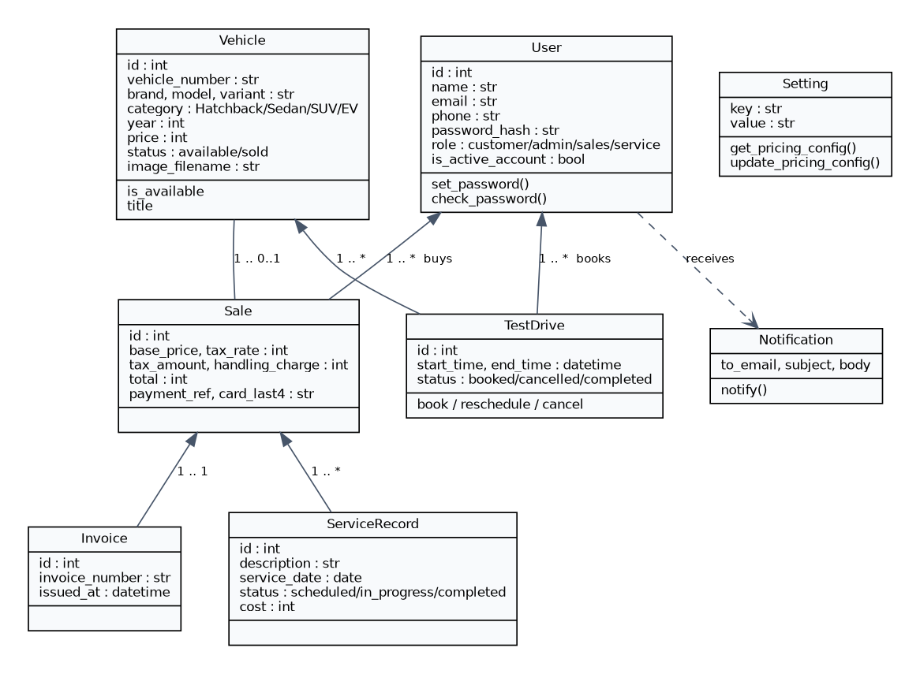
Fig. 2: Class diagram of the persistent model

5.3 Activity diagram: vehicle purchase
The activity diagram shows the purchase workflow including the decision points that guarantee a vehicle is never sold twice. The status change is performed as one conditional database update, and a declined payment rolls the change back.
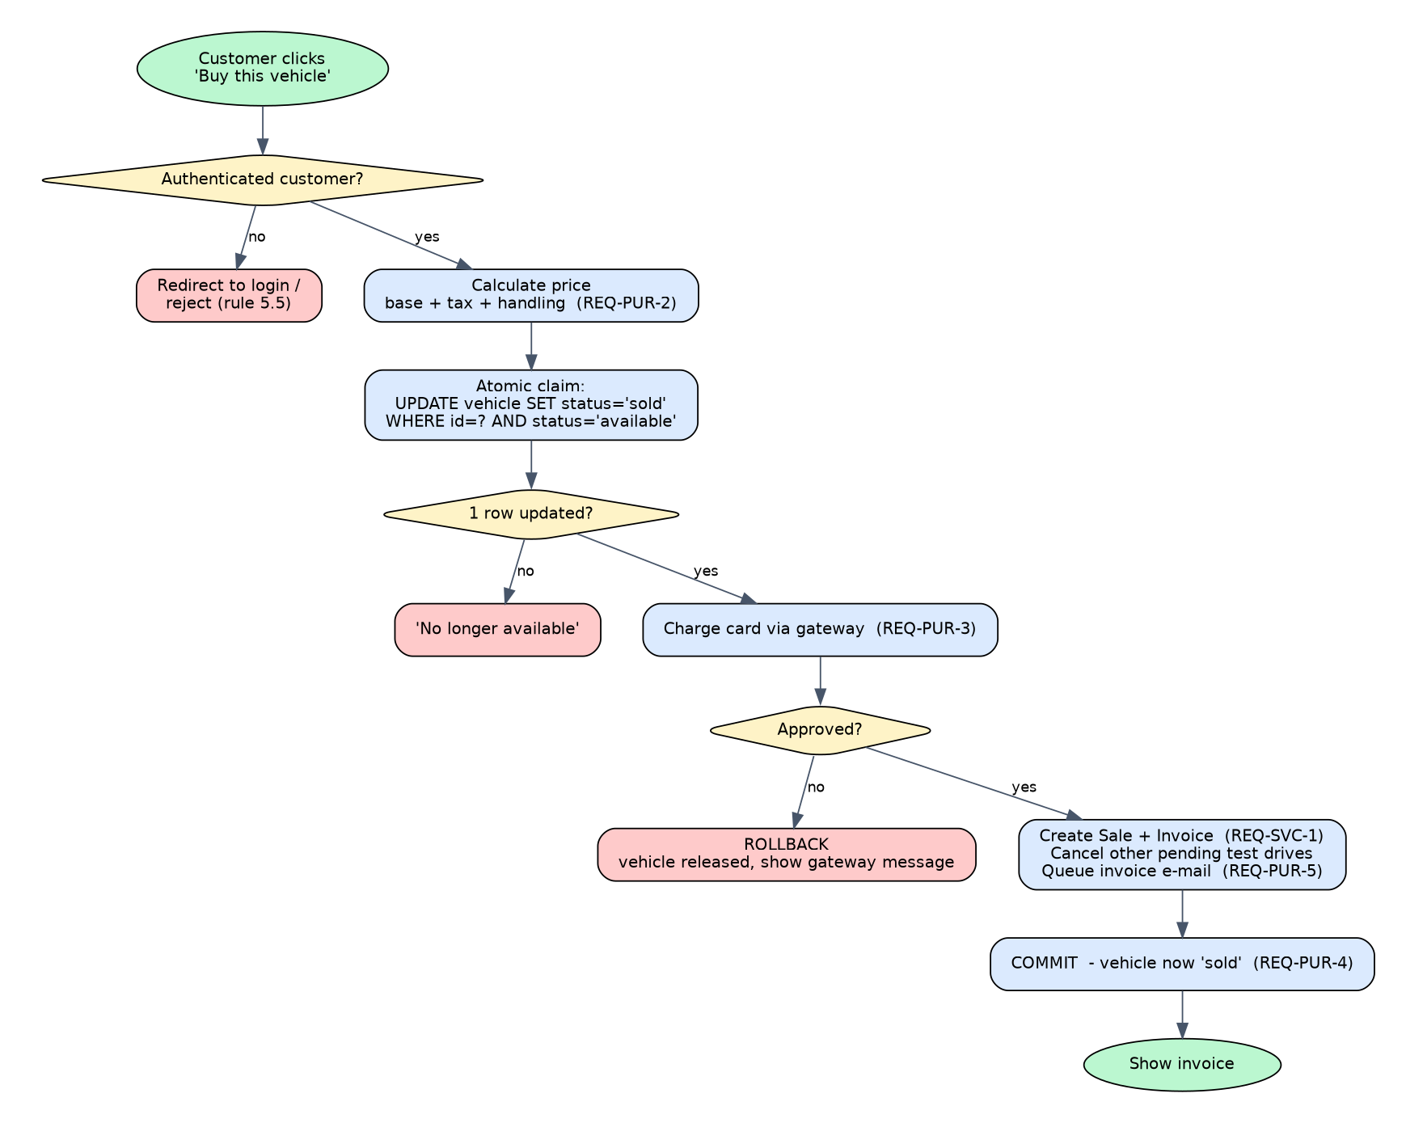
Fig. 3: Activity diagram of the purchase workflow

5.4 Data flow diagrams
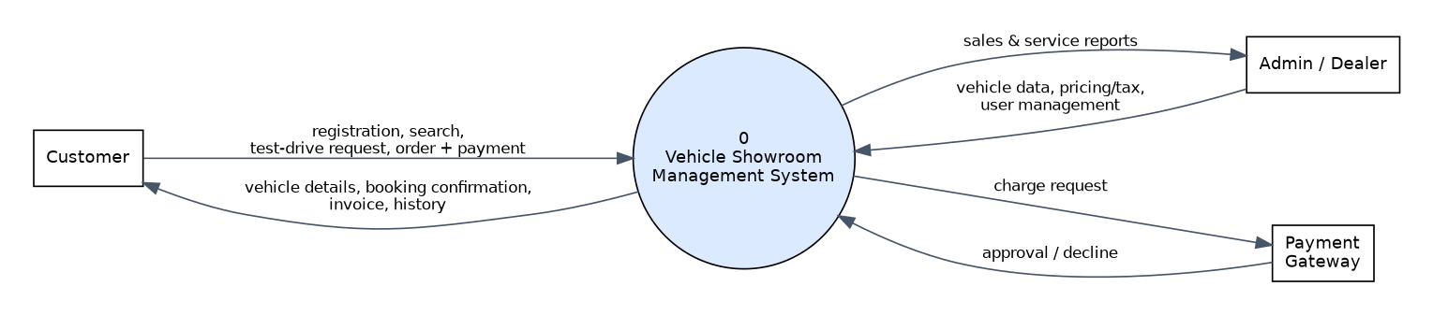
Fig. 4: DFD level 0 (context diagram)
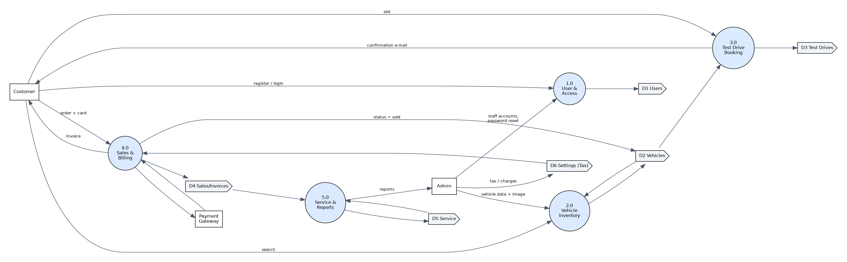
Fig. 5: DFD level 1 (major processes and data stores)

5.5 Entity-relationship diagram
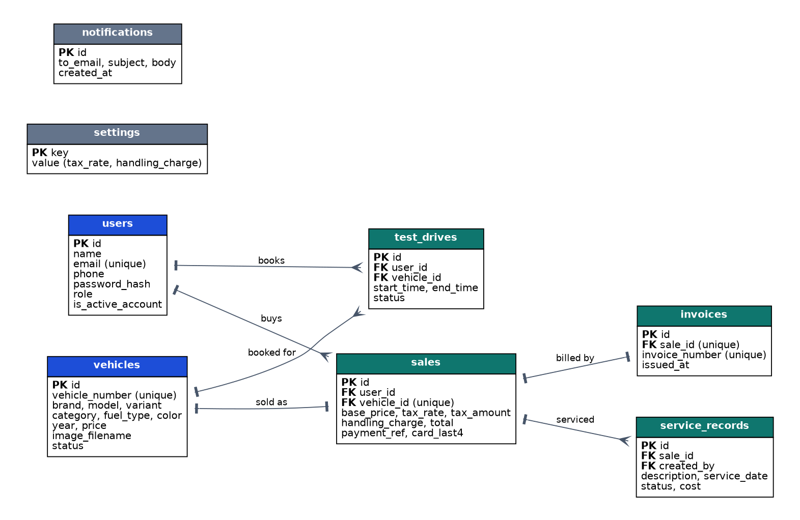
Fig. 6: Entity-relationship diagram of the database

5.6 Architecture
The application uses three layers. Flask routes and Jinja2 templates form the presentation layer and contain no business rules. A service module holds all business logic and is the only code that talks to the payment gateway and the notification outbox. SQLAlchemy models map to the database, which is SQLite by default and can be switched to MySQL, the database named in the SRS, through a connection string.
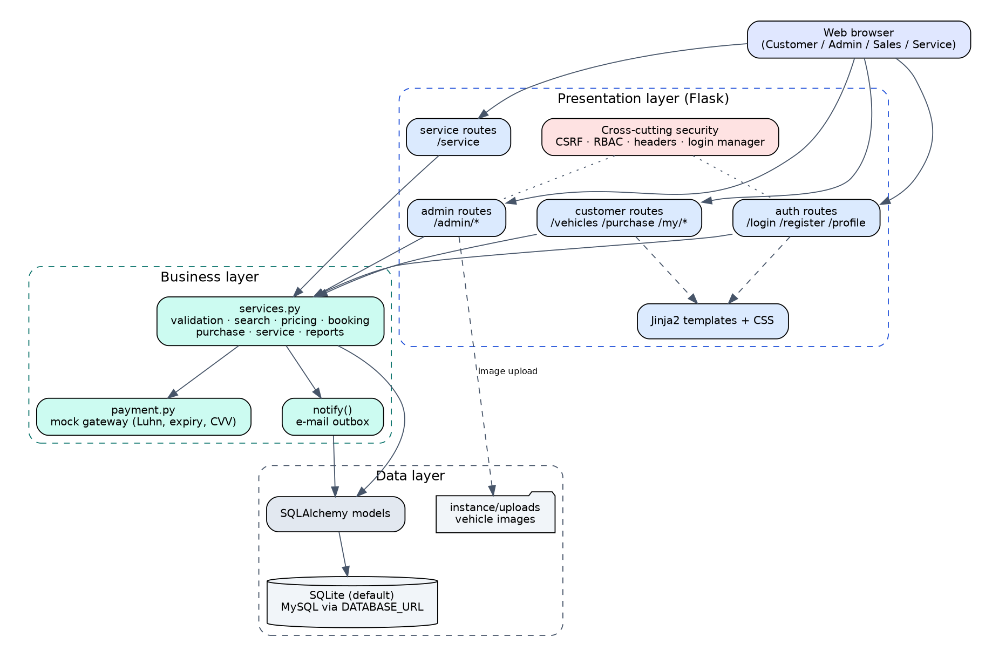
Fig. 7: Layered architecture

6. Implementation

6.1 Technology
Component | Choice and reason
Language / framework | Python 3.12 with Flask: compact, readable, easy to run in a lab and to test
Persistence | SQLAlchemy ORM; SQLite by default, MySQL by setting DATABASE_URL (SRS 2.4)
Authentication | Flask-Login sessions; Werkzeug salted password hashes
User interface | Server-rendered Jinja2 templates and a single responsive stylesheet; no external CDN needed
Testing | pytest, pytest-cov, radon for complexity
Version control | Git with feature branches, merge commits and annotated release tags
Table 5: Technology stack
Note on stack choice. The Jira board in Experiment 9 listed Spring Boot, MySQL and React as the initial task names. The implementation adopted Python and Flask so that the whole project can be installed and verified with one command; the data model and business rules are independent of that choice, and MySQL support is a configuration change (it has not been exercised against a MySQL server in this report).

6.2 Modules
Module | What it does
Accounts (auth routes, services) | Registration validation, login, profile, password change, administrator password reset, account activation
Inventory and search | Search by brand, model, category and price range; vehicle detail; admin add/edit/delete with image upload
Test drives | Book, reschedule, cancel; 60-minute slots between 09:00 and 18:00; overlap checks; completion by staff
Sales and billing | Price = ex-showroom + tax + handling; mock payment gateway; sale, invoice and e-mail record
Service | Service records with scheduled / in progress / completed status and cost
Administration and reports | Dashboard, user and staff management, tax configuration, sales report by brand and month, CSV export
Notifications | Every confirmation, cancellation and invoice e-mail is stored in an outbox table
Table 6: Modules

6.3 Key design decisions
Single source of pricing. One function calculates the total (tax is rounded half-up to whole rupees). The vehicle page, the checkout page and the invoice all use it, so a customer is never quoted a different number from the one charged. The tax rate and handling charge are stored in a settings table that the administrator edits, implementing the "Update Tax Details" process of the level 2 DFD.
A vehicle can only be sold once. Purchase begins with a conditional update that changes the vehicle from available to sold only if it is still available. If zero rows change, the purchase is refused. A failed payment rolls the update back. A test with four threads buying one vehicle at the same instant shows exactly one success and three refusals.
No double-booked test drives. Two bookings clash when each starts before the other ends, so back-to-back slots are allowed. The same check is reused when rescheduling, ignoring the booking being moved. A customer also cannot hold two overlapping bookings.
Payment data protection. The simulated gateway validates the card using the Luhn check, expiry and CVV, then the card number is discarded. Only the last four digits and the payment reference are stored.

6.4 Security measures
- Passwords stored only as salted hashes; password rules enforced; generic "invalid email or password" message.
- Role-based access on every protected route; staff pages return an access-denied response to customers.
- CSRF token required on every state-changing request.
- Open-redirect protection after login; output escaping in templates (tested with a script injection attempt).
- Security headers: content security policy, frame denial, content-type sniffing protection, referrer policy.
- Image uploads limited to PNG/JPG/WEBP, 2 MB, stored under random file names.
- Customers can only open their own invoices and bookings.

7. Testing
The testing plan of Experiment 1 (unit, integration, system) was extended with white-box, security and non-functional tests. All 120 tests are automated and run with a single command.
Level | Test file(s) | Tests | Focus
Unit | accounts, search/pricing, payment, format | 45 | Validation, hashing, search filters, price maths, card checks
Integration | booking, purchase | 25 | Booking with overlap and e-mail; payment to inventory to invoice
System | end-to-end | 9 | Customer, admin and service-staff journeys over HTTP
White-box | whitebox | 28 | Branch and boundary coverage of the most complex functions
Security | security | 11 | RBAC, CSRF, XSS, open redirect, uploads, data at rest
Non-functional | nonfunctional | 2 | Search speed on 3,000 vehicles; concurrent purchase race
Total |  | 120 | All passing; about 91% statement coverage
Table 7: Test suite summary

7.1 White-box testing
Cyclomatic complexity was measured with radon: the average over 100 code blocks is 3.05 (grade A). The most complex functions were chosen for branch testing: the vehicle form validator (16), the payment charge function (14), vehicle deletion (6), and the overlap check, where seven boundary positions of a new slot relative to an existing slot are tested, including slots that merely touch.

7.2 Mutation sanity checks
To confirm that the tests really detect faults, three defects were injected into the business logic one at a time and the suite was run each time. Every defect was caught.
Injected defect | Detected by
Overlap check ignores the end of the existing slot | 3 failing tests, including the touching-slot boundary case
Purchase no longer requires the vehicle to be still available | Test that a second customer cannot buy the same vehicle
Tax rounded down instead of half-up | Price rounding unit test
Table 8: Mutation checks

7.3 Non-functional results
Searching 3,000 vehicles with brand and price filters completes well inside the SRS limit of 3 seconds (the test asserts under 0.5 seconds). The concurrency test runs four threads against a file-backed database and verifies a single sale record.

7.4 Traceability
Every REQ identifier in the SRS maps to the implementing function and to named tests in docs/TRACEABILITY.md. Items that the SRS leaves undetermined (real payment provider, peak-load targets, retention policy) are listed there as not implemented.

8. Software Configuration Management
The repository follows the practice from Experiment 7. The main branch holds only released code. Work for each sprint is done on a feature branch, merged into the develop branch with an explicit merge commit, and each sprint end is marked with an annotated tag. The final release merges develop into main and is tagged v1.0.0.
Tag | Branch merged | Content
v0.2.0 | feature/system-design | App factory, models, layout, security headers
v0.3.0 | feature/user-management | Registration, login, profile, RBAC
v0.4.0 | feature/vehicle-inventory | Services layer, search, seed data
v0.5.0 | feature/test-drive-booking | Test drive booking and notifications
v0.6.0 | feature/sales-billing-service | Purchase, payment, invoice, service
v0.7.0 | feature/admin-module | Admin dashboard, users, reports, end-to-end tests
v0.8.0 | feature/final-testing | White-box, security, non-functional tests
v1.0.0 | develop into main | Documentation and first complete release
Table 9: Release baselines
Change control: a change is accepted only when the full test suite passes, and the traceability matrix is updated when a requirement changes. Virtual environments, databases, uploaded images and caches are excluded through .gitignore.

9. Risk Management
Experiment 6 produced a Risk Information Sheet (Risk 204: probability 60%, impact moderate) covering vehicle availability mismatch, poor data quality and incorrect vehicle categorisation. The mitigation actions were built into the software wherever software can enforce them.
Risk (Exp 6) | Mitigation implemented
Sold vehicle confirmed to another customer | Atomic availability claim during purchase; pending test drives of the sold vehicle auto-cancelled and the customers notified; proven by the race test
Inaccurate vehicle data | Validated admin form (required fields, realistic year, positive price, unique vehicle number); only administrators can edit
Wrong categorisation | Category restricted to Hatchback, Sedan, SUV and EV
Incorrect quotations | One tested price function; central tax and handling configuration
Stock visibility and monitoring | Inventory-by-category dashboard, sales reports, e-mail outbox audit trail
Table 10: Risk mitigation mapping

10. Project Tracking with Jira and Trello
In Experiment 9 a Jira Scrum space and a Trello board were created to plan the project. The Jira board held 14 work items (SCRUM-6 to SCRUM-17 visible on the board) distributed over To Do, In Progress, In Review and Done, including setting up the project, designing the database tables, building the inventory APIs, the login component, the checkout review and responsiveness checks. The Trello board mirrored the same tasks in four lists. Jira was used for sprint planning and progress summaries, and Trello for a quick visual view. The sprint structure in this report follows that plan.

11. Results: Application Screens
The following screens were captured from the running application using demonstration data. Each screen is driven through a real browser; no mock-ups are used.

11.1 Customer screens
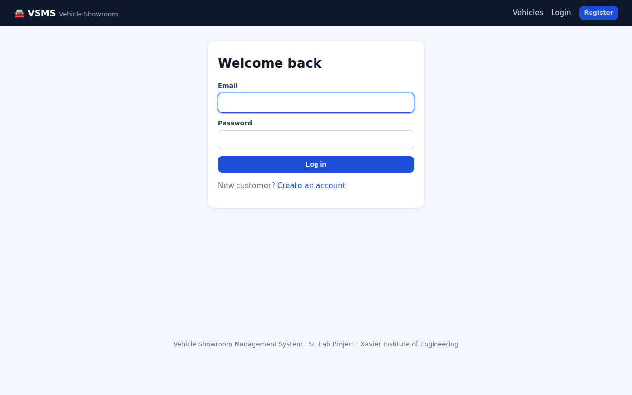
Fig. 8: Login page
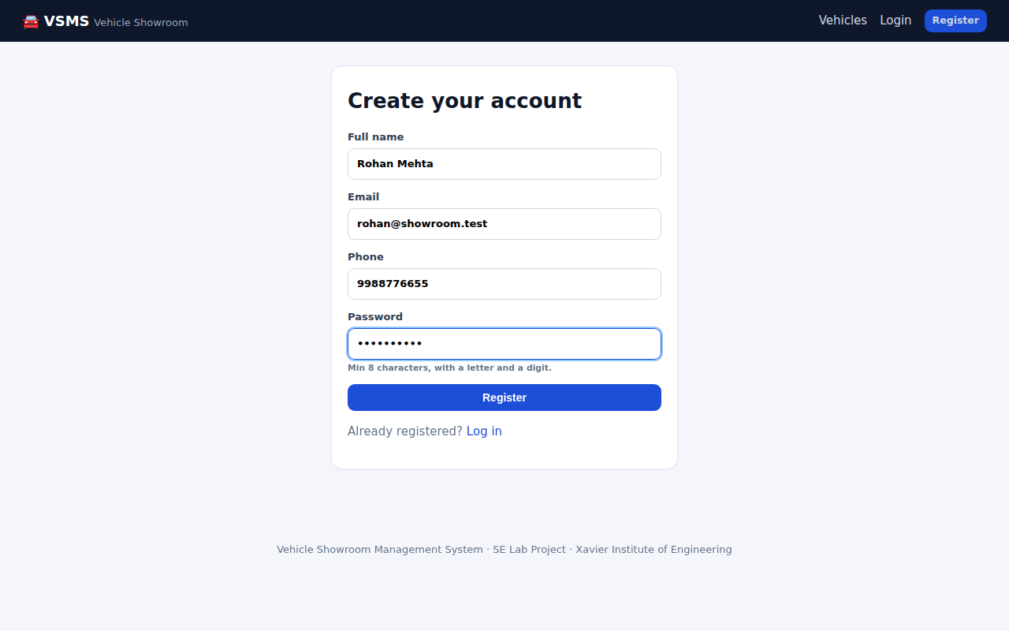
Fig. 9: Registration form
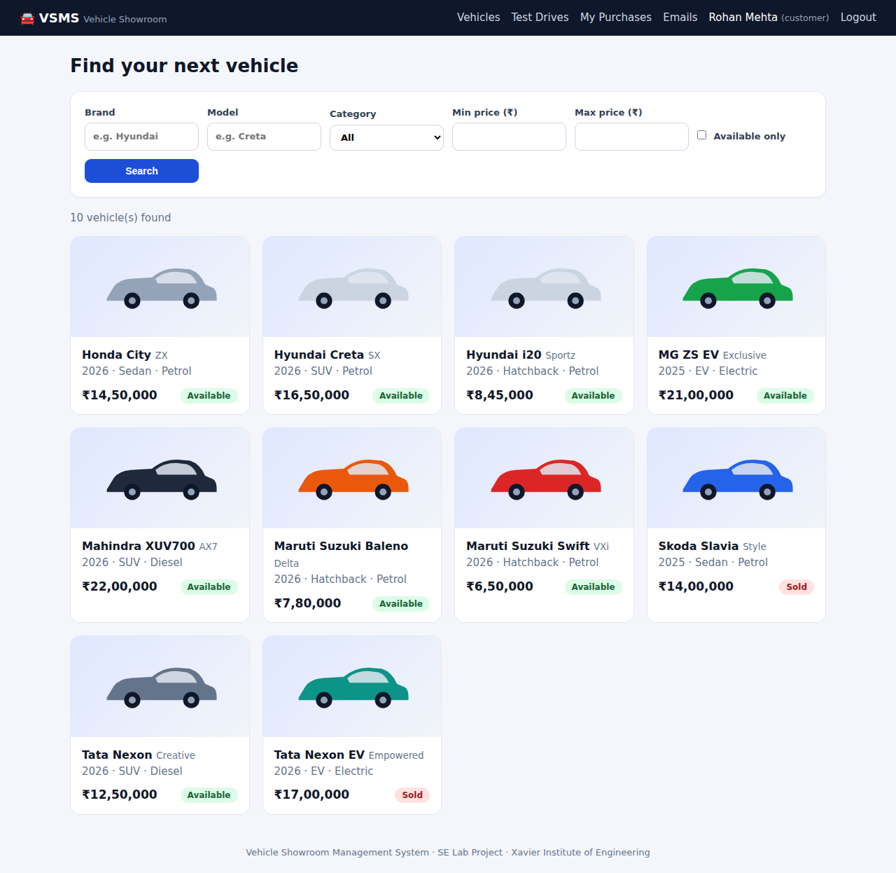
Fig. 10: Vehicle listing with search filters and availability badges
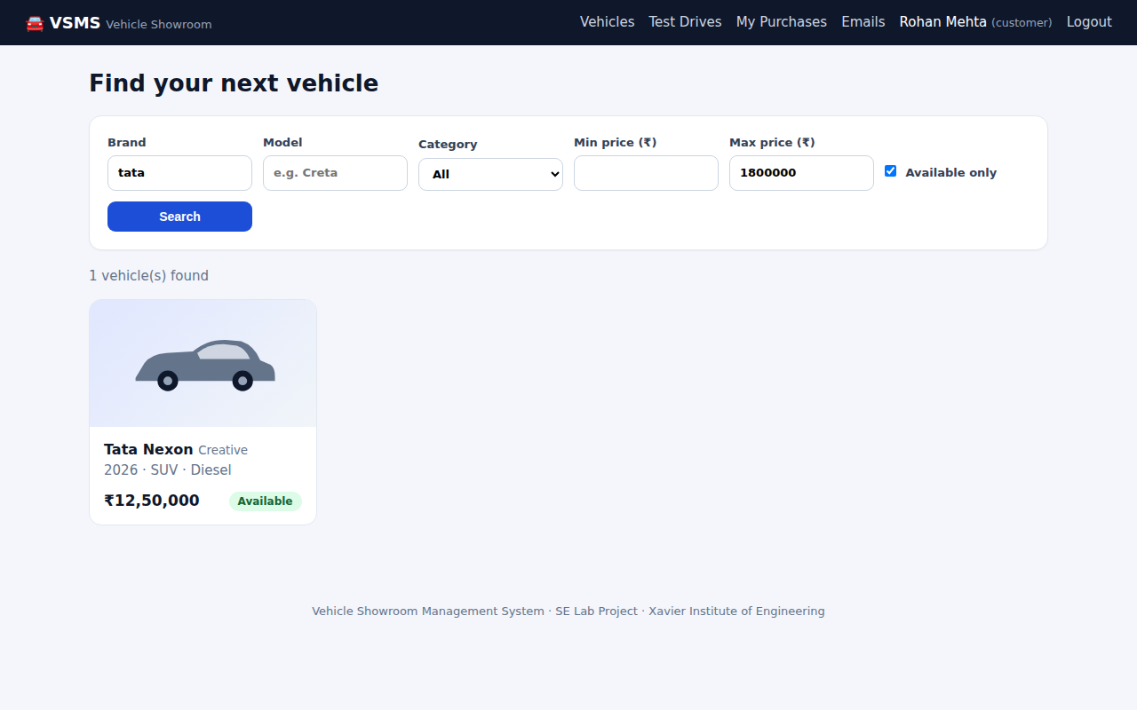
Fig. 11: Search results for brand "tata" under 18,00,000 (available only)
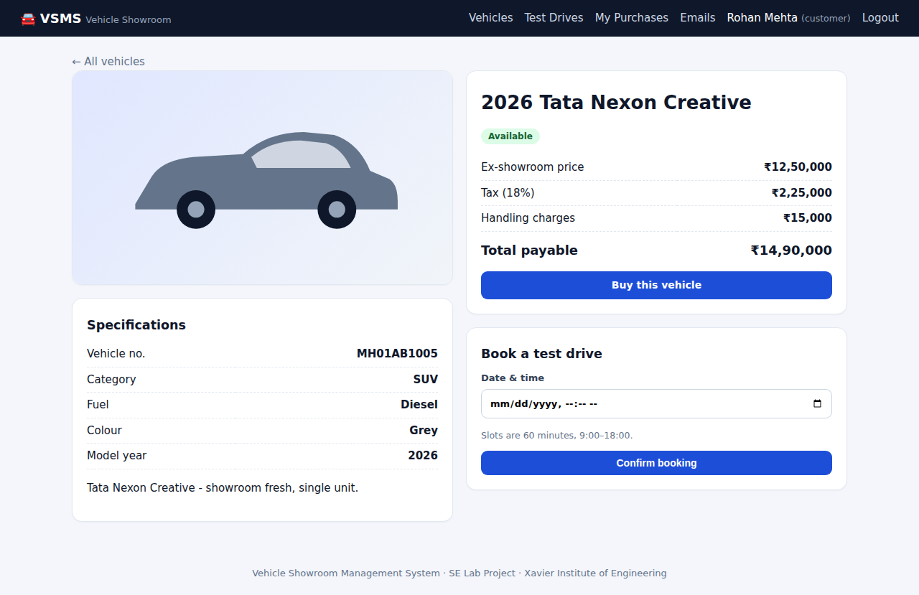
Fig. 12: Vehicle detail with price breakup and test-drive booking
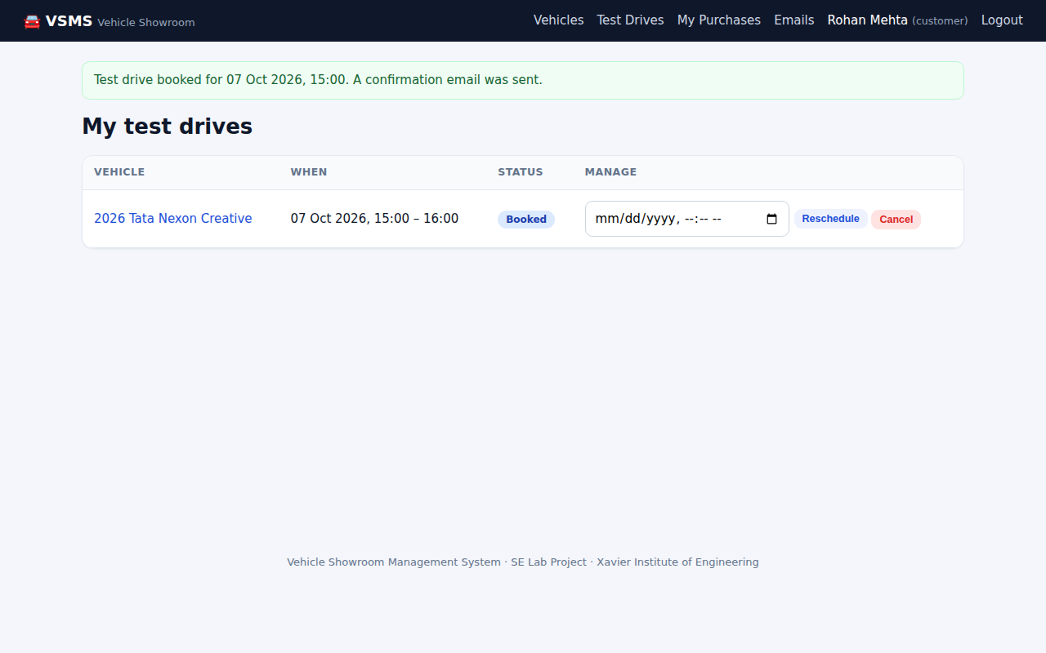
Fig. 13: Test drive booked successfully
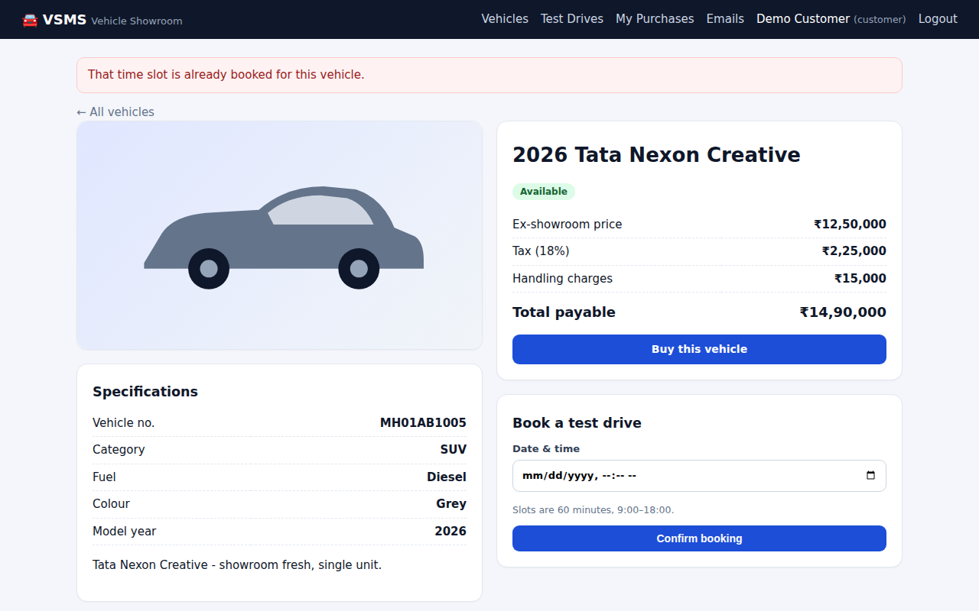
Fig. 14: A second customer is blocked from the same slot
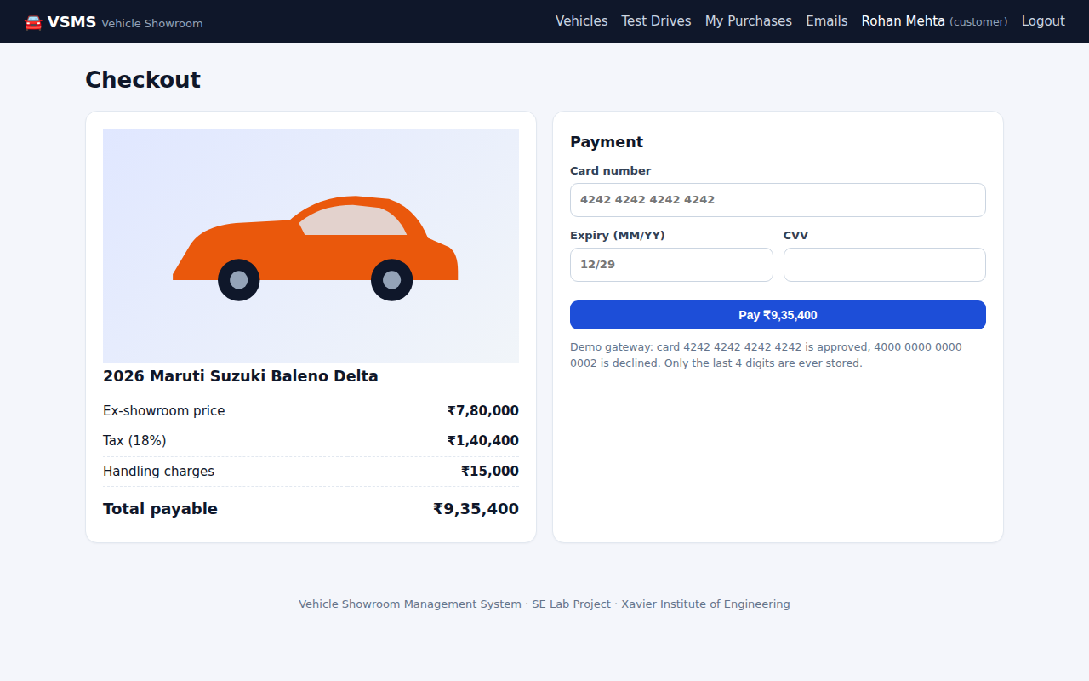
Fig. 15: Checkout with price breakup and payment form
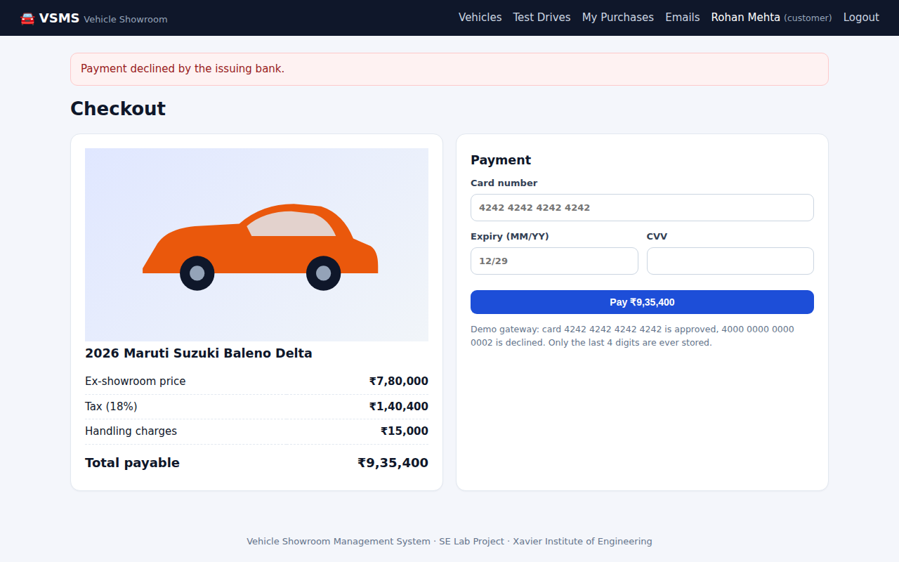
Fig. 16: Declined card: the vehicle stays available
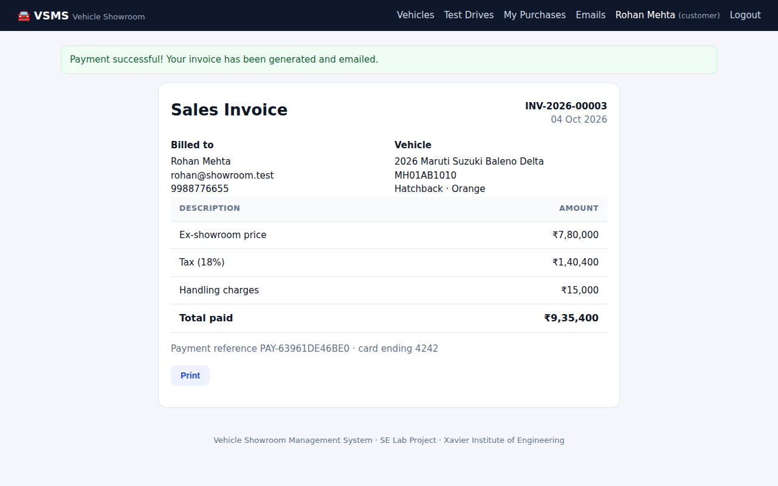
Fig. 17: Sales invoice generated after payment
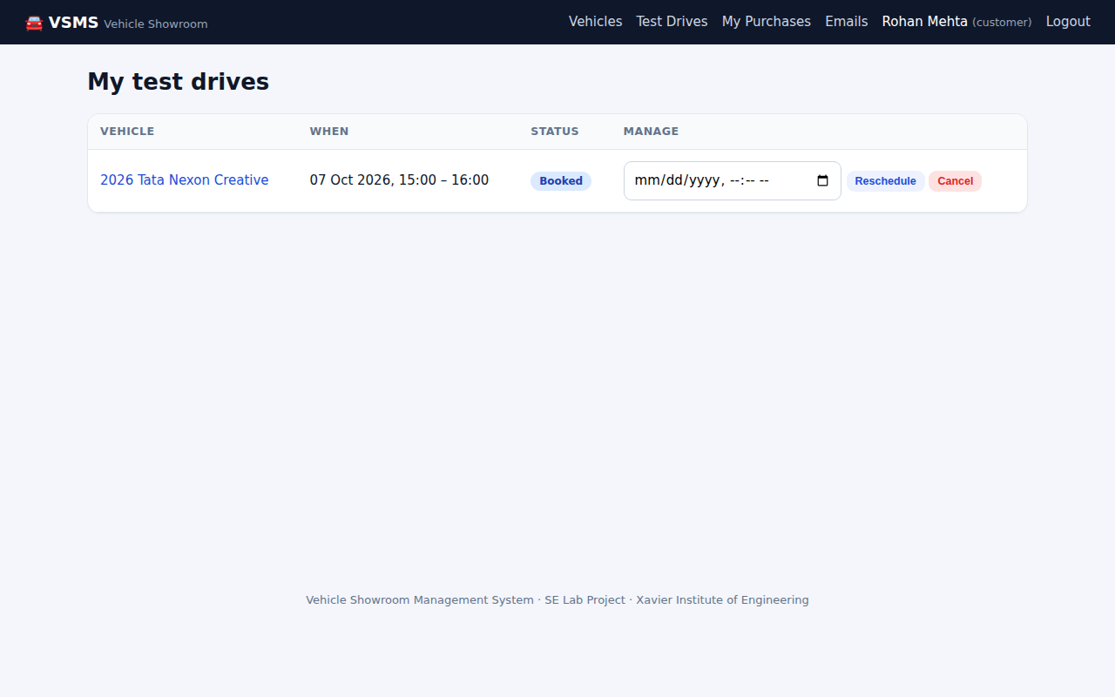
Fig. 18: My test drives with reschedule and cancel options
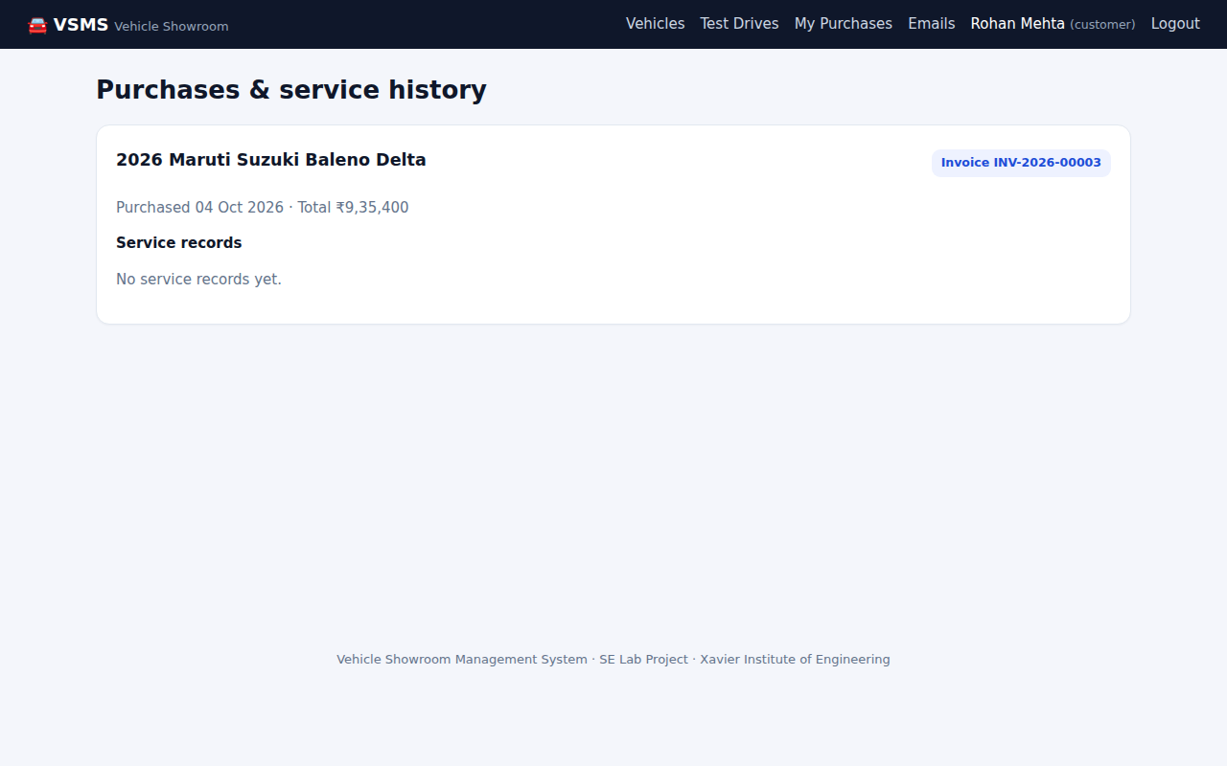
Fig. 19: Purchase and service history
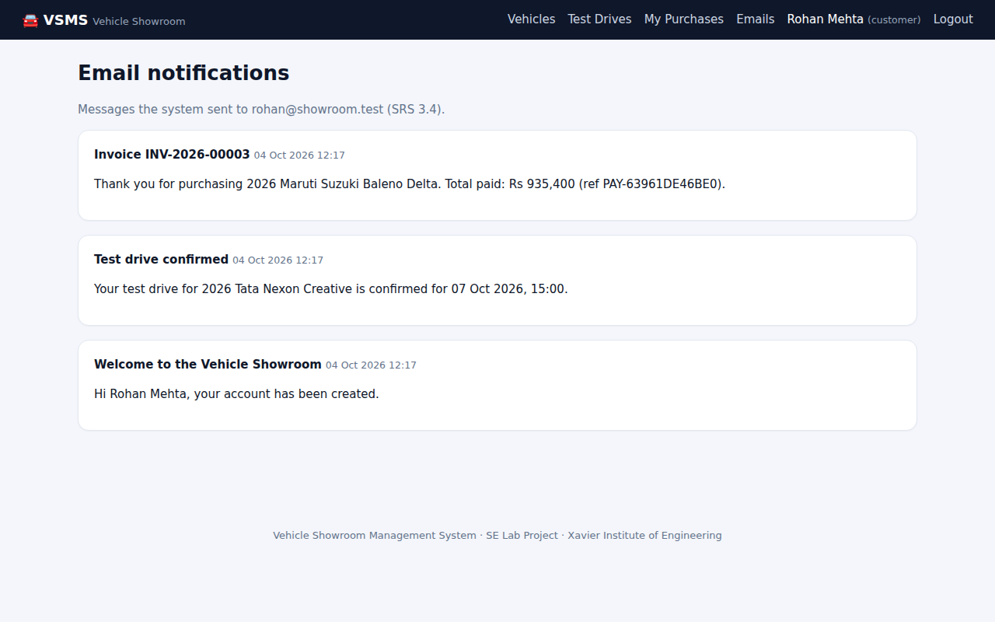
Fig. 20: E-mail notifications recorded for the customer

11.2 Administrator and staff screens
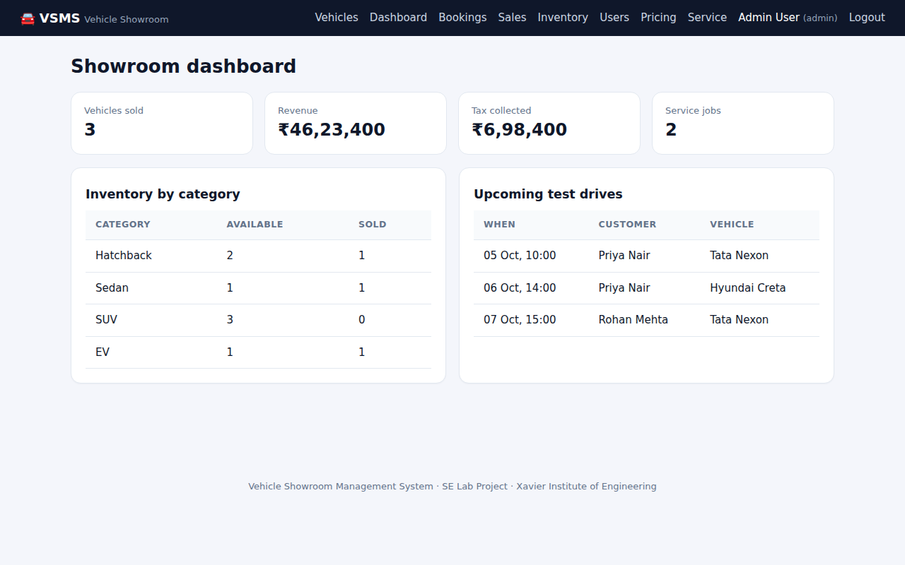
Fig. 21: Administrator dashboard
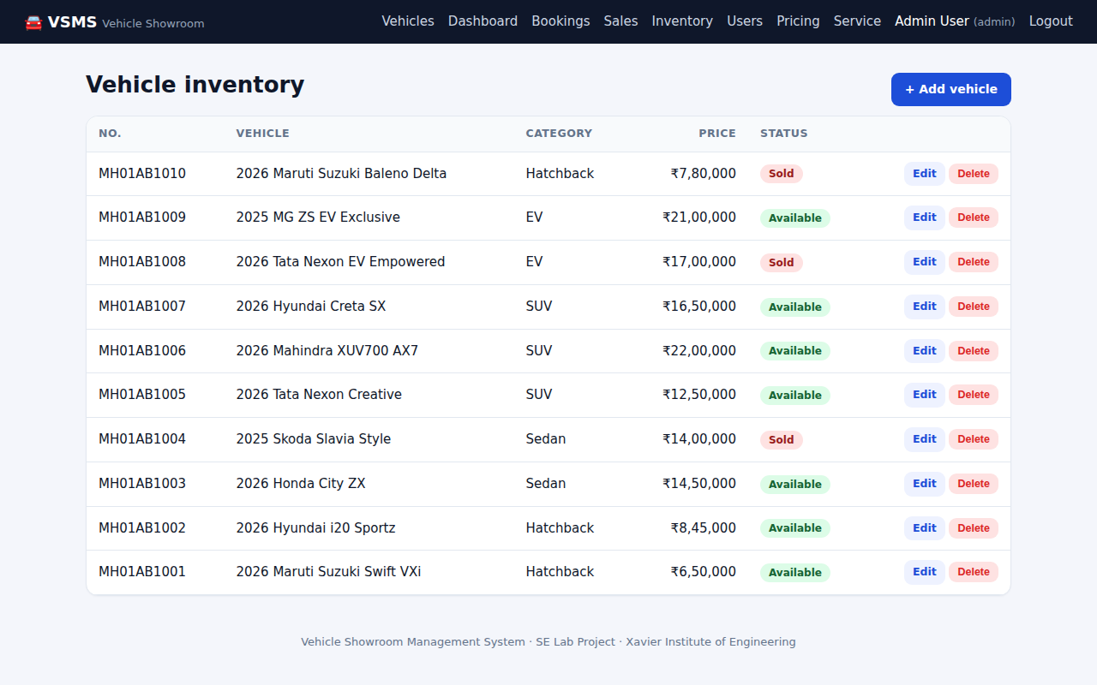
Fig. 22: Inventory management
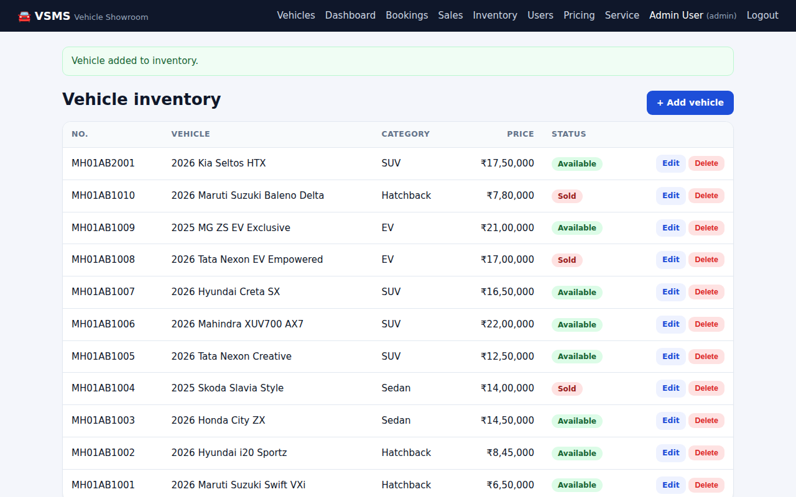
Fig. 23: Vehicle added through the admin form
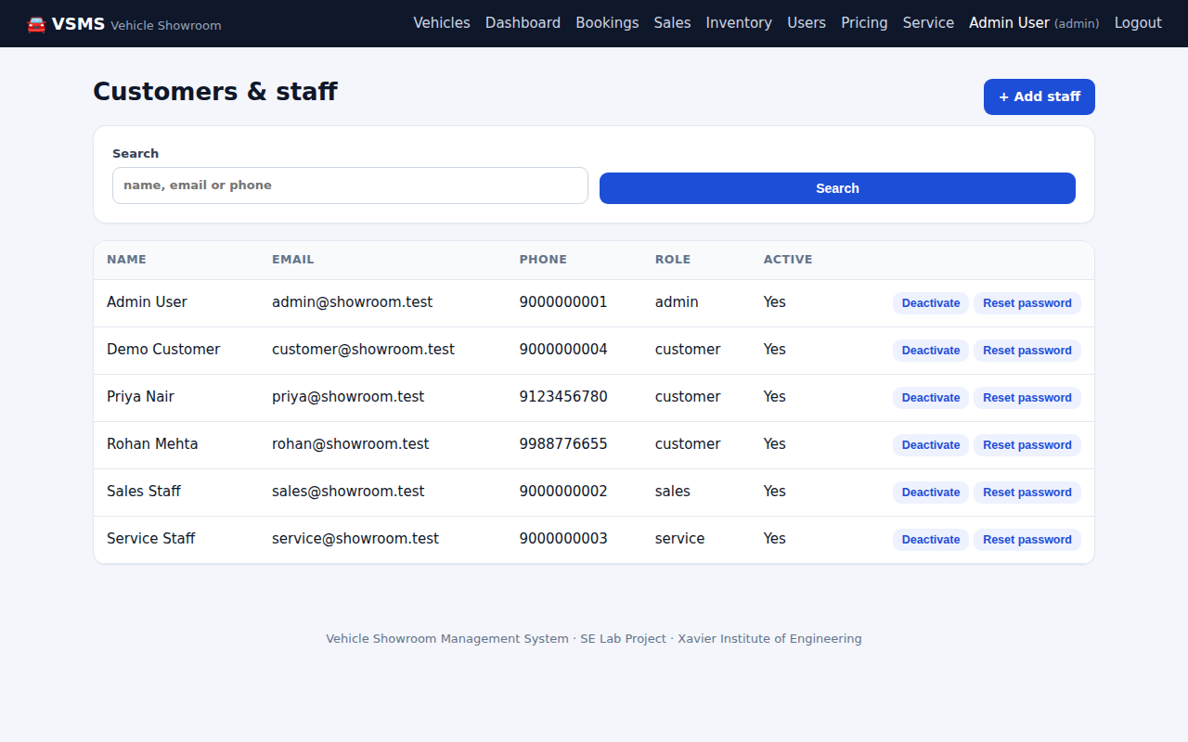
Fig. 24: Customer and staff management
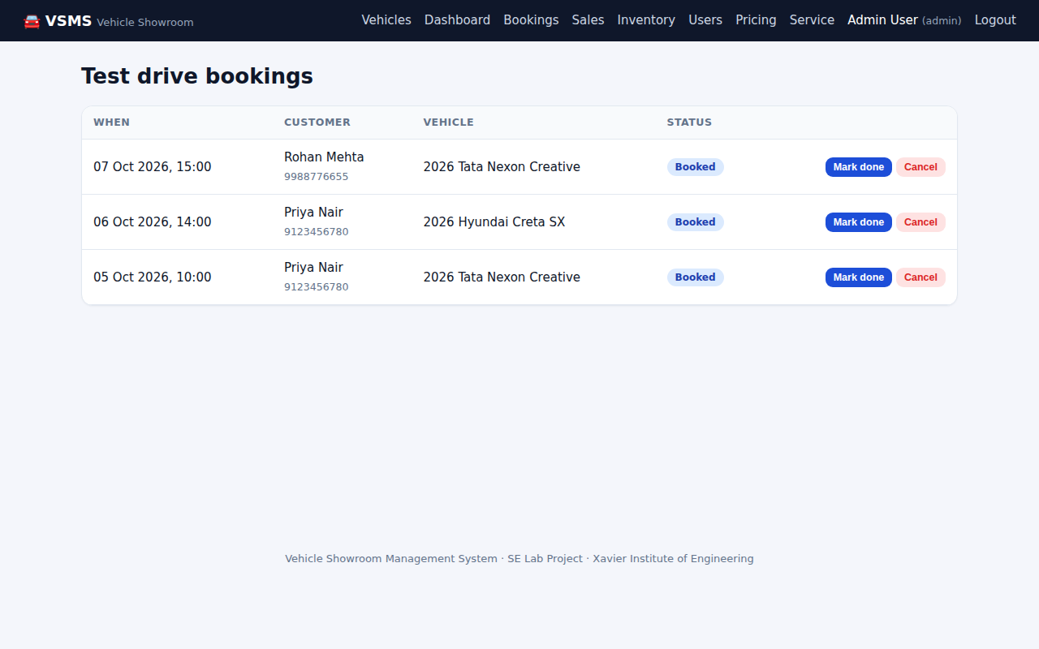
Fig. 25: Test drive bookings overview
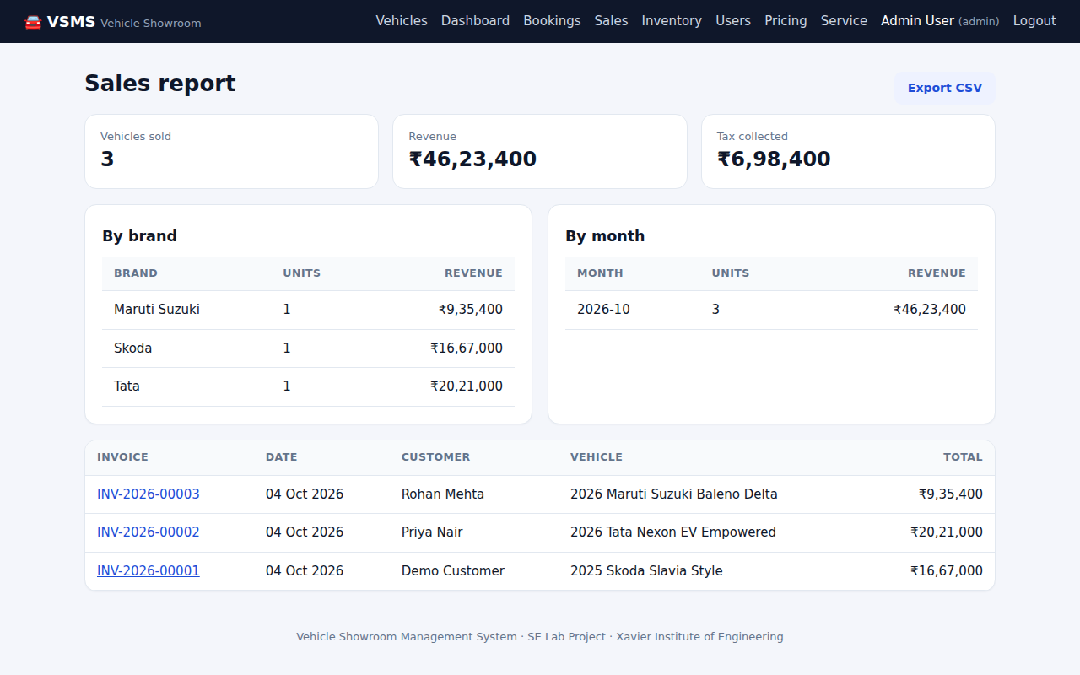
Fig. 26: Sales report by brand and month
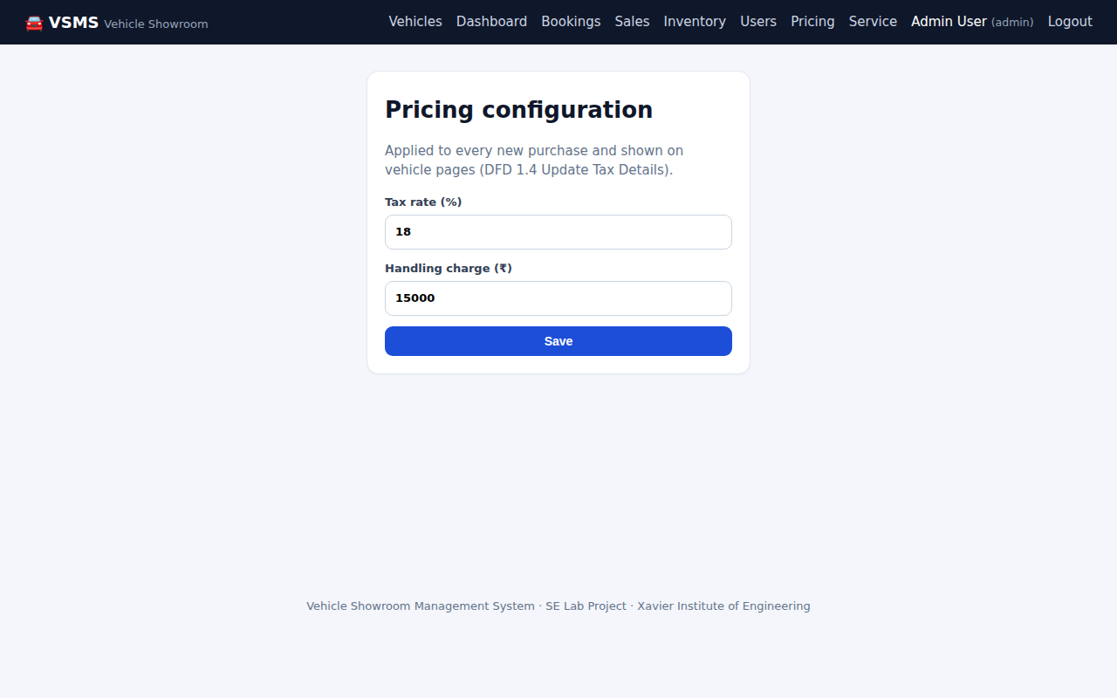
Fig. 27: Pricing configuration (tax and handling charge)
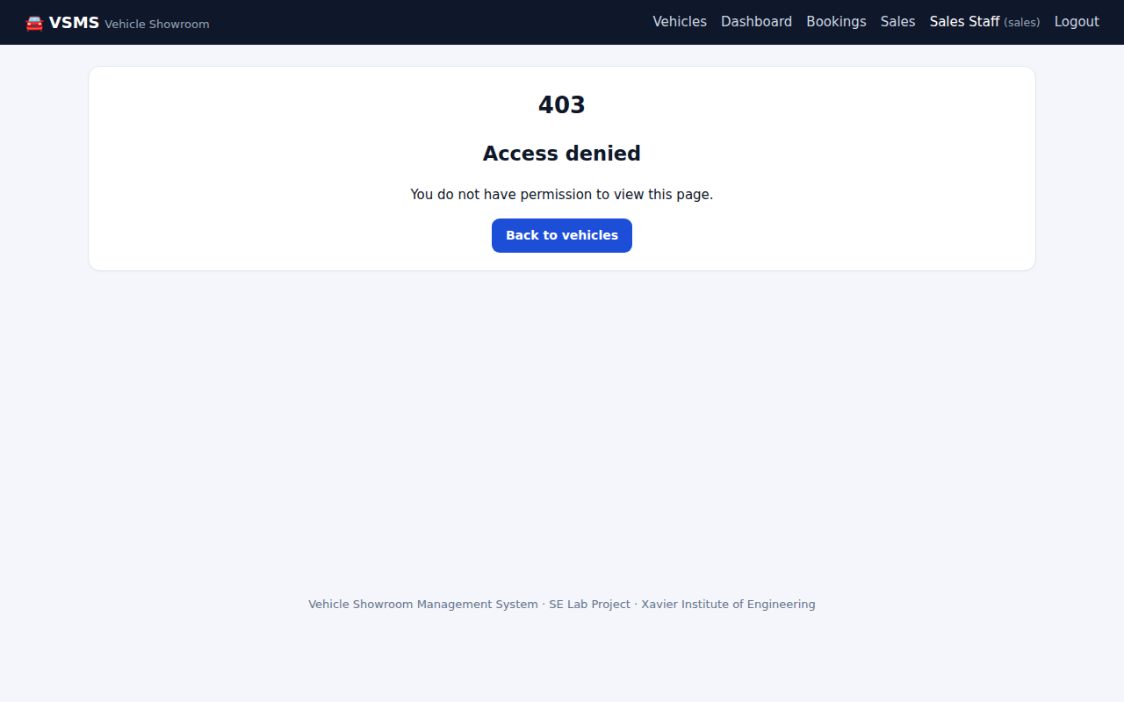
Fig. 28: Sales staff are denied access to inventory management
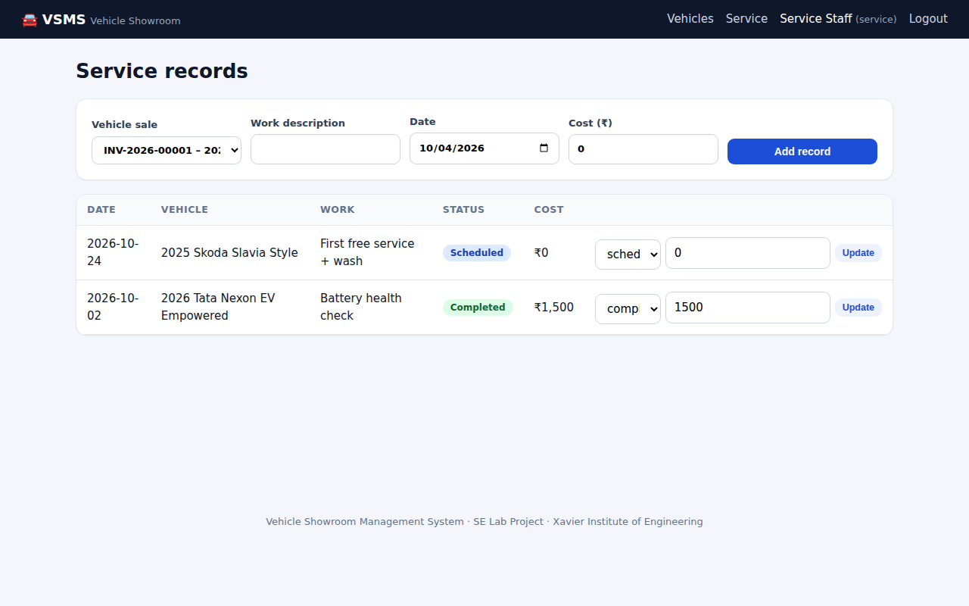
Fig. 29: Service staff maintaining service records

12. Limitations and Future Scope
The following items are deliberately simulated or left out of this release:
- Payment is simulated with a mock gateway; integrating a licensed provider (SRS TBD-1) means replacing one module.
- E-mails are stored in an outbox rather than sent; adding SMTP or an e-mail API means changing one function.
- Password recovery is performed by an administrator, not through an e-mailed link.
- Login throttling, HTTPS termination and 24x7 operation are deployment concerns not covered by the code.
- Each vehicle record is one physical unit; multiple identical units are separate records.
- Possible extensions: finance and EMI calculator, trade-in valuation, multi-branch stock reconciliation, a mobile app and richer reports.

13. Conclusion
The project shows how the lab experiments fit together as one engineering effort. The Agile plan organised the work into sprints, the SRS defined what to build, the function-point estimate and the risk sheet shaped planning, the UML and DFD models shaped the design, version control recorded the work sprint by sprint, and structured testing proved that the rules in the SRS hold. The resulting Vehicle Showroom Management System runs from a fresh clone with two commands, passes 120 automated tests, and enforces the business rules that matter most to a showroom: nobody can buy a vehicle that has already been sold, nobody can double-book a test drive, and every customer pays the price they were shown.

References
- IEEE Std 830-1998, IEEE Recommended Practice for Software Requirements Specifications.
- K. E. Wiegers, Software Requirements Specification Template, 1999.
- R. S. Pressman, Software Engineering: A Practitioner's Approach, McGraw-Hill.
- Flask documentation, https://flask.palletsprojects.com
- SQLAlchemy documentation, https://docs.sqlalchemy.org
- Atlassian Jira Software and Trello documentation, https://www.atlassian.com
- Project documents: SRS v1.0 (16 July 2026), Software Engineering Lab Experiments 1 to 9.

Appendix A: Running the System
Step | Command
Install | pip install -r requirements.txt
Load demo data | flask --app run seed
Start | python run.py (http://127.0.0.1:5000)
Run tests | pytest (add --cov=vsms for coverage)

Role | Email | Password
Administrator | admin@showroom.test | Admin@1234
Sales staff | sales@showroom.test | Sales@1234
Service staff | service@showroom.test | Service@1234
Customer | customer@showroom.test | Customer@1234
Demo accounts (created by the seed command)
Demo cards: 4242 4242 4242 4242 is approved and 4000 0000 0000 0002 is declined, with any future expiry and a 3-digit CVV.

