**Topics: Descriptive Statistics and Probability**

1. Look at the data given below. Plot the data, find the outliers and find out $μ, σ, σ^{2}$

|  |  |
| --- | --- |
| **Name of company** | **Measure X** |
| Allied Signal | 24.23% |
| Bankers Trust | 25.53% |
| General Mills | 25.41% |
| ITT Industries | 24.14% |
| J.P.Morgan & Co. | 29.62% |
| Lehman Brothers | 28.25% |
| Marriott | 25.81% |
| MCI | 24.39% |
| Merrill Lynch | 40.26% |
| Microsoft | 32.95% |
| Morgan Stanley | 91.36% |
| Sun Microsystems | 25.99% |
| Travelers | 39.42% |
| US Airways | 26.71% |
| Warner-Lambert | 35.00% |

Clearly from plot we can see that Morgan Stanley is outlier as all other points are in range 20% to 40%

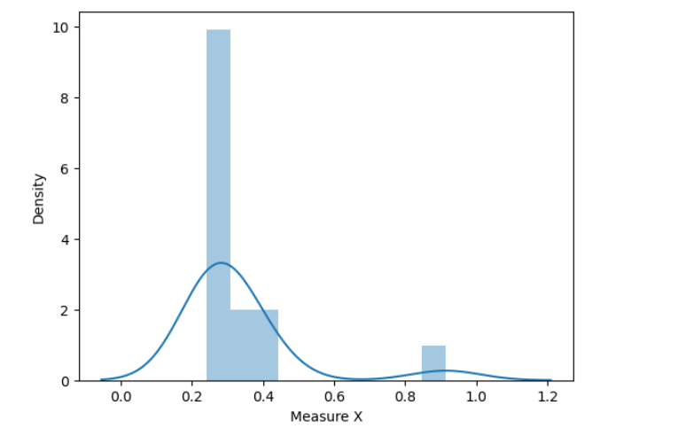

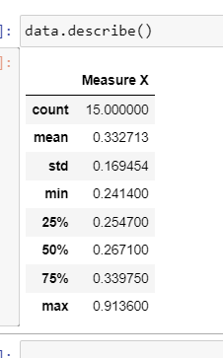

There is some difference in mean and median value and and data is showing some variation due to outlier value.



Answer the following three questions based on the box-plot above.

1. What is inter-quartile range of this dataset? (please approximate the numbers) In one line, explain what this value implies.

-          Inter-quartile range is 5 to 12, which implies that 50% data lies in 5 to 12 range.

1. What can we say about the skewness of this dataset?

-          Data is positively skewed. Median < Mean.

1. If it was found that the data point with the value 25 is actually 2.5, how would the new box-plot be affected?

-          Box plot won’t get affected that much.

1. 

Answer the following three questions based on the histogram above.

1. Where would the mode of this dataset lie?

-          Between 4 – 13

1. Comment on the skewness of the dataset.

-          Positively skewed.

1. Suppose that the above histogram and the box-plot in question 2 are plotted for the same dataset. Explain how these graphs complement each other in providing information about any dataset.

-          From both box plot and histogram we can get information about skewness of data, histogram provides more information on distribution of data along with mode, which we cannot get from boxplot.

1. AT&T was running commercials in 1990 aimed at luring back customers who had switched to one of the other long-distance phone service providers. One such commercial shows a businessman trying to reach Phoenix and mistakenly getting Fiji, where a half-naked native on a beach responds incomprehensibly in Polynesian. When asked about this advertisement, AT&T admitted that the portrayed incident did not actually take place but added that this was an enactment of something that “could happen.” Suppose that one in 200 long-distance telephone calls is misdirected. What is the probability that at least one in five attempted telephone calls reaches the wrong number? (Assume independence of attempts.)

Let X be number of calls getting misdirected.

Probability of call getting misdirected is 1/200

P(0<X<=5)=P(X=1)+P(X=2)+P(X=3)+P(X=4)+P(X=5)

=(1/200)*(199/200)^4+(1/200)^2*(199/200)^3+(1/200)^3*(199/200)^2+(1/200)^4*(199/200)+(1/200)^5

1. Returns on a certain business venture, to the nearest $1,000, are known to follow the following probability distribution

|  |  |
| --- | --- |
| x | P(x) |
| -2,000 | 0.1 |
| -1,000 | 0.1 |
| 0 | 0.2 |
| 1000 | 0.2 |
| 2000 | 0.3 |
| 3000 | 0.1 |

1. What is the most likely monetary outcome of the business venture? – x=2000
2. Is the venture likely to be successful? Explain Yes, as probability of getting positive business venture is more than getting is less than 0.
3. What is the long-term average earning of business ventures of this kind? Explain

-1100 – average probability is sum(x.p(x)) = 1100.

1. What is the good measure of the risk involved in a venture of this kind? Compute this measure

Good measure for calculating risk is standard deviation

Sd =1469.69, ie risk of 1469.69 loss or we might have profit of 1469.69.