**Topics: Normal distribution, Functions of Random Variables**

1. The time required for servicing transmissions is normally distributed with *μ* = 45 minutes and *σ* = 8 minutes. The service manager plans to have work begin on the transmission of a customer’s car 10 minutes after the car is dropped off and the customer is told that the car will be ready within 1 hour from drop-off. What is the probability that the service manager cannot meet his commitment?
2. 0.3875
3. 0.2676
4. 0.5
5. 0.6987

Let X be the time required for servicing transmissions.

X ~N(mean=45, standard deviation= 8)

P(X>50)=0.2676

1. The current age (in years) of 400 clerical employees at an insurance claims processing center is normally distributed with mean *μ* = 38 and Standard deviation *σ* =6. For each statement below, please specify True/False. If false, briefly explain why.
2. More employees at the processing center are older than 44 than between 38 and 44.

False, as P(X>44)<P(38<X<44).

1. A training program for employees under the age of 30 at the center would be expected to attract about 36 employees.

True, P(X<30)*400=36.

1. If *X1* ~ *N*(μ, σ2) and *X*2 ~ *N*(μ, σ2) are *iid* normal random variables, then what is the difference between 2 *X*1 and *X*1 + *X*2? Discuss both their distributions and parameters.

We know that E(aX)=aE(X) and Var(aX)=a^2Var(X)

E(aX+bY)=aE(X)+bE(Y) and Var(aX+bY)=a*2Var(X)+b^2Var(b) – where X and Y are independent

E(X1)=mu, E(X2)=mu, Var(X1)=sigma^2, Var(X1)=sigma^2

E(X1+X2)=E(X1)+E(X2)=2*mu

Var(X1+X2)=Var(X1)+Var(X2)=2*sigma^2

Hence X1+X2 ~N(2mu, 2sigma^2)

E(2X1)=2mu

Var(2X1)=4Var(X1)

Hence 2X1 ~N(2mu, 4sigma^2)

E(2X1-(X1+X2))=E(X1-X2)=0

Var(2X1-(X1+X2))=Var(X1-X2)=Var(X1)+(-1)^2Var(X2)=2sigma^2

Hence 2X1-(X1+X2) ~N(0,2sigma^2)

1. Let X ~ N(100, 202). Find two values, *a* and *b*, symmetric about the mean, such that the probability of the random variable taking a value between them is 0.99.

99% Confidence interval

stats.norm.interval(0.99,100,20)

(48.48341392902199, 151.516586070978)

1. 90.5, 105.9
2. 80.2, 119.8
3. 22, 78
4. 48.5, 151.5 - True
5. 90.1, 109.9
6. Consider a company that has two different divisions. The annual profits from the two divisions are independent and have distributions Profit1 ~ N(5, 32) and Profit2 ~ N(7, 42) respectively. Both the profits are in $ Million. Answer the following questions about the total profit of the company in Rupees. Assume that $1 = Rs. 45
7. Specify a Rupee range (centered on the mean) such that it contains 95% probability for the annual profit of the company.
8. Specify the 5th percentile of profit (in Rupees) for the company
9. Which of the two divisions has a larger probability of making a loss in a given year?

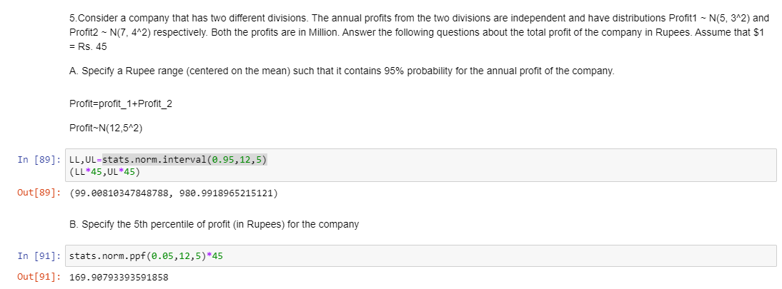

Annual profit od division 1 ~ N(5, 3)

Hence division 1 can make max profit of 5+3 ie 5 $ million but min profit of 5 -3 ie 2$ million

Annual profit of division 2 ~ N(7,4)

Hence division 2 can make max profit of 7+4 ie 11 $ million but min profit of 7-4 ie 3$ million

As sd is more for division 2 so it has larger probability of making loss.