**GitHub URL:** <https://github.com/VinayaBhat/VinayaBhat.github.io>

**Portfolio URL:** <https://vinayabhat.github.io/>

My portfolio has 5 HTML files namely:

1. **Index.HTML**
2. **Profile.HTML**
3. **Projects.HTML**
4. **Myclicks.HTML**
5. **Contact.HTML**

My first step in designing the portfolio was to choose the background and font colors. After trying a lot of different color combinations and images for background, I choose to go ahead with Medium Turquoise for the background and a black as the font color. I found Roboto font very appealing, so I choose to go ahead with that for the portfolio after trying out a couple of other font styles like Playfair display, Times New Roman to name a few.

I choose to use internal style sheet by defining it under <head><style></style></head> and inline style for some HTML elements. I found using external style sheets very tedious since I had to edit two different files for every change. Initially, I started designing the home page only using HTML and CSS. After designing the first page I decided to try on Bootstrap and found it very helpful especially for the implementing navigation bar and the flexbox.

The navigation bar and the footer had common content and formatting among the five pages.

***Navigation Bar:***

I choose to use Bootstrap Navbar to design my navigation bar. In Bootstrap 4, the Navbar is responsive by default and utilizes flexbox. I choose to use navbar-expand-sm class (navigation bar stacks up vertically for screen widths <576px). I decided to choose a a black background and a white links for the navigation bar for which I edited the navbar-default class. Doing this took a lot of time and effort since most of the Navigation bars are usually implemented with default class like bg-dark. I used the ***fixed-top*** class to keep the navbar fixed to the top of the page at all times.

Initially, I had designed the navigation bar only for large screens and then added the toggler button to support vertical stacking of links in small screens. I always wanted to keep the color formatting constant throughout the page, so I decided to format the hamburger icon also to have Medium Turquoise color. The drop-down menu of the hamburger icon had a white font color and transparent background which was not going well so I decided to change the background of the dropdown menu to a black as well.

Designing the navigation bar and its elements took me almost 2 days but it was worth the effort since I got to learn a lot.

***Footer:***

Designing the footer was another tough exercise since the footer was not sticking to the bottom of the page, it had space from the bottom, it was not centering items. After a lot of effort, I was able to successfully design a good footer, but I am not still satisfied with its design. I choose a black background and a white text color for the footer as well to keep it uniform with the navigation bar. I choose to keep extra padding of 3rem on top along with 0.2cm padding and have a small font size.

**Designing individual pages:**

1. **Index.HTML:**

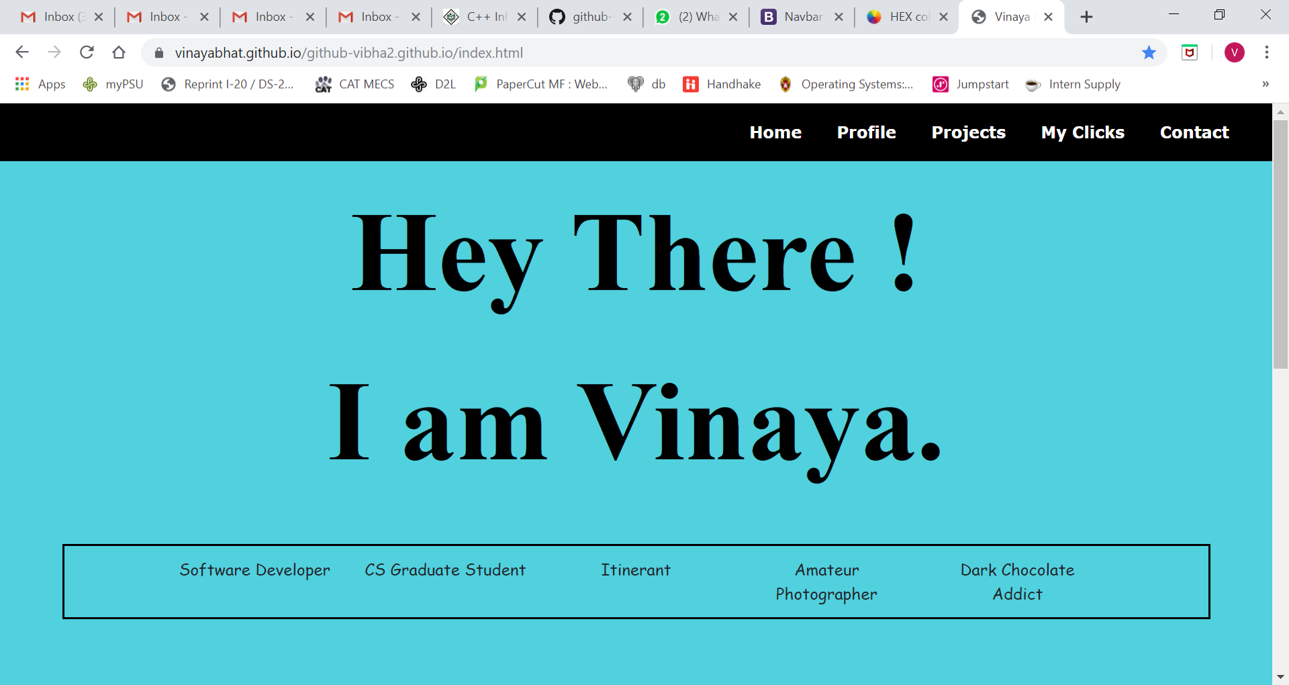

I had gone through a lot of personal websites online to get an idea of what to write and how to design my portfolio. When I started designing this home page, I knew my first page had to be something informal and give an idea of who I am and what I like. For *Hey There! I am Vinaya* I wanted to try Bootstrap jumbotron class. For the box description, I decided to go ahead with Bootstrap grid system. In the grid system, each row can have a maximum of 12 columns. I have specified that for small screens each column should occupy 2 columns in the grid system.

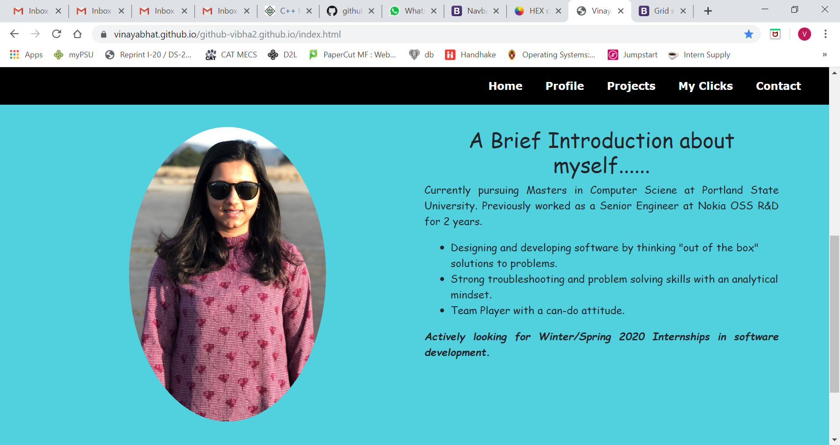

Once we scroll down on the home page, we get the Introduction page. For the introduction page, I decided to go ahead with the Bootstrap grid system with one row and 2 columns. To make my introduction informal I used the cursive font. One column displays my photo in an oval shape. One column gives a brief introduction about me.

1. **Profile.HTML:**



To design this page, I used the Bootstrap row class. I designed two classes called headcontainer and content container. Each topic heading and content was a separate row with rounded corners and a white background.

The headcontainer class was designed to have headings in the profile and was center-aligned. I decided to use Fuchsia color for text. I had seen this color online on one webpage. The left and the right margin was 5% and the bottom margin was 1%.

<https://hookagency.com/website-color-schemes/>

The contentcontainer class was designed to have information and was left-aligned. I decided to use a black text color. The left and right margin was 10% and the bottom margin was 3%.

1. **Projects.HTML:**

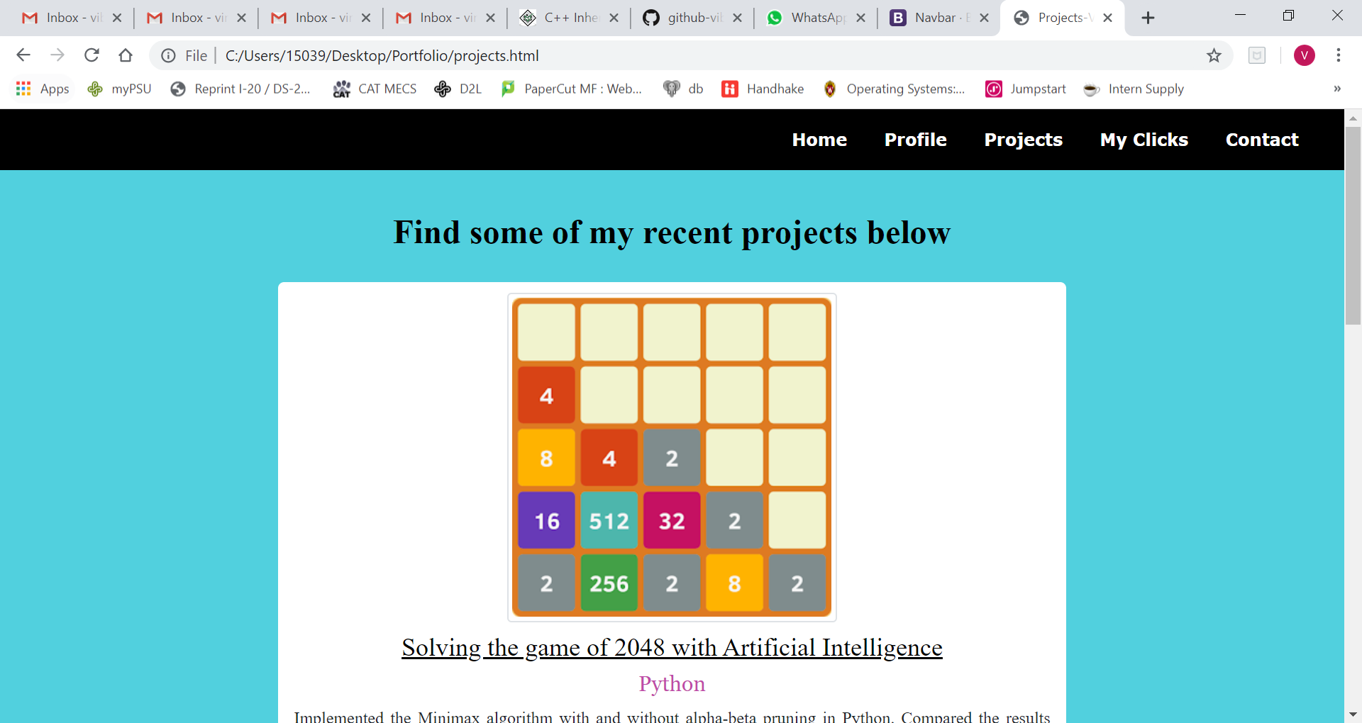

I used the Bootstrap grid system to design the contents of this page. Each project was placed in a separate column div which took up 8 columns on large screen. I set the left and the right margin as auto which centered the contents. Each column had a white background and rounded corners. Each project section has a link that directs to the git repository of that project on a new page.

1. **Myclicks.HTML:**

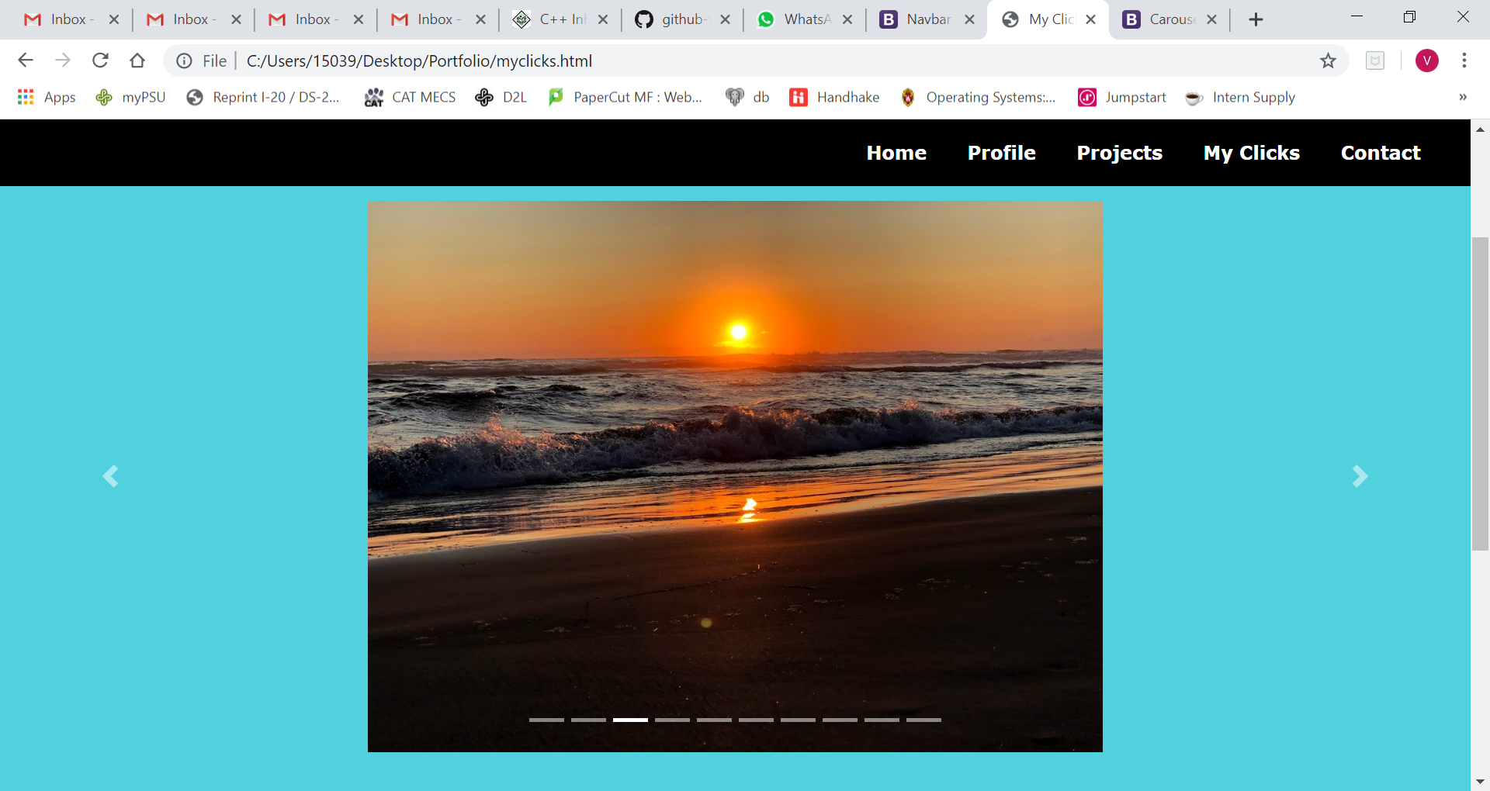

I decided to implement this page just to learn about Bootstrap Carousel. While learning about Bootstrap I came across the carousel and found it very cool and fascinating. I specified a unique id attribute called vin_clicks_carousel in which I aligned the photos to be in the middle. I added 10 of the photos I clicked and set the active class on the first photo. I took almost a day to understand how the carousel works and figure out the order of the elements inside the div tag.

The outer div tag has the class carousel and slide. The slide class adds a CSS transition and animation effect, which makes the items slide when showing a new item. The data-ride="carousel" attribute tells Bootstrap to begin animating the carousel immediately when the page loads. Inside this div tag, I created an ordered list which class carousel-indicators. The indicators are the dashes at the bottom of each slide which tell us the number of slides and which slide we are in. In the list items, we specify the next slide to go from the present slide. Next, I added another div tag with the class carousel-inner. Inside this tag, there are multiple div tags with class carousel-item containing the source of the images.

At the end, I added the next and prev links tag with carousel-control-next-icon.

1. **Contact.HTML:**

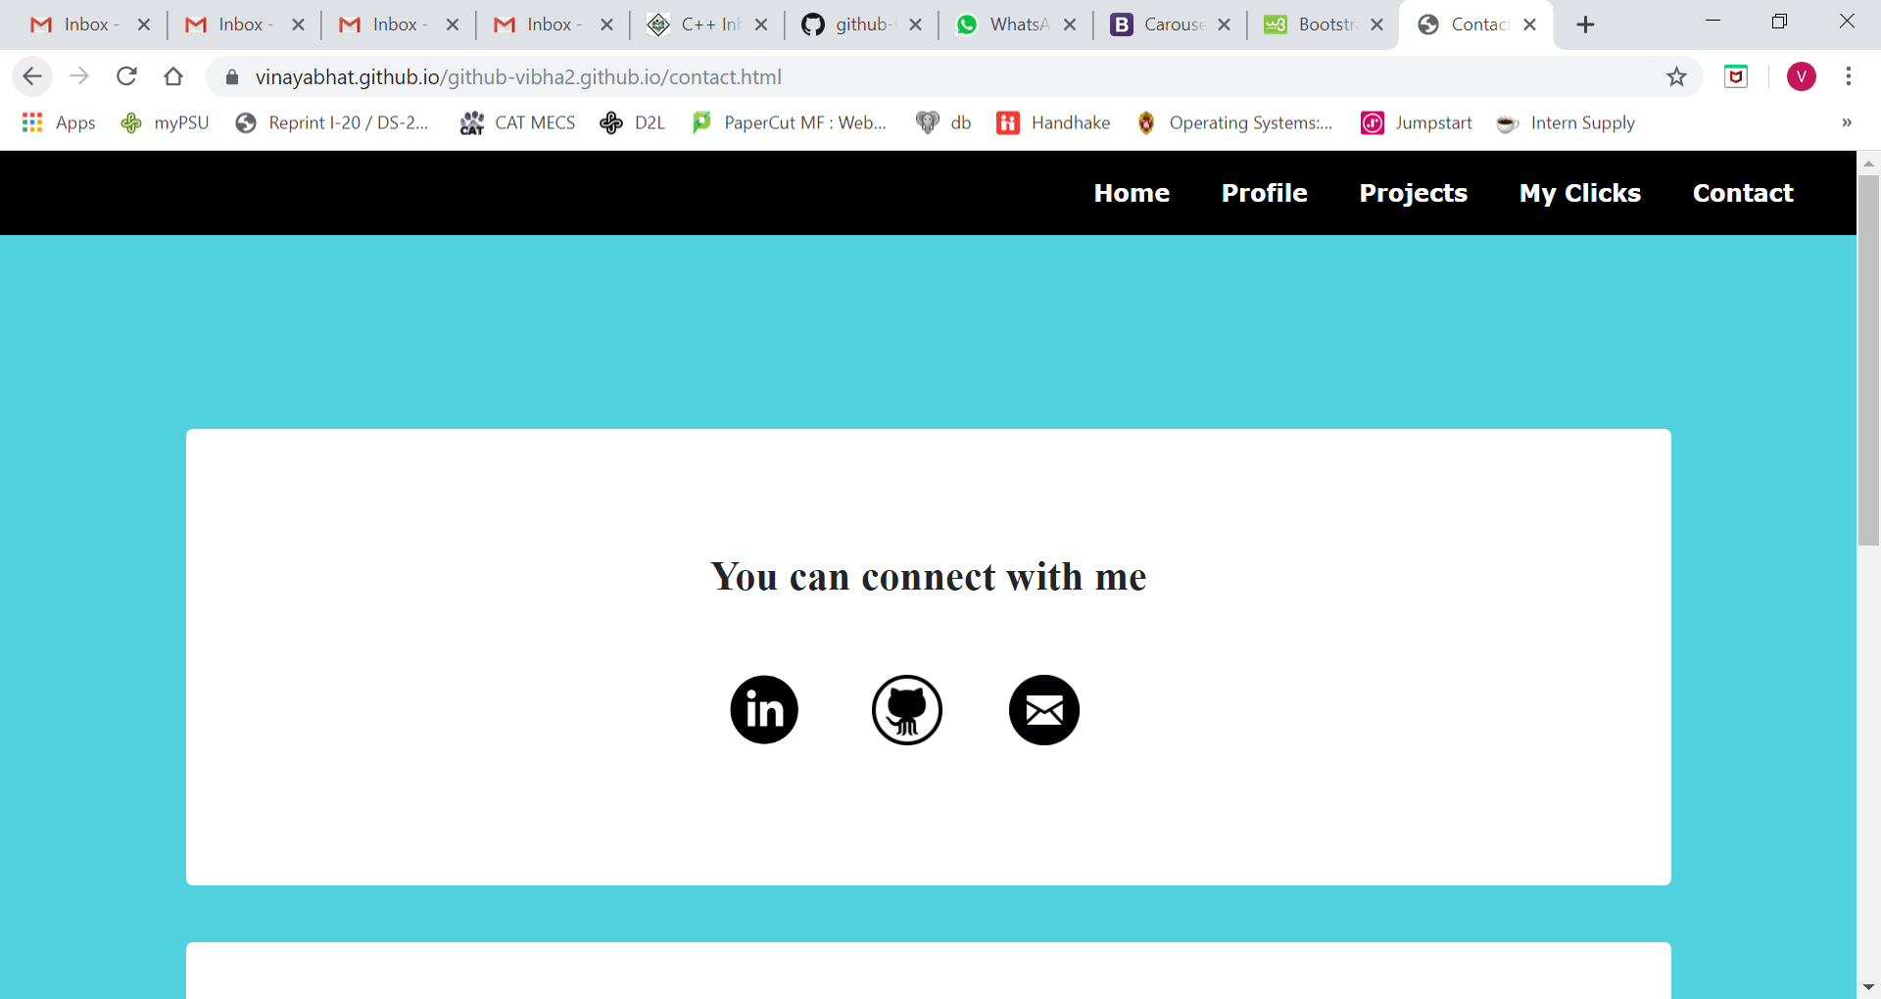

To design this page, I used 2 div tags with jumbotron classes. The first div tag contains images of LinkedIn, Github and mail which directs the user to the link attached with the image on the same page. The second div tag contains a Bootstrap contact form where a person can leave their name and email address to contact me. The submit button is customized with a black color and when hovered it changes to medium turquoise as well.

**Conclusion:**

This week has been very productive since I got to learn a lot about HTML/CSS and bootstrap. This was my first ever Web development class and this is my first ever website. I was very excited with the development of each page. Designing each page and choosing the color combinations was very exciting. I used **Visual Studio Code** to write the HTML files. I did not have any trouble with the IDE. My issues were writing properties in CSS classes like margin or padding because sometimes it would not work. Then I had to go online and check sites for more information about the classes and properties I was implementing. The properties which troubled me the most was centering the items and footer alignment. After hours of experimenting and searching for online sources about the properties, I was successfully able to design the website.

Given more time I would have tried out JavaScript as well. Going ahead I think I will deploy this project and use it as my personal website. Maybe I will add features using JavaScript as well.