FloodSense — Early Warning Grid
FOSSEE Open Hardware National Make-A-Thon 2026 Project Report
Category: Disaster Detection & Early Warnings: Floods Monitoring
Production Live URL: https://floodsense-production-4e0f.up.railway.app/
Health Endpoint: https://floodsense-production-4e0f.up.railway.app/api/health
GitHub Repository: https://github.com/Vinayak-123-jpj/FloodSense
Date: October 2026 | Version 1.0.0 (Production Release)

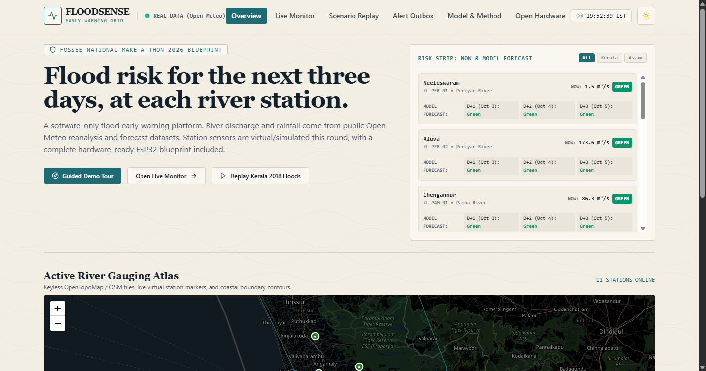
Figure 1: FloodSense Hydrological Survey Atlas — Live Dashboard Overview

1. Executive Summary
FloodSense — Early Warning Grid is a software-only flood early-warning platform and digital twin survey atlas built for the FOSSEE Open Hardware National Make-A-Thon 2026. The platform emulates physical IoT sensor grids to deliver 24-to-72-hour predictive flood risk warnings across 11 key river catchments in Kerala and Assam. Powered by live Open-Meteo GloFAS telemetry, a leakage-audited LightGBM multi-horizon classifier benchmarked against a Persistence Baseline, and a state-machine hysteresis alert engine, FloodSense dispatches localized warnings in English, Hindi, Malayalam, and Assamese paired with OpenStreetMap evacuation shelter directions.
2. Problem Statement & Objectives
During monsoon deluges in India, emergency responders face critical challenges: raw volumetric discharge forecasts (m³/s) lack station-specific stage context, sensor threshold alerts flap rapidly near danger boundaries causing alert fatigue, and emergency alerts neglect regional catchments where Malayalam and Assamese are spoken. FloodSense solves these bottlenecks with real-data integration, scientific baseline transparency, hysteresis alert deduplication, and an interactive August 2018 Kerala flood digital twin scrubber.
3. System Architecture & Data Pipeline
FloodSense is deployed as a single-container application on Railway. FastAPI orchestrates telemetry ingestion, ML predictions, hysteresis state tracking, and WebSocket broadcasts, while serving the compiled React Survey Atlas SPA directly. The pipeline ingests 115,502 daily resolution records (1990–2025) across 11 stations snapped to mainstem river grid cells.
4. Machine Learning Risk Engine & Science Audit
A multi-horizon LightGBM gradient boosted decision tree classifier predicts risk states at 1-day, 2-day, and 3-day horizons. On the held-out August 2018 Kerala flood event (153 test days across 5 stations), Persistence Baseline achieves 85.15% Macro F1 at 1-day horizon, outperforming LightGBM (69.39% Macro F1, 86.27% High-Risk Recall) due to day-to-day risk state autocorrelation.
5. Hysteresis Alert Engine & Multilingual Outbox
The hysteresis engine prevents alert flapping by enforcing immediate escalation (Green -> Orange) and requiring 2 consecutive lower ticks for state downgrades (Orange -> Green). Outbox logs generate parallel localized entries in English, Hindi, Malayalam, and Assamese.
6. Digital Twin Disaster Replay & Live Monitoring
The platform includes a 31-day held-out August 2018 Kerala flood replay scrubber with calendar dates ('01 Aug 2018' to '31 Aug 2018') and customizable 'What-If' rainfall multipliers (1.0x to 3.0x). The Live Monitor streams real-time telemetry over WebSockets (/ws/live).
7. Testing, Validation & Railway Deployment
FloodSense passes 34/34 automated pytest tests, 0-error TypeScript/Vite production build, and headless Chrome browser acceptance tests. The application is deployed publicly on Railway container infrastructure at https://floodsense-production-4e0f.up.railway.app/.

