Azure Migration HLD — Fictional Northstar Research Group
Project Aurora | High-Level Design
FICTIONAL DEMONSTRATION — NOT A CUSTOMER DOCUMENT
This source DOCX is the authoritative template. DocXUnravel populates only contract-bound elements.

Document Control
Field | Value
Customer | Fictional Northstar Research Group
Project | Fictional Project Aurora Azure Migration
Sponsor | Fictional Morgan Reed
Document owner | Fictional Avery Patel
Target start | 2027-01-11
Target completion | 2027-07-30

Executive Summary
Fictional migration of three demonstration applications and their supporting data services to a governed Azure landing zone.

Current-State Assessment
The observations below are populated from validated migration-discovery records.
Category | Observation | Impact
Fictional resilience observation | Fictional recovery procedures rely on manual virtual-machine restoration. | Fictional recovery objectives may not be met during a regional incident.
Fictional operations observation | Fictional application telemetry is retained in separate local tools. | Fictional incident diagnosis requires cross-team log collection.
Fictional security observation | Fictional privileged service accounts use long-lived credentials. | Fictional credential exposure would increase lateral-movement risk.

Application Inventory
ID | Application | Owner | Criticality | Current hosting | Data class | Disposition
FICTIONAL-APP-001 | Fictional Atlas Portal | Fictional Research Operations | high | Fictional IIS virtual machines | confidential | replatform
FICTIONAL-APP-002 | Fictional Beacon Scheduler | Fictional Laboratory Services | critical | Fictional Windows service cluster | restricted | refactor
FICTIONAL-APP-003 | Fictional Cedar Archive | Fictional Records Team | medium | Fictional file and SQL servers | internal | rehost

Target Architecture
The existing illustration is a read-only package asset retained during population.
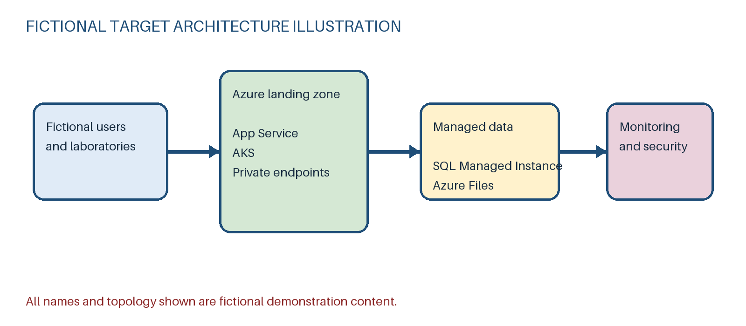
Figure 1 — Fictional Azure target architecture (pre-existing template asset)
Workload | Azure service | Region | Rationale
Fictional Atlas Portal | Azure App Service | UK South | Fictional managed web hosting reduces operating-system management.
Fictional Beacon Scheduler | Azure Kubernetes Service | UK South | Fictional container orchestration supports isolated scheduling workers.
Fictional relational data tier | Azure SQL Managed Instance | UK South | Fictional compatibility requirements favour managed SQL Server semantics.
Fictional Cedar Archive | Azure Files | UK West | Fictional SMB compatibility supports phased application migration.

Migration Strategy
Migration waves are sequenced by dependency, risk and operational readiness.
Wave | Name | Applications | Start | End | Exit criteria
1 | Fictional foundation and Cedar pilot | FICTIONAL-APP-003 | 2027-01-11 | 2027-03-05 | Fictional landing-zone controls pass and Cedar backup restoration is demonstrated.
2 | Fictional Atlas replatform | FICTIONAL-APP-001 | 2027-03-08 | 2027-05-14 | Fictional Atlas performance and recovery tests meet agreed targets.
3 | Fictional Beacon refactor | FICTIONAL-APP-002 | 2027-05-17 | 2027-07-30 | Fictional end-to-end scheduling and security accreditation are complete.

Security Considerations

Security requirements
ID | Requirement | Priority
FICTIONAL-SEC-001 | Fictional workloads must use managed identities where supported. | must
FICTIONAL-SEC-002 | Fictional confidential and restricted data must be encrypted with customer-managed keys. | must

Networking requirements
ID | Requirement | Priority
FICTIONAL-NET-001 | Fictional production ingress must traverse Azure Application Gateway with WAF enabled. | must
FICTIONAL-NET-002 | Fictional platform services should use private endpoints and central DNS resolution. | should

Risks and Assumptions

Risks
ID | Description | Likelihood | Impact | Mitigation
FICTIONAL-RISK-001 | Fictional laboratory integrations may use undocumented source addresses. | medium | high | Fictional packet capture and owner validation before wave planning.
FICTIONAL-RISK-002 | Fictional SQL compatibility testing may identify unsupported features. | medium | medium | Fictional compatibility assessment and rollback rehearsal.

Assumptions
ID | Description | Validation owner
FICTIONAL-ASM-001 | Fictional ExpressRoute connectivity will be available before the first migration wave. | Fictional Network Lead
FICTIONAL-ASM-002 | Fictional application owners will provide representative performance tests. | Fictional Programme Lead

Appendix

Outstanding design decisions
ID | Decision | Owner | Due date | Status
FICTIONAL-DD-001 | Fictional selection of active-passive or active-active regional recovery for Beacon. | Fictional Solution Design Authority | 2027-02-12 | open
FICTIONAL-DD-002 | Fictional retention period for migrated Cedar archive data. | Fictional Records Owner | 2027-02-19 | in_review

Source infrastructure inventory
ID | Name | Category | Location | Quantity | OS | Specification
FICTIONAL-INF-001 | Fictional VMware application cluster | compute | Fictional London data centre | 12 | Fictional mix of Windows Server 2019 and Ubuntu 22.04 | Fictional 8 vCPU and 32 GiB RAM average virtual machine
FICTIONAL-INF-002 | Fictional SQL Server availability group | database | Fictional London data centre | 2 | Fictional Windows Server 2019 | Fictional SQL Server 2019 Enterprise with 4 TiB allocated storage
FICTIONAL-INF-003 | Fictional research file estate | storage | Fictional Manchester data centre | 1 | Fictional storage appliance OS | Fictional 18 TiB used capacity with 12 percent annual growth

Application dependencies
Source | Target | Type | Notes
FICTIONAL-APP-001 | FICTIONAL-APP-002 | synchronous | Fictional HTTPS scheduling request dependency.
FICTIONAL-APP-002 | FICTIONAL-APP-003 | file | Fictional nightly result archive transfer.

