***File 1***

*MPC_CODE|MOBO_DATE|AMOUNT*

*0708|20200608|0.50*

*100821|20200608|1.50*

*110|20200608|2.50*

*1112|20200608|3.50*

*1114|20200608|4.50*

*12121212|20200608|5.50*

*121345|20200608|6.50*

*1234|20200608|7.50*

*12345|20200608|8.50*

*123454|20200608|9.50*

***No rejection data***

***No temp table data***

***VALIDATION***

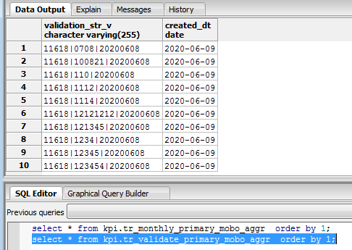

***DAILY***

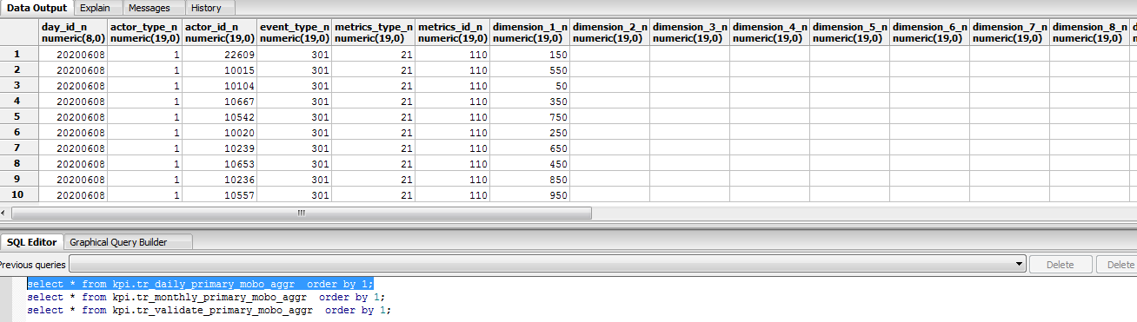

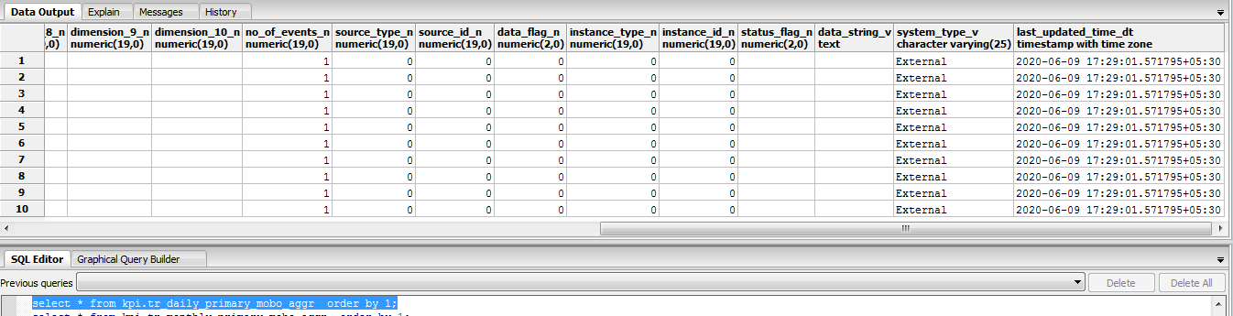

***Monthly***

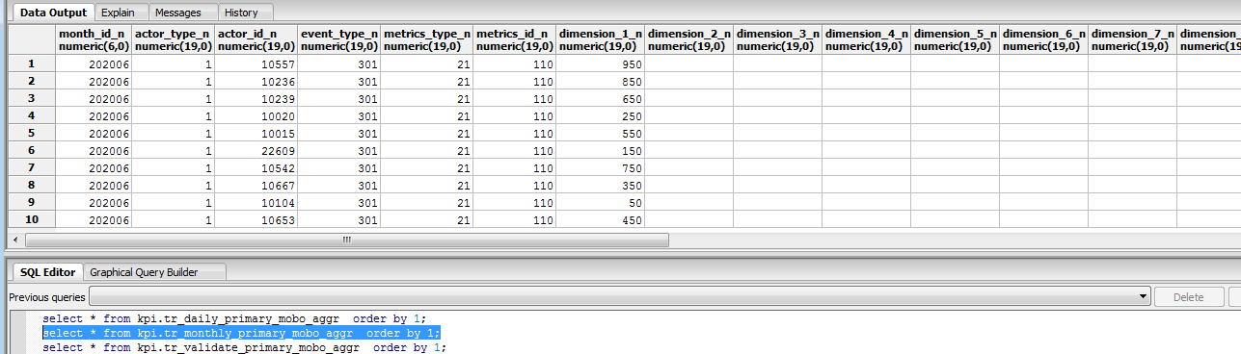

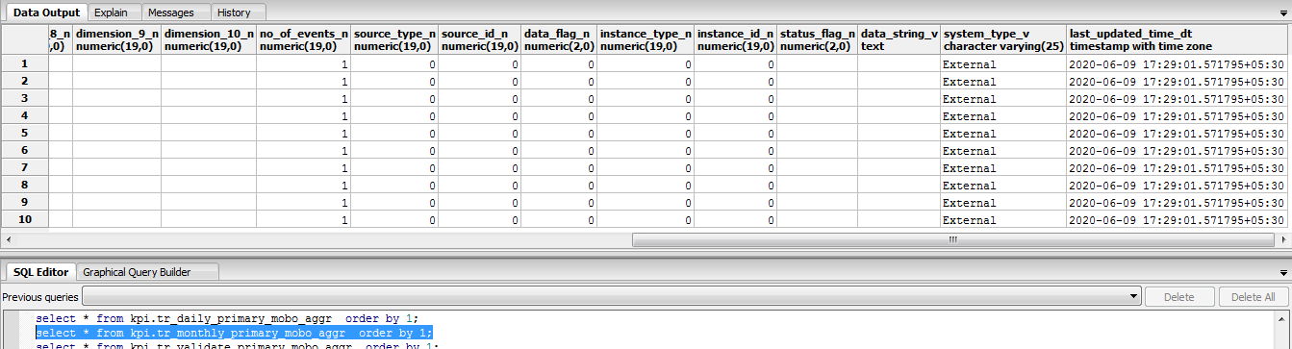

**File 2**

MPC_CODE|MOBO_DATE|AMOUNT

0708|20200608|60.25

100821|20200608|70.25

110|20200608|80.25

1112|20200608|90.25

1114|20200608|100.25

***No rejection data***

***VALIDATION***

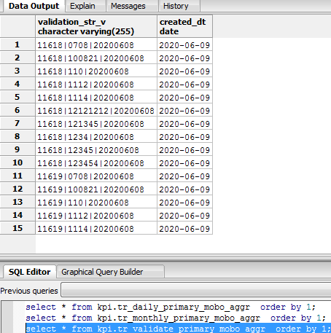

**DAILY**

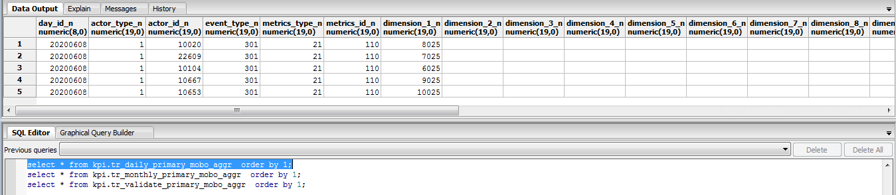

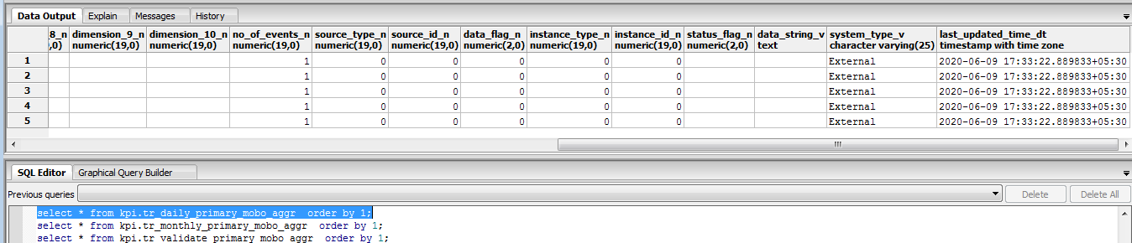

**Monthly**

