**Snd-Integration’s Entities generation Issue**

**Plug-in Configuration(*com.sun.tools.jxc.maven2*) at pom.xml level**

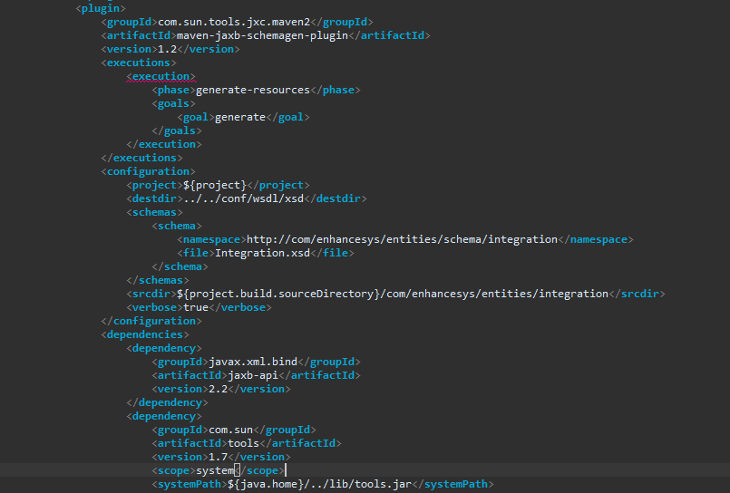

**Failed at generating entities**

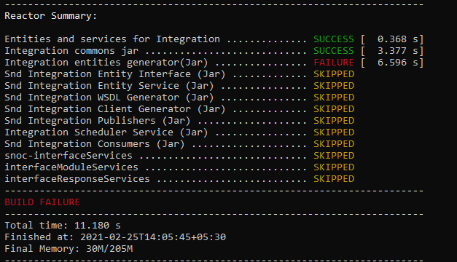

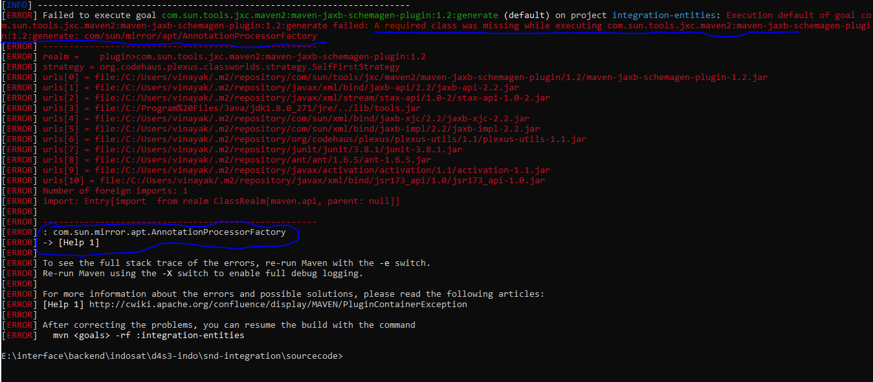

**Reference at Plug-In at Maven Central Repository**

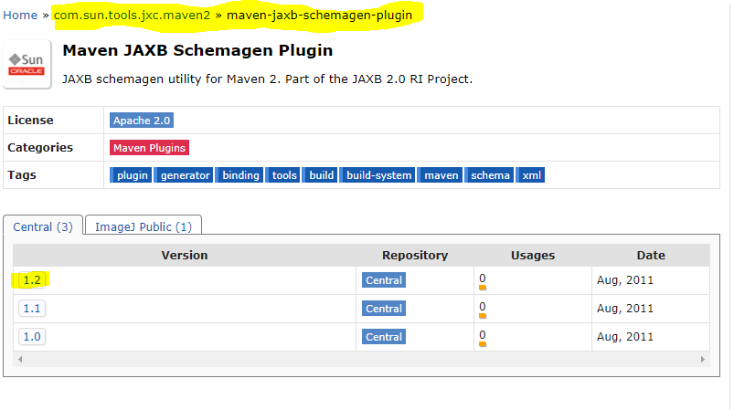

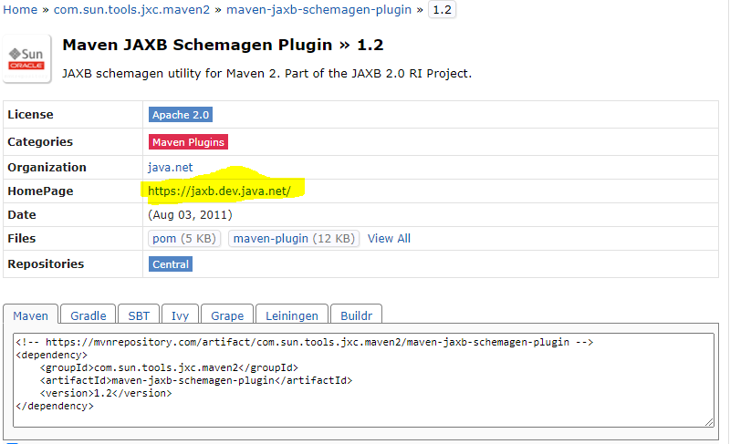

**Above 1.2 version not supporting to generate entity classes. Need latest version or else need alternate solution.**

**----------------------------------------------------------------------------------------------------------**

**External Site Reference for 1.2 version**

