**INTERFACE DUMP-DATA-TEMPLATES**

**Audience**

This tutorial has been prepared for the beginners to help them understand the basic concepts related to configuration of the DUMP or REPORT templates.

## Prerequisites

Before you start practicing various types of examples given in this mail, we assume that you are already aware about Json, SQL scripting and Mongo DB scripting (with lookup concept).

**Explanation throughout examples**

Consider scenario like below picture:

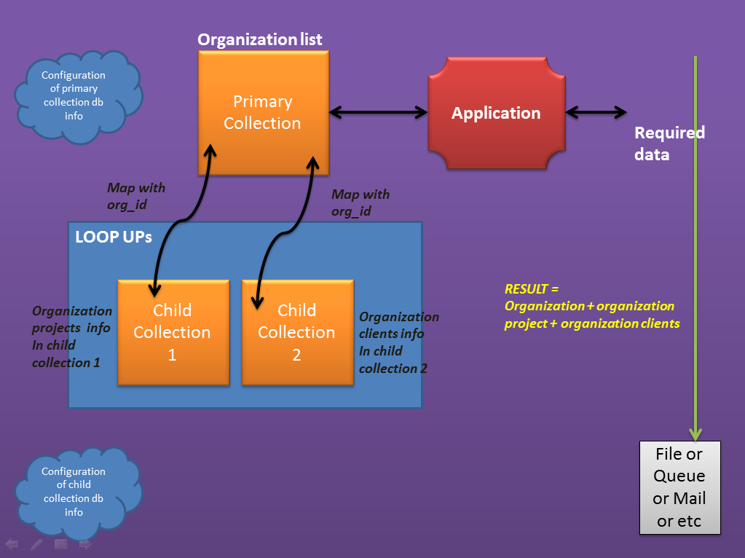

In Primary Collection Configuration we should configure

*Like below*

"Primary":

{

"primary-collection": "poi_object",

"poi_object":

{

"connection-id": "snoc-r1",

"schema-name": "custom_features",

"collection-name": "poi_object",

"parameters":

[

{

"param-name": "crtd_dt",

"param-value": 1,

"param-type": "date"

}

],

"projection":

{

"poi_type_desc": 1,

"_id": 1,

"name": 1,

"lng": 1,

"lat": 1,

"status": 1,

"updtd_dt": 1,

"requested_by": 1,

"crtd_dt": 1,

"deactivation_approved_dt": 1,

"deactivation_approved_by": 1

}

}

}

Look up (child collections) Configuration:

"Lookup":

{

"genericMasterValueCollection":

{

"connection-id": "snoc-r1",

"schema-name": "snoc",

"collection-name": "genericMasterValueCollection"

},

"org_user_node_acc":

{

"connection-id": "snoc-r4",

"schema-name": "snoc_report",

"collection-name": "org_user_node_acc"

}

}

**Writing Result:**

OutputConf : {

"file-headers": "Date|date_time|status|.......",

"fields": "date_time,status,area......",

"dump-date-field": "date"

}

,"Configuration":

{

"date_time":

{

"field": "crtd_dt",

"date-format": "dd-MMM-yyyy HH:mm:ss"

},

"status":

{

"field": "status",

"lookup":

[

{

"name": "genericMasterValueCollection",

"mapping-field": "s_id",

"lookup-field": "description"

}

]

},

,

"register_user_name":

{

"field": "crtd_by",

"lookup":

[

{

"name": "org_user_node_acc",

"mapping-field": "user_id",

"lookup-field": "user_name"

}

]

}

}

**NOTE**: **Here** **lookup-field is what you project from primary collection**