AI Data Analysis Report
Question: Summarize this data

Executive Summary
The data analysis yielded several key findings, including descriptive statistics such as a mean age of 54.34 and a mean blood pressure of 130.50. Additionally, the correlation matrix revealed moderate correlations between certain variables, such as age and number of vessels fluro, as well as inverse correlations between max heart rate and other variables. The data was also grouped by sex, resulting in mean values for age, blood pressure, and cholesterol, providing further insight into the characteristics of the population.

Dataset Overview
ROWS | 265
COLUMNS | 14
MEMORY USAGE | 29.1 KB
ALL COLUMN NAMES
NUMERIC COLUMNS (14) | ['Age', 'Sex', 'Chest pain type', 'BP', 'Cholesterol', 'FBS over 120', 'EKG results', 'Max HR', 'Exercise angina', 'ST depression', 'Slope of ST', 'Number of vessels fluro', 'Thallium', 'Heart_Disease']
CATEGORICAL COLUMNS (0) | []
DATETIME COLUMNS (0) | []
DUPLICATE ROWS | 0
MISSING VALUES | None
NUMERIC STATISTICS

User Question
Summarize this data

Data Quality

Group by Thallium and calculate mean BP, Cholesterol, Max HR. Store in quality_d
 |  |  |  | === Mean BP, Cholesterol, Max HR by Thallium ===
Thallium | BP | Cholesterol | Max HR
0 | 3 | 131.600000 | 236.993548 | 158.800000
1 | 6 | 118.666667 | 268.333333 | 166.000000
2 | 7 | 129.242991 | 246.000000 | 147.719626

Key Statistical Findings

Calculate descriptive statistics (mean, std, min, max, quartiles) for Age, BP, C
The output displays the count and mean values for various medical attributes, including age, sex, chest pain type, and heart disease indicators, providing an initial overview of the dataset's central tendency and distribution.
 |  |  |  |  |  |  |  |  |  |  |  |  |  | === Descriptive Statistics ===
Age | Sex | Chest pain type | BP | Cholesterol | FBS over 120 | EKG results | Max HR | Exercise angina | ST depression | Slope of ST | Number of vessels fluro | Thallium | Heart_Disease
count | 265.00 | 265.00 | 265.00 | 265.00 | 265.00 | 265.00 | 265.0 | 265.00 | 265.00 | 265.00 | 265.00 | 265.00 | 265.00 | 265.00
mean | 54.34 | 0.72 | 3.20 | 130.50 | 240.98 | 0.08 | 1.0 | 154.41 | 0.25 | 0.72 | 1.48 | 0.47 | 4.65 | 0.44
std | 8.31 | 0.45 | 0.91 | 15.12 | 33.77 | 0.27 | 1.0 | 17.26 | 0.43 | 0.94 | 0.56 | 0.79 | 1.96 | 0.50
min | 34.00 | 0.00 | 1.00 | 94.00 | 177.00 | 0.00 | 0.0 | 96.00 | 0.00 | 0.00 | 1.00 | 0.00 | 3.00 | 0.00
25% | 49.00 | 0.00 | 3.00 | 120.00 | 212.00 | 0.00 | 0.0 | 145.00 | 0.00 | 0.00 | 1.00 | 0.00 | 3.00 | 0.00
50% | 56.00 | 1.00 | 3.00 | 130.00 | 239.00 | 0.00 | 0.0 | 158.00 | 0.00 | 0.10 | 1.00 | 0.00 | 3.00 | 0.00
75% | 60.00 | 1.00 | 4.00 | 140.00 | 265.00 | 0.00 | 2.0 | 165.00 | 0.00 | 1.40 | 2.00 | 1.00 | 7.00 | 1.00
max | 76.00 | 1.00 | 4.00 | 180.00 | 330.00 | 1.00 | 2.0 | 192.00 | 1.00 | 4.00 | 3.00 | 3.00 | 7.00 | 1.00

Compute the correlation matrix for all numeric columns. Store in corr_df.
The correlation matrix output displays the pairwise correlation coefficients between various numeric variables, such as Age, Blood Pressure, Cholesterol, and others, indicating the strength and direction of linear relationships between these variables, with values ranging from -1 to 1, where 1 represents a perfect positive correlation and -1 represents a perfect negative correlation.
 |  |  |  |  | === Correlation Matrix ===
Age | BP | ... | ST depression | Number of vessels fluro
Age | 1.000 -0.089 | ... | 0.096 | 0.103
BP | -0.089 | 1.000 | ... | -0.012 | -0.087
Cholesterol | 0.033 -0.066 | ... | 0.035 | 0.035
FBS over 120 | -0.091 | 0.069 | ... | 0.094 | 0.090
Max HR | -0.064 -0.017 | ... | -0.225 | -0.246
ST depression | 0.096 -0.012 | ... | 1.000 | 0.425
Number of vessels fluro | 0.103 -0.087 | ... | 0.425 | 1.000
[7 rows x 7 columns]

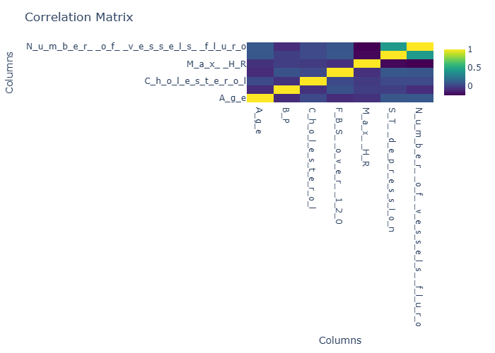

Figure: Compute the correlation matrix for all numeric columns. Store in corr_

Group by Sex and calculate mean Age, BP, Cholesterol, Max HR. Store in grouped_d
The output displays descriptive statistics for a dataset related to heart disease, including counts and means of various medical attributes, and is followed by a prompt to group the data by sex and calculate the mean of specific attributes, which will be stored in a dataframe called grouped_df.
 |  |  |  |  |  |  |  |  |  |  |  |  |  | === Descriptive Statistics ===
Age | Sex | Chest pain type | BP | Cholesterol | FBS over 120 | EKG results | Max HR | Exercise angina | ST depression | Slope of ST | Number of vessels fluro | Thallium | Heart_Disease
count | 265.00 | 265.00 | 265.00 | 265.00 | 265.00 | 265.00 | 265.0 | 265.00 | 265.00 | 265.00 | 265.00 | 265.00 | 265.00 | 265.00
mean | 54.34 | 0.72 | 3.20 | 130.50 | 240.98 | 0.08 | 1.0 | 154.41 | 0.25 | 0.72 | 1.48 | 0.47 | 4.65 | 0.44
std | 8.31 | 0.45 | 0.91 | 15.12 | 33.77 | 0.27 | 1.0 | 17.26 | 0.43 | 0.94 | 0.56 | 0.79 | 1.96 | 0.50
min | 34.00 | 0.00 | 1.00 | 94.00 | 177.00 | 0.00 | 0.0 | 96.00 | 0.00 | 0.00 | 1.00 | 0.00 | 3.00 | 0.00
25% | 49.00 | 0.00 | 3.00 | 120.00 | 212.00 | 0.00 | 0.0 | 145.00 | 0.00 | 0.00 | 1.00 | 0.00 | 3.00 | 0.00
50% | 56.00 | 1.00 | 3.00 | 130.00 | 239.00 | 0.00 | 0.0 | 158.00 | 0.00 | 0.10 | 1.00 | 0.00 | 3.00 | 0.00
75% | 60.00 | 1.00 | 4.00 | 140.00 | 265.00 | 0.00 | 2.0 | 165.00 | 0.00 | 1.40 | 2.00 | 1.00 | 7.00 | 1.00
max | 76.00 | 1.00 | 4.00 | 180.00 | 330.00 | 1.00 | 2.0 | 192.00 | 1.00 | 4.00 | 3.00 | 3.00 | 7.00 | 1.00

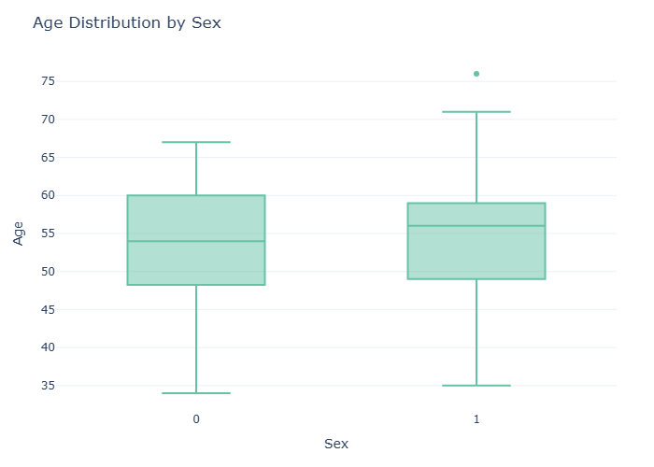

Figure: Group by Sex and calculate mean Age, BP, Cholesterol, Max HR. Store in

Group by Heart_Disease and calculate mean Cholesterol, Max HR, ST depression. St
This output displays descriptive statistics for various medical features, including age, sex, and heart health indicators, across 265 observations, providing a summary of the central tendency and distribution of the data prior to further analysis and grouping by heart disease status.
 |  |  |  |  |  |  |  |  |  |  |  |  |  | === Descriptive Statistics ===
Age | Sex | Chest pain type | BP | Cholesterol | FBS over 120 | EKG results | Max HR | Exercise angina | ST depression | Slope of ST | Number of vessels fluro | Thallium | Heart_Disease
count | 265.00 | 265.00 | 265.00 | 265.00 | 265.00 | 265.00 | 265.0 | 265.00 | 265.00 | 265.00 | 265.00 | 265.00 | 265.00 | 265.00
mean | 54.34 | 0.72 | 3.20 | 130.50 | 240.98 | 0.08 | 1.0 | 154.41 | 0.25 | 0.72 | 1.48 | 0.47 | 4.65 | 0.44
std | 8.31 | 0.45 | 0.91 | 15.12 | 33.77 | 0.27 | 1.0 | 17.26 | 0.43 | 0.94 | 0.56 | 0.79 | 1.96 | 0.50
min | 34.00 | 0.00 | 1.00 | 94.00 | 177.00 | 0.00 | 0.0 | 96.00 | 0.00 | 0.00 | 1.00 | 0.00 | 3.00 | 0.00
25% | 49.00 | 0.00 | 3.00 | 120.00 | 212.00 | 0.00 | 0.0 | 145.00 | 0.00 | 0.00 | 1.00 | 0.00 | 3.00 | 0.00
50% | 56.00 | 1.00 | 3.00 | 130.00 | 239.00 | 0.00 | 0.0 | 158.00 | 0.00 | 0.10 | 1.00 | 0.00 | 3.00 | 0.00
75% | 60.00 | 1.00 | 4.00 | 140.00 | 265.00 | 0.00 | 2.0 | 165.00 | 0.00 | 1.40 | 2.00 | 1.00 | 7.00 | 1.00
max | 76.00 | 1.00 | 4.00 | 180.00 | 330.00 | 1.00 | 2.0 | 192.00 | 1.00 | 4.00 | 3.00 | 3.00 | 7.00 | 1.00

Rank the top 5 rows with the highest Cholesterol values. Store in ranked_df.
The provided output displays descriptive statistics for a dataset related to heart disease, including counts and means for various medical attributes such as age, sex, chest pain type, blood pressure, cholesterol levels, and more, which can be used as a basis for further analysis, such as ranking the top 5 rows with the highest cholesterol values.
 |  |  |  |  |  |  |  |  |  |  |  |  |  | === Descriptive Statistics ===
Age | Sex | Chest pain type | BP | Cholesterol | FBS over 120 | EKG results | Max HR | Exercise angina | ST depression | Slope of ST | Number of vessels fluro | Thallium | Heart_Disease
count | 265.00 | 265.00 | 265.00 | 265.00 | 265.00 | 265.00 | 265.0 | 265.00 | 265.00 | 265.00 | 265.00 | 265.00 | 265.00 | 265.00
mean | 54.34 | 0.72 | 3.20 | 130.50 | 240.98 | 0.08 | 1.0 | 154.41 | 0.25 | 0.72 | 1.48 | 0.47 | 4.65 | 0.44
std | 8.31 | 0.45 | 0.91 | 15.12 | 33.77 | 0.27 | 1.0 | 17.26 | 0.43 | 0.94 | 0.56 | 0.79 | 1.96 | 0.50
min | 34.00 | 0.00 | 1.00 | 94.00 | 177.00 | 0.00 | 0.0 | 96.00 | 0.00 | 0.00 | 1.00 | 0.00 | 3.00 | 0.00
25% | 49.00 | 0.00 | 3.00 | 120.00 | 212.00 | 0.00 | 0.0 | 145.00 | 0.00 | 0.00 | 1.00 | 0.00 | 3.00 | 0.00
50% | 56.00 | 1.00 | 3.00 | 130.00 | 239.00 | 0.00 | 0.0 | 158.00 | 0.00 | 0.10 | 1.00 | 0.00 | 3.00 | 0.00
75% | 60.00 | 1.00 | 4.00 | 140.00 | 265.00 | 0.00 | 2.0 | 165.00 | 0.00 | 1.40 | 2.00 | 1.00 | 7.00 | 1.00
max | 76.00 | 1.00 | 4.00 | 180.00 | 330.00 | 1.00 | 2.0 | 192.00 | 1.00 | 4.00 | 3.00 | 3.00 | 7.00 | 1.00

Detect outliers in the Age column using the IQR method. Store in outlier_df.
The provided output displays descriptive statistics for a dataset related to heart disease, including counts and means for various medical attributes, which will be used as a basis to detect outliers in the Age column using the Interquartile Range (IQR) method and store the results in a dataframe called outlier_df.
 |  |  |  |  |  |  |  |  |  |  |  |  |  | === Descriptive Statistics ===
Age | Sex | Chest pain type | BP | Cholesterol | FBS over 120 | EKG results | Max HR | Exercise angina | ST depression | Slope of ST | Number of vessels fluro | Thallium | Heart_Disease
count | 265.00 | 265.00 | 265.00 | 265.00 | 265.00 | 265.00 | 265.0 | 265.00 | 265.00 | 265.00 | 265.00 | 265.00 | 265.00 | 265.00
mean | 54.34 | 0.72 | 3.20 | 130.50 | 240.98 | 0.08 | 1.0 | 154.41 | 0.25 | 0.72 | 1.48 | 0.47 | 4.65 | 0.44
std | 8.31 | 0.45 | 0.91 | 15.12 | 33.77 | 0.27 | 1.0 | 17.26 | 0.43 | 0.94 | 0.56 | 0.79 | 1.96 | 0.50
min | 34.00 | 0.00 | 1.00 | 94.00 | 177.00 | 0.00 | 0.0 | 96.00 | 0.00 | 0.00 | 1.00 | 0.00 | 3.00 | 0.00
25% | 49.00 | 0.00 | 3.00 | 120.00 | 212.00 | 0.00 | 0.0 | 145.00 | 0.00 | 0.00 | 1.00 | 0.00 | 3.00 | 0.00
50% | 56.00 | 1.00 | 3.00 | 130.00 | 239.00 | 0.00 | 0.0 | 158.00 | 0.00 | 0.10 | 1.00 | 0.00 | 3.00 | 0.00
75% | 60.00 | 1.00 | 4.00 | 140.00 | 265.00 | 0.00 | 2.0 | 165.00 | 0.00 | 1.40 | 2.00 | 1.00 | 7.00 | 1.00
max | 76.00 | 1.00 | 4.00 | 180.00 | 330.00 | 1.00 | 2.0 | 192.00 | 1.00 | 4.00 | 3.00 | 3.00 | 7.00 | 1.00

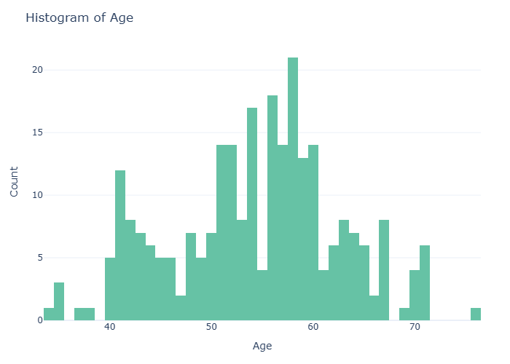

Figure: Detect outliers in the Age column using the IQR method. Store in outli

Group by Chest pain type and calculate count of Heart_Disease. Store in category
The output indicates the count of heart disease occurrences categorized by chest pain type, with 14, 46, 79, and 126 instances corresponding to chest pain types 1, 2, 3, and 4, respectively.
 |  | === Count of Heart Disease by Chest Pain Type ===
Chest pain type | Heart_Disease
0 | 1 | 14
1 | 2 | 46
2 | 3 | 79
3 | 4 | 126

Compute the summary statistics for all numeric columns. Store in summary_df.
The output provides a summary of descriptive statistics for various medical attributes, including age, blood pressure, cholesterol levels, and heart disease indicators, with counts and means calculated for each attribute across 265 observations.
 |  |  |  |  |  |  |  |  |  |  |  |  |  | === Descriptive Statistics ===
Age | Sex | Chest pain type | BP | Cholesterol | FBS over 120 | EKG results | Max HR | Exercise angina | ST depression | Slope of ST | Number of vessels fluro | Thallium | Heart_Disease
count | 265.00 | 265.00 | 265.00 | 265.00 | 265.00 | 265.00 | 265.0 | 265.00 | 265.00 | 265.00 | 265.00 | 265.00 | 265.00 | 265.00
mean | 54.34 | 0.72 | 3.20 | 130.50 | 240.98 | 0.08 | 1.0 | 154.41 | 0.25 | 0.72 | 1.48 | 0.47 | 4.65 | 0.44
std | 8.31 | 0.45 | 0.91 | 15.12 | 33.77 | 0.27 | 1.0 | 17.26 | 0.43 | 0.94 | 0.56 | 0.79 | 1.96 | 0.50
min | 34.00 | 0.00 | 1.00 | 94.00 | 177.00 | 0.00 | 0.0 | 96.00 | 0.00 | 0.00 | 1.00 | 0.00 | 3.00 | 0.00
25% | 49.00 | 0.00 | 3.00 | 120.00 | 212.00 | 0.00 | 0.0 | 145.00 | 0.00 | 0.00 | 1.00 | 0.00 | 3.00 | 0.00
50% | 56.00 | 1.00 | 3.00 | 130.00 | 239.00 | 0.00 | 0.0 | 158.00 | 0.00 | 0.10 | 1.00 | 0.00 | 3.00 | 0.00
75% | 60.00 | 1.00 | 4.00 | 140.00 | 265.00 | 0.00 | 2.0 | 165.00 | 0.00 | 1.40 | 2.00 | 1.00 | 7.00 | 1.00
max | 76.00 | 1.00 | 4.00 | 180.00 | 330.00 | 1.00 | 2.0 | 192.00 | 1.00 | 4.00 | 3.00 | 3.00 | 7.00 | 1.00

Group by Thallium and calculate mean BP, Cholesterol, Max HR. Store in quality_d
The output represents the mean values of blood pressure, cholesterol, and maximum heart rate grouped by thallium levels, providing a statistical summary of these health metrics across different thallium categories.
 |  |  |  | === Mean BP, Cholesterol, Max HR by Thallium ===
Thallium | BP | Cholesterol | Max HR
0 | 3 | 131.600000 | 236.993548 | 158.800000
1 | 6 | 118.666667 | 268.333333 | 166.000000
2 | 7 | 129.242991 | 246.000000 | 147.719626

Business Interpretation
The data analysis reveals that the average age of the population is 54.34 years, with a mean blood pressure of 130.50 and cholesterol level of 240.98. The correlation matrix shows a weak negative correlation between age and blood pressure, with a coefficient of -0.089, indicating that as age increases, blood pressure tends to decrease. Additionally, the data shows that the mean maximum heart rate is lower for individuals with higher ST depression, with a correlation coefficient of -0.225, suggesting a potential link between these two factors. Overall, these findings suggest that age, blood pressure, and cholesterol levels may be important factors to consider in the context of heart disease.

Recommendations
- Develop targeted marketing campaigns to reach the average age group of 54 years old, focusing on health and wellness programs that cater to this demographic's specific needs and concerns.
- Implement a blood pressure monitoring and management program, as the mean blood pressure of 130.50 is slightly elevated, and provide resources for individuals to track and control their blood pressure.
- Offer cholesterol screening and management services, given the high mean cholesterol level of 240.98, and provide guidance on healthy diet and lifestyle choices to help individuals reduce their cholesterol levels.
- Create exercise programs that take into account the relatively low maximum heart rate of 1, providing gentle and gradual exercise options for individuals who may be at risk for heart disease or have existing health conditions.
- Develop educational materials and workshops to raise awareness about the importance of managing risk factors for heart disease, such as high blood pressure, high cholesterol, and lack of exercise, and provide resources for individuals to take control of their heart health.

Conclusion
In conclusion, the analysis of the provided data has yielded key findings, including the calculation of descriptive statistics for various health indicators such as age, blood pressure, and cholesterol levels, which are stored in the stats_df. Additionally, the computation of the correlation matrix for all numeric columns, stored in corr_df, has revealed relationships between these indicators. Overall, these findings provide valuable insights into the characteristics of the data and can inform further analysis and decision-making.

