CommuniMe

Version 2

This is a summary document of CommuniMe. The purpose of this document is to:

1. Describe what Version 2 of CommuniMe is capable of
2. Present the mechanics of CommuniMe
3. Explore the opportunities for CommuniMe for use in the data ecosystem

# CommuniMe

## What is CommuniMe?

CommuniMe is a digital product designed to identify locations that meet specific requirements. Version 1 (V1) was developed as a mobile application as part of GovHack 2015, which was a 48 hour competition to theorise/ develop tools that would increase accessibility to open data. V1 enabled individuals and families to identify communities that met their needs for renting or purchasing property within Wellington city. Version 2 (V2) was developed as a web application with the same purpose that would be delivered through a browser. The product allows customers to specify what is important (e.g. schools, parks, cafes) and how important each element is (through ranking). It then presents communities that meet customer requirements in order of desirability. Table 1 presents the current product specifications. The primary aim of CommuniMe V2 was to demonstrate it could be built using open source platforms and to develop the infrastructure (i.e. code and database), that would guide future development.

*Table 1*. Table presenting the specifications for CommuniMe version 2.

|  |  |
| --- | --- |
|  | CommuniMe V2 |
| Purpose | Enable individuals/ families to identify communities that meet their needs for renting/ purchasing property |
| Scope | Wellington city |
| Customers | Individuals |
| Mode | Web application |
| Data | Schools |
| Bars |
| Pools |
| Supermarkets |
| Medical practices |
| Takeaway food |
| Weekly markets |
| Reserves |
| Sports clubs |

## How it works?

The following section explores the elements of CommuniMe, presenting the:

* Intent behind the design
* Tools used to build the product

### Design

The aim was to create an easy to use interface. This was primarily operationalised by enabling customers to get to the output with as few steps as possible. The customers are presented with communities that meet their needs in just four steps:

1. Arriving at the landing page
2. Choosing elements that are important in identifying a community
3. Ranking each element to demonstrate how important it is
4. Being presented with six most relevant communities

Ease of use is reinforced through a progress bar at the top of the page; providing feedback on how many steps are required to get to the output. Furthermore, a minimalist design was adopted, which prioritised functionality. That is, the majority of elements included in the application serve a functional purpose. The design team did well to execute this whilst creating an aesthetic appeal. A flow chart of the process is demonstrated in Figure 1.

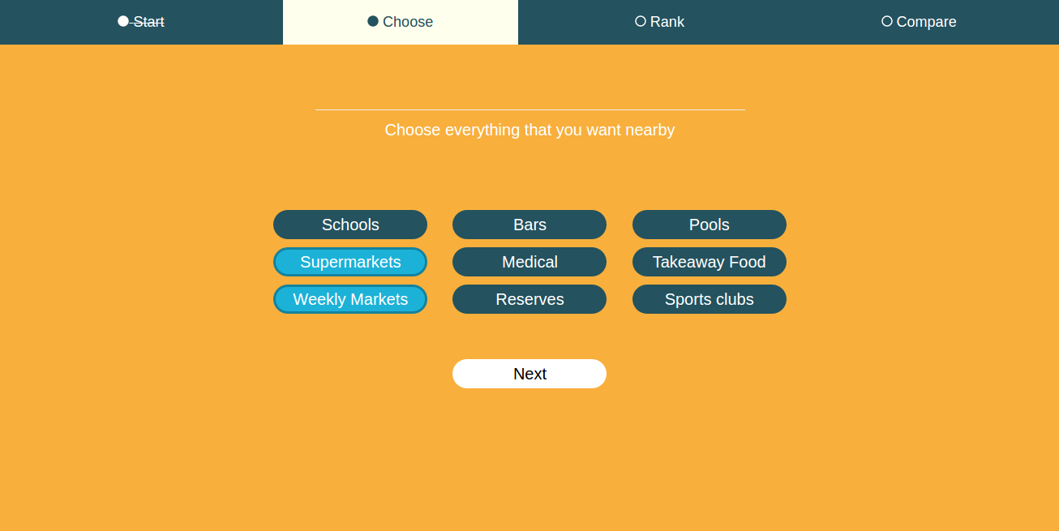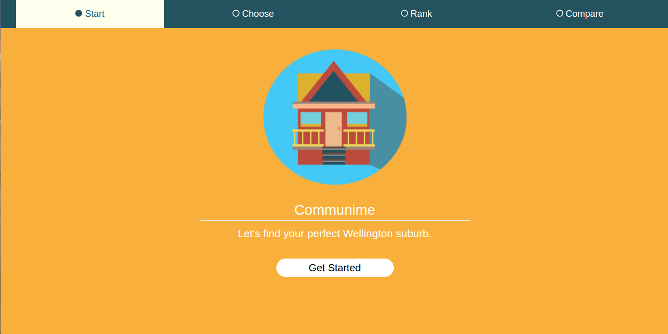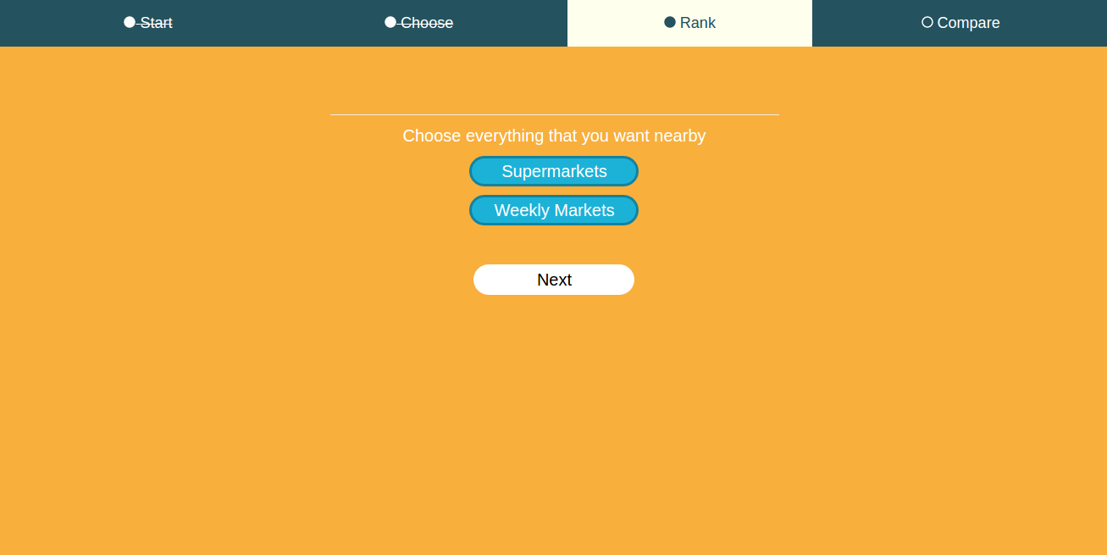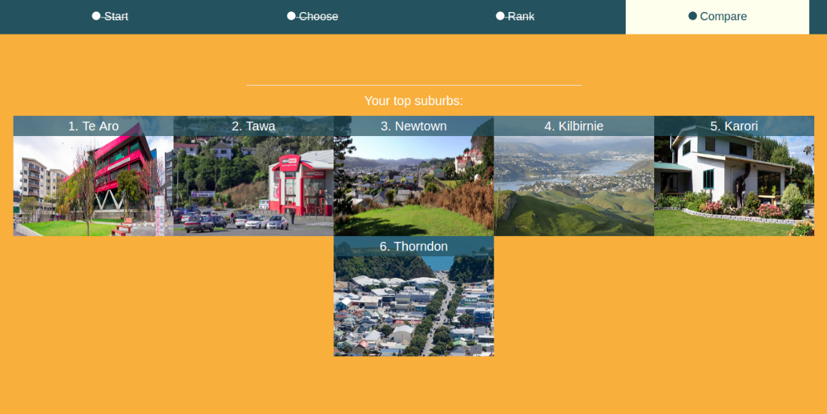

a)

c)

d)

b)

Figure 1. Figure presenting screenshots of the four steps involved in getting the output from CommuniMe; 1a) customers arrive at the landing page, 1b) customers choose elements that are important to them, 1c) customers rank elements and 1d) customers are presented with suburbs that meet their needs.

### Build

The aim was to construct a front end and back end that would facilitate future development of CommuniMe. In order to achieve this aim, the build was carried out using open source tools and environments that are commonly used in app development:

1. MySQL was utilised to load the data, structure the database tables and establish the relationship between tables.
2. Node.js was used to access the data and calculate suburb scores
3. Angular.js was used to determine how the customer interacts with elements of the web page and how objects are presented to the customer

Figure 2 presents how data travels from the database through the environments to present output to customers.

3)

2)

1)

MySQL

node.JS

angular.JS

customer

Figure 2. Figure presenting the flow of data through the back end and front environments; 1) data is pulled out of the MySQL database using node.JS to compute suburb scores, 2) the scores computed in node.JS are sent to angular.JS and 3) the presentation of suburbs in relation to their scores is established in angular.JS.

# Opportunities

## Existing architecture

CommuniMe was envisioned as a tool that would bring together data found in disparate sources; enabling the public to make more timely and informed decisions. That is, customers would not have to search for and compile datasets to guide decision making. Moreover, the product creates more value from existing data by allowing them to be used for a specific purpose; CommuniMe brings together datasets for the public to target communities ideal for buying/ renting property. It is worth exploring the need for CommuniMe amongst other customer groups, and identifying other means by which its architecture and concept could be utilised by National Statistics Offices.

CommuniMe can be repurposed to meet the needs of different customers groups. The tool is currently designed for public use; namely individuals and families that are looking to relocate. The existing product could have variables added and/or removed for use by community groups and local government that would enable targeted interventions. A future state of CommuniMe is presented in Table 2, which would serve a larger group of customers and house more data.

With its current design and architecture, the tool can enable customers to answer four questions. These include where to build, where to promote/ advertise, where to deliver a service and where to live. Table 3 presents examples where customers could utilise CommuniMe to address each of these questions.

*Table 2*. Table presenting current and future state of CommuniMe.

|  |  |  |
| --- | --- | --- |
|  | Current | Future |
| Purpose | Enable individuals/ families to identify communities that meet their needs for renting/ purchasing property | Enable customers to identify locations that meet their needs for a particular action/ intervention |
| Scope | Wellington city | New Zealand |
| Customers | Individuals | Central Government  Local Government  Businesses  Maori Interest Groups  Community organisations  Individuals |
| Mode | Web application | Web application |
| Data | Schools | Survey data  Administrative data  Modelled data |
| Bars |
| Pools |
| Supermarkets |
| Medical practices |
| Takeaway food |
| Weekly markets |
| Reserves |
| Sports clubs |

*Table 3*. Table presenting examples of the potential uses of CommuniMe. Data sources listed include examples of data available in New Zealand.

|  |  |  |  |
| --- | --- | --- | --- |
| Question | Customer | Potential purpose | Data |
| Where to build? | Business | What locations would be appropriate for setting up a new business/ branch? | Identify locations using:  Demography  Business Operations Survey (performance and competition)  Regional GDP  List of businesses |
| Where to advertise/ promote? | Central & Local Government (e.g. electoral commission) | Where to advertise/ promote voter registration? | Identify communities with low voter turnout using:  Voter turnout data for last election  Derived variable that predicts voter turnout for current election  Identify communities that have options for placing voter registration services and ad campaigns to encourage voting using:  List of cafes  List of shopping centres  List of recreation centres |
| Community organisations (e.g. YouthLine) | Where to advertise/ promote youth outreach services? | Identify communities with a need for youth outreach services using:  General Social Survey data (contact with family and friends, loneliness)  Suicide statistics  Demography  Deprivation index  Derived variable that predicts self-harm  Identify communities that have options for placing advertisements for youth outreach services using:  List of recreation centres  List of schools  List of businesses |
| Where to deliver a service? | Local Government & Business | Where to place mobile health clinics for screening/ treating? | Identify high risk groups using:  Demography  Derived variable that predicts risk for particular health condition  Identify communities that have options for delivering health services using:  List of schools  List of recreation centres |
| Where to live? | New Zealand Public | What suburbs to rent/ purchase property? | Identify communities using:  List of schools  List of cafes  List of parks  List of markets  Crime data |

## Advantages

* **Enables informed decision making**: CommuniMe enables customers to identify geo-graphic locations that are relevant based on specific requirements. Highlighting relevant locations will allow for targeted actions and/ interventions that achieve intended outcomes.
* **Leverages value from existing data**: CommuniMe supports the integration of datasets; unifying disparate data sources into one tool that would add value to existing data by 1) establishing new uses for that dataset and 2) contextualising the data with other data sources to further power evidence based decision making.
* **Open by default**: CommuniMe was built utilising open source tools and environments. Moreover, its architecture and build enables safe use of data that would otherwise be closed. Its ability to increase accessibility of data and statistics would make CommuniMe an appealing product for National Statistics Offices (NSOs). Whereas its use of open source tools will facilitate future development by other groups to meet their specific needs.
* **Stewards access to data**: CommuniMe increases the access to safe data. That is, it would be used to advise decision making using lower level data. It would achieve this whilst managing disclosure risk; the product currently utilises suburb level (~ area unit) data to produce qualitative and rank based output whilst never revealing the data itself.
* **Relevant dissemination format**: CommuniMe is a digital first environment, which directly present customers with the desired output, addressing the question “what locations meet my needs?” That is, the product allows customers to readily derive value from it without having to interpret tables/ graphs or print out any content.

## Next steps

CommuniMe V2 is not the complete product. It is a one step improvement from V1; demonstrating that it could be built using open source tools and establishing the infrastructure for future development. Any future work should be preceded by customer research, and consideration for how data will be sourced, what partnerships will be required for development and maintenance, the value added by National Statistics Offices and incorporating proximity data (see Table 4).

*Table 4*. Table presenting areas to explore for future development of CommuniMe.

|  |  |
| --- | --- |
| Future consideration | Comments |
| Customer Research | Prior to any further development, it is important to explore:   * Would customers gain value from CommuniMe? * What customer groups would utilise CommuniMe? |
| Sourcing data | The data was obtained through web scraping, and was not sourced in accordance with the terms and conditions of the data provider. A productionised version of CommuniMe would require National Statistics Offices to identify data providers and establish partnerships for sustainable provision of data. |
| Database | For version 2, data was imported to the databases using SQL insert statements. Future development would require automated loading of data or accessing data utilising an application program interface (API). |
| Partnerships | National Statistics Offices (NSOs) do not necessarily have to develop, own or maintain this product. However, as the co-leader of the data ecosystem, NSOs would be well placed to initiate conversations between relevant parties that would progress development and assign roles for ongoing development. |
| Insight | National Statistics Offices could add value to the tool by creating derived variables that can predict specific outcomes. For example, if the customer would like to make use of variables that are either not available through an administrative data source or reflect a latent construct, National Statistics Offices could derive these variables using modelling. |
| Proximity | One of the key needs of customers in selecting a community is its relative proximity to a given location. The user Interface and design of the product would require changes to enable customers to select a reference location. |

# Appendix

## Team

Table 5 presents the team that were involved in developing CommuniMe V1 and V2.

*Table 5*. Table presenting the team members involved in developing CommuniMe Version 1 (V1) and Version 2 (V2). Cells are shaded if individuals were available during the version build.

|  |  |  |  |
| --- | --- | --- | --- |
| Role | Team | V1 | V2 |
| Project management | Alex Komarovsky (Managed V2 between Nov 2015 and April 2016) |  |  |
| Vinayak Anand-Kumar (Managed V1 and V2 between March and June 2016) |  |  |
| Establishing need | Alex Komarovsky (customer research) |  |  |
| Charlie Dohrman (customer research) |  |  |
| Design | Sid Bardiya (user interface) |  |  |
| Lohit Petikam (user interface) |  |  |
| Anna Young (database design) |  |  |
| Build | Anna Young (co-ordinating build & MySQL databases) |  |  |
| Suyog Jog (consulted for node.JS) |  |  |
| Troy Lamerton (angular.JS) |  |  |
| Ahmed Shabaan (node.JS) |  |  |
| Danny Oberhaus (sourcing data & data analysis) |  |  |
| Charlie Dohrman (sourcing data & data analysis) |  |  |
| Chris Bryant (sourcing data & data analysis) |  |  |
| Chris Hansen (back end & front end development) |  |  |