Study four

Vinayak Anand-Kumar

2023-07-13

##   
## iter imp variable  
## 1 1 hapa1_t1 hapa2_t1  
## 1 2 hapa1_t1 hapa2_t1  
## 1 3 hapa1_t1 hapa2_t1  
## 1 4 hapa1_t1 hapa2_t1  
## 1 5 hapa1_t1 hapa2_t1  
## 2 1 hapa1_t1 hapa2_t1  
## 2 2 hapa1_t1 hapa2_t1  
## 2 3 hapa1_t1 hapa2_t1  
## 2 4 hapa1_t1 hapa2_t1  
## 2 5 hapa1_t1 hapa2_t1  
## 3 1 hapa1_t1 hapa2_t1  
## 3 2 hapa1_t1 hapa2_t1  
## 3 3 hapa1_t1 hapa2_t1  
## 3 4 hapa1_t1 hapa2_t1  
## 3 5 hapa1_t1 hapa2_t1  
## 4 1 hapa1_t1 hapa2_t1  
## 4 2 hapa1_t1 hapa2_t1  
## 4 3 hapa1_t1 hapa2_t1  
## 4 4 hapa1_t1 hapa2_t1  
## 4 5 hapa1_t1 hapa2_t1  
## 5 1 hapa1_t1 hapa2_t1  
## 5 2 hapa1_t1 hapa2_t1  
## 5 3 hapa1_t1 hapa2_t1  
## 5 4 hapa1_t1 hapa2_t1  
## 5 5 hapa1_t1 hapa2_t1

## Methods

The main focus of this study was to evaluate the impact of incorporating feedback from end users and stakeholders on the TeamBaby digital health tool, with respect to:

* Sentiment towards the digital health tool
* Frequency, intensity and duration of engagement with the digital health tool

### Participants

The TeamBaby digital health tool was promoted, primarily across Germany, using both physical and virtual approaches. Flyers were sent out to health care settings that pregnant women were likely to interact with, such as pharmacies, obstetric clinics, and general practitioner clinics. The broader public were notified through press releases; using print media to share insights from the TeamBaby project and invite people that are receiving obstetric care to use the tool. Relevant groups were targeted through social media and existing digital services for pregnant women; links to the TeamBaby digital health tool were made available through Facebook, Twitter, Instagram, Google Ads and via an existing Native app developed for pregnant women. Additional recruitment efforts were made for Version 1; two participating Obstetric clinics had researchers on site to promote and support use of the TeamBaby digital health tool. In order to limit the impact of confounders, such as app-use support, when comparing Versions 1 and 2, pregnant women that were recruited through the participating obstetric clinics (n = 202) were removed from the analysis. After exclusions, Versions 1 and 2 had 485 and 407 pregnant women who had registered with consent for data collection respectively. Figures 1 to 4 present the socio-demographic characteristics of end users from Version 1 and 2 of the web-app.

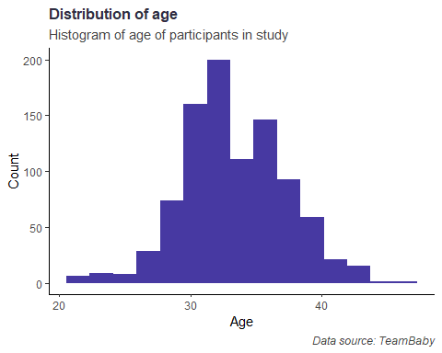

Figure 1: Age distribution of participants

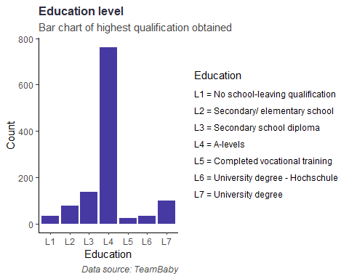

Figure 1: Education background of participants

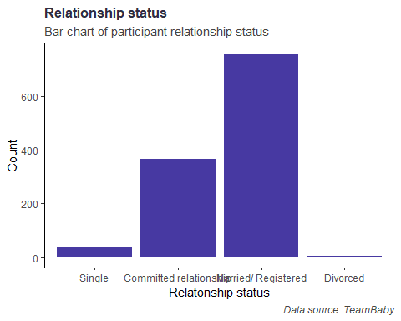

Figure 1: Relationship status of participants

## Results

You can also embed plots, for example:



Note that the echo = FALSE parameter was added to the code chunk to prevent printing of the R code that generated the plot.