3D ULPIN UI demo guide
  - A five minute walkthrough from files to a corrected model
Use this guide to present the local workbench or learn it yourself. You will load sample property files, prepare seven spaces, explore the building, identify a 6.4 m³ overlap, and resolve it by applying revised level evidence.
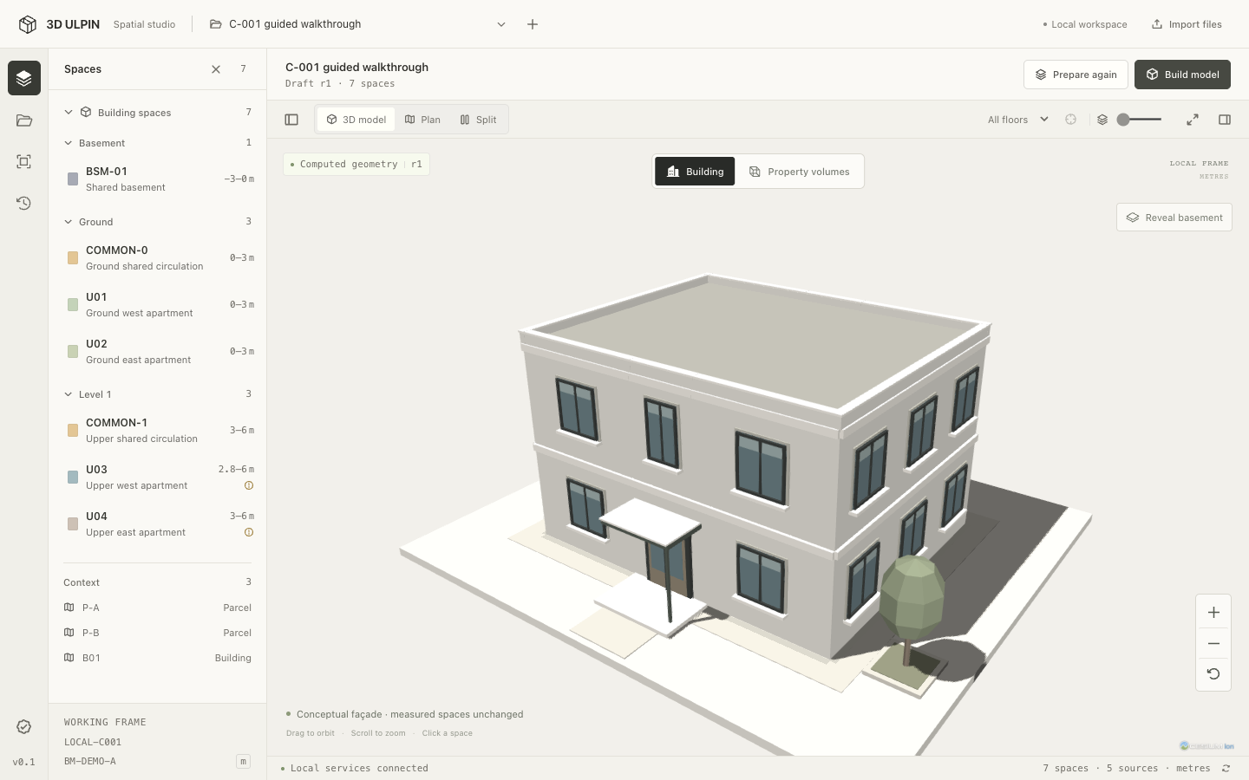
The Building view adds a conceptual façade to the measured property spaces.

Start on the demo computer
Double-click Start Demo.command in the project folder, or run pnpm demo there. Keep that terminal open. In the browser, open http://127.0.0.1:3000 and wait for Local services connected in the bottom status bar.
Open the workbench | Open the prepared building showcase
The story: Files → draft spaces → computed model → overlap finding → applied evidence → rebuilt model.
For a repeatable demo, create a fresh workspace on page 2. The sample files are teaching data. The workbench does not issue an official ULPIN or establish legal ownership.

1 Create a workspace and load inputs
Start with an empty case so the audience sees the model being created from source files. A new workspace keeps this rehearsal separate from earlier runs.
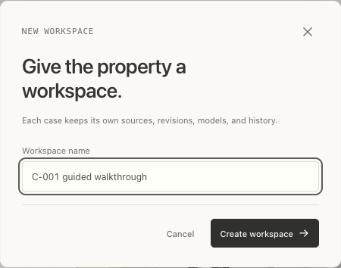
The plus button beside the workspace selector opens this dialog.
1. Click the + beside the workspace selector. Enter C-001 guided walkthrough, then click Create workspace.
2. Choose C-001 · Reference building in the sample selector and click Load sample inputs. Wait for processing to finish.
3. Open Sources in the left rail. Five originals appear. Selecting a source opens its inspector on the right.
Source | What it supplies
spatial.json | Property footprints, space IDs and local context.
levels-r1.csv | Initial elevation evidence; U03 and U04 have missing lower measurements.
controls.csv | The local metric frame and reference controls.
plan.png and plan.pdf | Plan references for optional calibration and tracing.

Expected: 5 sources and 0 spaces. Needs Input on the initial levels and plan references is expected. It means evidence needs attention; the sample is designed to continue with clearly marked draft values.
Say during the demo “These files are our starting evidence. Receiving a file does not create a building or automatically verify every measurement.”

2 Prepare draft spaces and build
Preparation turns inspected inputs into editable spaces. Building computes the saved 3D geometry, quantities and checks from those spaces.
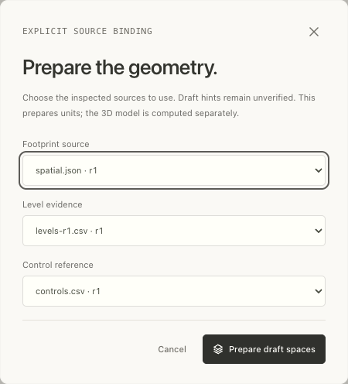
Bind the initial footprint, level and control revisions before preparing the draft.
1. Click Prepare geometry. Confirm Footprint source = spatial.json · r1, Level evidence = levels-r1.csv · r1, and Control reference = controls.csv · r1.
2. Click Prepare draft spaces. The Spaces pane should list 7 spaces, including the shared basement, ground spaces and upper spaces.
3. Click Build model at the top right. Wait for the building and Computed geometry r1 to appear. Keep All floors selected and the floor-separation slider at zero.
Expected: U03 begins at a draft lower limit of 2.8 m. Its lower elevation is marked unverified. This is the value that produces the conflict you will inspect next.
Say during the demo “Preparation gives us editable candidates. Building calculates their actual volumes and intersections, while keeping the evidence status visible.”

3 Explore the building and its spaces
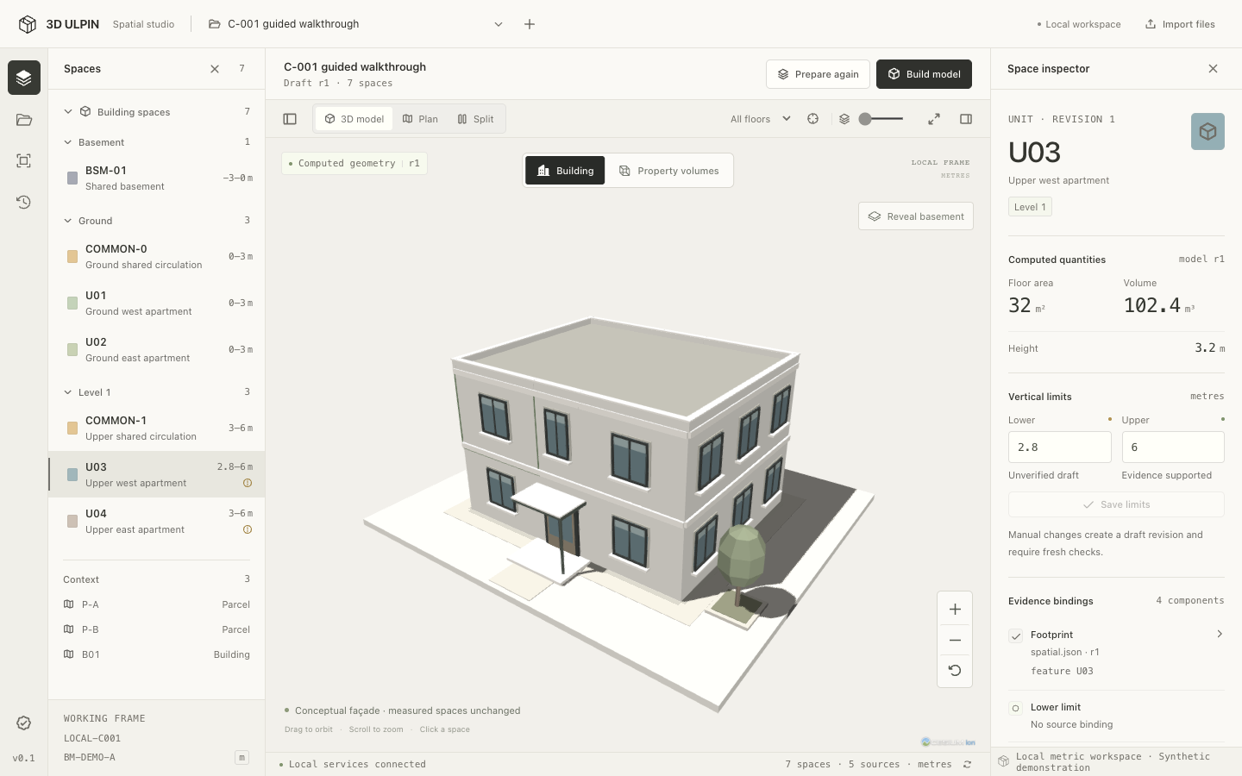
Select a space in the left list or click its façade to open the linked inspector.
Select U03 Upper west apartment under Spaces. The inspector shows a 32 m² floor area, 102.4 m³ volume, lower limit 2.8 m and upper limit 6 m. Its lower limit remains unverified.
Control | Use during the demo
Building and Property volumes | Switch between the conceptual building and exact measured prisms.
Drag, scroll and Reset camera | Orbit, zoom and return to the standard view.
All floors and Isolate selected space | Filter a storey or focus on one selected space.
Reveal basement | Expose the below-ground space.
Separate floors visually | Spread storeys apart for explanation; return the slider to zero afterward.
Focus model | Expand the viewer. Exit focus to restore the panels.

Say during the demo “The windows, roof and landscaping help us recognize the building. Measurements and conflict checks come from the stored property geometry. These display controls do not edit that geometry.”

4 Find and explain the overlap
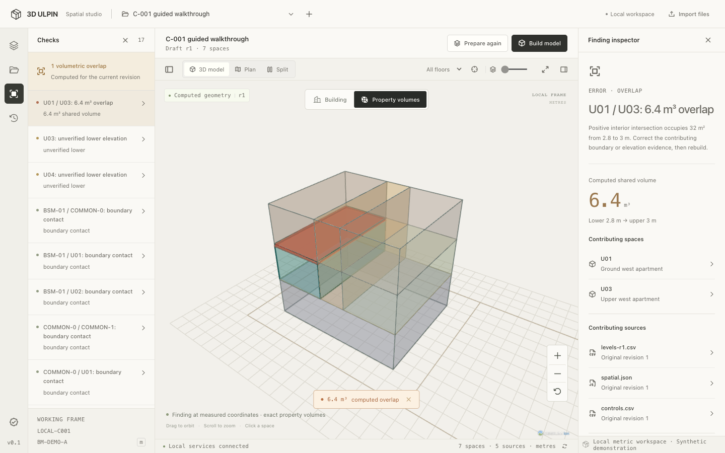
Selecting the finding automatically opens Property volumes and the measured overlap.
1. Open Checks in the left rail. Click U01 / U03: 6.4 m³ overlap.
2. Point out the orange region and 6.4 m³ computed overlap label. Read the finding inspector and its contributing source revisions.
3. Explain the vertical conflict: U01 reaches 3.0 m, while U03 begins at 2.8 m. They share a 0.2 m band over 32 m².
Calculation: 32 m² × 0.2 m = 6.4 m³.
Expected: one positive-volume overlap. Other findings can describe unverified evidence or boundary contact; they are separate from the highlighted intersection.
Say during the demo “This is the actual shared volume. We will resolve it with a new source revision so we can explain why the measurement changed.”

5 Apply revised level evidence
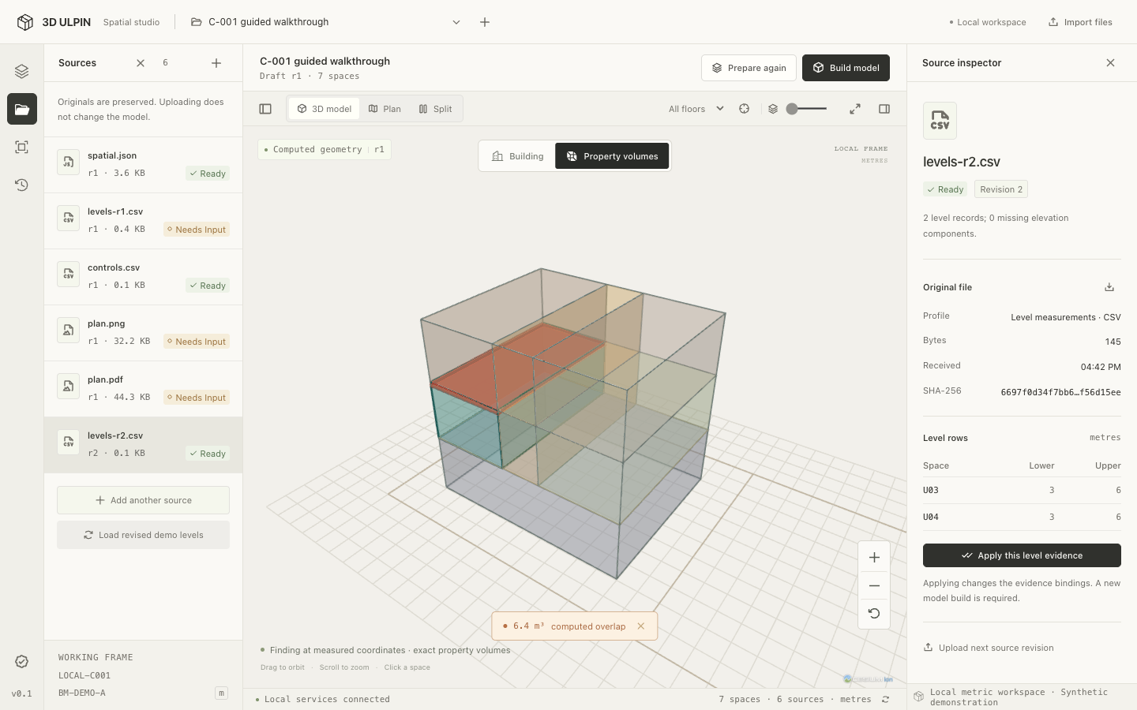
Revision 2 is received and inspected here, but the existing model still shows its original overlap.
1. Open Sources, then click Load revised demo levels. Wait for levels-r2.csv · r2 to become Ready. Select it if its inspector is not already open.
2. Check the level rows: U03 and U04 both have Lower = 3 m and Upper = 6 m.
3. Click Apply this level evidence. The workspace advances to a new draft revision and asks for a rebuild.
Expected: uploading r2 alone leaves the computed model unchanged. Applying r2 updates the evidence bindings and draft measurements; the previous model remains visible until you rebuild.
Use Apply this level evidence for this correction. Prepare again can replace draft edits and is not the action for this step.
Say during the demo “A newer file is available, but it only affects the draft when I apply it. A separate rebuild is required to calculate the result.”

6 Rebuild and confirm the result
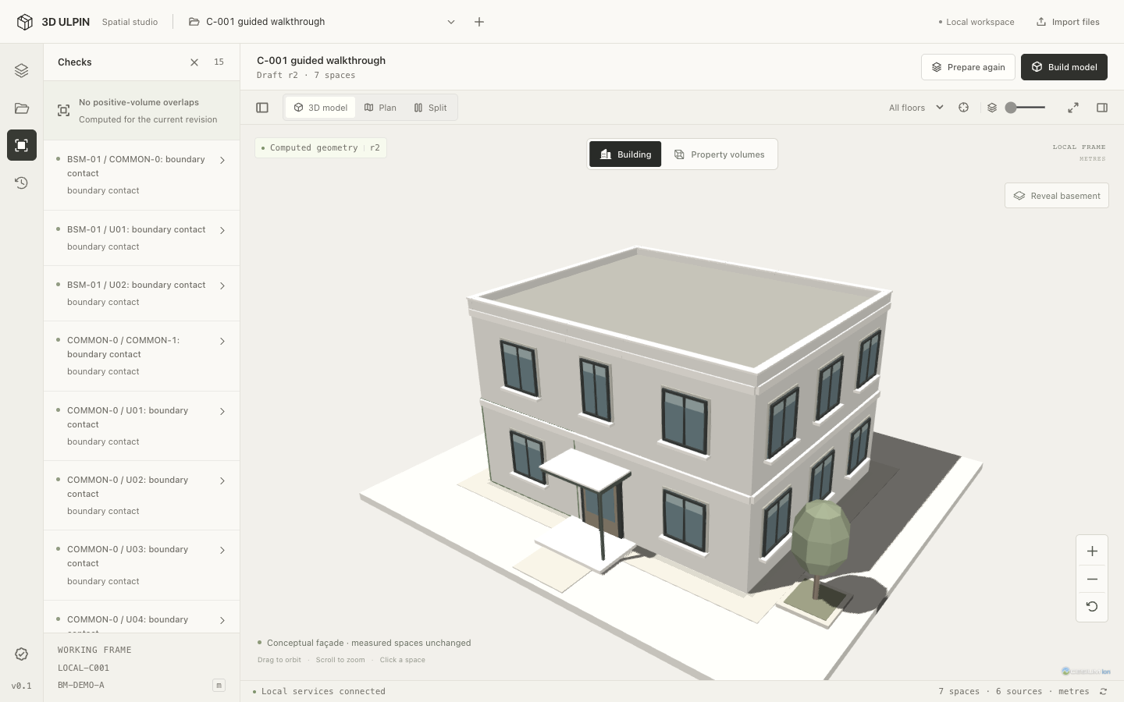
After rebuilding, Checks reports no positive-volume overlaps for the current revision.
1. Click Rebuild model and wait for Computed geometry r2. Open Checks again.
2. Confirm No positive-volume overlaps. The positive overlap is now 0 m³. U03 now spans 3–6 m, giving a volume of 96 m³.
3. Open History to show the source, preparation, application and build events. Refresh the browser and reopen the same workspace if needed.
Expected after refresh: the same corrected model and its source revisions remain. This walkthrough was verified with 7 spaces at revision 2.
Boundary-contact findings may remain: surfaces that touch at a floor boundary do not necessarily share positive interior volume.
Say during the demo “The revised measurement has been applied and computed. The conflict is gone, and we retain a history of the evidence and actions that produced the result.”

7 Presenter script and quick recovery
Use this timing sheet for a five-minute presentation after rehearsing once. Allow extra time for cold 3D startup or queued processing; continue when the expected state appears.
Time | Screen and action | Suggested narration
0:00–0:30 | Create workspace and load C-001 | We start with source files and an empty workspace.
0:30–1:00 | Sources and initial levels | Some measurements are incomplete; their status stays visible.
1:00–1:35 | Prepare geometry and Build model | We bind the sources, prepare seven spaces and calculate their geometry.
1:35–2:10 | Building view and U03 inspector | The building view is illustrative. The inspector exposes the measured limits and quantities.
2:10–2:55 | Checks and the 6.4 m³ finding | U03 begins 0.2 metres too low, creating this shared volume.
2:55–3:45 | Load r2 and apply evidence | Receiving new evidence does not apply it. I make that change explicitly.
3:45–4:25 | Rebuild and Checks | The recomputed model now has zero positive-volume overlap.
4:25–5:00 | History and browser refresh | The corrected result and its evidence persist when we reopen the workspace.

If the screen differs from the guide
The starting overlap is missing: create a fresh C-001 workspace using r1. The prepared showcase and earlier rehearsals may already be at a different stage.
The overlap remains after r2 upload: select r2, click Apply this level evidence, then Rebuild model. All three actions are required.
The inspector or navigation is hidden: use Show inspector or Show model tree in the viewer toolbar, or exit Focus model. Hover icon-only controls to see their labels.
Processing is slow or fails: wait for the queue, check Local services connected, and read the error in the inspector. Keep the launch terminal open. Restart with pnpm demo if needed; preserve existing data.

Optional demonstrations
Choose Import files to upload your own supported JSON, CSV, PNG or PDF. Use Plan to edit outlines, or a plan source’s Open reference & trace and Calibrate & trace controls to create a traced space. These are separate exercises; run them after the main correction story.
For a second example, create a fresh C-002 · Alternate footprint workspace. Its initial overlap is 14.4 m³, and the same revised-evidence workflow clears it.
Guide verified: 12 September 2026 against the running UI. Start a fresh case to replay every step; the captured “C-001 guided walkthrough” case is already corrected.

