Name : Siddhi Vinayak || Class : MCADS11 || Roll No : 56 || Subject : NoSql and MongoDB
MongoDB Project
Write a Query for Each Question
1. Complex Filters & Projections
Q1. List the names and departments of students who have more than 85% attendance and are
skilled in both "MongoDB" and "Python".

Answer1)
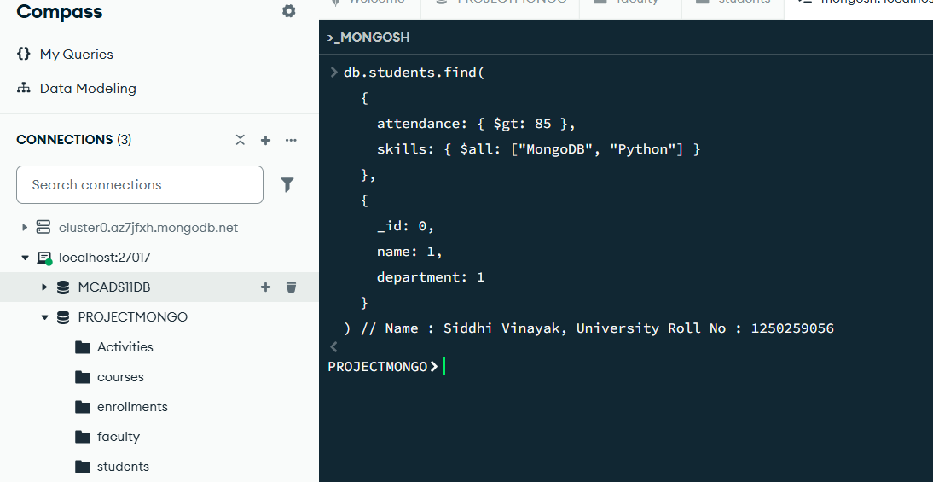

Output :
No Output for the given query mean no data matched

Q2. Show all faculty who are teaching more than 2 courses. Display their names and the total
number of courses they teach.
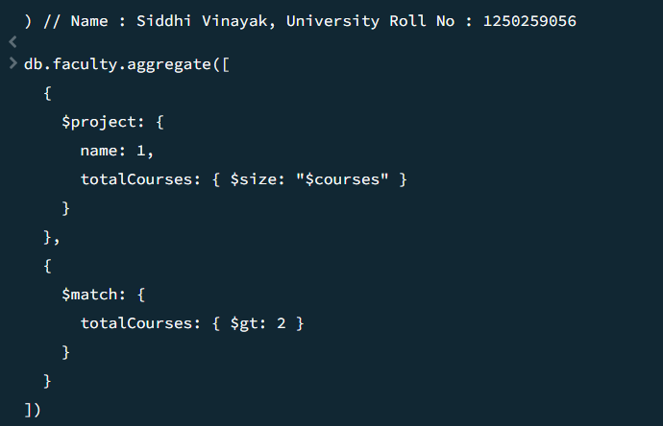
Output :
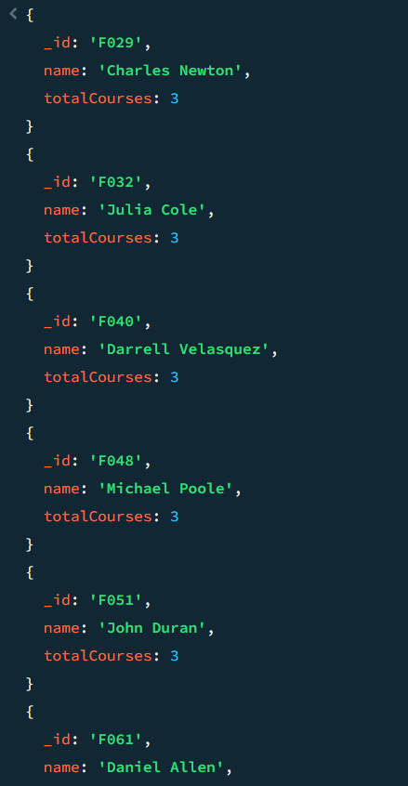

2. Joins ($lookup) and Aggregations
Q3. Write a query to show each student’s name along with the course titles they are enrolled in
(use $lookup between enrollments, students, and courses).
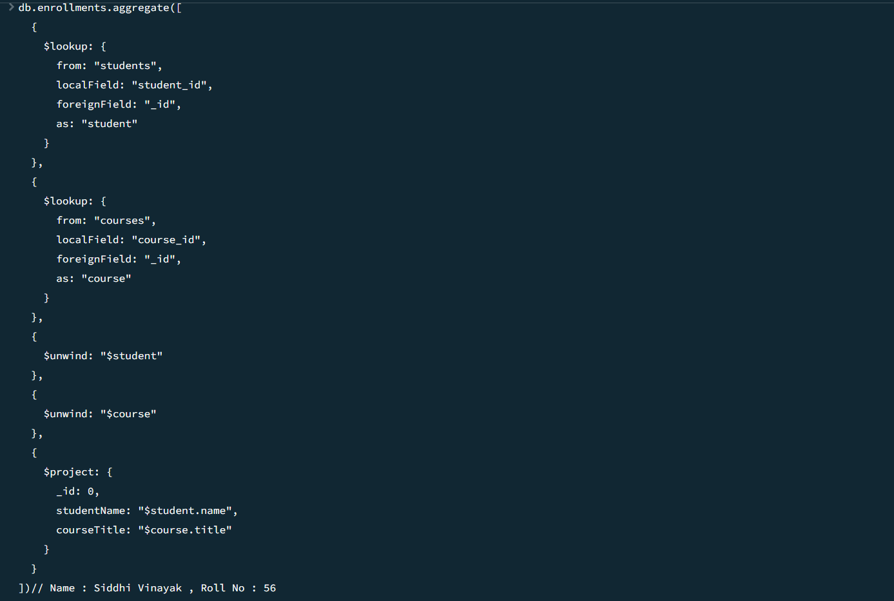

Output:
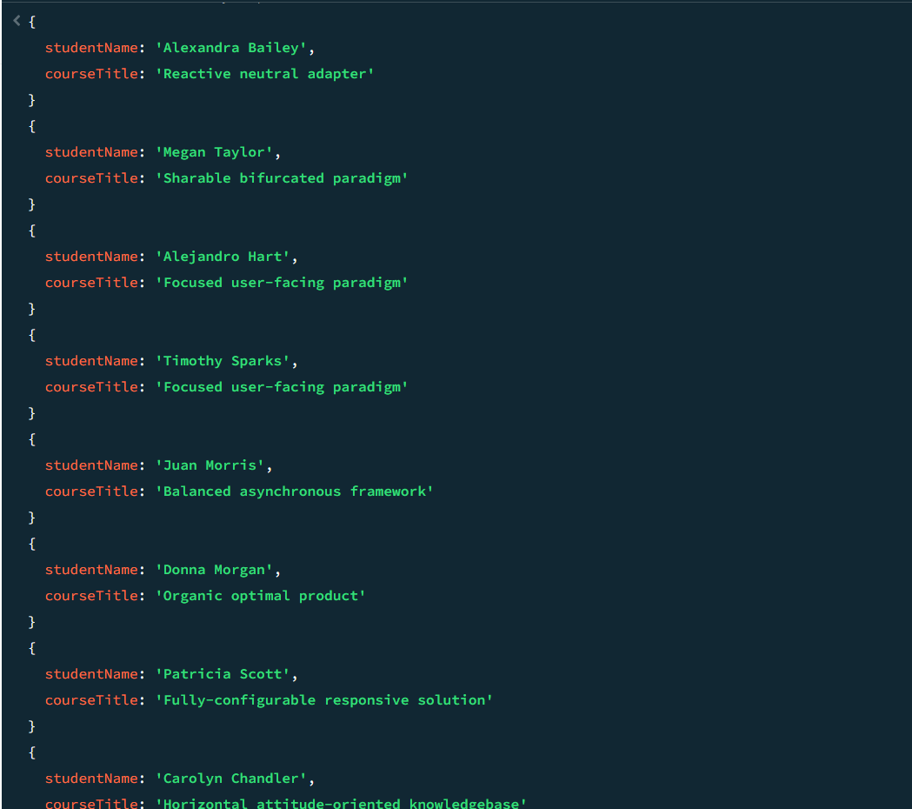

Q4. For each course, display the course title, number of students enrolled, and average marks
(use $group).
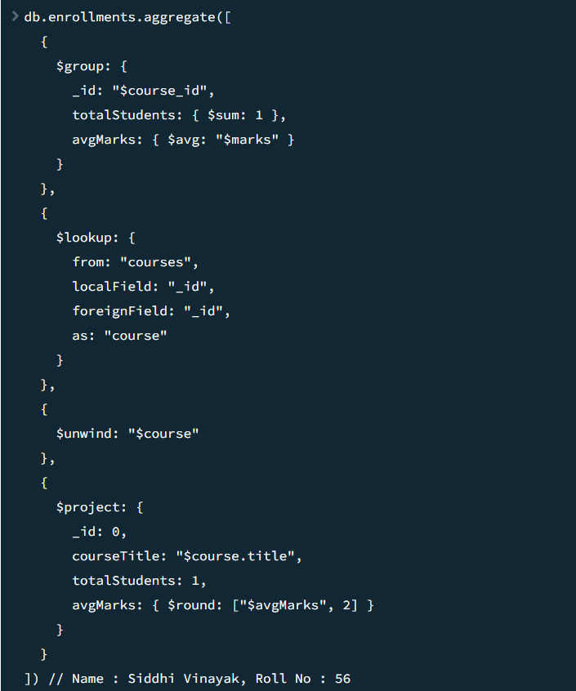

Output:
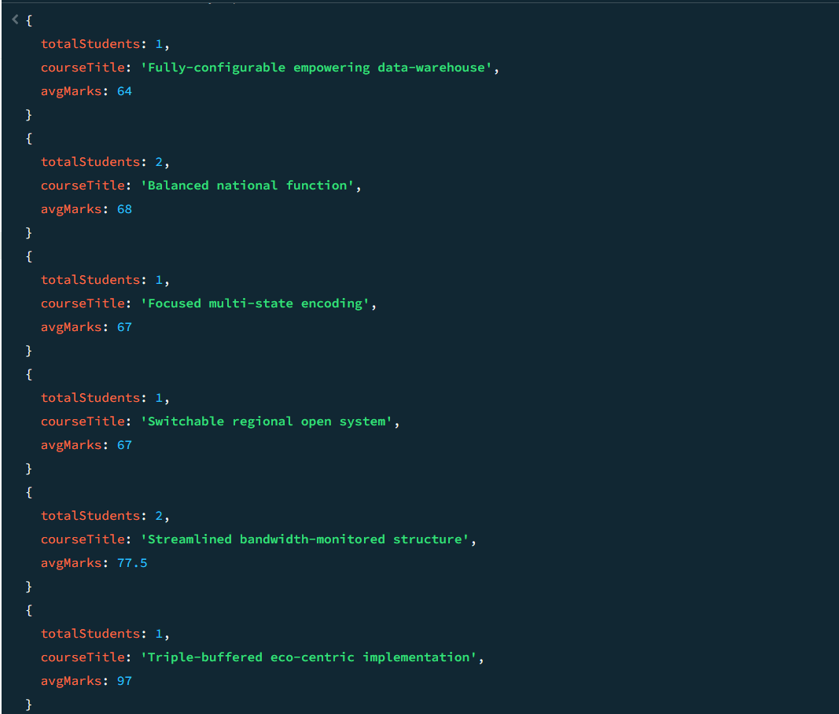

3. Grouping, Sorting, and Limiting
Q5. Find the top 3 students with the highest average marks across all enrolled courses.
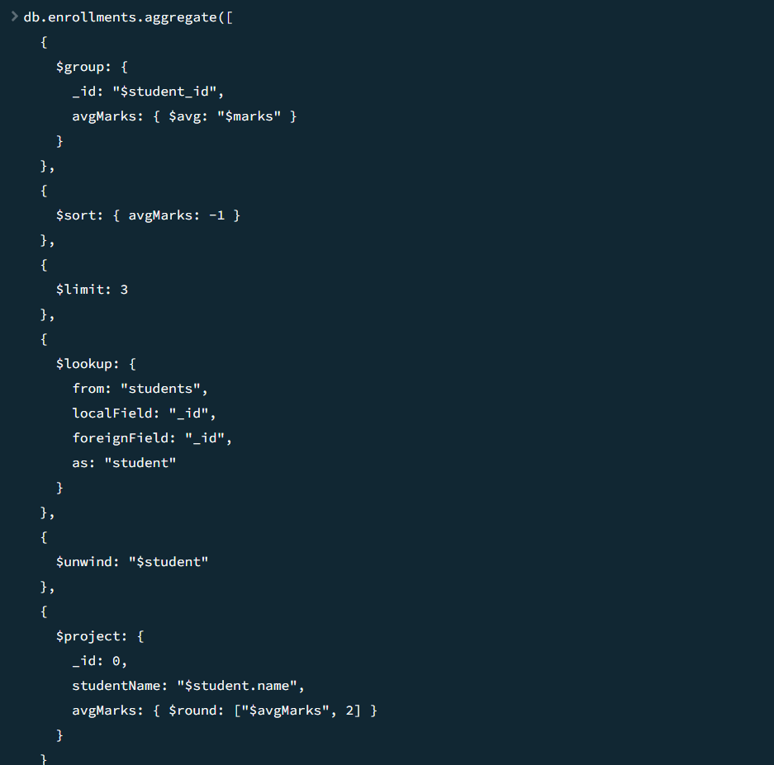
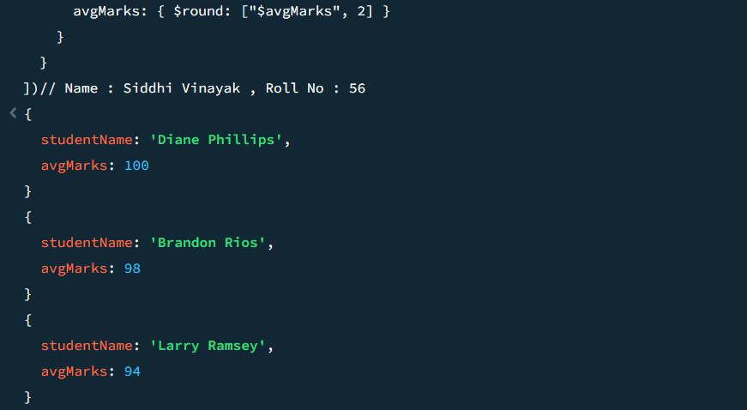

Q6. Count how many students are in each department. Display the department with the highest
number of students.
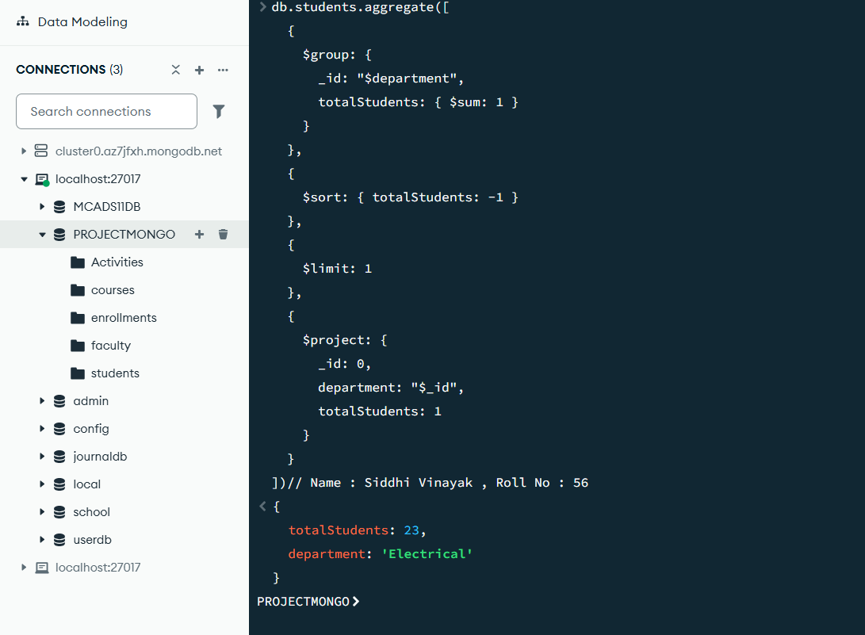
Output:
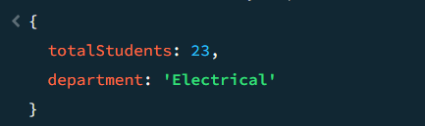

4. Update, Upsert, and Delete
Q7. Update attendance to 100% for all students who won any "Hackathon".
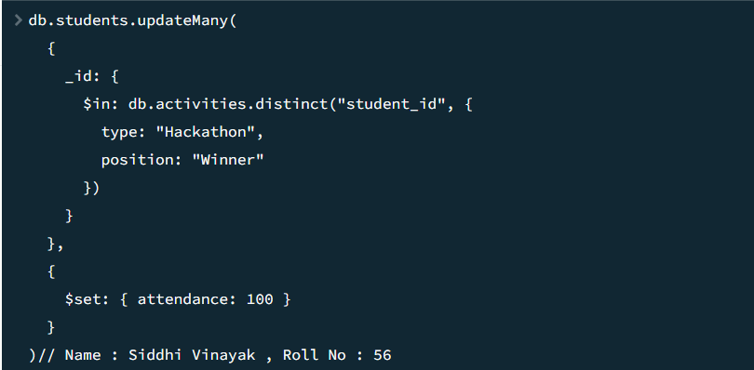
Output:
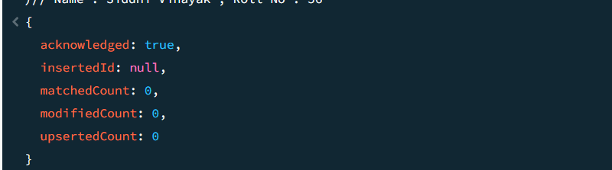
Q8. Delete all student activity records where the activity year is before 2022.

Input and Output:
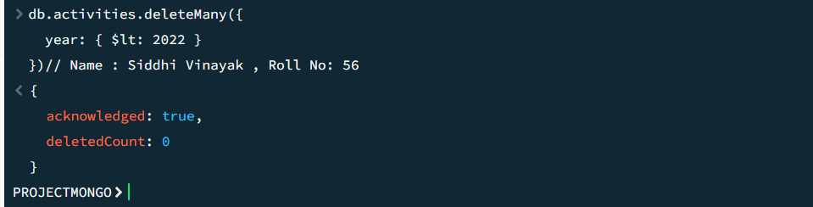

Q9. Upsert a course record for "Data Structures" with ID "C150" and credits 4—if it
doesn’t exist, insert it; otherwise update its title to "Advanced Data Structures".

Input and Output:
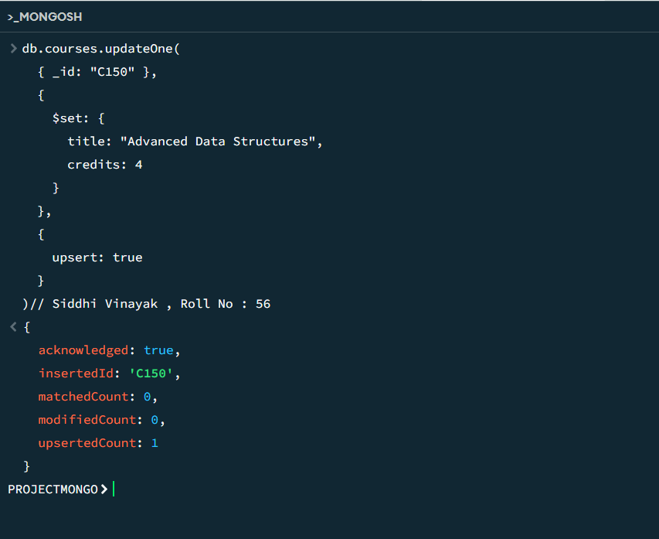
5. Array & Operator Usage
Q10. Find all students who have "Python" as a skill but not "C++".
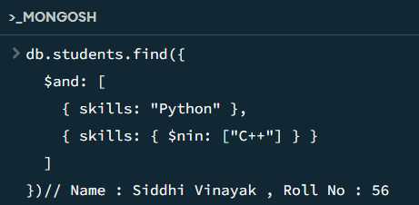
Output:
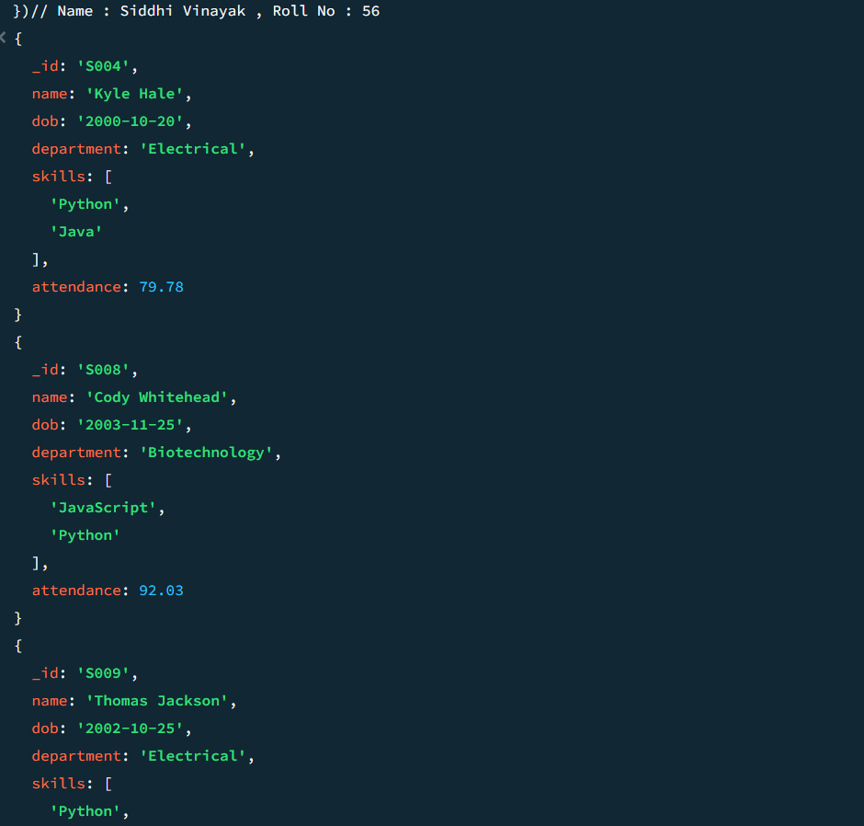
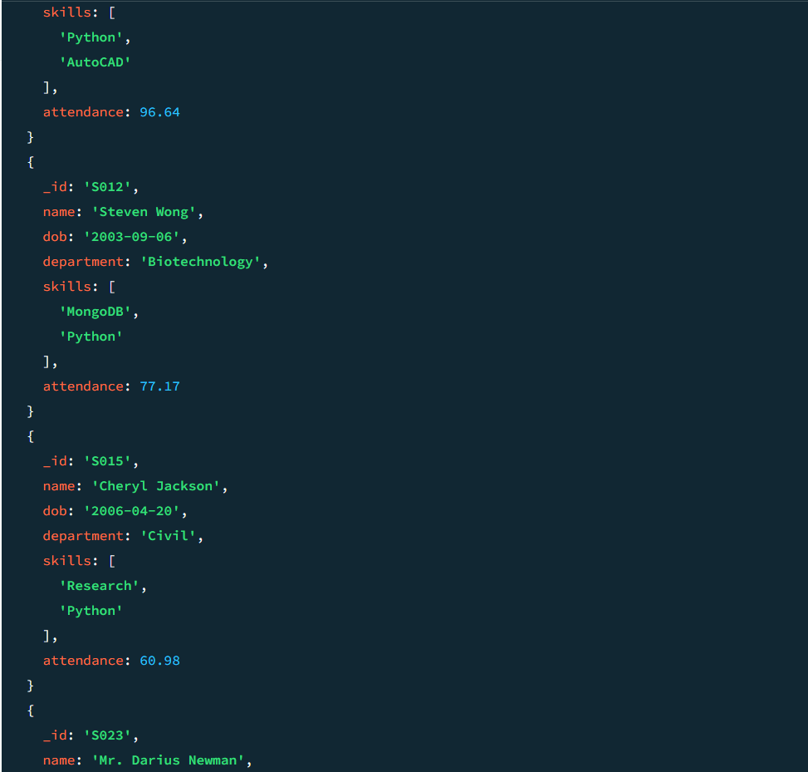
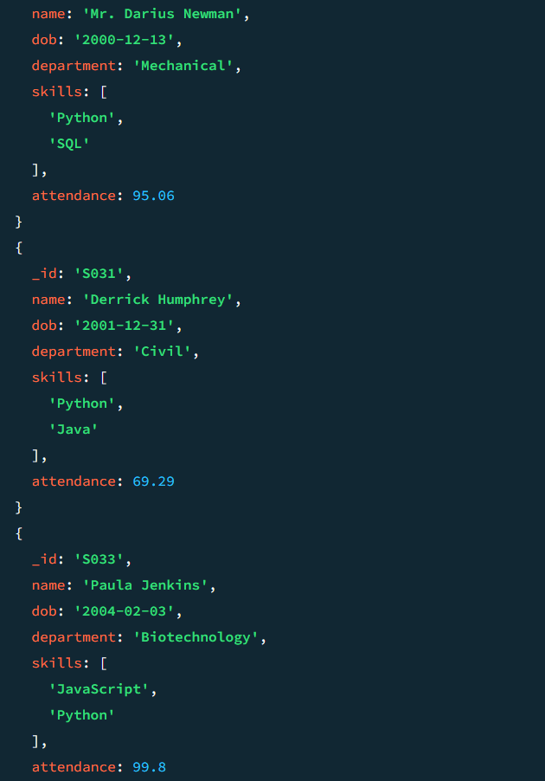
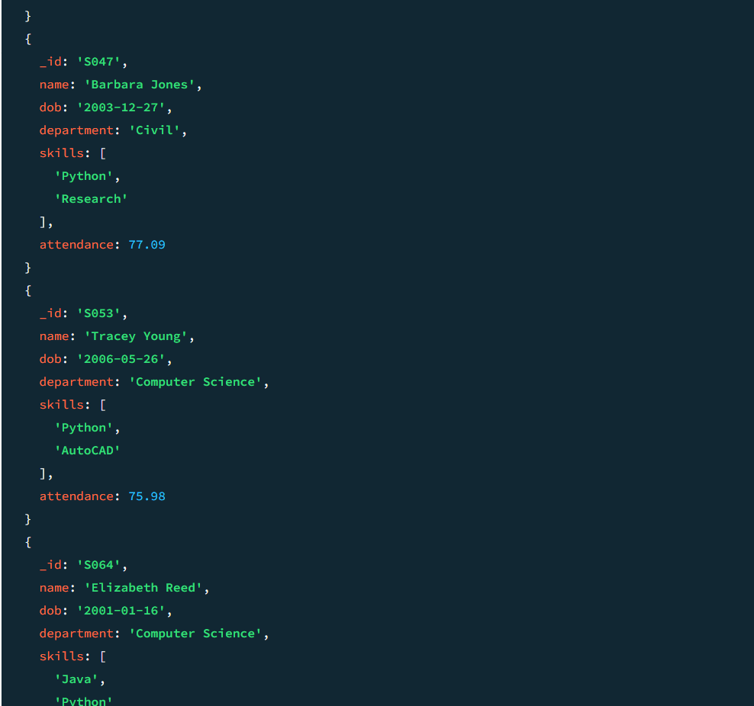
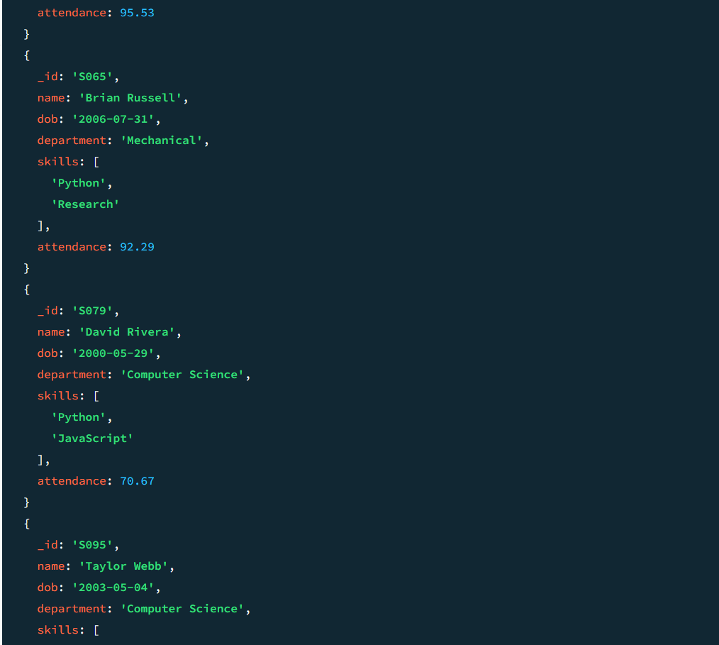
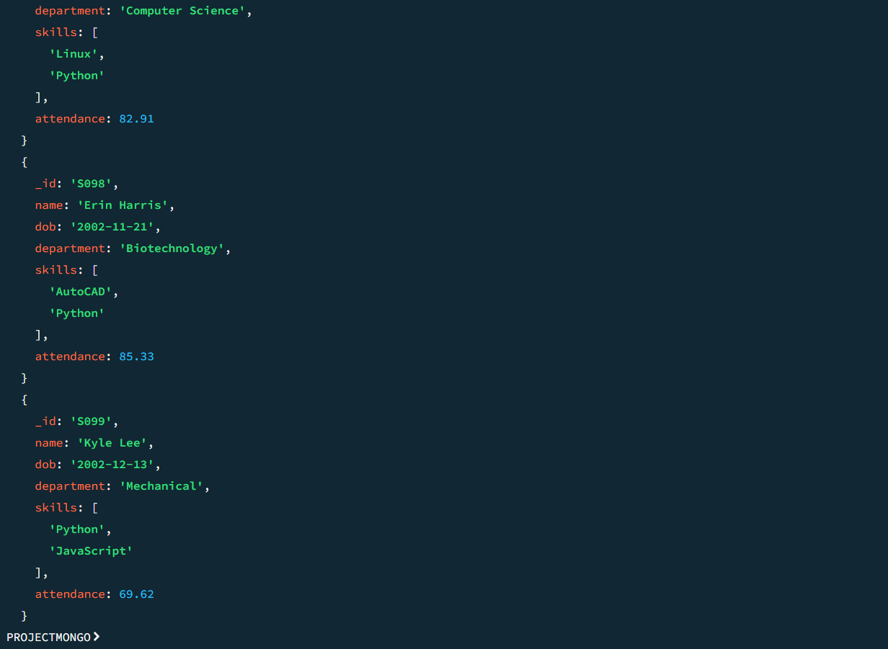

Q11. Return names of students who participated in "Seminar" and "Hackathon" both.
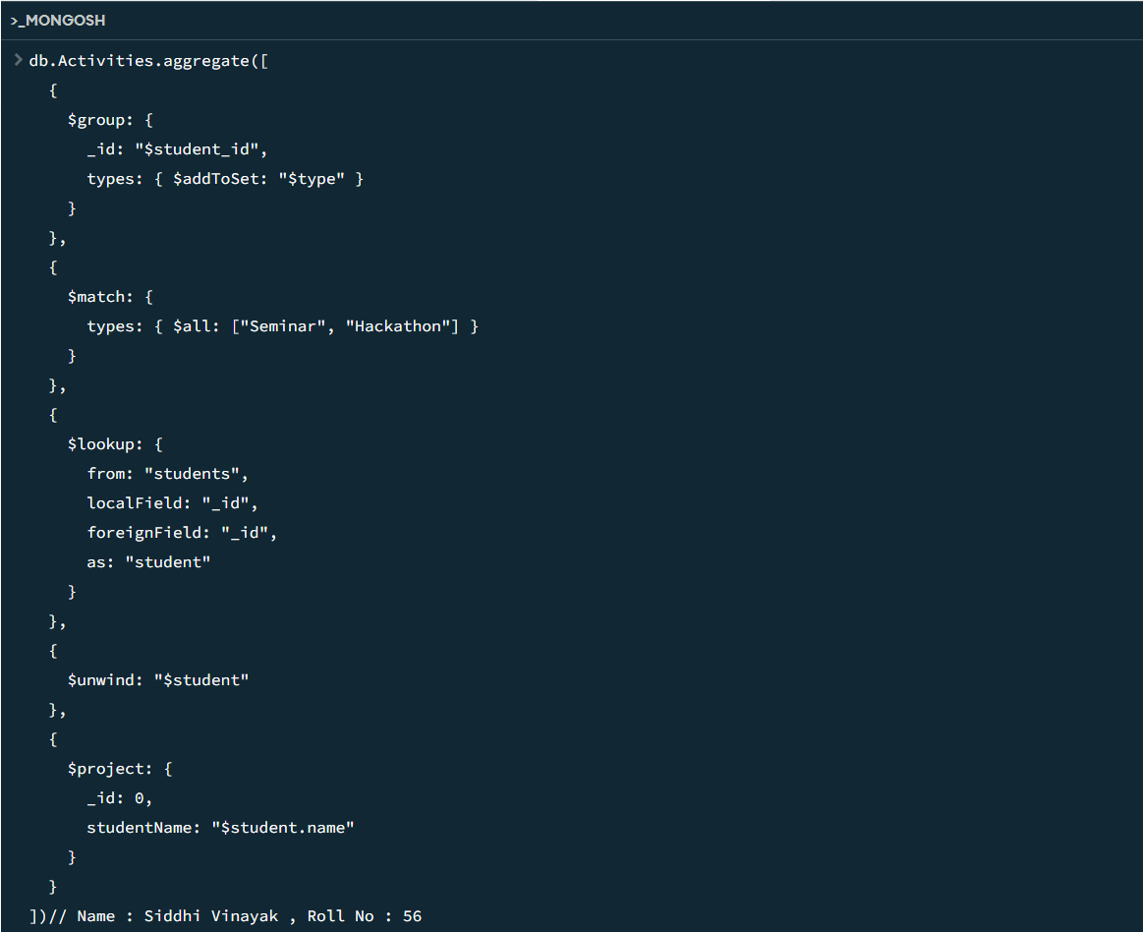
Output:
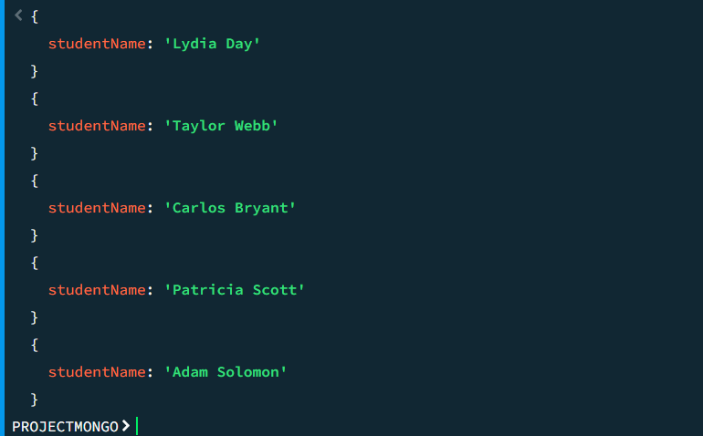

6. Subdocuments and Nested Conditions
Q12. Find students who scored more than 80 in "Web Development" only if they belong to
the "Computer Science" department.
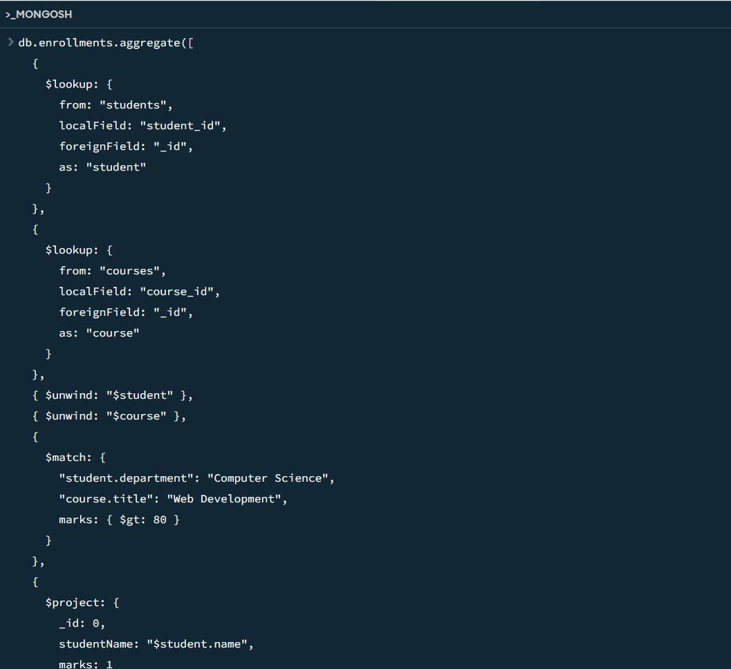
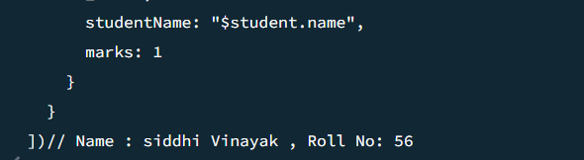
Output:
No Output

7. Advanced Aggregation (Challenge Level)
Q13. For each faculty member, list the names of all students enrolled in their courses along with
average marks per student per faculty.
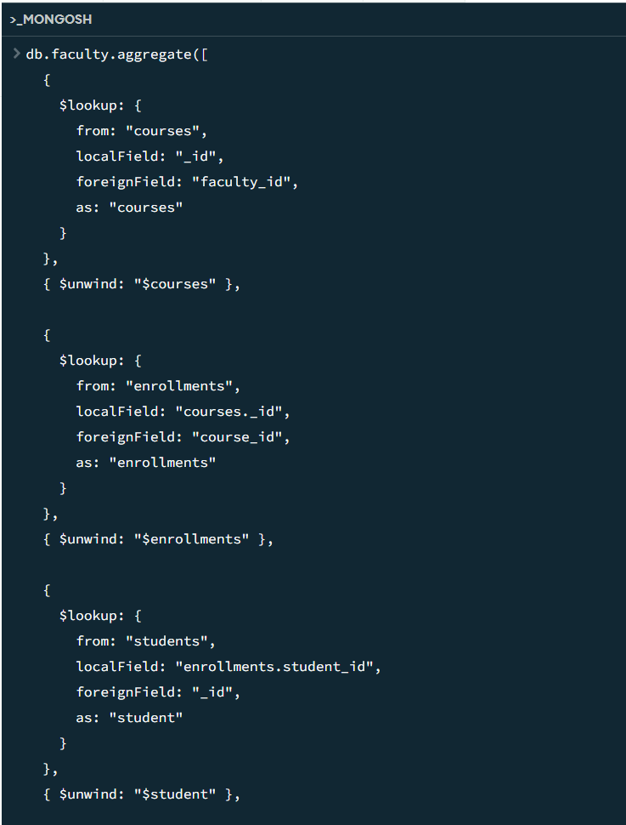
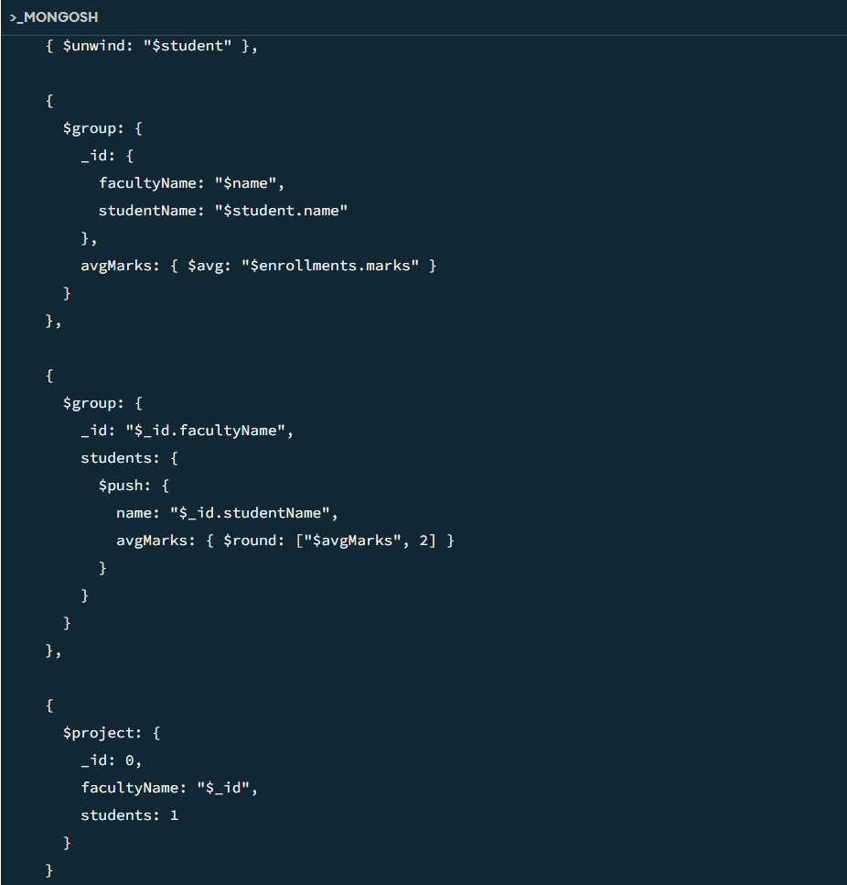
Output:
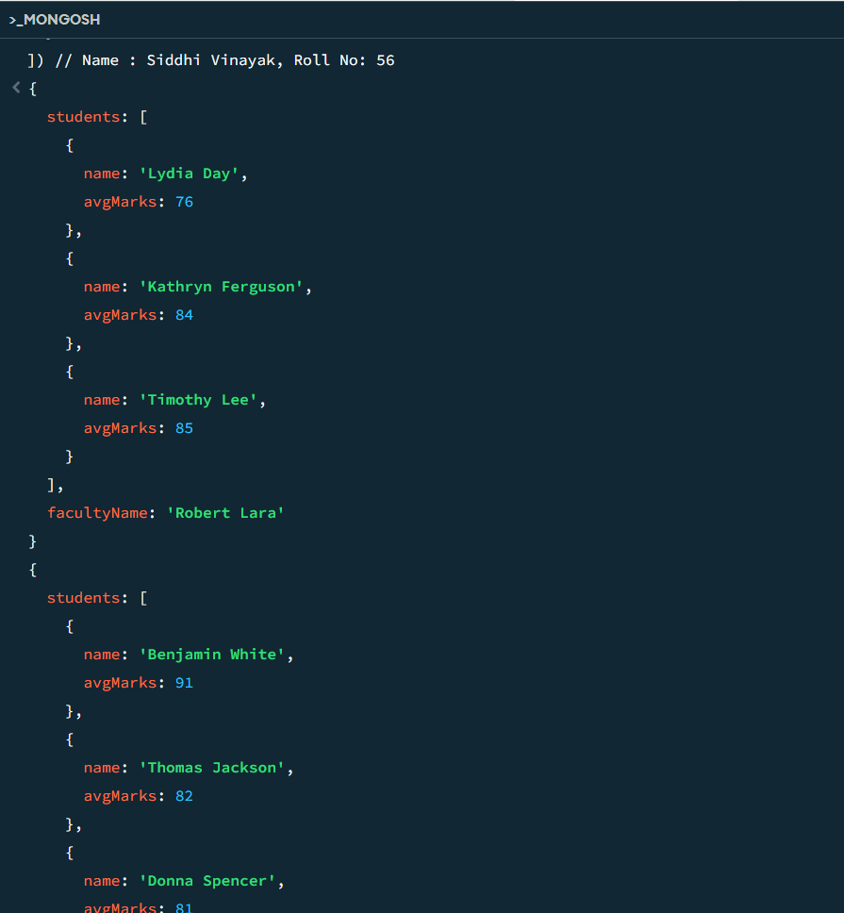
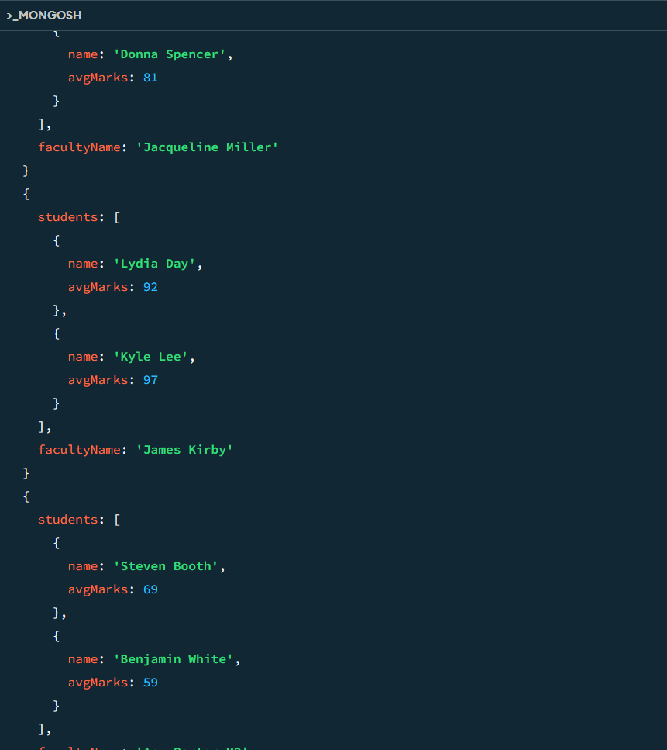
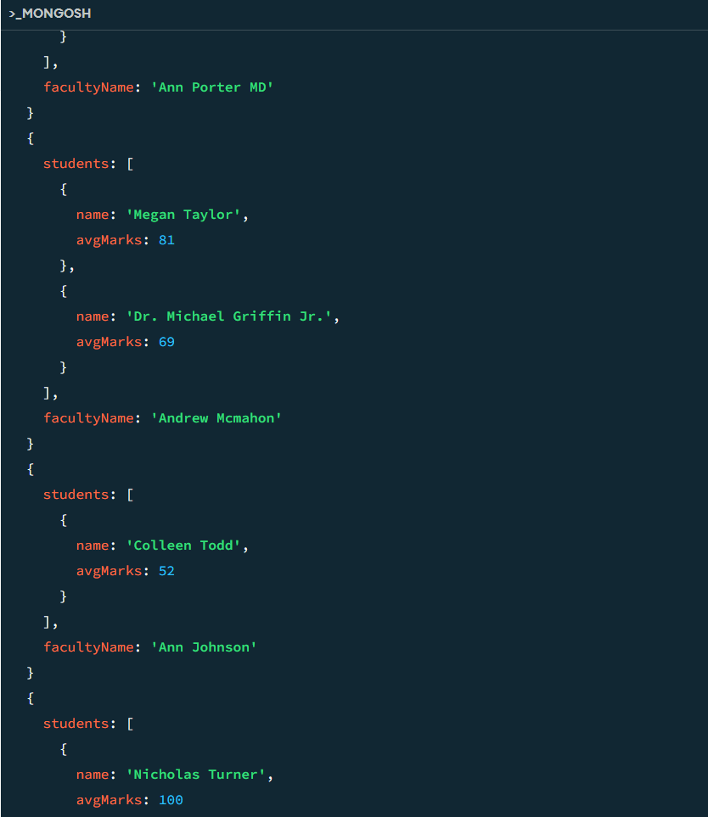
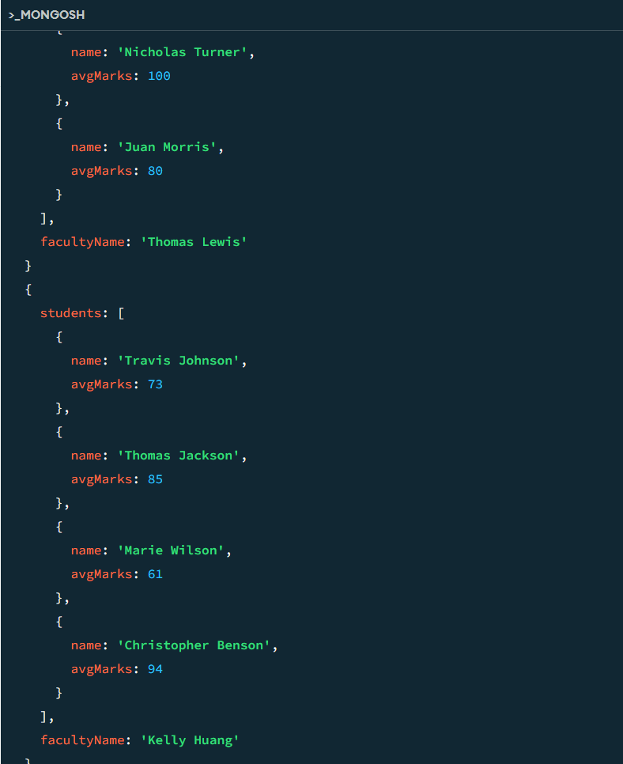
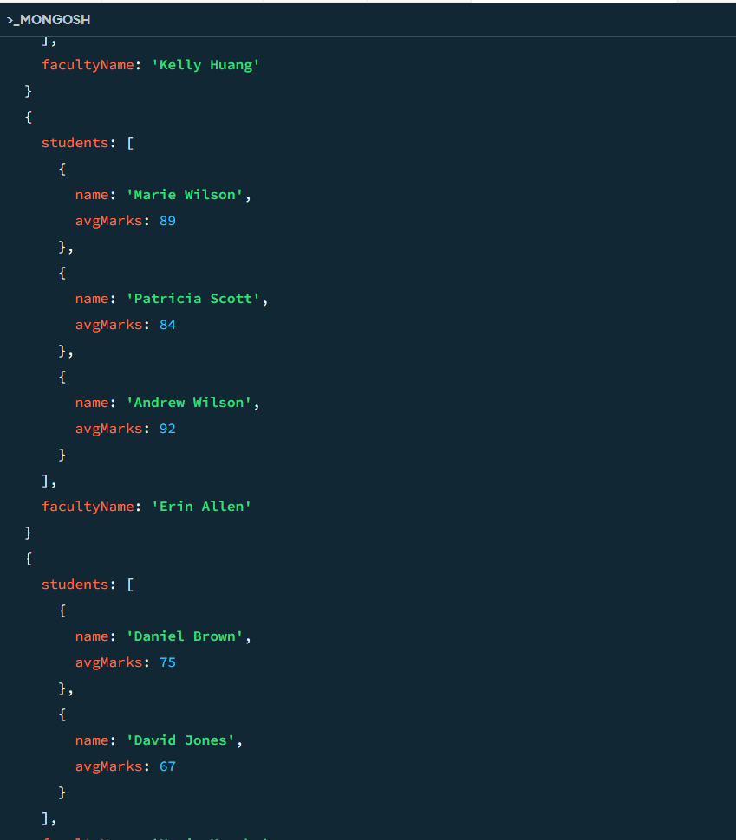
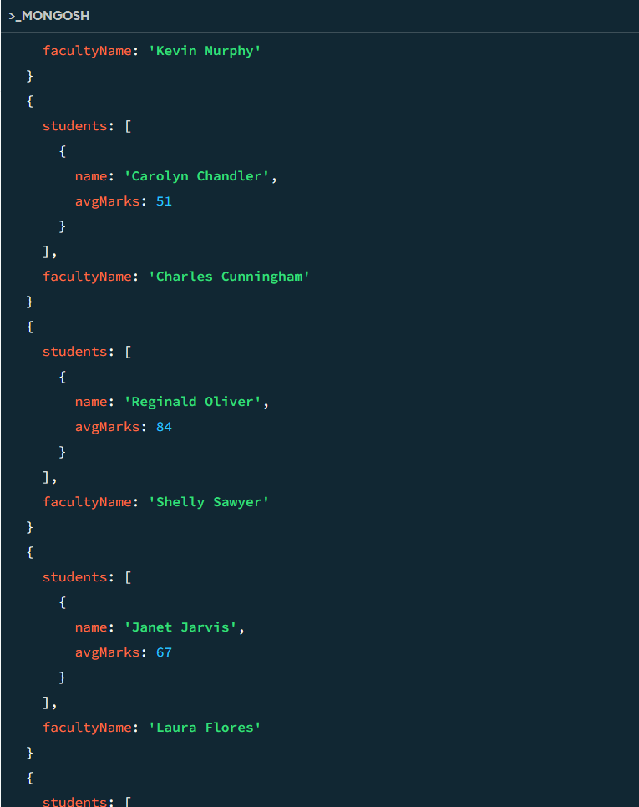
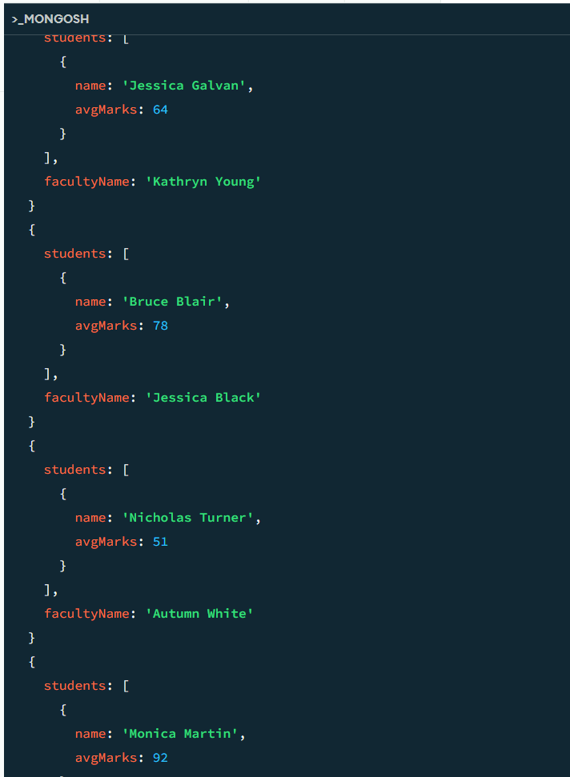
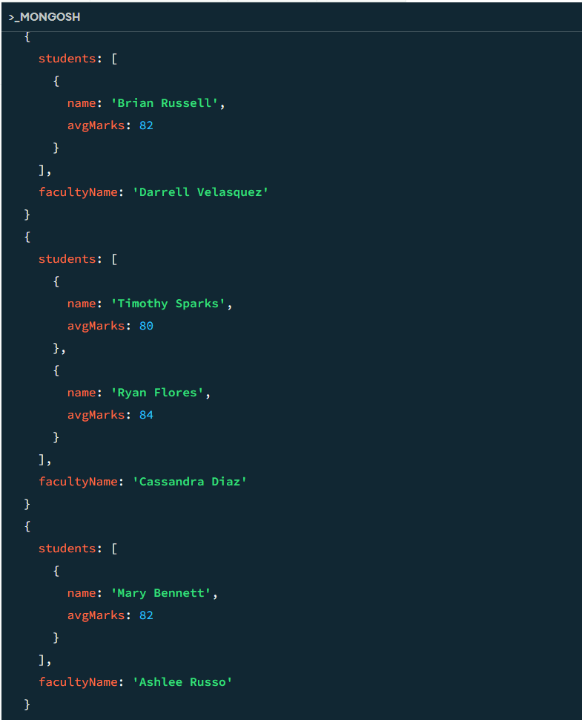
Q14. Show the most popular activity type (e.g., Hackathon, Seminar, etc.) by number of student
participants.
Input and Output:
