Core Concepts and Skills
Internship Phase 2 Report | Vinayak Vaishy

1. Overview
In this phase I studied the core concepts of the MERN stack and applied each one in a small project. The concepts covered were JavaScript fundamentals, React, REST APIs with Node.js, and MongoDB with Mongoose. Each project is in its own folder of the GitHub repository.
GitHub repository: <paste your repo link here>

2. Core concepts studied
Area | Key concepts | Why it matters
JavaScript | Scope, closures, promises, async/await, array methods (map, filter, reduce), destructuring, modules | Every other layer of the stack is written in it; array methods and async code appear in almost every feature.
React | Components, props vs state, hooks (useState, useEffect), lists and keys, conditional rendering | State-driven UI keeps the screen consistent with the data without manual DOM updates.
Node and Express | Request/response cycle, routing, middleware, REST, HTTP methods and status codes | The server exposes data to the front end in a predictable, standard way.
MongoDB and Mongoose | Documents, collections, schemas, validation, CRUD | Schemas add structure and validation on top of flexible documents.

3. Mini projects
Project 1: JavaScript To-Do (DOM, events, array methods)
Tasks can be added, marked done, deleted and filtered (All, Active, Done). The filter uses Array.filter, and user text is escaped before being inserted into the page.
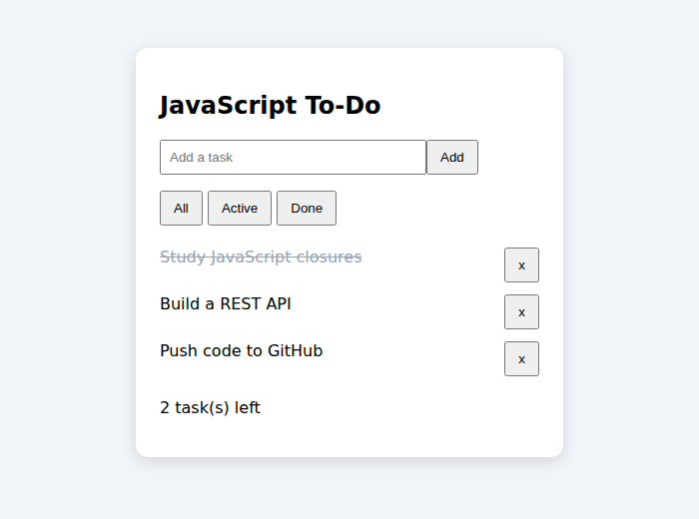
Figure 1: JavaScript To-Do with one completed task
Project 2: React Mini App (components, state, hooks)
A Counter component uses useState and updates the page title with useEffect. A Todos component keeps a list in state, adds items by creating a new array instead of mutating the old one, and renders them with unique keys.
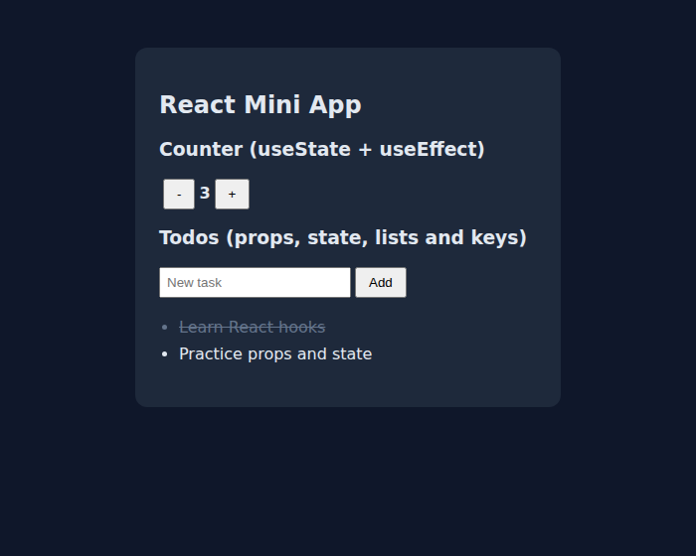
Figure 2: React app after three counter clicks and two tasks, one completed
Project 3: REST API (HTTP methods, status codes, JSON)
The API supports GET, POST, PUT and DELETE on /todos. It returns 201 for created items, 400 for invalid input (missing title) and 404 for unknown ids. I tested each route with curl. An Express version of the same API is included in server-express.js.
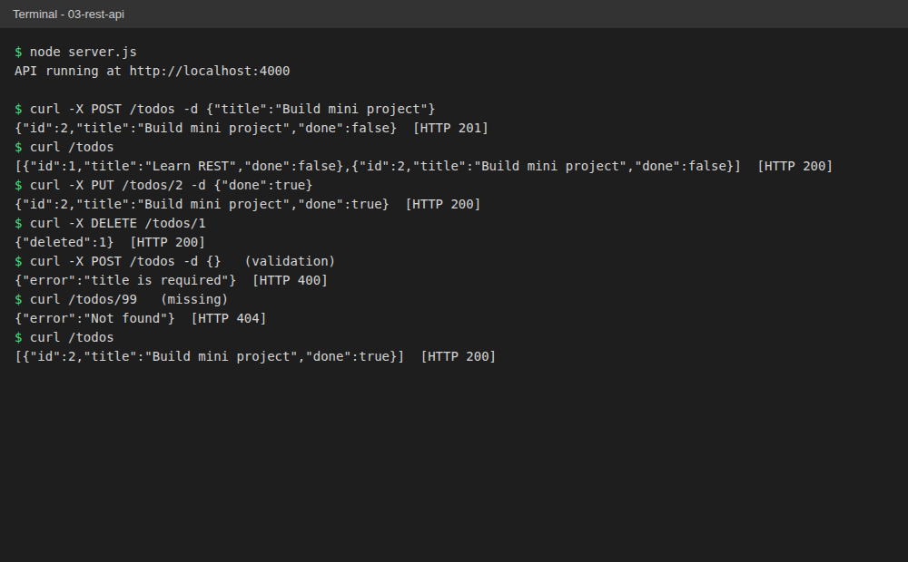
Figure 3: curl requests against the running API, including error cases
Project 4: MongoDB API with Mongoose (schema and CRUD)
The same API is connected to MongoDB through a Mongoose schema (title required, done defaults to false, timestamps enabled). The connection string is kept in a .env file that is excluded from Git; .env.example shows the format.

4. Best practices applied
- Meaningful names and small functions; consistent formatting with Prettier and ESLint.
- Secrets such as the database URI go in .env, which is listed in .gitignore.
- Input is validated on the server and errors return the correct HTTP status code.
- User text is escaped before being added to the page, to avoid script injection.
- State in React is updated immutably, using new arrays and objects.
- Each project has its own folder, a README, and small, clear commits.

5. Common pitfalls and how to avoid them
Pitfall | Problem | How to avoid it
Mutating state in React | The UI may not re-render | Use setItems([...items, newItem]) or map/filter to create new values
Missing useEffect dependencies | Stale values or endless loops | List every value the effect uses in the dependency array
Forgetting await | Code gets a Promise instead of the data | Use async/await and wrap calls in try/catch
Committing secrets or node_modules | Leaked credentials, huge repo | Add .env and node_modules to .gitignore before the first commit
Trusting user input | Bad data or injection | Validate on the server; escape text before rendering as HTML

6. Quizzes and self-assessment
<Add the quizzes you took: name, date, score, and the topics you got wrong.>
Areas I plan to strengthen: <fill in based on your quiz results>

7. Mentor feedback
<Add the date of your session, the questions you asked, the feedback you received, and the action points you will follow.>

8. Conclusion
This phase gave me hands-on practice with the four layers of the MERN stack and showed me how the layers connect: the same to-do idea moved from plain DOM code to React state, then to a REST API, then to a database. Next I plan to connect the React front end to the API to complete a full-stack application.

