VINAYAK R VIBHUTI
24BAI1519
SOFTWARE REQUIREMENTS SPECIFICATION
StanceAI — Biomechanical Cricket Analyzer

Table of Contents
1. Introduction
1.1 Purpose of the Document
1.2 Scope of the System
1.3 Definitions, Acronyms, and Abbreviations
1.4 References
1.5 Overview of the Document
2. Requirement Engineering Process
2.1 Feasibility Study
2.2 Requirement Elicitation and Analysis
2.3 Requirement Validation & Verification
2.4 Requirement Management Plan
3. Overall Description
3.1 Product Perspective
3.2 Product Functions
3.3 User Classes and Characteristics
3.4 Operating Environment
3.5 Design and Implementation Constraints
3.6 Assumptions and Dependencies
4. Requirements Specification
4.1 Functional Requirements
4.2 Non-Functional Requirements (NFRs)
4.3 Domain Requirements
4.4 System Requirements
5. Work Breakdown Structure (WBS)
5.1 Level 1 – Major Phases
5.2 Level 2 – Tasks under Each Phase
5.3 WBS Diagram Representation
6. System Models (UML Diagrams)
6.1 Use Case Diagram
6.2 Class Diagram
6.3 ER Diagram
7. Risk Analysis
7.1 Risk Identification
7.2 Risk Assessment Matrix (Probability vs. Impact)
7.3 Risk Mitigation Strategies
8. Testing Strategy
8.1 Test Plan
8.2 Unit Testing
8.3 Integration Testing
8.4 System Testing
8.5 Acceptance Testing
9. Glossary
10. Appendices
A. References

1. Introduction

1.1 Purpose of the Document
This Software Requirements Specification (SRS) document details the complete functional, non-functional, domain, architectural, and modeling requirements for the StanceAI platform. It establishes a formal engineering and technical baseline among developers, sports biomechanists, performance analysts, and end-users (batters, coaches, and academies) to govern the design, implementation, verification, and deployment phases.

1.2 Scope of the System
StanceAI is an AI-powered, browser-native biomechanical motion analysis system tailored for cricket batting technique evaluation. The system captures live video feeds via standard webcams or pre-recorded media uploads (videos and images), extracts 33 full-body skeletal keypoints at 15–30+ FPS using Google MediaPipe PoseLandmarker (WebAssembly/WebGL/WebGPU), and executes vector-based trigonometric biomechanical algorithms entirely on the client browser. Computed angles across 8 primary joint kinematic chains are evaluated against peer-reviewed empirical cricket benchmarks across 11 standard batting shot types. The platform integrates with a PostgreSQL backend (Supabase) for benchmark retrieval, session tracking, and biomechanical anomaly persistence.

1.3 Definitions, Acronyms, and Abbreviations
Term / Acronym | Definition
SRS | Software Requirements Specification (IEEE 830-1998 compliant standard document).
FPS | Frames Per Second (rate at which motion capture frames are captured and rendered).
WASM | WebAssembly (portable binary-code format for near-native client browser execution).
WBS | Work Breakdown Structure (hierarchical decomposition of total project scope).
DFD | Data Flow Diagram (graphical representation of data movement across system processes).
UML | Unified Modeling Language (standardized visual modeling language for software architecture).
ERD | Entity-Relationship Diagram (data structure modeling entities, attributes, and relationships).
RLS | Row-Level Security (PostgreSQL security mechanism restricting row access based on role).
NFR | Non-Functional Requirement (system performance, security, usability, and operational attributes).
ECB | England and Wales Cricket Board (governing body producing Level 3/4 coaching biomechanics).
MCC | Marylebone Cricket Club (author of standard cricket rules and biomechanical manuals).
Kinematic Chain | An articulated linkage of body segments connected by joints (e.g., Shoulder-Elbow-Wrist).

1.4 References
1. IEEE Std 830-1998: IEEE Recommended Practice for Software Requirements Specifications.
2. McErlain-Naylor, S.A., & King, M.A. (2020). Biomechanical determinants of batting performance in elite cricket. Journal of Sports Sciences.
3. Marylebone Cricket Club (MCC). (2022). The MCC Cricket Coaching Book.
4. England and Wales Cricket Board (ECB). (2021). Level 3 Coaching Technical Manual: Batting Biomechanics.
5. Cricket Australia. (2023). Batting Biomechanics and Technique Guide.
6. Ferdinands, R.E.D. (2013). Kinematic Analysis of Front-Foot and Back-Foot Strokes in Cricket. Sports Biomechanics.
7. Google MediaPipe PoseLandmarker Tasks API Specification (2024).

1.5 Overview of the Document
This specification is organized as follows: Section 2 covers the requirement engineering methodologies and feasibility study. Section 3 presents overall product characteristics, user personas, operating environments, and design constraints. Section 4 defines functional, non-functional, domain, and system requirements. Section 5 provides the Work Breakdown Structure (WBS). Section 6 and 7 provide UML models and Data Flow Diagrams. Section 8 details the Risk Analysis. Section 9 covers the Testing Strategy, followed by the Glossary (Section 10) and Appendices (Section 11).

2. Requirement Engineering Process

2.1 Feasibility Study
• Technical Feasibility: The execution of Google MediaPipe PoseLandmarker via WebAssembly (WASM) and hardware acceleration (WebGL/WebGPU) allows client-side computer vision inference at 15–30+ FPS without needing dedicated GPU cloud clusters. Biomechanical 2D Euclidean vector math executes in O(1) time complexity per joint, guaranteeing low CPU overhead.
• Economic Feasibility: Zero server inference costs are incurred because processing is distributed to client devices. Supabase free-tier managed PostgreSQL covers relational data persistence, reducing hosting overhead to near-zero.
• Operational Feasibility: Delivered as a zero-installation, responsive web application (React 19 + Vite), operating smoothly across standard consumer laptops, tablets, and smartphones.

2.2 Requirement Elicitation and Analysis
Requirements were synthesized through a combination of cricket coaching manuals (ECB Level 3/4, MCC, Cricket Australia), sports biomechanics kinematics papers, and interviews with cricket performance coaches. Core user stories focus on two workflows: real-time instant feedback during live batting sessions and frame-by-frame analysis of recorded video drill uploads.

2.3 Requirement Validation & Verification
Validation and verification methods include:
• Requirements Traceability Matrix linking requirements to automated test suites and database schema DDL constraints.
• Domain Verification: Scientific validation of joint angle benchmark ranges against published kinematic studies.
• Automated Unit Testing: Jest/Vitest test suites confirming mathematical precision for 2D dot-product angle calculations.

2.4 Requirement Management Plan
Requirement modifications are tracked using GitHub Issue trackers and pull request reviews. Any update to benchmark tolerance ranges undergoes biomechanical peer review. Database migrations are managed via version-controlled SQL migration scripts (schema.sql, rls_patch.sql) ensuring backward compatibility.

3. Overall Description

3.1 Product Perspective
StanceAI functions as a standalone, decentralized sports analytics web application. Unlike expensive multi-camera motion capture labs (such as Vicon or Qualisys) that require markers and dedicated indoor facilities, StanceAI provides markerless, single-camera joint angle estimation accessible on everyday consumer devices.

3.2 Product Functions
1. Ingestion: Multi-modal feed ingestion via live webcam streams, local video files (.mp4, .mov, .webm), and still images (.jpg, .png).
2. Landmark Tracking: Extraction of 33 body keypoints with spatial coordinates (x, y, z, visibility).
3. Biomechanics Calculation: Real-time 2D vector calculation for 8 major joints (Front/Back Elbow, Front/Back Knee, Front/Back Hip, Left/Right Shoulder).
4. Benchmark Classification: Continuous classification against 11 shot profiles into Optimal, Warning, Critical, or N/A.
5. Canvas Visualization: Interactive color-coded skeleton overlay on video and photo canvases.
6. Instant Re-analysis: Re-evaluating buffered uploads against alternative shot types without media re-upload.
7. Session & Anomaly Logging: Cloud persistence of session metadata, technique scores, and anomalous frame snapshots to Supabase.

3.3 User Classes and Characteristics
• Batter / Athlete: Requires high-contrast visual cues (green/orange/red badges), live FPS display, and simple deviation metrics during drills.
• Coach / Analyst: Needs comprehensive joint angle breakdowns, historical session statistics, and anomaly logs for targeted technical intervention.
• Administrator / Data Maintainer: Manages shot benchmark datasets, tunes tolerance ranges, and monitors database security.

3.4 Operating Environment
• Client Browsers: Google Chrome 110+, Microsoft Edge 110+, Safari 16+, Mozilla Firefox 115+ with WebGL/WebAssembly enabled.
• Client Hardware: Dual-core x86_64 or ARM64 processor (Apple Silicon M-series, Intel Core i3+), 4 GB RAM, integrated or external 720p/1080p webcam.
• Cloud Infrastructure: Supabase Managed PostgreSQL 15+ with Row-Level Security (RLS) enabled.

3.5 Design and Implementation Constraints
• Client-side Inference Constraint: Uncompressed video feeds must never be streamed to external cloud servers to ensure user privacy.
• Browser Sandbox Constraint: Camera stream access strictly mandates secure HTTPS origin or localhost context.
• Coordinate Normalization: Landmark coordinates are normalized in [0.0, 1.0] and must scale dynamically to responsive canvas dimensions.

3.6 Assumptions and Dependencies
• The athlete is in clear view of the camera during stance and stroke execution.
• MediaPipe PoseLandmarker WebAssembly assets are available via CDN or bundled assets.
• An active network connection is required for cloud database synchronization; offline fallback to internal memory benchmarks is supported.

4. Requirements Specification

4.1 Functional Requirements
Req ID | Functional Requirement Description | Priority
FR-01 | The system shall capture live video streams from connected webcams at >= 15 FPS. | High
FR-02 | The system shall parse local video files (.mp4, .webm) and still photos (.jpg, .png). | High
FR-03 | The system shall execute 33-point skeletal landmark detection via MediaPipe PoseLandmarker WASM. | High
FR-04 | The system shall calculate 2D Euclidean angles for 8 standard cricket joint kinematic chains. | High
FR-05 | The system shall support 11 distinct batting shot types: Cover Drive, Pull Shot, Forward Defense, Sweep Shot, Cut Shot, Straight Drive, Hook Shot, On Drive, Lofted Drive, Flick Shot, Defensive Leave. | High
FR-06 | The system shall classify observed angles into OPTIMAL, WARNING, CRITICAL, or UNCLASSIFIED. | High
FR-07 | The system shall render dynamic color-coded skeletal overlays on an HTML5 canvas. | High
FR-08 | The system shall query active benchmark ranges dynamically from Supabase shot_benchmarks table. | Medium
FR-09 | The system shall fallback to hardcoded scientific inline benchmarks if the database is unreachable. | High
FR-10 | The system shall create analysis session records in analysis_sessions table with input source tags. | Medium
FR-11 | The system shall persist anomalous frames and keypoint snapshots in session_anomalies table. | Medium
FR-12 | The system shall support instant re-analysis of uploaded media upon changing shot type. | Medium
FR-13 | The system shall display live metrics: frame count, current FPS, flagged frames, and technique score. | High

4.2 Non-Functional Requirements (NFRs)
• NFR-P1 (Performance): Landmark detection and joint angle computation shall execute within <= 45 ms per frame.
• NFR-P2 (Throughput): Canvas rendering shall sustain >= 20 FPS during active camera/video streaming.
• NFR-S1 (Security & Privacy): Raw camera feeds and user video files shall be processed purely client-side.
• NFR-S2 (Access Control): Supabase PostgreSQL database shall enforce Row-Level Security (RLS) on all tables.
• NFR-R1 (Reliability): The application shall continue functioning offline using fallback memory benchmarks.
• NFR-U1 (Usability): User interface shall maintain clear visual contrast with responsive dark theme layouts.

4.3 Domain Requirements
• Mathematical Formulation: Given joint vertex B between landmarks A and C, vectors BA = A - B and BC = C - B form angle theta:
theta = arccos( (BA . BC) / (|BA| * |BC|) ) * (180 / pi)
• 8 Standard Tracked Joints:
1. Front Elbow: Left Shoulder -> Left Elbow -> Left Wrist
2. Back Elbow: Right Shoulder -> Right Elbow -> Right Wrist
3. Front Knee: Left Hip -> Left Knee -> Left Ankle
4. Back Knee: Right Hip -> Right Knee -> Right Ankle
5. Front Hip: Left Shoulder -> Left Hip -> Left Knee
6. Back Hip: Right Shoulder -> Right Hip -> Right Knee
7. Left Shoulder: Left Elbow -> Left Shoulder -> Left Hip
8. Right Shoulder: Right Elbow -> Right Shoulder -> Right Hip

4.4 System Requirements
• Software: Node.js 18+, React 19, Vite 8, @mediapipe/tasks-vision 0.10+, @supabase/supabase-js 2.x.
• Client Environment: WebGL 2.0 / WebGPU capable web browser with Camera permission granted.

5. Work Breakdown Structure (WBS)

5.1 Level 1 – Major Phases
1.0 Project Inception & Biomechanical Research
2.0 Database Architecture & Benchmark Seeding
3.0 Frontend Core & Computer Vision Pipeline
4.0 Biomechanics Engine & Angle Classifier
5.0 Integration, UI/UX Polish & Verification
6.0 Deployment & Documentation

5.2 Level 2 – Tasks under Each Phase
1.0 Project Inception & Biomechanical Research
1.1 Literature review on cricket batting biomechanics (MCC, ECB, Cricket Australia)
1.2 Architectural feasibility analysis & technology selection
1.3 SRS document compilation and requirement verification
2.0 Database Architecture & Benchmark Seeding
2.1 Relational schema definition (Supabase / PostgreSQL DDL)
2.2 Row-Level Security (RLS) policies and index optimization
2.3 Automated benchmark database seeding script (import_benchmarks.js)
3.0 Frontend Core & Computer Vision Pipeline
3.1 React 19 + Vite project initialization
3.2 MediaPipe PoseLandmarker WASM hook lifecycle implementation
3.3 Live webcam video stream and HTML5 canvas skeleton overlay
3.4 Local media upload parser (video and photo processing loop)
4.0 Biomechanics Engine & Angle Classifier
4.1 Euclidean vector math & dot product calculation module
4.2 Joint landmark mapping across 33 keypoints
4.3 Dynamic tolerance classification (Optimal, Warning, Critical)
4.4 Fallback offline memory benchmark dictionary
5.0 Integration, UI/UX Polish & Verification
5.1 Dashboard UI layout, metrics cards, and angle deviation bars
5.2 Supabase API CRUD client integration (sessions, benchmarks, anomalies)
5.3 Automated unit and system regression test execution
6.0 Deployment & Documentation
6.1 Production bundle build and asset optimization
6.2 UML and DFD architectural documentation
6.3 User guide and technical deployment manual

5.3 WBS Diagram Representation
The visual Work Breakdown Structure (WBS) diagram is presented below:
📷 FIGURE 5.1: Work Breakdown Structure (WBS) Diagram

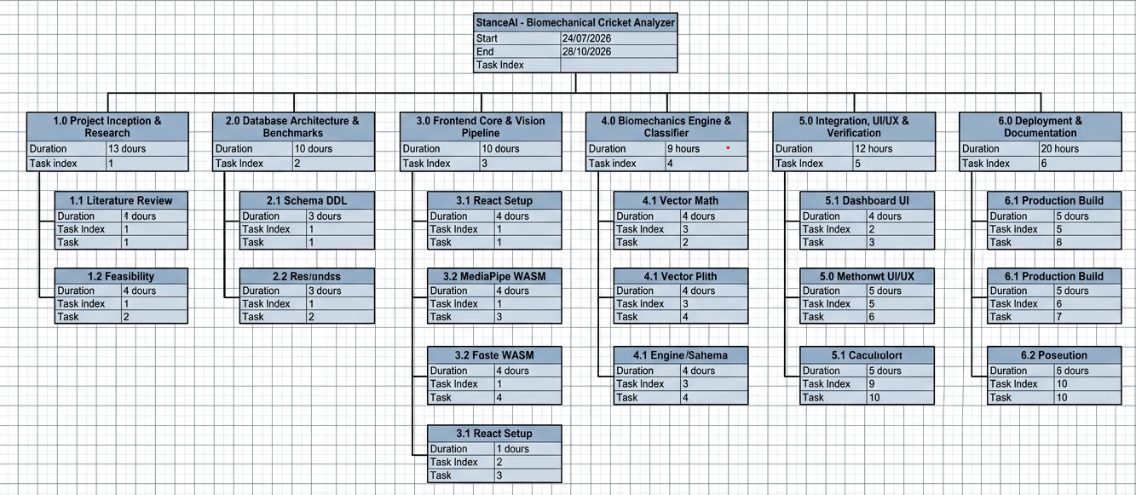

6. System Models (UML Diagrams)

6.1 Use Case Diagram
The Use Case diagram illustrates interactions between primary actors (Batter/User, Coach/Analyst, Admin/Data Maintainer, Camera Device, MediaPipe Runtime, Supabase Service) and core use cases including live analysis, uploads, benchmark retrieval, angle computation, and anomaly logging.
📷 FIGURE 6.1: StanceAI System Use Case Diagram
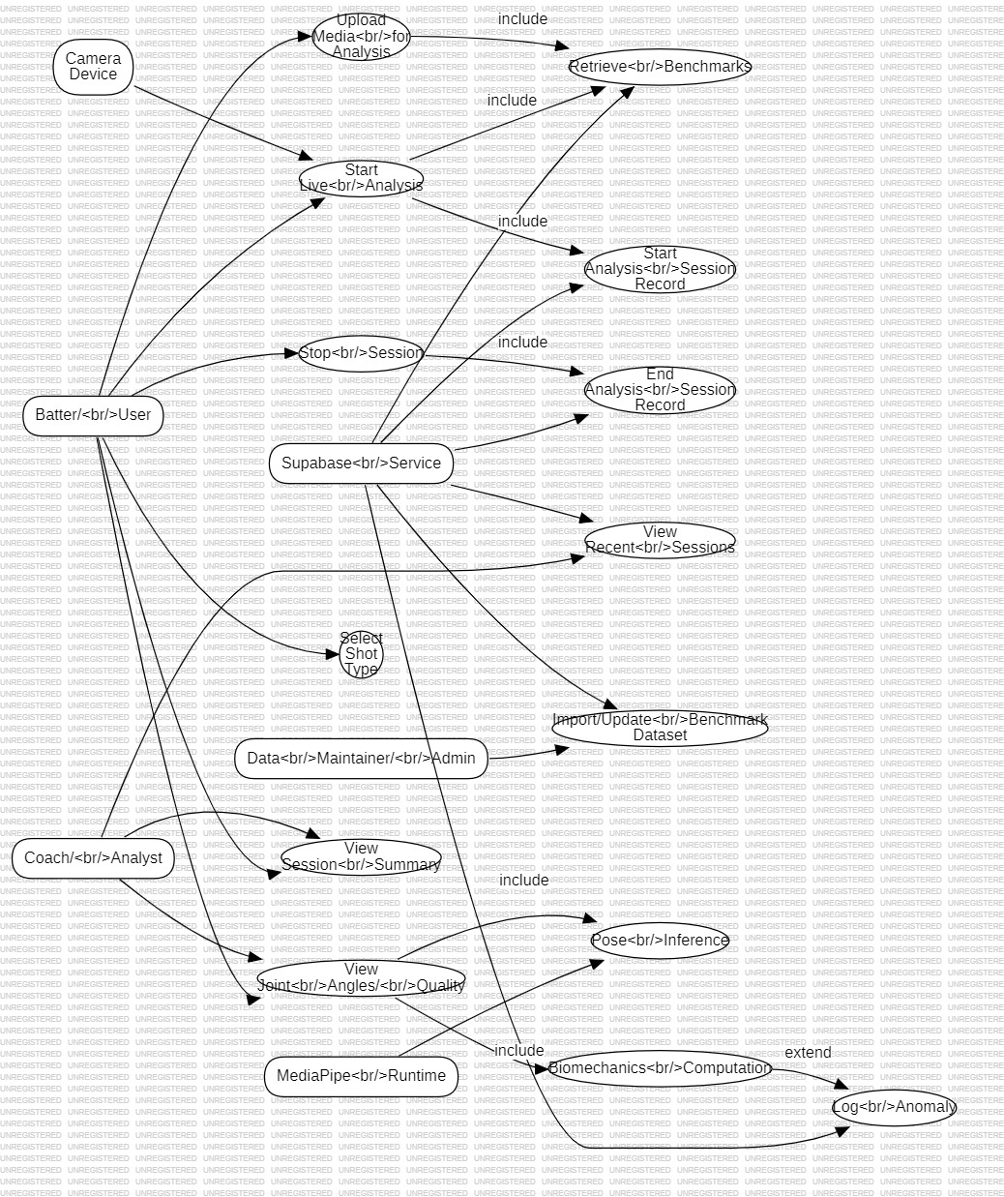

6.2 Class Diagram
The Class diagram models the static object-oriented structure of the StanceAI architecture, depicting relationships between Dashboard, usePoseDetection hook, SkeletonOverlay renderer, biomechanics math engine, biomechanicsApi client, and database entities.
📷 FIGURE 6.2: StanceAI Class Diagram

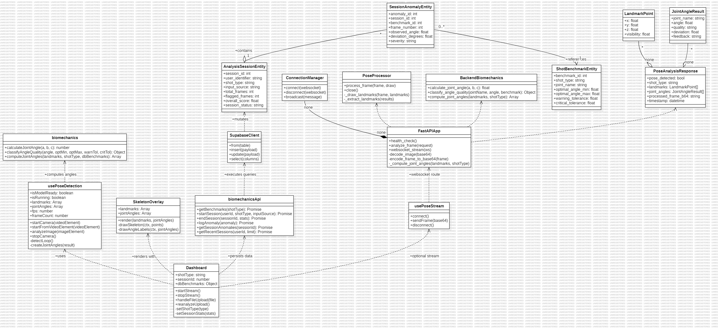

6.3 ER Diagram
The Entity-Relationship (ER) diagram models relational data persistence across shot_benchmarks, analysis_sessions, and session_anomalies tables, including primary keys, foreign key constraints, tolerances, and frame landmarks.

📷 FIGURE 6.3: StanceAI Entity-Relationship (ER) Diagram

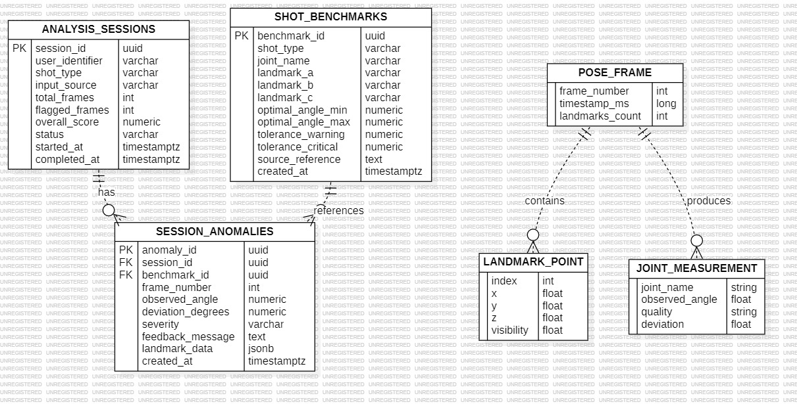

7. Risk Analysis

7.1 Risk Identification
1. R-01 (Hardware/GPU Acceleration Incompatibility): Client lacks WebGL/WebGPU acceleration causing frame drops.
2. R-02 (Lighting & Environmental Occlusion): Poor lighting or loose apparel reducing keypoint detection confidence.
3. R-03 (Database Disconnection): Network loss interrupting Supabase API calls.
4. R-04 (Transient False-Positive Anomalies): Non-contact preparatory movement phases triggering false angle warnings.

7.2 Risk Assessment Matrix (Probability vs. Impact)
Risk ID | Risk Description | Prob (1-5) | Impact (1-5) | Score (P*I) | Severity Level
R-01 | Client WebGL / WASM GPU fallback failure | 2 | 4 | 8 | Medium
R-02 | Poor lighting / apparel occlusion | 4 | 3 | 12 | High
R-03 | Supabase database network timeout | 3 | 2 | 6 | Low-Med
R-04 | Transient transition false anomalies | 4 | 2 | 8 | Medium
R-05 | Corrupt video codec parsing error | 2 | 3 | 6 | Low

7.3 Risk Mitigation Strategies
• Mitigation for R-01: Configure automatic CPU fallback delegate in MediaPipe and display low-FPS UI alerts.
• Mitigation for R-02: Implement landmark visibility score verification (visibility >= 0.5) before computing joint angles.
• Mitigation for R-03: Implement automatic failover to static INLINE_BENCHMARKS memory cache.
• Mitigation for R-04: Implement temporal moving average smoothing to eliminate single-frame transient spikes.

8. Testing Strategy

8.1 Test Plan
The testing lifecycle follows a structured multi-tier verification process spanning unit tests, integration tests, system-level end-to-end tests, and domain acceptance testing with cricket coaching professionals.

8.2 Unit Testing
• Trigonometric Angle Accuracy: Test calculateJointAngle([0,1], [0,0], [1,0]) == 90.00 deg (+/- 0.01 deg).
• Collinear Vertex Angle: Test calculateJointAngle([0,1], [0,0], [0,-1]) == 180.00 deg.
• Quality Classifier Boundaries: Test classifyAngleQuality() under exact benchmark boundaries (optMin, optMax, warnTol, critTol).

8.3 Integration Testing
• MediaPipe to Biomechanics Pipeline: Feed synthetic 33-landmark arrays to computeJointAngles() and verify output format.
• Supabase API Client: Verify startSession(), logAnomaly(), and endSession() properly execute PostgreSQL CRUD operations.

8.4 System Testing
• Live Camera Stream Execution: Execute 300+ frames of live webcam tracking, stop session, and verify accurate session persistence.
• Media Upload & Re-Analysis: Upload video footage, toggle across shot types, and verify instantaneous UI re-render.

8.5 Acceptance Testing
Evaluated alongside ECB/Cricket Australia certified cricket coaches using test footage across all 11 batting shot types to confirm that flagged kinematic anomalies correlate with technical coaching faults.

9. Glossary
• PoseLandmarker: Google MediaPipe deep learning model producing 33 3D body keypoints from media feeds.
• Vertex (B): The anatomical joint center (e.g., elbow or knee) where two limb vectors intersect.
• Row-Level Security (RLS): PostgreSQL security feature ensuring fine-grained access control on table rows.
• Supabase: Managed Backend-as-a-Service providing PostgreSQL databases, Auth, and real-time RESTful APIs.
• Vite: Modern frontend tooling providing lightning-fast Hot Module Replacement (HMR) and optimized build bundles.

10. Appendices

A. References
1. Marylebone Cricket Club (MCC) Coaching Manual, Lord's Ground, London.
2. England and Wales Cricket Board (ECB) Level 3 & 4 Biomechanical Models.
3. Google MediaPipe Tasks Vision JavaScript API Reference.
4. Supabase JavaScript Client Reference Documentation.

