**TRAFFIC MANAGEMENT [PHASE 3]**

Creating a smart traffic management technology project involves multiple steps, from deploying IoT devices to developing Python scripts for these devices. Here's a general outline of how you can approach this project:

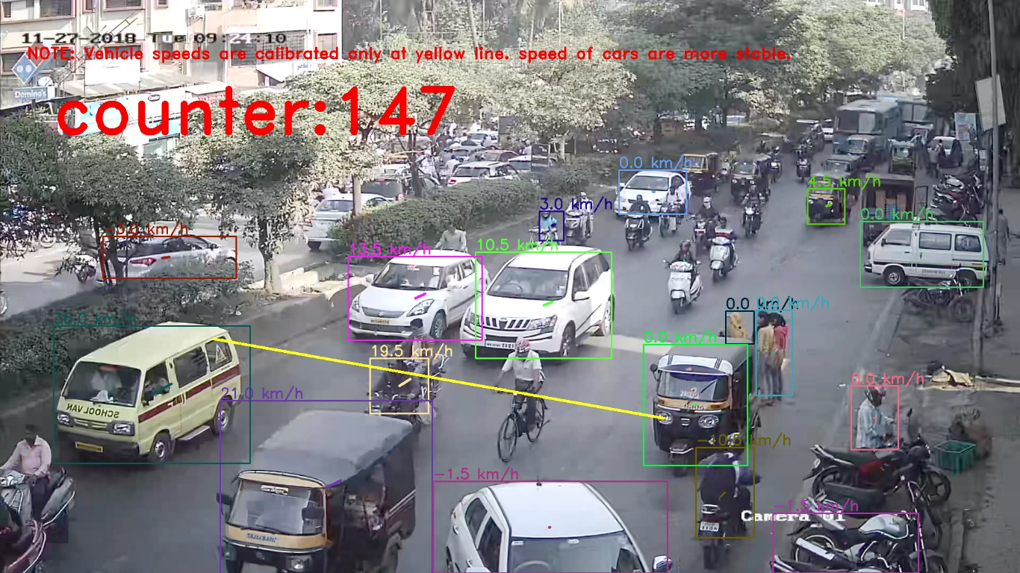

**1. Project Goals and Objectives:**

* Define the specific goals and objectives of your smart traffic management project.
* Identify the problem you aim to address, such as traffic congestion, accidents, or pollution.

**2. Hardware Requirements:**

* List the IoT devices and sensors needed for your project. These may include cameras, traffic light controllers, GPS modules, and environmental sensors.

**3. IoT Device Deployment:**

* Deploy the IoT devices at strategic locations within your target area.
* Ensure proper power supply and network connectivity for these devices.
* Document the installation process and the location of each device.

**4. Data Collection:**

* Configure the IoT devices to collect relevant traffic data, such as vehicle count, speed, and environmental conditions.
* Set up data transmission to a central server or cloud platform for further analysis.

**5. Python Script Development:**

* Develop Python scripts to run on the IoT devices. These scripts will control device operation and data collection.
* Consider using libraries and frameworks suitable for IoT, such as MQTT or CoAP for data communication.
* Implement error handling and data validation in your scripts.

**6. Data Analysis and Processing:**

* Set up a central server or cloud environment for receiving and processing the collected data.
* Write Python scripts or use data analytics tools to process and analyze the data. For example, you could identify traffic patterns, congestion areas, or anomalies.

**7. Traffic Control and Management:**

* Develop Python scripts for traffic control systems, such as adaptive traffic signal management.
* Integrate AI or machine learning algorithms for real-time traffic prediction and control.

**8. User Interface Development:**

* Create a user interface (web or mobile app) for authorities and users to access real-time traffic information.
* Use Python-based frameworks like Django or Flask for web development if needed.

**9. Documentation:**

* Create a comprehensive document that includes:
  + Project overview and objectives
  + Hardware specifications and deployment details
  + Python script source code and explanation
  + Data collection and analysis procedures
  + Traffic control and management algorithms
  + User interface design and functionality
  + Security and privacy considerations
  + Troubleshooting and maintenance guidelines

**10. Testing and Evaluation:**

* Conduct rigorous testing to ensure the system works as intended.
* Evaluate the system's performance against the project objectives.

**11. Deployment and Assessment:**

* Deploy the smart traffic management system in the target area.
* Assess its effectiveness in addressing the identified traffic-related issues.

**12. Continuous Improvement:**

* Consider feedback and real-world data to make necessary improvements to the system

**Creating a vehicle counting program for traffic management using Python and IoT involves multiple components, including hardware, software, and data analysis. Here's a high-level overview of the steps to create such a system:**

**Hardware Components:**

1. **Camera(s):** You'll need one or more cameras to capture video footage of the road or area you want to monitor. These cameras can be regular IP cameras or specialized traffic monitoring cameras.
2. **IoT Device(s):** Use IoT devices like Raspberry Pi or Arduino to connect the cameras and collect data. These devices can be used to process images and send the data to a central server.

**Software Components:**

1. **Image Capture:** Set up your camera(s) to capture images or video of the road.
2. **Image Processing:** Use computer vision libraries such as OpenCV to process the images and detect vehicles. You can apply object detection techniques like YOLO (You Only Look Once), Haar cascades, or deep learning models to identify and count vehicles.
3. **Data Transmission:** Transmit the vehicle count data to a central server or cloud platform. You can use MQTT, HTTP, or other communication protocols to send data from your IoT devices to a central server.
4. **Central Server:** Create a central server that receives and stores data from IoT devices. You can use a cloud platform like AWS, Azure, or Google Cloud, or set up your own server.
5. **Data Storage:** Store the vehicle count data in a database. You can use databases like MySQL, PostgreSQL, or NoSQL databases like MongoDB.
6. **Data Analysis:** Analyze the vehicle count data to generate traffic insights. You can create reports, charts, and dashboards to visualize the data using tools like Python libraries (Matplotlib, Seaborn), or data visualization platforms like Tableau or Power BI.
7. **Alerts and Notifications:** Implement a system to trigger alerts or notifications when specific traffic conditions are met, such as traffic congestion or accidents.
8. **Data Access:** Provide a way to access the traffic data, such as through a web dashboard or API.

**PYTHON CODE:**

import cv2

# Load pre-trained vehicle detection model

vehicle_cascade = cv2.CascadeClassifier('haarcascade_car.xml')

# Open a video capture

cap = cv2.VideoCapture('traffic_video.mp4')

vehicle_count = 0

while True:

ret, frame = cap.read()

if not ret:

break

# Convert frame to grayscale for detection

gray = cv2.cvtColor(frame, cv2.COLOR_BGR2GRAY)

# Detect vehicles in the frame

vehicles = vehicle_cascade.detectMultiScale(gray, scaleFactor=1.1, minNeighbors=5)

# Draw rectangles around detected vehicles

for (x, y, w, h) in vehicles:

cv2.rectangle(frame, (x, y), (x + w, y + h), (0, 255, 0), 2)

vehicle_count += 1

# Display the frame with vehicle count

cv2.imshow('Vehicle Counting', frame)

if cv2.waitKey(1) & 0xFF == 27:

break

cap.release()

cv2.destroyAllWindows()

print("Total vehicles detected:", vehicle_count)