**TRAFFIC MANAGEMENT [PHASE 4]**

Creating a traffic management system with web-based components will involve web development technologies for creating a user interface to interact with the system and display traffic data. Below is a high-level overview of the components and technologies might use for this project.

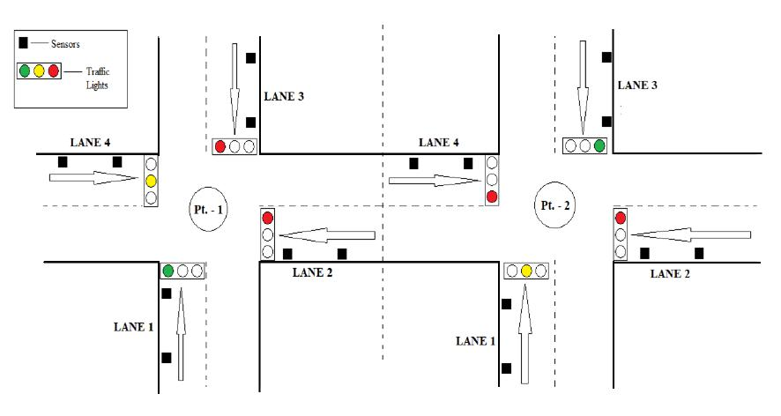

**Web Development Technologies and Components:**

1. **Web Server**: You'll need a web server to host your web application. Popular choices include Apache, Nginx, or you can use a framework like Django or Flask to handle the server setup.
2. **Front-End (User Interface)**:
   * **HTML, CSS, JavaScript**: These are the fundamental technologies for building the user interface.
   * **Front-End Framework**: Consider using a front-end framework like React, Angular, or Vue.js for a more dynamic and responsive user interface.
   * **Data Visualization**: You can use libraries like D3.js or Chart.js to create interactive data visualizations.
3. **Back-End (Server-Side Logic)**:
   * **Python**: If you are comfortable with Python for back-end development, you can use frameworks like Django or Flask.
   * **Database**: Choose a database system to store traffic data. You might use MySQL, PostgreSQL, or NoSQL databases like MongoDB depending on your data structure and requirements.
4. **RESTful API**: Create an API to communicate with your central server and provide data to the front-end. You can use RESTful principles and frameworks like Django REST framework or Flask-RESTful to build your API.
5. **Real-Time Data Streaming**: For real-time traffic updates, you might consider technologies like WebSockets or Server-Sent Events (SSE).
6. **Authentication and Authorization**: Implement user authentication and authorization to ensure that only authorized users can access certain features or data.
7. **User Interface for Traffic Data**:
   * Develop user-friendly dashboards and pages for viewing traffic data.
   * Implement features like live camera feeds, vehicle count reports, traffic conditions, and alerts.
8. **Map Integration**: If needed, integrate mapping services like Google Maps or OpenStreetMap to display real-time traffic data on maps.
9. **Alerts and Notifications**: Implement email or SMS notifications for critical traffic incidents or updates.
10. **Data Analysis and Reporting**: Create a feature to generate reports and visualizations from traffic data.
11. **Security**: Ensure the security of your web application and data, including using HTTPS, input validation, and protecting against common web application security vulnerabilities.
12. **Documentation**: Create comprehensive documentation that includes how to set up the system, use the web application, and API documentation.
13. **Testing**: Rigorously test the application to ensure it works as expected. You can use testing frameworks like Selenium for end-to-end testing.
14. **Deployment**: Deploy your application to a production server. You can use cloud services like AWS, Azure, or Heroku for deployment.
15. **Maintenance and Updates**: Regularly maintain and update your system as needed. Ensure that security patches are applied.
16. **User Training**: If applicable, provide user training or documentation for the users of the system.
17. **Scalability**: Consider the potential for system scalability as your traffic management system grows.

**To create a web interface for traffic management with IoT**

**1.Project Setup:**

* First, ensure that you have Node.js and npm installed on your machine. You can download them from <https://nodejs.org/en/download/>.
* Next, create a new folder for your project. Navigate to this folder using the terminal.
* Initialize a new Node.js project by running the command: npm init -y.
* Install the required packages for the project: npm install express body-parser multer socket.io-client.

**2.Backend Setup:**

* Create a new folder called 'server'. Inside this folder, create a new file called 'server.js'.
* Set up a basic Express server in 'server.js'.

**JavaScript**

const express = require('express');

const bodyParser = require('body-parser');

const multer = require('multer');

const socketIOClient = require('socket.io-client');

const app = express();

app.use(bodyParser.json());

app.use(multer().any());

const port = process.env.PORT || 3000;

const server = app.listen(port, () => console.log(`Server is running on port ${port}`));

const socket = socketIOClient('http://localhost:5000');

socket.on('connect', () => console.log('Connected to server'));

// Websocket communication here

* Create a websocket connection to your IoT device/server. This connection should handle the traffic data sent from your IoT devices.

### 3. Frontend setup:

* Create a new folder called 'client'. Inside this folder, create an 'index.html' file.
* Set up a basic HTML page with a Socket.IO script and a basic CSS style:

**HTML**

<!DOCTYPE html>

<html lang="en">

<head>

<meta charset="UTF-8">

<meta name="viewport" content="width=device-width, initial-scale=1.0">

<title>Traffic Management Dashboard</title>

<style>

body {

font-family: Arial, sans-serif;

margin: 0;

padding: 0;

display: flex;

justify-content: center;

align-items: center;

height: 100vh;

background-color: #f0f0f0;

}

#dashboard {

width: 100%;

max-width: 800px;

background-color: #ffffff;

padding: 20px;

border-radius: 5px;

box-shadow: 0 2px 4px rgba(0, 0, 0, 0.1);

}

</style>

</head>

<body>

<div id="dashboard">

<!-- Traffic data display here -->

</div>

<script src="/socket.io/socket.io.js"></script>

<script>

const socket = io();

// Handle incoming traffic data from the server here

</script>

</body>

</html>

* Implement the logic for handling the traffic data sent from your IoT devices. Display this data in the browser using JavaScript and HTML.
* Note: Make sure to replace '[http://localhost:5000](http://localhost:5000/)' with the actual URL of your IoT device/server. Also, remember to secure your IoT devices and servers to prevent unauthorized access and data tampering.