**Starbucks SEM Practical**

**Statement**:

Considering the belief for Starbucks, there is a relationship between Experiential Marketing (EM), Brand Image (BI) and Brand Loyalty (BL), that is all go hand in hand. But the question is how we can prove this relationship statistically? Hence we measure factors mathematically. Hence we do it with the help of SEM.

**Theory:**

**SEM** (Structural Equation Modelling) is a multivariate statistical analysis technique that is used to analyze structural relationships between Latent Constructs and measured variables.

**Construct**: Unobservable factors which are represented with the help of multiple factors.

**Exogenous Construct**: Latent variable that are equivalent to independent variable.

**Endogenous Construct**: Latent variable that are equivalent to dependent variable.

**Measured (Observable) Variable**: Variables which are used to quantify these latent constructs.

In our Case SEM has the following variables:

• **Brand Image**: Endogenous Construct

• **Experiential Marketing**: Exogenous Construct

• **Brand Loyalty**: Endogenous Construct

• **Measured Variables**: Questions Asked to the customers based on a likert scale.

**Examples**: How to rate the cleanliness of Starbucks that I have been to? Do you consider visiting a Starbucks store as a symbol of social status?

• Dataset has **350** **responses**.

**Measured Variables for Brand Image are:**

|  |  |  |
| --- | --- | --- |
| **Questions Asked** | **Variable Name** | **Options (Scale)** |
| How much do you rate the quality of Starbucks compared to other brands? | Quality | (Very Poor, Poor, Okay, Good, Very Good) (1/2/3/4/5) |
| Do you have Starbucks Membership Card? | Membership | (Yes/No) - (1,0) |
| Do you consider visiting a Starbucks store as a symbol of social status? | Social Symbol | (Never, Rarely, Sometimes, Most of the time, Always) (1,2,3,4,5) |

**Measured Variables for Experiential Marketing are:**

|  |  |  |
| --- | --- | --- |
| **Questions Asked** | **Variable Name** | **Options (Scale)** |
| How do you usually enjoy Starbucks? | Consumption | (Dine-in/Drive through/Take away/Never) (1/2/3/4) |
| How do you rate the ambience at Starbucks? (lighting,music, etc.) | Ambience | (Very Poor, Poor, Moderate ,Good, Very Good) (1/2//3/4/5) |
| How do you rate the WiFi quality provided at Starbucks? | Wifi Quality | (Very Poor, Poor, Moderate ,Good, Very Good) (1/2//3/4/5) |

**Measured Variable for Brand Loyalty is:**

|  |  |  |
| --- | --- | --- |
| **Question Asked** | **Variable Name** | **Options (Scale)** |
| Will you continue buying at Starbucks? | Loyalty | (Yes/No) - (1,0) |

**OUTPUT:**

Output of the association of latent variables and their respective measured variables:

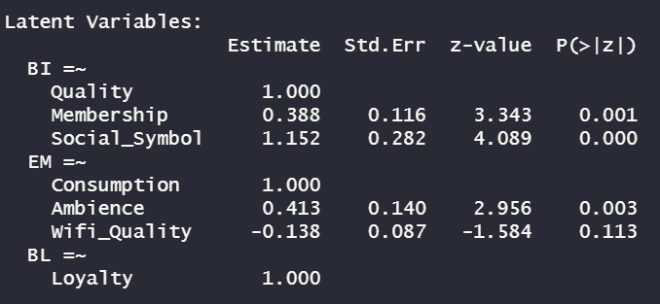

Here we can observe that some of the variables are in Positive association with their constructs and some are in Negative association with their constructs. The output may differ as in this model the first variable for every construct is considered as reference and then the association is computed for the other variables. Also, we have generated the data by ourselves. For Brand Image, the Social symbol is the main driving factor and for Experiential Marketing, Consumption type is the most driving factor.

**Output of the association within the Latent variables:**

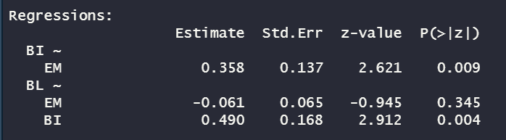

Here we can observe that Brand Image (BI) and Experiential Marketing (EM) are associated with each other and Experiential Marketing (EM) is not directly related to Brand Loyalty (BL) but Brand Image (BI) is positively associated with Brand Loyalty (BL) so we can say that Experiential Marketing (EM) is indirectly related to Brand Loyalty (BL).

Hence, we can say that the cliet belief is correct for this set of data where Experiential Marketing (EM) is indirecly related to Brand Loyalty (BL) through Brand Image (BI).

**Output of the error estimated for all the variables:**

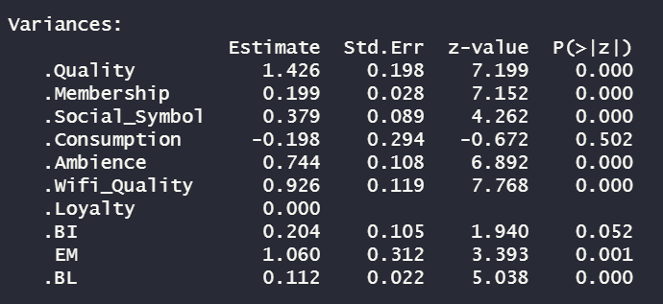

All the errors are positive except for the Consumption Variable.

**PLOT:**

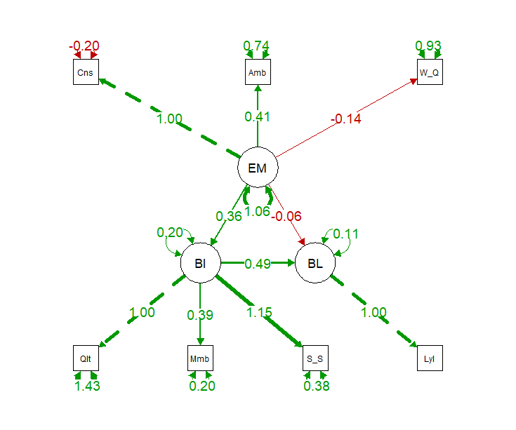

This is the visual representation of the SEM model where it is clearly visible that Experiential Marketing (EM) and Brand Image (BI) are positively associated with each other. Also, Brand Image (BI) and Brand Loyalty (BL) are positively associated with each other.

So, we can say that the cliet belief is correct for this set of data where Experiential Marketing (EM) is indirecly related to Brand Loyalty (BL) through Brand Image (BI).