Capstone Project: Report Figures

Figure 3.1: System Architecture Diagram
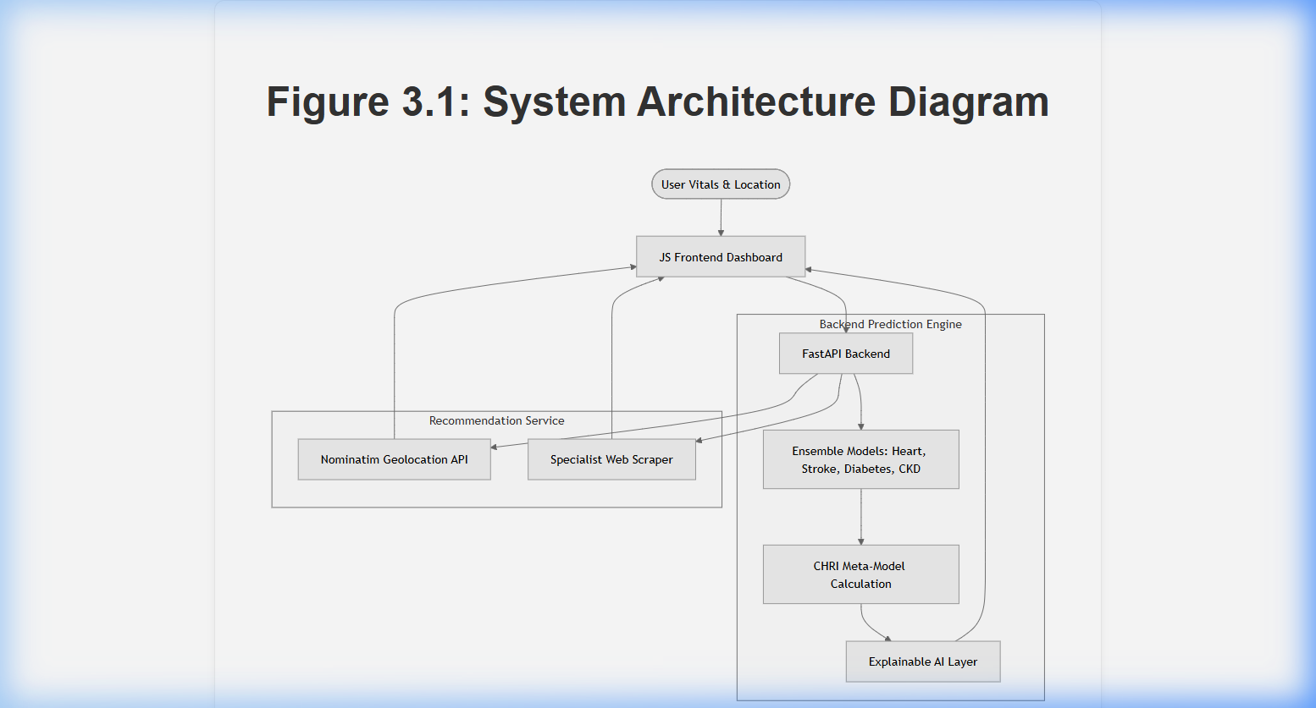
A technical schematic showing the decoupled FastAPI architecture. The 'Explainable AI Layer' is highlighted as the core component that translates model math into user-friendly insights.

Figure 3.2: Data Flow Diagram (DFD)
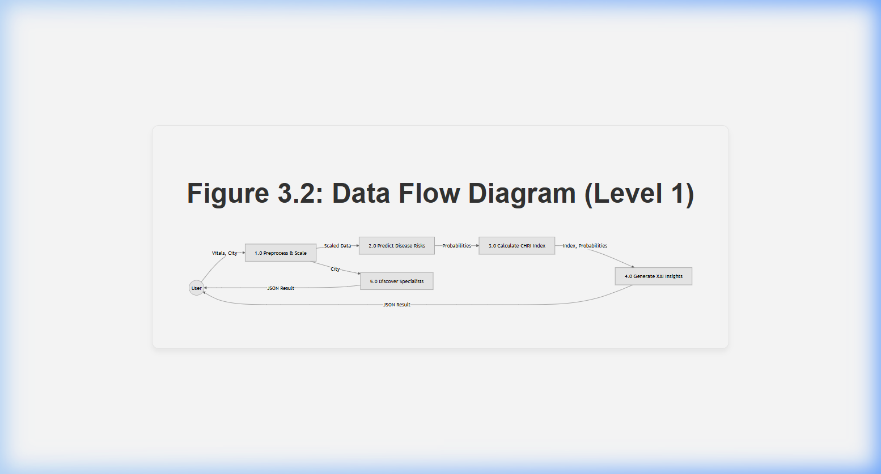
Illustrating the logical flow of data. Notice process 4.0 (Generate XAI Insights) which processes probabilities before delivery to the user.

Figure 3.3: Machine Learning Pipeline with XAI
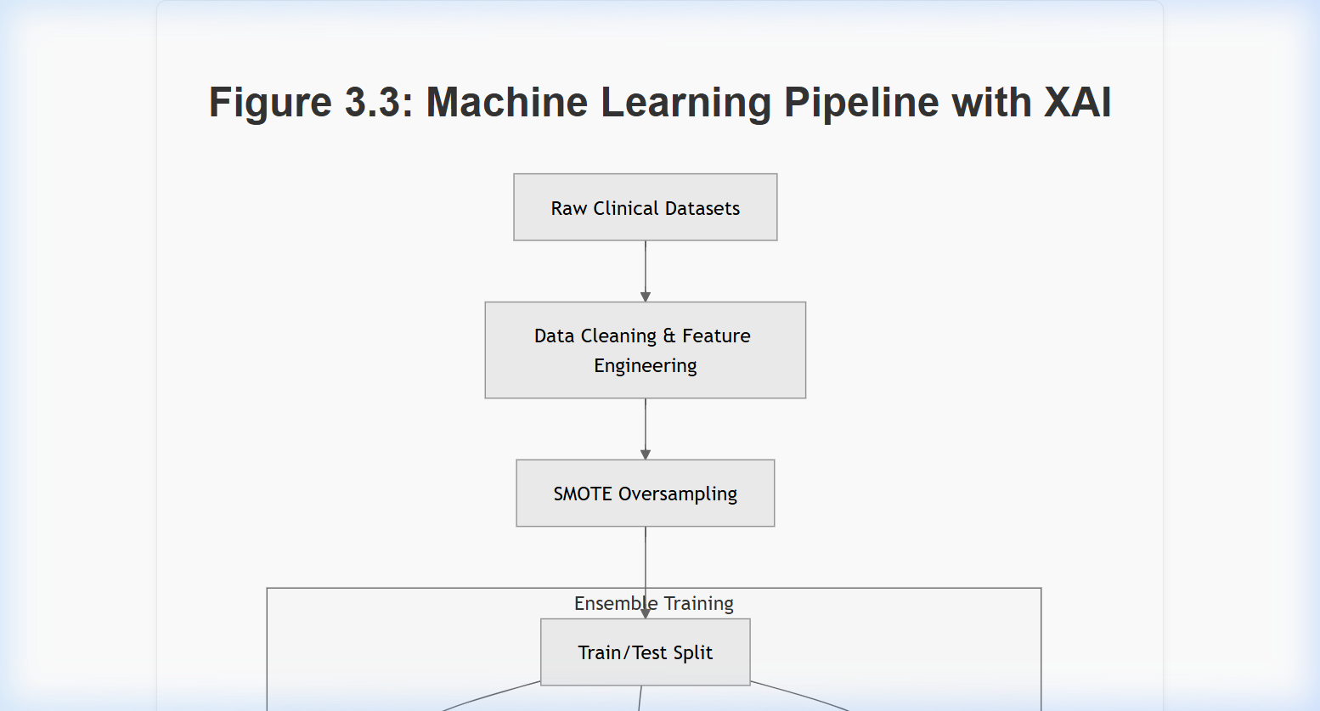
The end-to-end ML lifecycle. The diagram explicitly shows the 'XAI: Feature Importance Calculation' step, ensuring every prediction is accountable and transparent.

Figure 4.1: Backend API Workflow (Explainable)
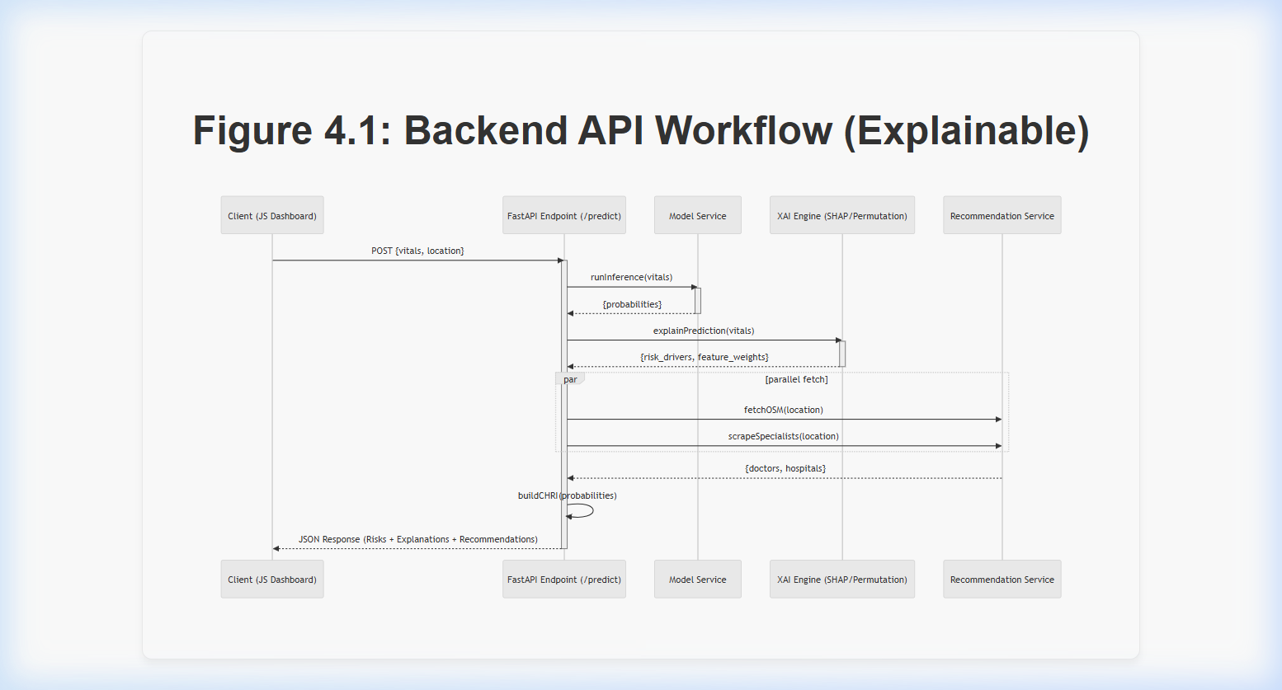
Sequence diagram of the API request. The XAI Engine is invoked in parallel with external services to provide immediate clinical context for the results.

Figure 4.2: Frontend Dashboard Interface

Real snapshot of the AI Health Navigator. This dashboard integrates diagnostic scores with a transparent 'Action Plan' and 'Explainability Panel'.

Figure 4.4: XAI Insights & Risk Breakdown
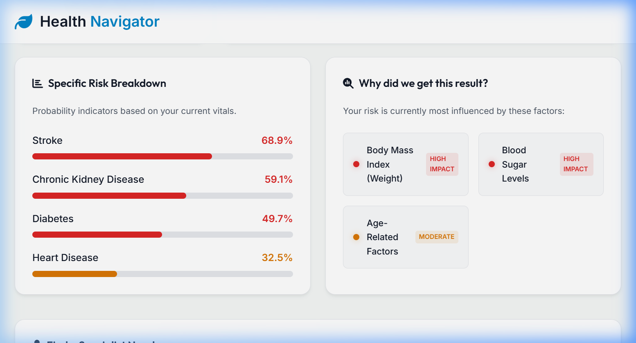
Detailed snapshot of the XAI layer in action. It explicitly identifies risk drivers like 'Body Mass Index' and 'Blood Sugar Levels' to explain the clinical reasoning behind the score.

