Blink Rate Detection for Dry Eye Disease
Technical Evolution & Methodology

Introduction
This document details the evolutionary phases of the Blink Rate Detection project, developed for monitoring Dry Eye Disease. The project has undergone three distinct architectural iterations, transitioning from raw geometric distance measurements (EAR) in a Web environment to a robust, AI-driven native mobile application using Google ML Kit.

Phase 1: Geometric Eye Aspect Ratio (Web App V1)

Basic Concept
The initial version utilized Google MediaPipe's Face Landmarker (478 points) running in the browser. By extracting the 16 specific landmarks outlining the eyes, we calculated the physical pixel distance between the upper and lower eyelids. This metric is known as the Eye Aspect Ratio (EAR).

Block Diagram
[ Camera Frame ] -> [ MediaPipe Face Landmarker ] -> [ Extract 16 Eye Points ] -> [ Calculate Geometric EAR ] -> [ Threshold: EAR < Baseline * 0.65 ] -> [ Blink Detected ]

Feedback & Limitations
Clinical testing revealed several vulnerabilities with raw geometric math:
• Head Movement: Spatial distortion (foreshortening) caused the physical distance between eyelids to appear smaller to the camera, triggering false blinks.
• Eyebrow Raises: Raising the eyebrows increased EAR significantly, and the subsequent relaxation mimicked the geometric pattern of a blink.
• Swollen Eyes: Infections or swelling resulted in a tiny baseline EAR, causing the absolute mathematical thresholds to fail.
• Environmental Lighting: Low light introduced severe sensor noise, causing the 3D landmark points to jitter and falsely trigger closures.

Phase 2: 1st-Derivative Velocity (Web App V2)

Basic Concept
To combat the sensitivity to slow spatial distortions (like head turns), the algorithm was upgraded to utilize calculus—specifically the 1st derivative of the EAR over time (Velocity). Instead of triggering based on physical distance, the system triggered on the speed of the eyelid closing, using a 3-State 'Valley Detection' Machine.

Enhancements
By enforcing a strict downward velocity threshold (-0.11 EAR/frame), slow head movements and baseline swelling were effectively filtered out. However, this version remained tied to the camera framerate, meaning variable FPS (e.g., iOS devices dropping frames or running at 60 FPS instead of 30) corrupted the velocity math.

Valley Detection Graph
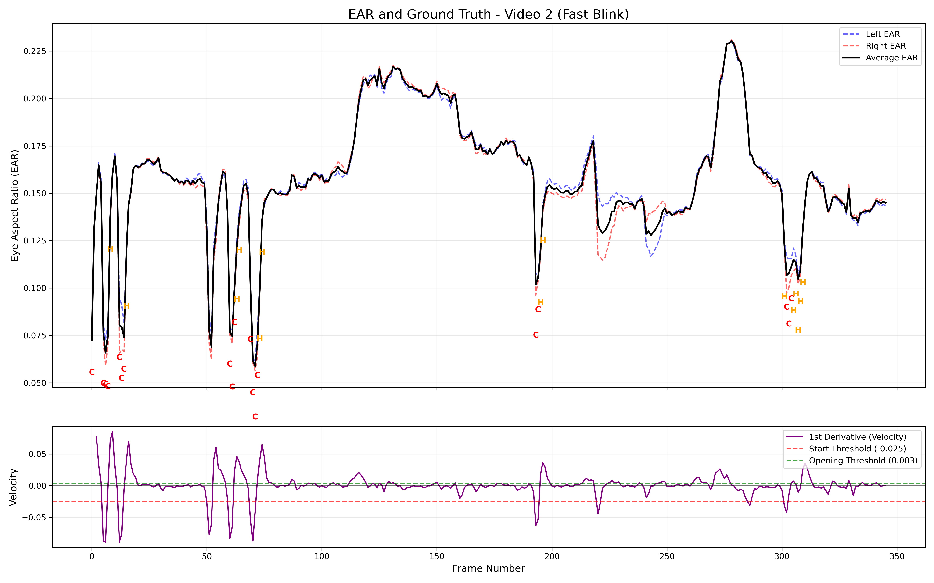
Figure 1: 1st-Derivative Velocity graph highlighting the steep 'valleys' characteristic of genuine blinks.

Phase 3: AI-Driven Native Application (Flutter + ML Kit)

Concept & Architecture
The project was ported to a native iOS application using Flutter. Because an official, complete 'MediaPipe Vision' plugin does not currently exist for Flutter, we utilized the Google ML Kit Flutter Wrappers. This platform necessity led to a significant algorithmic upgrade: completely replacing the fragile geometric EAR math with ML Kit's pre-trained Neural Network classification (eyeOpenProbability).

Workflow Block Diagram
1. [ Camera Frame ]
2. [ Google ML Kit Face Detection ]
3. [ Motion Rejection: Check Head Yaw/Pitch < 30° ]
4. [ Blur Rejection: Check Face Speed < 5% Width/100ms ]
5. [ Extract AI Open Probability (0.0 to 1.0) ]
6. [ Time-Based Velocity (Change in Prob / 100ms) ]
7. [ 3-State Valley Detection Machine ] -> [ Full/Half Blink ]

Final Enhancements
• AI Robustness: The neural network intrinsically handles lighting, swelling, and eyebrow raises without geometric tuning.
• Framerate Independence: Velocity is now calculated using absolute millisecond timestamps (Change per 100ms), ensuring consistent behavior across 30 FPS, 60 FPS, and variable-rate devices.
• Motion/Edge Rejection: Hard limits protect against camera shake and optical distortion at the edges of the lens.

