SIH26190
Secure Digital Document Management System
Full System Design Reference — Architecture, Connections, Flows & Domain Views

System Design — SIH26190 Secure Digital Document Management System

Full Reference: Architecture, Connections, Flows & Domain Views
Source of truth: this document diagrams and explains decisions already made in
[LegaDoc_v2.md](LegaDoc_v2.md), [SIH26190_Role_Document_Taxonomy.docx](SIH26190_Role_Document_Taxonomy.docx),
and [SIH26190_Architecture.pptx](SIH26190_Architecture.pptx). Nothing here re-litigates those
decisions (tiered DocumentSchema, Domestic Violence as demo showcase, all-Python stack, org-vs-role
boundary for specialized police units, etc.) — it goes one layer deeper: every connection in the
system, every flow end-to-end, and every real-world domain's view into the platform.

Scope
A multi-organization case management system for law enforcement, forensic, medical, and judicial
bodies to jointly manage a criminal case's full lifecycle — FIR through investigation, parallel
evidence collection, an independently-running bail track, charge sheet filing, and court disposition
(trial → judgment). Field-level sensitivity redaction is AI-assisted (self-hosted, non-generative)
with a human override path; every state-changing action is hash-chained to a permissioned blockchain
ledger for tamper evidence.

Scale tier
MVP-that-becomes-a-capstone — 1 week to a demoable build, 5-person team, zero external SaaS
dependencies. Full reasoning in LegaDoc_v2.md's Scale Tier section; unchanged here.

Architecture

C4 Context Diagram
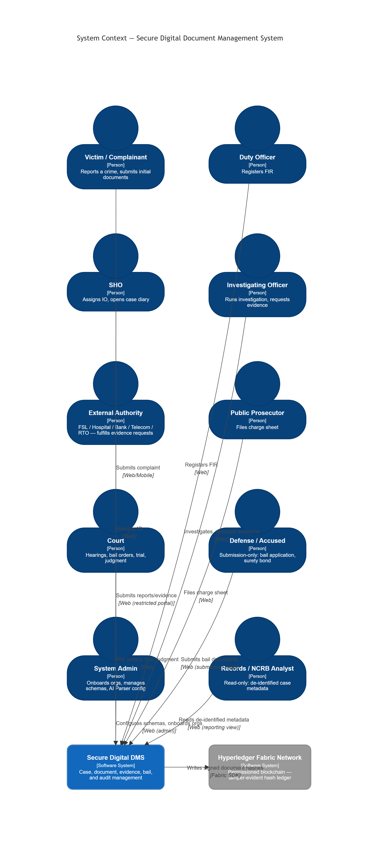

C4 Container Diagram
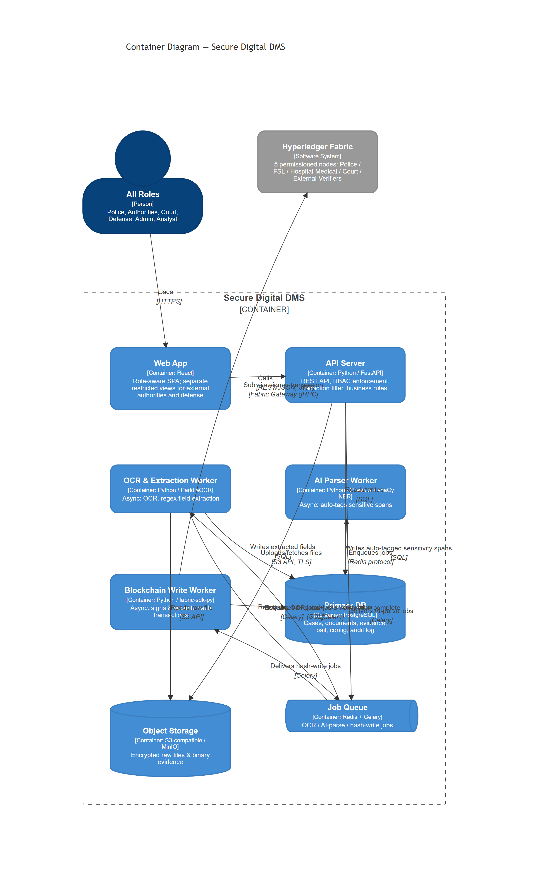

System Connections — Usage Reference
This is the expansion of the Container Diagram's arrows into something a team member can build and
debug from — not just "A talks to B" but why the connection exists, how it fails, and what tool sits
on it. Numbers below match the diagram; the table after it is the thing to actually reference while
building.
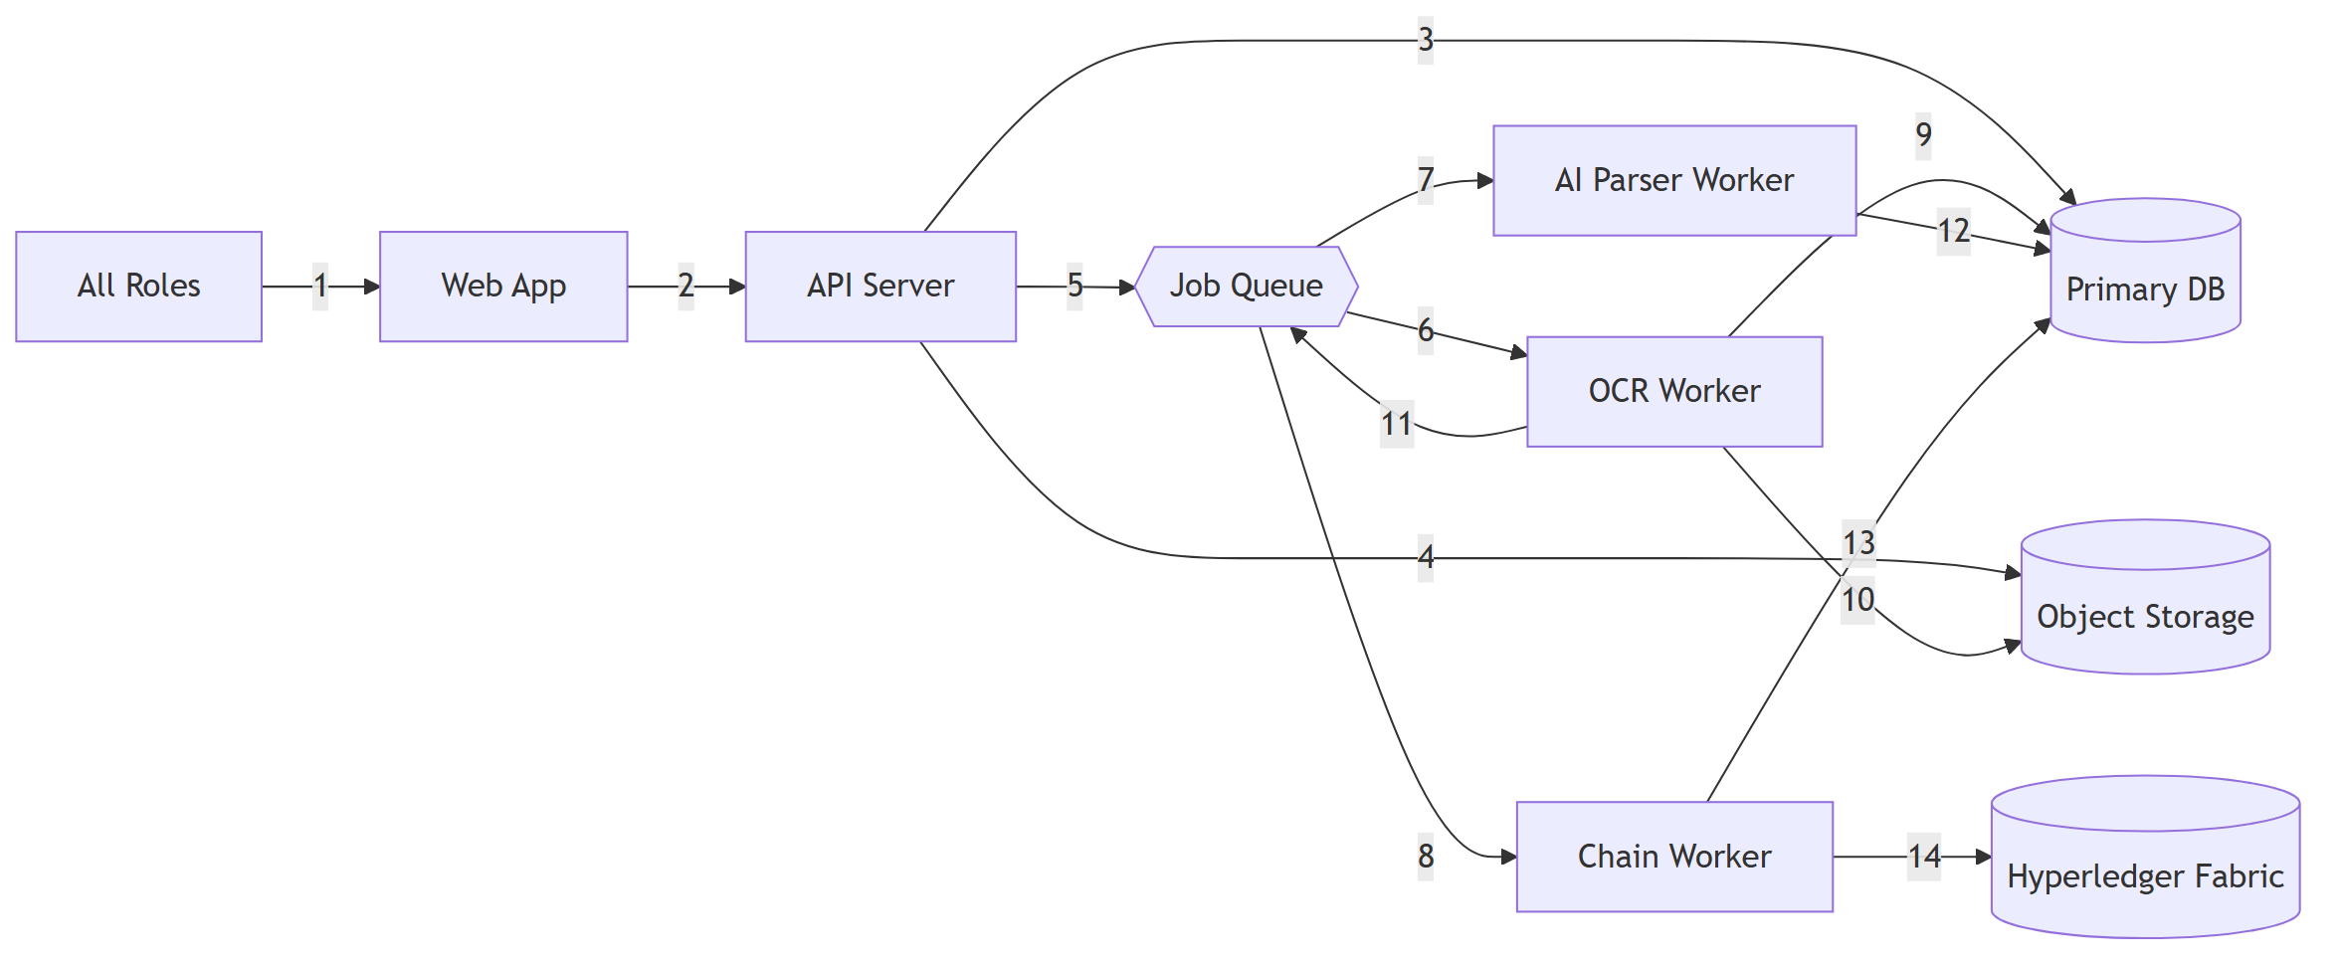
# | Connection | Use case — why it exists | Drawbacks & failure modes | Tooling
1 | Roles → Web App | Every human interaction with the system starts here — the one entry point for 10 different role types | Client-side only; a compromised browser session is a compromised role until the JWT expires | React SPA, HTTPS
2 | Web App → API | Every read/write goes through one enforcement point (RBAC + redaction), never direct DB access from the browser | If the API is down, the whole system is down — no offline mode, no read-through cache at MVP scale | REST/JSON, JWT (role + org claim)
3 | API → DB | Source of truth for every structured fact in the system (cases, documents metadata, evidence, bail, config, audit) | Single real point of failure in this design (per LegaDoc_v2.md's dependency table) — no read replica at MVP scale | PostgreSQL, SQL over service credential
4 | API → Object Storage | Raw files (scans, CCTV, device dumps) don't belong in relational rows — keeps DB lean and lets large binaries scale independently | Upload/fetch failures are surfaced to the user directly; no server-side retry beyond client-triggered re-upload | MinIO (S3-compatible), TLS, per-org scoped path
5 | API → Job Queue | Decouples slow work (OCR, AI-tagging, blockchain writes) from the request/response cycle — the user gets a 202, not a multi-second wait | Fire-and-forget enqueue: if Redis is down, jobs are never queued (not silently lost, but visibly failed at enqueue time, not hidden) | Redis + Celery, idempotency key in every job payload
6 | Queue → OCR Worker | Text-bearing documents need extraction before anything downstream (tagging, redaction) can happen | Retried with backoff; after N failures, dead-lettered + flagged via GET /documents?status=needs_review | Celery, PaddleOCR
7 | Queue → AI Parser Worker | Delivers the AI-parse job the OCR worker enqueues — this is the automatic-redaction step | On repeated failure, fails closed: document defaults to fully redacted, not fully exposed, and flags for review — the one failure mode in this system deliberately designed to be safe rather than convenient | Celery, Presidio + spaCy NER
8 | Queue → Chain Worker | Delivers the hash-write job — runs independently of the OCR/AI-parse track since it only needs the raw file bytes, which never change | Fabric transaction submission is this system's single most flaky integration point (community-maintained Python SDK) — retried with backoff, and has a manual retry-chain-write admin escape hatch | Celery, fabric-sdk-py
9 | OCR Worker → DB | Persists extracted structured fields so the AI Parser and the redaction filter both have something to read | Re-extraction only happens if the document is re-uploaded as a new version — an OCR mistake on v1 doesn't silently self-correct | SQL
10 | OCR Worker → Object Storage | Needs the actual file bytes to run PaddleOCR against | Read-only; a storage outage here just delays extraction, it can't corrupt the stored original | S3 API
11 | OCR Worker → Job Queue | This is the causal link between extraction finishing and auto-redaction starting — OCR doesn't call the AI Parser directly, it hands off through the same queue | If this enqueue silently failed, a document could sit "extracted but never tagged" indefinitely — worth an explicit test case, not just a hope | Celery
12 | AI Parser → DB | Writes the auto-tagged sensitivity spans (entity type + location + confidence — never the raw redacted text itself) | If this write is what fails repeatedly (not just the tagging logic), the fail-closed rule still applies — the document stays "processing," never silently serves an untagged view | SQL
13 | Chain Worker → DB | Reads the document hash to sign, then writes back chain_status (pending/confirmed/failed) | The classic split-brain risk: Fabric confirms but the DB write crashes before recording it — this is exactly why retry-chain-write reuses the *original* idempotency key instead of minting a new one | SQL
14 | Chain Worker → Fabric | The actual tamper-evidence mechanism — a signed hash transaction per document, submitted under the org's own Fabric MSP identity | On repeated endorsement failure, the document is flagged chain_status=failed for manual review; there is no inbound webhook from Fabric — confirmation is read back by polling, deliberately, to avoid standing up event-listening infrastructure at MVP scale | Fabric Gateway gRPC, fabric-sdk-py, org signing key

Full per-arrow sync/async, retry, and volume detail (the compact version of this same table) already
lives in LegaDoc_v2.md's Arrow Specifications section — this table is the "why and how it
breaks" companion to that one, not a replacement.

Key Flows

Flow 1 — FIR Registration & Case Creation (synchronous)
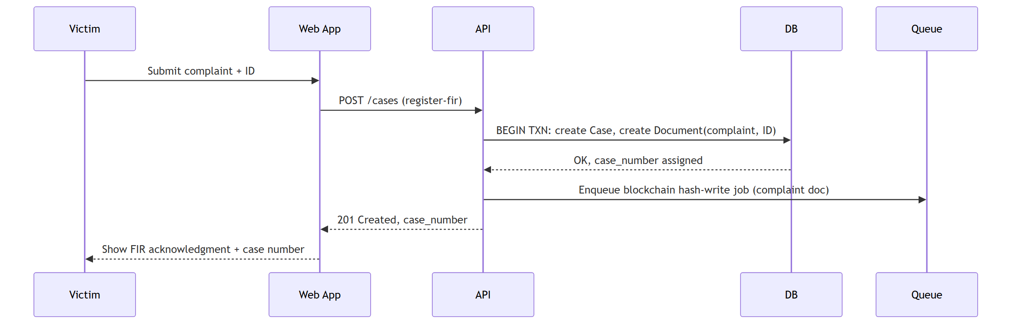
Use case: the victim needs a case number to reference immediately — this is the one flow where
waiting on anything async (even a blockchain write) would be a bad user experience for zero benefit.
Drawback: because it's fully synchronous end-to-end except the hash-write, a slow DB transaction
here is directly felt by a victim standing at a desk — this is the one endpoint worth watching for
p99 latency even at demo scale.
Tooling: FastAPI request handler + a single DB transaction; no queue involvement except the
fire-and-forget hash-write enqueue.

Flow 2 — Document Upload → OCR → AI-Parsed Redaction → Blockchain Hash-Write
*(the core technical differentiator — two independent parallel tracks)*
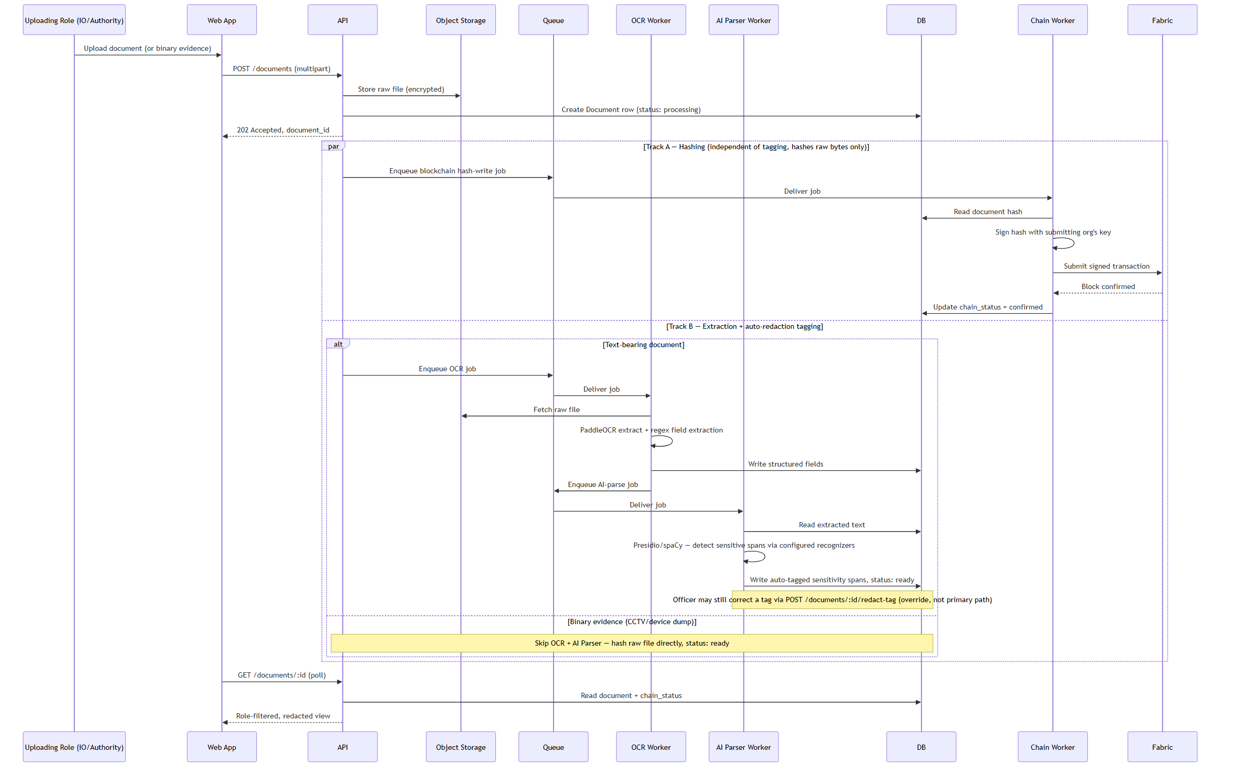
Use case: this is the flow that makes the whole "tamper-evident + auto-redacted" pitch real — a
document is simultaneously being made legally provable (hash on Fabric) and safe to share across
organizations (auto-tagged redaction), without either process blocking the other or blocking the
uploader.
Drawbacks:
- The AI Parser's out-of-the-box NER model wasn't trained on Indian legal/medical/police-report
language — expect real misses on domain-specific fields until recognizer patterns are tuned
per document type. This is precisely why redact-tag exists as a correction path, not a
nice-to-have.
- Two independent async tracks means two independent places a document can get "stuck" —
chain_status=pending forever, or status=processing forever. Both have a designed recovery
path (retry-chain-write, and the AI Parser's fail-closed + needs_review flag respectively) —
neither should ever require a manual DB edit to unstick.
Tooling: MinIO (storage), Celery (queue), PaddleOCR (extraction), Presidio + spaCy (tagging),
fabric-sdk-py (hashing).

Flow 3 — Parallel Evidence Requests (AND-join) → Charge Sheet Filing
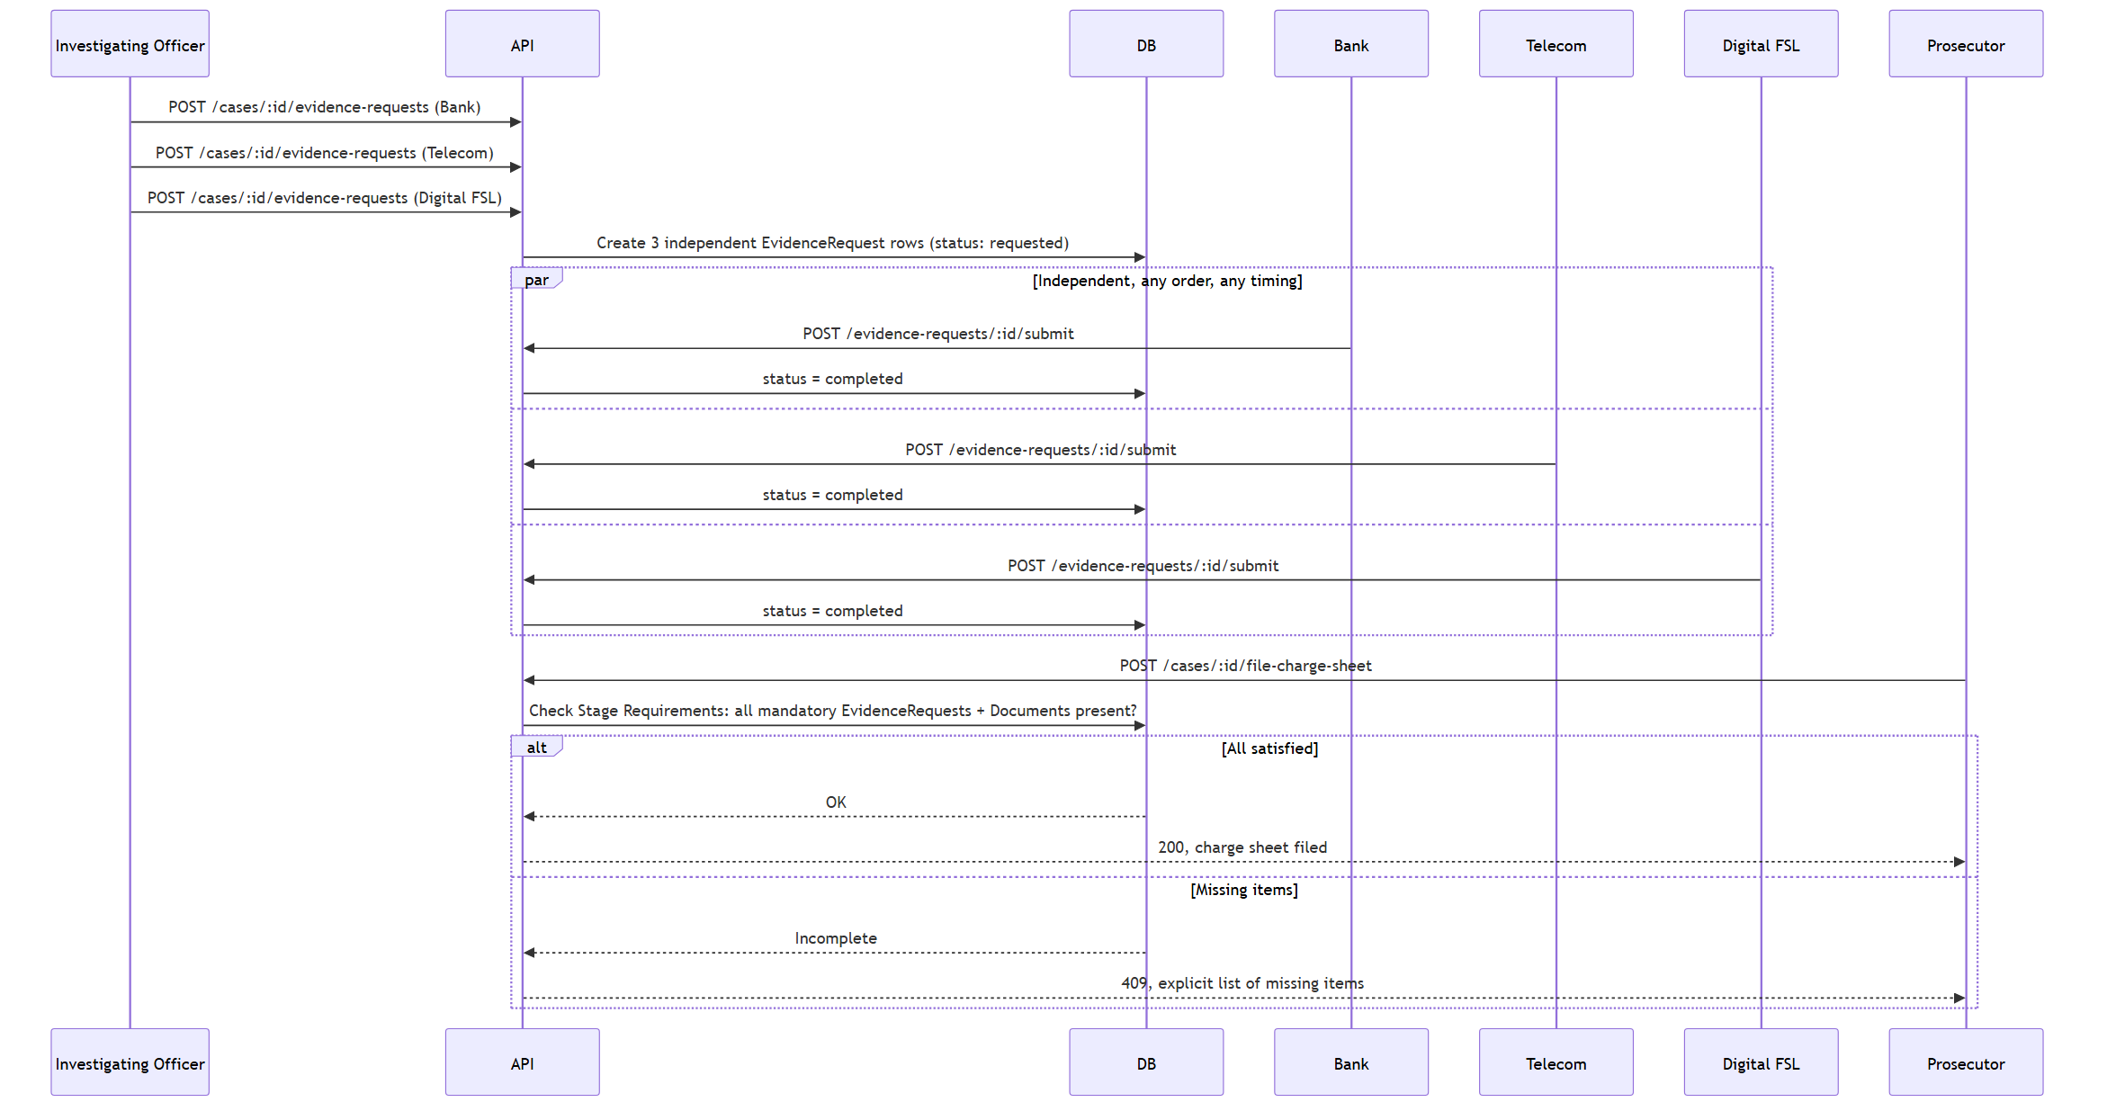
Use case: real investigations don't get evidence back in a fixed order — Bank might respond in a
day, Digital FSL in three weeks. Modeling this as N independent rows with an AND-join gate (rather
than a fixed sequence) is what makes the design match how evidence actually arrives.
Drawbacks: external authorities are real institutions with real response-time variance outside
this system's control. A single slow authority blocks charge-sheet filing indefinitely — there's no
reminder/escalation job at MVP scale (explicitly deferred to LATER), so a stuck request currently
relies on the IO noticing and following up manually.
Tooling: plain synchronous API calls + a DB-side validation query against the
StageRequirements config table — no queue involvement, this is fast enough to stay synchronous.

Flow 4 — Bail Track (runs independently of the Investigation Track)
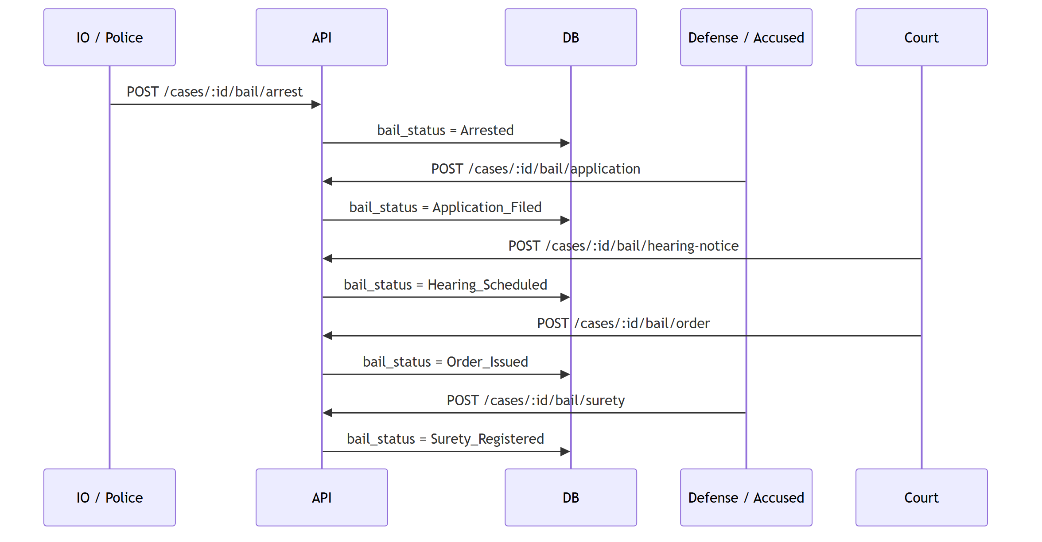
Use case: investigation_status and bail_status are two independent columns on the same case
row — a case can be "Charge Sheet Ready" while bail is still "Hearing Scheduled," and vice versa.
Domestic Violence was chosen as the demo showcase specifically because it's the only women-safety
case in the taxonomy with a *confirmed* bail pathway, so this flow can actually run live in a demo.
Drawbacks: 9 of the 15 crime types have "bail pathway not yet confirmed" in the source taxonomy
data (some legally load-bearing — NDPS Section 37, non-bailable sexual-offence classifications).
Doesn't block this flow or the demo, but it's a real legal-accuracy gap if the system is asked to
make a bail-pathway claim for those crime types.
Tooling: same as Flow 3 — synchronous API + DB state transition, no queue.

Flow 5 — Trial → Judgment (Court Disposition)
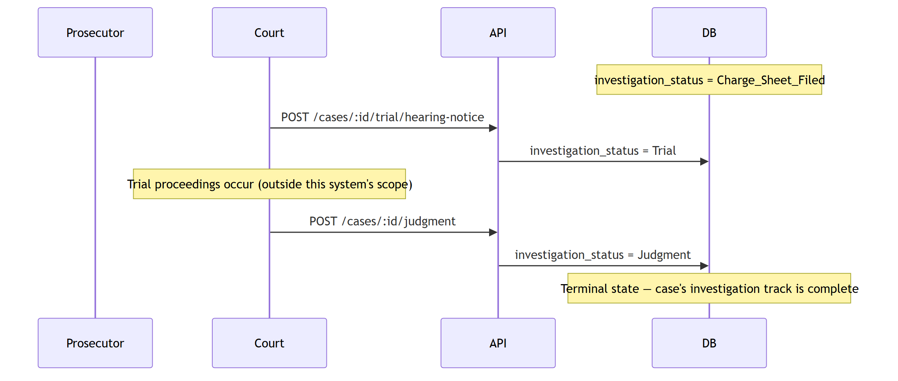
Use case: closes the investigation-track state diagram's final transition
(Trial → Judgment → [*]), which — before this design pass — had no backing endpoint at all despite
being named in the Scope statement ("...charge sheet filing, and court disposition").
Drawbacks: this flow deliberately does *not* model what happens inside a trial (witness
examination, adjournments, multiple hearing dates) — it only records the two endpoints that matter
to this system's state machine. If the team later needs finer-grained trial tracking, this is a
LATER item, not a gap in what's built now.
Tooling: identical shape to the bail endpoints — synchronous API + DB state transition.

Flow 6 — AI Parser Audit Trail: Who Can See What the AI Decided
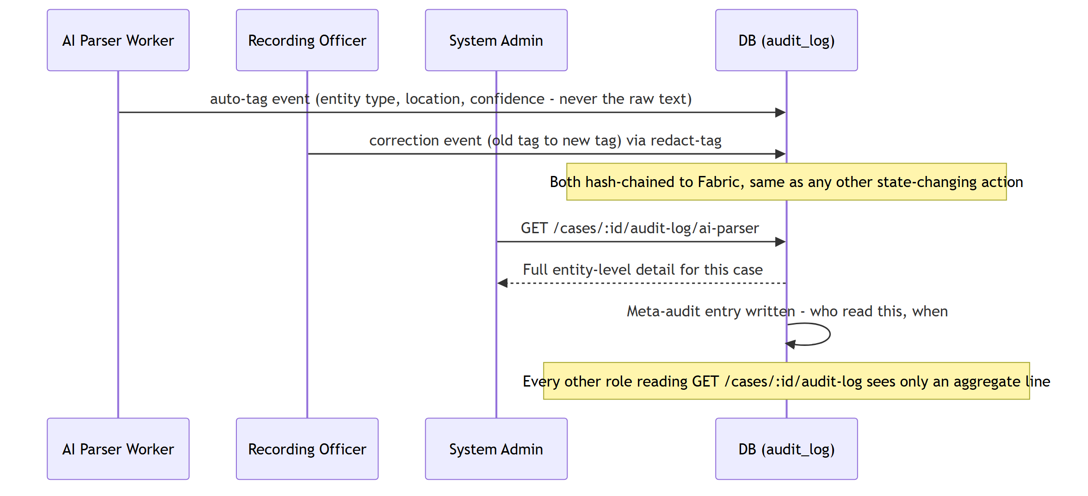
Use case: proves two separate things — that the AI's redaction decisions are tamper-evident
(same hash-chain as everything else), and that access to the *detail* of those decisions is itself
tracked, not just the decisions.
Drawbacks: the meta-audit doubles the write volume on this specific endpoint (every read is now
also a write) — negligible at demo scale, worth knowing if this endpoint is ever exposed to a
high-frequency automated caller later.
Tooling: same append-only audit log table as everything else; no separate logging system.

Domain Views — Diagrams & Use Cases
Each of the system's real-world domains gets its own view: what its actors actually do, which
endpoints they touch, and what's non-obvious or risky about building for that domain specifically.
This is the layer between "here's a container diagram" and "here's how a Women Cell officer's day
actually goes."

Domain 1 — Police & Investigation
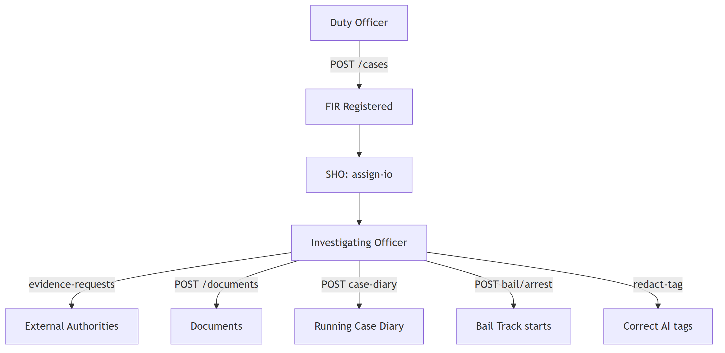
- Use cases: register FIR, assign/reassign IO, request evidence from external authorities,
upload documents, maintain a running case diary, record an arrest (which starts the independent
Bail Track), correct an AI Parser mis-tag.
- Endpoints touched: /cases, /cases/:id/assign-io, /reassign-io, /evidence-requests,
/documents, /cases/:id/case-diary, /bail/arrest, /documents/:id/redact-tag.
- Risks / non-obvious: specialized units (Women Cell, Cyber Cell, Narcotics Police, Traffic
Police, Crime Scene Unit, Rescue Team, Counselor) are roles inside the Police org, not
separate tenants — easy to accidentally model as separate orgs, which would break the
cross-tenant RBAC middleware's simple org_id check. Case Diary is an append-only running log,
distinct from a Document upload — conflating the two loses the "running notebook" semantics real
investigations need.

Domain 2 — Forensic (FSL / Digital FSL)
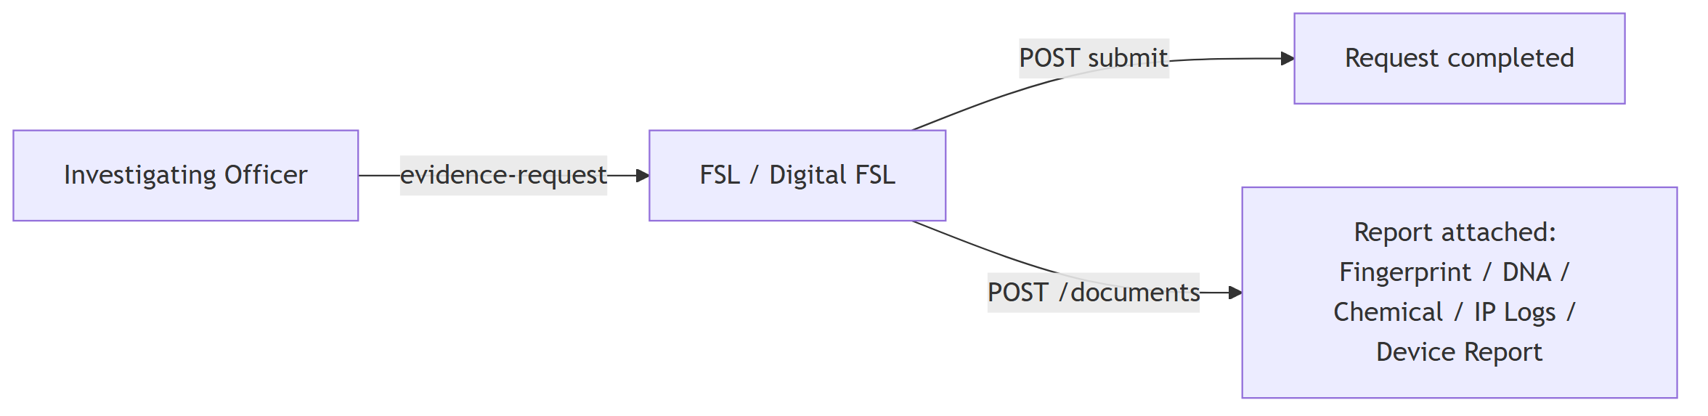
- Use cases: fulfill a routed evidence request; attach the resulting forensic report (general
FSL: Fingerprint/DNA/Chemical/Blood/Biological reports; Digital FSL: IP Logs, Device Report, SIM
Details for cyber cases).
- Endpoints touched: GET /cases/:id/evidence-requests (own only), POST /evidence-requests/:id/submit, POST /documents.
- Risks / non-obvious: access must be scoped to the specific request routed to them, never
the rest of the case file — if this is implemented as "any user in the FSL org can see anything
tagged FSL" instead of "only requests explicitly assigned to this org," it silently becomes a
much bigger information leak than intended.

Domain 3 — Medical (Hospital)
- Use cases: submit MLC (Medical Legal Certificate) or Injury Certificate/Report for Robbery,
Road Accident, Assault, Rape, Domestic Violence, Acid Attack cases.
- Endpoints touched: same evidence-request/document pattern as Forensic.
- Risks / non-obvious: MLC is one of only three Tier 1 full-custom DocumentSchema types
precisely because of its sensitivity concentration — this is also the document type where the AI
Parser's out-of-the-box accuracy gap (medical/diagnosis fields, caste/religion-adjacent fields)
matters most. Recognizer tuning here is not optional polish.

Domain 4 — Financial & Verification Authorities (Bank, Telecom, RTO)
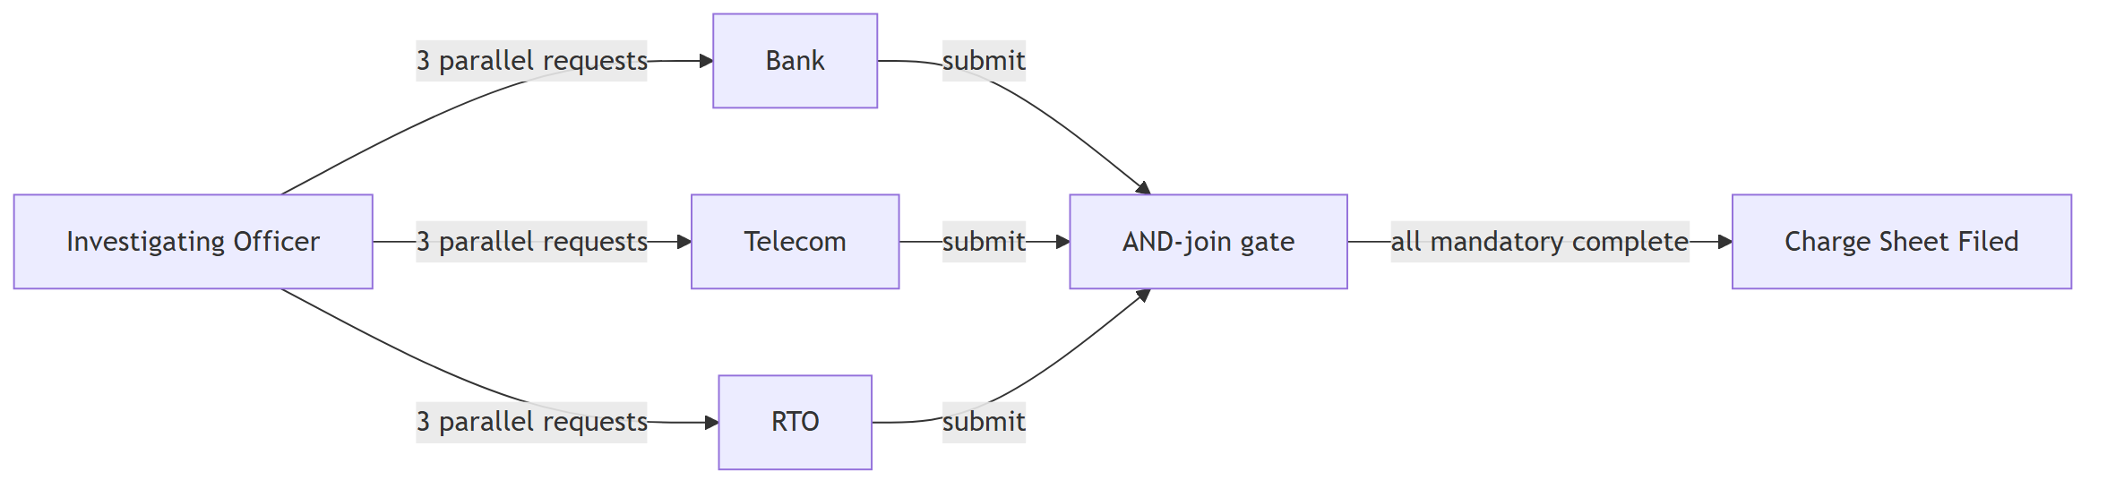
- Use cases: Bank/Telecom fulfill Cyber Fraud evidence requests (Bank Statement, UPI records,
CDR, SIM details); RTO verifies vehicle registration/insurance for Road Accident cases. This
domain is the clearest real-world demonstration of Flow 3's AND-join.
- Endpoints touched: same evidence-request/document pattern.
- Risks / non-obvious: these are genuinely separate real-world institutions (unlike the
internal police specialized units) — the correct place to actually create a new org_id. Real
response-time variance (days to weeks) means a slow authority silently blocks charge-sheet
filing with no reminder mechanism at MVP scale — a known, accepted LATER gap, not an oversight.

Domain 5 — Judiciary (Magistrate / Sessions / NDPS Court)
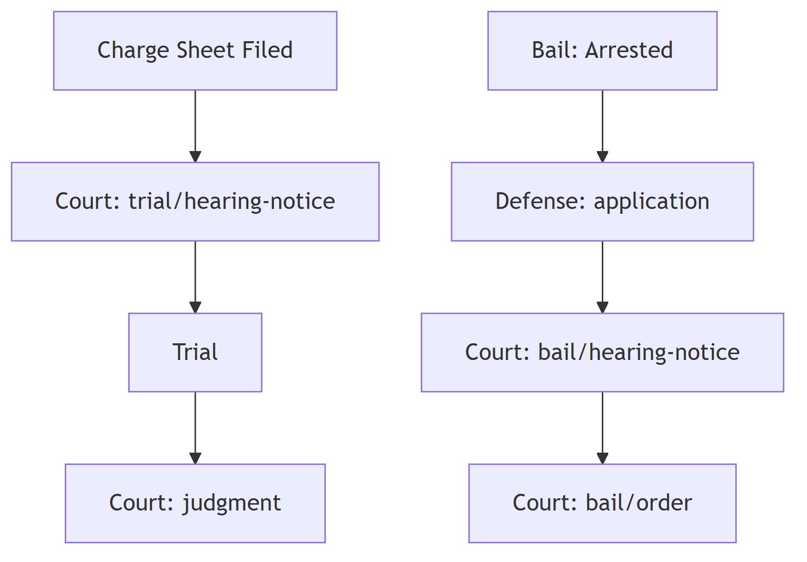
- Use cases: schedule and record bail hearings/orders; schedule trial hearings and record final
judgment. Magistrate/Sessions/NDPS Court each own their org, matched to crime type and severity.
- Endpoints touched: /bail/hearing-notice, /bail/order, /trial/hearing-notice, /judgment,
full GET /cases/:id/audit-log access (Court gets the unredacted full trail per the Access Model).
- Risks / non-obvious: hearing-notice and order actions share the same Court role — they're
differentiated by audit-log action type, not a separate "Judge" role. A team member modeling
RBAC from scratch might reach for a Judge role that doesn't exist in this design on purpose.
Court-instance routing (which specific Magistrate Court, not just which level) isn't modeled —
fine at single-court demo scale, a real limitation past it.

Domain 6 — Defense / Accused
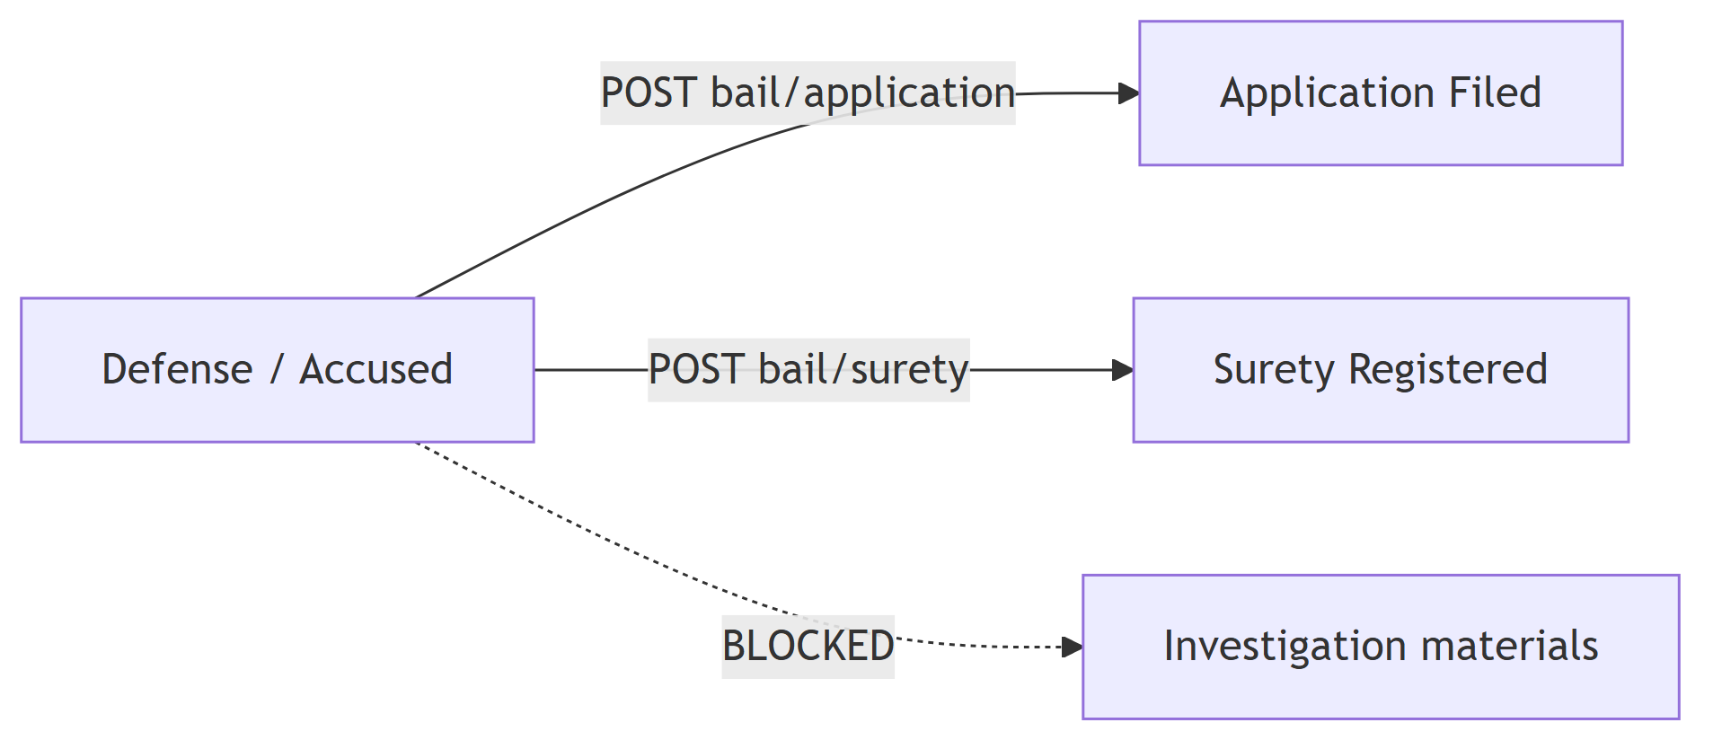
- Use cases: file a bail application, register a surety bond — submission-only, nothing else.
- Endpoints touched: /bail/application, /bail/surety, GET /cases/:id (own bail submissions
only).
- Risks / non-obvious: this is the domain with the least access and the most consequence if
RBAC is implemented loosely — Defense/Accused must never see investigation materials during
an active investigation, per the Access Model. This is exactly why Auth/RBAC tests are the
system's stated #1 testing priority: a broken filter here is not a cosmetic bug.

Domain 7 — Records / NCRB Reporting
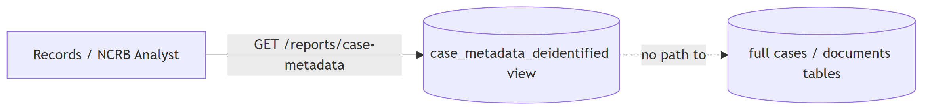
- Use cases: read de-identified case metadata (crime type, status, dates, court level) for
reporting — nothing else.
- Endpoints touched: GET /reports/case-metadata only.
- Risks / non-obvious: this role deliberately gets its own dedicated Postgres view, never a
filtered pass through the normal /cases or /documents/:id endpoints. That's not extra
engineering for its own sake — it's the one domain in this system architected to make the
"someone forgot to apply the redaction filter on this code path" bug class structurally
impossible rather than just tested against.

Domain 8 — Platform / Admin (Schema Config, AI Parser, Security)
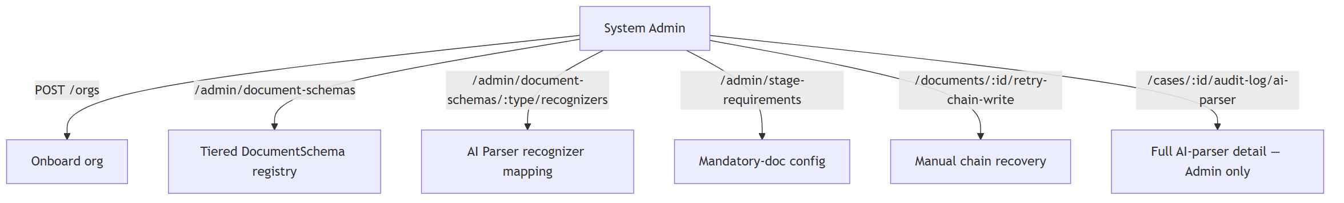
- Use cases: onboard organizations, manage the tiered DocumentSchema registry, configure AI
Parser recognizer mappings per document type, manage Stage Requirements, manually recover a stuck
chain-write, read the full AI Parser audit trail.
- Endpoints touched: everything under /admin/*, plus /documents/:id/retry-chain-write and
/cases/:id/audit-log/ai-parser.
- Risks / non-obvious: this role concentrates nearly every genuinely dangerous capability in
the system — a schema change affects redaction correctness system-wide, a recognizer
misconfiguration affects AI Parser accuracy, and the ai-parser audit endpoint is the most
sensitive read path that exists. A compromised Admin credential is the single highest-impact
credential here, which is exactly why retry-chain-write reuses idempotency keys and the
ai-parser audit endpoint has no bulk/cross-case export — both are deliberate blast-radius limits
on this one role, not incidental design choices.

Interface Contracts
Full 36-row endpoint table, arrow specifications, and async pattern decisions already live in
LegaDoc_v2.md's Interface Contracts section — reused here by reference rather than duplicated,
since nothing about them changed in this pass. The System Connections — Usage Reference table
above is the new material this document adds on top of that endpoint table.

State Ownership Map
Reused as-is from LegaDoc_v2.md — every piece of state (case core data, investigation/bail status,
document bytes, structured fields, sensitivity tags, chain_status, evidence requests, bail records,
case assignment, schema registry, stage requirements, audit log, meta-audit) has exactly one owner.
No changes in this pass.

Environments
Reused as-is from LegaDoc_v2.md — local/dev, demo (judging day), production (stated, not built).
Zero external SaaS dependencies confirmed intact after the AI Parser addition (Presidio + spaCy run
entirely self-hosted).

Domain Overlays Applied
Reused as-is from LegaDoc_v2.md — B2B SaaS multi-tenant overlay partially adapted (org/role model,
tenant context propagation); Fintech/Trading/AI-agent overlays explicitly not applicable, with the
AI-agent non-applicability now stated precisely (classical NLP via Presidio/spaCy, not a generative
model or LLM agent).

Concepts Checklist
NOW / LATER / WATCHLIST tables reused as-is from LegaDoc_v2.md, including every addition from this
design's review sessions (Celery over BullMQ, AI Parser Worker, tiered DocumentSchema coverage,
retry-chain-write idempotency, trial/judgment endpoints, Case Diary, needs-review queue,
Records/NCRB data path, AI Parser audit trail).

Open Questions
- Role-model capacity — can the team build the full expanded role set (Women Cell, Cyber Cell,
Records/NCRB Analyst, etc.) in the time remaining, or do some fold back into generic buckets for
the demo?
- Bail-pathway data gaps — 9 of 15 crime types have "bail pathway not yet confirmed" in the
source taxonomy (some legally load-bearing). Doesn't block the Domestic Violence demo; a real gap
if judges ask about other crime types.
Everything else in this document and in LegaDoc_v2.md is confirmed and buildable as-is.

Build Prompt Seed
Building a multi-organization criminal case management system (Python/FastAPI API, React
frontend, PostgreSQL, Redis+Celery queue, MinIO object storage, Python/PaddleOCR worker,
Python/Presidio+spaCy AI Parser worker, Python fabric-sdk-py Chain Worker against a 5-node
Hyperledger Fabric network). The repository already has a blank baseline scaffold matching this
container diagram (api/, workers/ocr_worker/, workers/ai_parser_worker/,
workers/chain_worker/, web/, fabric-network/, scripts/, db/migrations/) — fill it in
against LegaDoc_v2.md's Interface Contracts and this document's System Connections table. First
milestone unchanged from prior guidance: stand up the Fabric test network and confirm the Python
Chain Worker can submit and confirm one signed hash transaction end-to-end, in isolation, before
wiring the rest of the pipeline around it — this remains the highest-setup-risk component in the
system.

Review Gate
This document is additive to LegaDoc_v2.md, not a replacement — it adds the System Connections
usage reference, per-flow diagrams for Trial/Judgment and the AI Parser audit trail (neither had a
dedicated diagram before), and the eight domain views. The two open questions above are the only
items still needing your team's explicit call before treating the full design as final.

