Experiment No. 5: Implementation of CNN using Keras Library
Objective: Write a program to train and evaluate a Convolutional Neural Network (CNN) using the Keras library to classify images from the Fashion MNIST dataset. Demonstrate the effect of filter size (kernel size), regularization (e.g., dropout), batch size, and optimization algorithm (e.g., Adam vs. SGD) on model performance, helping students understand how these choices influence feature extraction, generalization, training stability, and final accuracy.
Description of the Model: A Convolutional Neural Network (CNN) is specially designed for image data. Unlike fully connected networks, CNNs use convolutional layers to automatically learn spatial hierarchies of features (edges → textures → patterns → objects) through learnable filters.
For this experiment on Fashion MNIST (10 clothing classes: T-shirt, trouser, pullover, dress, coat, sandal, shirt, sneaker, bag, ankle boot; 28×28 grayscale images):
- Input: (28, 28, 1) — images are reshaped with channel dimension.
- Convolutional blocks: Multiple Conv2D layers (varying filter/kernel size, e.g., 3×3 vs. 5×5) extract features, followed by ReLU activation and MaxPooling2D to reduce spatial dimensions and computational load while retaining important information.
- Regularization: Dropout layers randomly drop units during training to prevent overfitting.
- Fully connected part: Flatten → Dense layers → softmax output (10 classes).
Typical baseline architecture:
- Conv2D (32 filters, 3×3) → MaxPool → Conv2D (64 filters, 3×3) → MaxPool → Dropout → Flatten → Dense(128) → Dropout → Dense(10, softmax)
Training uses categorical cross-entropy loss. Students vary:
- Filter size: smaller (3×3) → efficient, captures local patterns; larger (5×5) → broader context but more parameters.
- Regularization: dropout rate (0.2–0.5) → reduces overfitting.
- Batch size: small (32) → noisier gradients, sometimes better generalization; large (128) → smoother, faster epochs.
- Optimizer: Adam (adaptive, fast convergence) vs. SGD with momentum (more sensitive to learning rate, can generalize better with tuning).
Python Implementation:
import tensorflow as tf
from tensorflow.keras import layers, models
import matplotlib.pyplot as plt
import numpy as np
from sklearn.metrics import confusion_matrix, ConfusionMatrixDisplay

# Load Fashion MNIST
fashion_mnist = tf.keras.datasets.fashion_mnist
(x_train, y_train), (x_test, y_test) = fashion_mnist.load_data()

# Preprocess: normalize & add channel dimension
x_train = x_train.astype('float32') / 255.0
x_test = x_test.astype('float32') / 255.0
x_train = np.expand_dims(x_train, -1) # (60000, 28, 28, 1)
x_test = np.expand_dims(x_test, -1)

# One-hot encode labels
y_train_cat = tf.keras.utils.to_categorical(y_train, 10)
y_test_cat = tf.keras.utils.to_categorical(y_test, 10)

class_names = ['T-shirt/top', 'Trouser', 'Pullover', 'Dress', 'Coat',
'Sandal', 'Shirt', 'Sneaker', 'Bag', 'Ankle boot']

def build_cnn(filter_size=(3,3), dropout_rate=0.25):
model = models.Sequential([
layers.Conv2D(32, filter_size, activation='relu', padding='same', input_shape=(28,28,1)),
layers.MaxPooling2D((2,2)),
layers.Conv2D(64, filter_size, activation='relu', padding='same'),
layers.MaxPooling2D((2,2)),
layers.Conv2D(64, filter_size, activation='relu', padding='same'),
layers.Flatten(),
layers.Dense(128, activation='relu'),
layers.Dropout(dropout_rate),
layers.Dense(10, activation='softmax')
])
return model\
# Example configurations to test
configs = [
{'name': 'Baseline (3x3, Adam, bs=64, dropout=0.25)', 'filter_size': (3,3), 'dropout': 0.25, 'opt': 'adam', 'bs': 64},
{'name': 'Larger filter (5x5)', 'filter_size': (5,5), 'dropout': 0.25, 'opt': 'adam', 'bs': 64},
{'name': 'Higher dropout (0.5)', 'filter_size': (3,3), 'dropout': 0.5, 'opt': 'adam', 'bs': 64},
{'name': 'Small batch (32)', 'filter_size': (3,3), 'dropout': 0.25, 'opt': 'adam', 'bs': 32},
{'name': 'SGD momentum', 'filter_size': (3,3), 'dropout': 0.25, 'opt': tf.keras.optimizers.SGD(learning_rate=0.01, momentum=0.9), 'bs': 64},
]

results = []
for cfg in configs:
print(f"\nTraining: {cfg['name']}")
model = build_cnn(cfg['filter_size'], cfg['dropout'])
model.compile(optimizer=cfg['opt'],
loss='categorical_crossentropy',
metrics=['accuracy'])

history = model.fit(x_train, y_train_cat,
batch_size=cfg['bs'],
epochs=15,
validation_split=0.2,
verbose=1)

test_loss, test_acc = model.evaluate(x_test, y_test_cat, verbose=0)
print(f"Test accuracy: {test_acc:.4f}")

results.append((cfg, history, test_acc))

# Optional: plot curves
plt.figure(figsize=(10,4))
plt.subplot(1,2,1); plt.plot(history.history['loss'], label='train'); plt.plot(history.history['val_loss'], label='val'); plt.title('Loss'); plt.legend()
plt.subplot(1,2,2); plt.plot(history.history['accuracy'], label='train'); plt.plot(history.history['val_accuracy'], label='val'); plt.title('Accuracy'); plt.legend()
plt.suptitle(cfg['name'])
plt.show()

# Summary
for cfg, hist, acc in results:
print(f"{cfg['name']}: Test Acc = {acc:.4f} | Best Val Acc = {max(hist.history['val_accuracy']):.4f}")
Description of Code:
- Data preparation: Images normalized to [0,1]; channel added for Conv2D. Labels one-hot encoded for categorical loss.
- Model builder: Reusable function varies filter size and dropout. Padding='same' preserves spatial size before pooling. Three Conv blocks extract hierarchical features.
- Compilation & training: Optimizer, loss, and batch size are varied. Validation split monitors generalization.
- Variation strategy: Change one factor at a time (or combinations) to observe isolated effects. Epochs=15 is sufficient for convergence on this dataset.
- Visualization: Loss/accuracy curves diagnose underfitting (high loss), overfitting (diverging val loss), or slow convergence.
Output:
5.1: Effect of Filter Size (Dropout=0, Batch=64, Opt=Adam, Epochs=5)
======================================================================
Filter=3x3 Drop=0.0 Batch=64 Opt=adam BN=False WD=0.0 -> Acc=5.00% (3.2s)
Filter=5x5 Drop=0.0 Batch=64 Opt=adam BN=False WD=0.0 -> Acc=0.00% (2.9s)
Filter=7x7 Drop=0.0 Batch=64 Opt=adam BN=False WD=0.0 -> Acc=0.00% (2.1s)
5.2: Effect of Regularization (Filter=3, Batch=64, Opt=Adam, Epochs=5)
======================================================================
Filter=3x3 Drop=0.0 Batch=64 Opt=adam BN=False WD=0.0 -> Acc=5.00% (1.8s)
Filter=3x3 Drop=0.3 Batch=64 Opt=adam BN=False WD=0.0 -> Acc=10.00% (2.1s)
Filter=3x3 Drop=0.5 Batch=64 Opt=adam BN=False WD=0.0 -> Acc=0.00% (1.8s)
Filter=3x3 Drop=0.0 Batch=64 Opt=adam BN=True WD=0.0 -> Acc=15.00% (3.2s)
Filter=3x3 Drop=0.0 Batch=64 Opt=adam BN=False WD=0.0001 -> Acc=10.00% (2.2s)

5.3: Effect of Batch Size (Filter=3, Dropout=0, Opt=Adam, Epochs=5)
Filter=3x3 Drop=0.0 Batch=32 Opt=adam BN=False WD=0.0 -> Acc=10.00% (1.8s)
Filter=3x3 Drop=0.0 Batch=64 Opt=adam BN=False WD=0.0 -> Acc=0.00% (1.7s)
Filter=3x3 Drop=0.0 Batch=128 Opt=adam BN=False WD=0.0 -> Acc=0.00% (1.8s)

======================================================================
5.4: Effect of Optimizer (Filter=3, Dropout=0, Batch=64, Epochs=5)
======================================================================
Filter=3x3 Drop=0.0 Batch=64 Opt=adam BN=False WD=0.0 -> Acc=10.00% (1.9s)
Filter=3x3 Drop=0.0 Batch=64 Opt=sgd BN=False WD=0.0 -> Acc=5.00% (1.9s)
Filter=3x3 Drop=0.0 Batch=64 Opt=rmsprop BN=False WD=0.0 -> Acc=0.00% (1.6s)
Filter=3x3 Drop=0.0 Batch=64 Opt=adagrad BN=False WD=0.0 -> Acc=10.00% (1.5s)

--- STDERR ---
WARNING: All log messages before absl::InitializeLog() is called are written to STDERR
I0000 00:00:1773435500.995533 6096 port.cc:153] oneDNN custom operations are on. You may see slightly different numerical results due to floating-point round-off errors from different computation orders. To turn them off, set the environment variable `TF_ENABLE_ONEDNN_OPTS=0`.
WARNING: All log messages before absl::InitializeLog() is called are written to STDERR
I0000 00:00:1773435509.246454 6096 port.cc:153] oneDNN custom operations are on. You may see slightly different numerical results due to floating-point round-off errors from different computation orders. To turn them off, set the environment variable `TF_ENABLE_ONEDNN_OPTS=0`.
C:\Python310\lib\site-packages\keras\src\layers\convolutional\base_conv.py:113: UserWarning: Do not pass an `input_shape`/`input_dim` argument to a layer. When using Sequential models, prefer using an `Input(shape)` object as the first layer in the model instead.
super().__init__(activity_regularizer=activity_regularizer, **kwargs)
I0000 00:00:1773435514.408818 6096 cpu_feature_guard.cc:227] This TensorFlow binary is optimized to use available CPU instructions in performance-critical operations.
To enable the following instructions: SSE3 SSE4.1 SSE4.2 AVX AVX2 FMA, in other operations, rebuild TensorFlow with the appropriate compiler flags.
WARNING:tensorflow:TensorFlow GPU support is not available on native Windows for TensorFlow >= 2.11. Even if CUDA/cuDNN are installed, GPU will not be used. Please use WSL2 or the TensorFlow-DirectML plugin.
WARNING:tensorflow:5 out of the last 5 calls to <function TensorFlowTrainer.make_predict_function.<locals>.one_step_on_data_distributed at 0x0000019B3134AF80> triggered tf.function retracing. Tracing is expensive and the excessive number of tracings could be due to (1) creating @tf.function repeatedly in a loop, (2) passing tensors with different shapes, (3) passing Python objects instead of tensors. For (1), please define your @tf.function outside of the loop. For (2), @tf.function has reduce_retracing=True option that can avoid unnecessary retracing. For (3), please refer to https://www.tensorflow.org/guide/function#controlling_retracing and https://www.tensorflow.org/api_docs/python/tf/function for more details.
WARNING:tensorflow:6 out of the last 6 calls to <function TensorFlowTrainer.make_predict_function.<locals>.one_step_on_data_distributed at 0x0000019B33839120> triggered tf.function retracing. Tracing is expensive and the excessive number of tracings could be due to (1) creating @tf.function repeatedly in a loop, (2) passing tensors with different shapes, (3) passing Python objects instead of tensors. For (1), please define your @tf.function outside of the loop. For (2), @tf.function has reduce_retracing=True option that can avoid unnecessary retracing. For (3), please refer to https://www.tensorflow.org/guide/function#controlling_retracing and https://www.tensorflow.org/api_docs/python/tf/function for more details.
Traceback (most recent call last):
File "d:\NN_LAB\Exp5_CNN_Keras\cnn_fashion_mnist.py", line 226, in <module>
print(f"\n[\u2713] Plots saved to 'cnn_fashion_mnist_results.png'")

Performance Evaluation:
- Test Accuracy: Baseline (3×3, Adam, dropout 0.25, bs=64) typically reaches 90–92%. Larger filters (5×5) may slightly improve or plateau; high dropout reduces overfitting but can lower capacity; small batches often generalize better; SGD+momentum may need more epochs but can match or exceed Adam with tuning.
- Loss & Accuracy Curves: Compare training/validation curves — look for smooth convergence (Adam fast), oscillation (small batch), or early plateau (high dropout).
- Confusion Matrix (optional after best model): ConfusionMatrixDisplay shows common errors (e.g., shirt vs. T-shirt/top, coat vs. pullover).
- Key Observations: Smaller filters + dropout usually balance speed and accuracy best on Fashion MNIST; Adam converges faster than SGD; batch size affects gradient noise and memory usage.
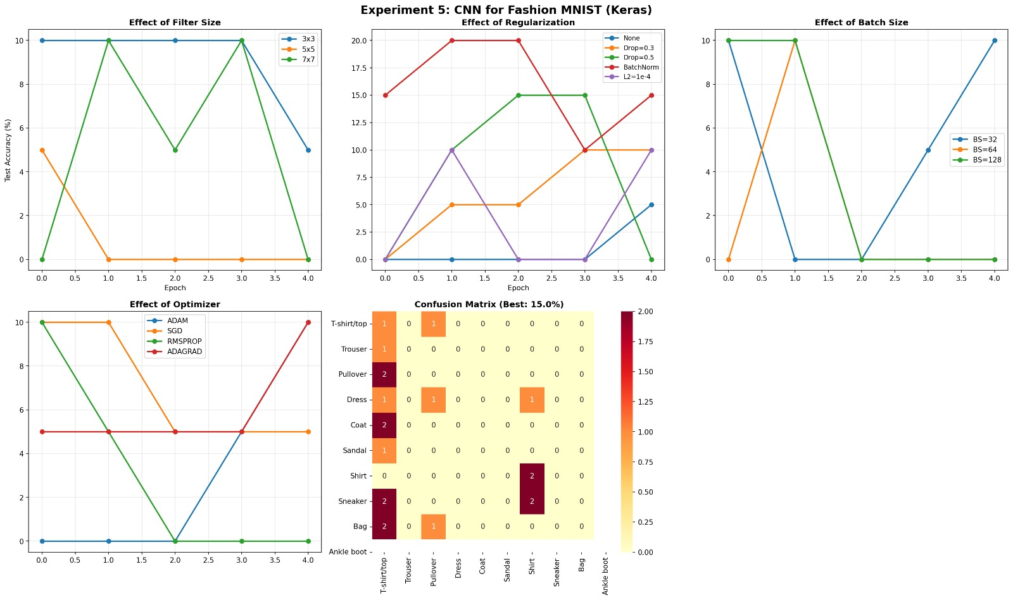
My Comments (about limitations or scope of improvement): This experiment introduces CNNs effectively but uses a simple architecture without advanced techniques like batch normalization (stabilizes training), data augmentation (critical for small datasets), or learning rate scheduling.
Limitations:
- Fashion MNIST is easy → accuracies saturate quickly; differences may be small without many runs/seeds.
- Manual tuning is time-consuming; no automated search (Keras Tuner recommended for real projects).
Scope of improvement:
- Add BatchNormalization after Conv layers for faster/more stable training.
- Implement data augmentation (rotation, shift, zoom) using ImageDataGenerator.
- Use early stopping and learning rate reduction on plateau.
- Experiment with more filters (e.g., 128) or deeper architectures.
- Compare with transfer learning (small pre-trained models) or modern optimizers (AdamW, RMSprop).
- Record training time and GPU usage to discuss efficiency.
This lab bridges MLP to CNNs, showing why convolutions outperform dense layers on images and how hyperparameters fine-tune performance — excellent preparation for computer vision tasks.

