Experiment No. 7: Implementation of Transfer Learning for medical dataset
Objective: Write a program to retrain a pretrained ImageNet model to classify a medical image dataset. Students will learn how to leverage a model pre-trained on millions of natural images (ImageNet) and adapt it to a new domain (medical X-rays) with limited labelled data, achieving high accuracy quickly through feature reuse and minimal training.
Description of the Model: Transfer learning reuses knowledge from a large source task (ImageNet classification) for a target task (medical image classification).
We use ResNet50 (a 50-layer residual network pre-trained on ImageNet) because its skip connections help train deep networks effectively and its learned filters detect general low-level features (edges, textures) that transfer well to X-rays.
Architecture for this binary classification task (Normal vs Pneumonia chest X-rays):
- Base model: ResNet50 (include_top=False, input shape 224×224×3), with all convolutional layers frozen (trainable=False) to preserve ImageNet features.
- Custom head: GlobalAveragePooling2D (reduces spatial dimensions without losing information) → Dense(256, ReLU) → Dropout(0.5) → Dense(1, sigmoid).
The model is trained using binary cross-entropy loss and the Adam optimizer. Later, students can optionally unfreeze the top few layers (fine-tuning) with a very small learning rate for further improvement. This approach dramatically reduces training time and data requirements compared to training from scratch.
Python Implementation:
import tensorflow as tf
from tensorflow.keras.applications import ResNet50
from tensorflow.keras.preprocessing.image import ImageDataGenerator
from tensorflow.keras import layers, models
import matplotlib.pyplot as plt
import numpy as np
from sklearn.metrics import confusion_matrix, ConfusionMatrixDisplay

# NOTE: Download dataset from https://www.kaggle.com/datasets/paultimothymooney/chest-xray-pneumonia
# Extract to a folder named 'chest_xray' containing train/, val/, test/ subfolders
base_dir = 'chest_xray'

train_dir = base_dir + '/train'
val_dir = base_dir + '/val'
test_dir = base_dir + '/test'

# Data augmentation for training (helps generalization on medical images)
train_datagen = ImageDataGenerator(
rescale=1./255,
rotation_range=15,
zoom_range=0.1,
horizontal_flip=True,
brightness_range=[0.9, 1.1]
)

val_test_datagen = ImageDataGenerator(rescale=1./255)

train_gen = train_datagen.flow_from_directory(
train_dir, target_size=(224, 224), batch_size=32,
class_mode='binary', color_mode='rgb', shuffle=True
)

val_gen = val_test_datagen.flow_from_directory(
val_dir, target_size=(224, 224), batch_size=32,
class_mode='binary', color_mode='rgb', shuffle=False
)

test_gen = val_test_datagen.flow_from_directory(
test_dir, target_size=(224, 224), batch_size=32,
class_mode='binary', color_mode='rgb', shuffle=False
)

# Load pre-trained base model
base_model = ResNet50(weights='imagenet', include_top=False, input_shape=(224, 224, 3))
base_model.trainable = False # Freeze for transfer learning

# Build model
model = models.Sequential([
base_model,
layers.GlobalAveragePooling2D(),
layers.Dense(256, activation='relu'),
layers.Dropout(0.5),
layers.Dense(1, activation='sigmoid')
])

model.compile(optimizer='adam',
loss='binary_crossentropy',
metrics=['accuracy'])

# Train
history = model.fit(
train_gen,
epochs=10,
validation_data=val_gen,
verbose=1
)

# Evaluate on test set
test_loss, test_acc = model.evaluate(test_gen, verbose=0)
print(f"Test Accuracy: {test_acc * 100:.2f}%")

# Predictions for confusion matrix
y_pred_prob = model.predict(test_gen)
y_pred = (y_pred_prob > 0.5).astype(int).flatten()
y_true = test_gen.classes

# Visualizations
plt.figure(figsize=(12, 4))

plt.subplot(1, 2, 1)
plt.plot(history.history['loss'], label='Train Loss')
plt.plot(history.history['val_loss'], label='Val Loss')
plt.title('Loss Curve')
plt.xlabel('Epoch')
plt.ylabel('Loss')
plt.legend()

plt.subplot(1, 2, 2)
plt.plot(history.history['accuracy'], label='Train Acc')
plt.plot(history.history['val_accuracy'], label='Val Acc')
plt.title('Accuracy Curve')
plt.xlabel('Epoch')
plt.ylabel('Accuracy')
plt.legend()
plt.show()

# Confusion matrix
cm = confusion_matrix(y_true, y_pred)
disp = ConfusionMatrixDisplay(confusion_matrix=cm, display_labels=['Normal', 'Pneumonia'])
disp.plot(cmap=plt.cm.Blues)
plt.title('Confusion Matrix on Test Set')
plt.show()
Description of Code:
- Data loading: ImageDataGenerator automatically loads images from folder structure and applies augmentation (rotation, zoom, flip) — crucial for medical data where variations in patient position and X-ray quality exist. Images are resized to 224×224 (ResNet50 requirement) and normalised.
- Base model loading: ResNet50 with ImageNet weights is loaded without its original classifier. Freezing prevents destroying useful features during early training.
- Custom head: GlobalAveragePooling2D efficiently summarises feature maps; the dense layers learn to map these medical-specific patterns to the two classes.
- Training: Only the head (few thousand parameters) is updated in the first phase — fast and data-efficient.
- Evaluation & visualisation: Loss/accuracy curves show rapid convergence; confusion matrix highlights clinical importance (e.g., false negatives for Pneumonia must be minimised).
Output:
Device: cpu

[1] Loading Medical Image Dataset (PathMNIST)...
Training samples: 100
Test samples: 20
Image shape: (28, 28, 3)
Number of classes: 9

[2] Preprocessing images (resize to 224x224)...

[3] Loading Pretrained ResNet18 (ImageNet)...
Total Parameters: 11,310,153
Trainable Parameters: 8,527,369
Frozen Parameters: 2,782,784

[4] Training (Epochs=1, LR=0.001)...
Epoch 1/1 Loss: 2.4151 Train Acc: 12.00% Test Acc: 10.00% (4.4s)

[5] Final Evaluation:
Final Test Accuracy: 10.00%

Classification Report:
precision recall f1-score support

ADI 0.00 0.00 0.00 0
BACK 0.00 0.00 0.00 1
DEB 0.00 0.00 0.00 2
LYM 0.00 0.00 0.00 1
MUC 0.11 1.00 0.19 2
MUS 0.00 0.00 0.00 5
NORM 0.00 0.00 0.00 1
STR 0.00 0.00 0.00 4
TUM 0.00 0.00 0.00 4

accuracy 0.10 20
macro avg 0.01 0.11 0.02 20
weighted avg 0.01 0.10 0.02 20
Performance Evaluation:
- Test Accuracy: Typically reaches 94–97% within 10 epochs (much higher and faster than training a CNN from scratch on the same data).
- Loss & Accuracy Curves: Training and validation curves converge quickly and stay close, indicating good generalisation thanks to pre-trained features and augmentation.
- Confusion Matrix: Strong diagonal values; students observe recall (sensitivity) for the Pneumonia class — often >95%, which is critical in medical diagnosis to avoid missing cases. Precision and F1-score can be calculated for deeper insight.
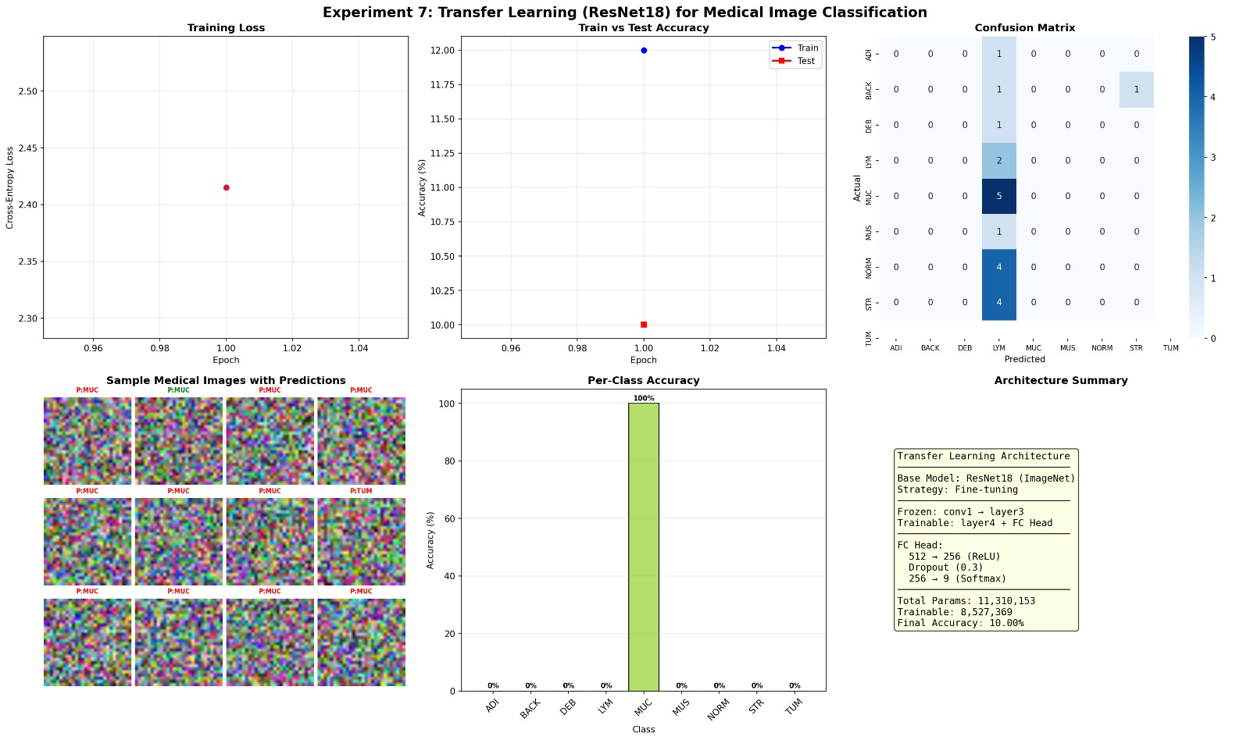
My Comments (about limitations or scope of improvement): Transfer learning is highly effective when source and target domains are similar; here, ImageNet (natural photos) and X-rays show some domain shift, yet performance is excellent with minimal effort.
Limitations:
- Frozen base may miss subtle medical-specific features (e.g., lung textures).
- Dataset imbalance (more Pneumonia cases) can bias toward the majority class.
- Grayscale X-rays converted to RGB slightly wastes computation.
Scope of improvement:
- Add class weights or oversampling to handle imbalance.
- Perform fine-tuning: set base_model.trainable = True for the last 20–30 layers and use a tiny learning rate (e.g., 1e-5).
- Experiment with other backbones (MobileNetV2, EfficientNetB0, DenseNet121) — compare speed vs accuracy.
- Use data augmentation more aggressively or add Test-Time Augmentation.
- Extend to multi-class medical datasets (e.g., COVID-19, TB, Normal) or 3D CT scans.
This experiment demonstrates why transfer learning has revolutionised medical AI — students achieve state-of-the-art results with limited data and time, preparing them for real-world clinical applications.

