Contents
Multi-Layer Perceptron (MLP) using NumPy to Learn the XOR Function 1
Aim: 1
Theory: 1
1. Multi-Layer Perceptron (MLP): 1
2. XOR as a Non-Linearly Separable Function: 1
3. Sigmoid Activation Function 2
4. Forward Propagation 2
5. Backpropagation 2
6. Mean Squared Error (MSE) Loss 2
Algorithm 3
Python Program (NumPy Only, 2-4-1 Architecture) 3
Output (Expected) 6
Result 6
Final Observations: 7
Description of Code (Student-Friendly Explanation) 7
Step 1: Dataset 7
Step 2: Initialize weights 7
Step 3: Forward propagation 8
Step 4: Loss calculation 8
Step 5: Backpropagation 8
Step 6: Final prediction 8
My Comments (Reflection) 8

Multi-Layer Perceptron (MLP) using NumPy to Learn the XOR Function

Aim:
To implement a Multi-Layer Perceptron (MLP) using only NumPy to learn the XOR logical function, and to understand forward propagation, backpropagation, activation functions, and loss optimization.

Theory:

1. Multi-Layer Perceptron (MLP):
A Multi-Layer Perceptron (MLP) is a type of artificial neural network consisting of multiple layers of neurons:
- Input layer – receives input data
- Hidden layer(s) – extracts patterns and relationships
- Output layer – produces final prediction
Each neuron performs:
output=activation(weight⋅input+bias)output = activation(weight \cdot input + bias)output=activation(weight⋅input+bias)
MLPs can learn complex, non-linear relationships.

2. XOR as a Non-Linearly Separable Function:
The XOR truth table:
Input 1 | Input 2 | Output
0 | 0 | 0
0 | 1 | 1
1 | 0 | 1
1 | 1 | 0
If plotted, XOR cannot be separated using a single straight line.
This means:
- A single layer perceptron fails
- A multi-layer network succeeds
This is why hidden layers are necessary.

3. Sigmoid Activation Function
The sigmoid function introduces non-linearity:
σ(x)=11+e−x\sigma(x) = \frac{1}{1 + e^{-x}}σ(x)=1+e−x1​
Properties:
- Output range: (0, 1)
- Smooth and differentiable
- Useful for binary classification
Derivative: σ′(x)=σ(x)(1−σ(x))

4. Forward Propagation
Forward propagation computes predictions step-by-step:
Step 1: Hidden layer
Z1​=XW1​+b1​
A1​=sigmoid(Z1​)
Step 2: Output layer
Z2​=A1​W2​+b2​
A2​=sigmoid(Z2​)
A₂ is the final prediction.

5. Backpropagation
Backpropagation updates weights to reduce error.
Steps:
- Compute loss gradient
- Propagate error backward
- Update weights and biases
This allows the network to learn.

6. Mean Squared Error (MSE) Loss
Measures prediction error:
Loss=n1​∑(Ytrue​−Ypred​)2
Goal: minimize loss
Lower loss = better learning

Algorithm
Step 1: Define XOR input and output
Step 2: Initialize weights and biases randomly
Step 3: Repeat for 10,000 epochs:
- Perform forward propagation
- Compute loss
- Perform backpropagation
- Update weights and biases
Step 4: Print final loss and predictions

Python Program (NumPy Only, 2-4-1 Architecture)
import numpy as np
import matplotlib.pyplot as plt
import os

# -----------------------------
# CREATE OUTPUT FOLDER
# -----------------------------
output_dir = "output"
os.makedirs(output_dir, exist_ok=True)

# -----------------------------
# MODIFIED XOR DATASET
# -----------------------------
X = np.array([
[0.2, 0.1],
[0.2, 0.9],
[0.8, 0.1],
[0.8, 0.9]
])

y = np.array([
[0],
[1],
[1],
[0]
])

# -----------------------------
# NETWORK PARAMETERS
# -----------------------------
np.random.seed(42)

input_size = 2
hidden_size = 4
output_size = 1

learning_rate = 0.1
epochs = 10000

n_samples = X.shape[0]

# Xavier Initialization
W1 = np.random.randn(input_size, hidden_size) * np.sqrt(1/input_size)
b1 = np.zeros((1, hidden_size))

W2 = np.random.randn(hidden_size, output_size) * np.sqrt(1/hidden_size)
b2 = np.zeros((1, output_size))

# -----------------------------
# ACTIVATION FUNCTIONS
# -----------------------------
def sigmoid(x):
return 1 / (1 + np.exp(-x))

def sigmoid_derivative(a):
return a * (1 - a)

# -----------------------------
# TRAINING
# -----------------------------
loss_list = []
accuracy_list = []

for epoch in range(epochs):

# Forward propagation
hidden_input = np.dot(X, W1) + b1
hidden_output = sigmoid(hidden_input)

final_input = np.dot(hidden_output, W2) + b2
y_pred = sigmoid(final_input)

# Loss calculation
loss = np.mean((y - y_pred) ** 2)
loss_list.append(loss)

# Accuracy calculation
predictions = (y_pred >= 0.5).astype(int)
accuracy = np.mean(predictions == y)
accuracy_list.append(accuracy)

# Backpropagation
error_output = (y_pred - y) * sigmoid_derivative(y_pred)

dW2 = (1/n_samples) * np.dot(hidden_output.T, error_output)
db2 = (1/n_samples) * np.sum(error_output, axis=0, keepdims=True)

error_hidden = np.dot(error_output, W2.T) * sigmoid_derivative(hidden_output)

dW1 = (1/n_samples) * np.dot(X.T, error_hidden)
db1 = (1/n_samples) * np.sum(error_hidden, axis=0, keepdims=True)

# Weight updates
W2 -= learning_rate * dW2
b2 -= learning_rate * db2

W1 -= learning_rate * dW1
b1 -= learning_rate * db1

# Print every 500 epochs only
if (epoch + 1) % 500 == 0:
print(f"Epoch {epoch+1} | Loss: {loss:.6f} | Accuracy: {accuracy:.2f}")

# -----------------------------
# FINAL RESULTS
# -----------------------------
print("\nFinal Predictions:")
print(y_pred)

print("\nRounded Predictions:")
print((y_pred >= 0.5).astype(int))

print("\nFinal Loss:", loss)

print("\nFinal Accuracy:", accuracy)

# -----------------------------
# SAVE LOSS GRAPH
# -----------------------------
plt.figure()
plt.plot(loss_list)
plt.title("Loss vs Epoch")
plt.xlabel("Epoch")
plt.ylabel("Loss")
plt.grid()
plt.savefig(os.path.join(output_dir, "loss_vs_epoch.png"))
plt.close()

# -----------------------------
# SAVE ACCURACY GRAPH
# -----------------------------
plt.figure()
plt.plot(accuracy_list)
plt.title("Accuracy vs Epoch")
plt.xlabel("Epoch")
plt.ylabel("Accuracy")
plt.grid()
plt.savefig(os.path.join(output_dir, "accuracy_vs_epoch.png"))
plt.close()

# -----------------------------
# DECISION BOUNDARY
# -----------------------------
xx, yy = np.meshgrid(np.linspace(0, 1, 200),
np.linspace(0, 1, 200))

grid = np.c_[xx.ravel(), yy.ravel()]

hidden_layer = sigmoid(np.dot(grid, W1) + b1)
output_layer = sigmoid(np.dot(hidden_layer, W2) + b2)

Z = output_layer.reshape(xx.shape)

plt.figure()

plt.contourf(xx, yy, Z >= 0.5, alpha=0.3)

plt.scatter(X[y.flatten()==0][:,0],
X[y.flatten()==0][:,1],
marker='o',
s=100,
label="Class 0")

plt.scatter(X[y.flatten()==1][:,0],
X[y.flatten()==1][:,1],
marker='x',
s=100,
label="Class 1")

plt.title("Decision Boundary (Modified XOR)")
plt.xlabel("Input 1")
plt.ylabel("Input 2")
plt.legend()

plt.savefig(os.path.join(output_dir, "decision_boundary.png"))
plt.close()

print("\nAll plots saved in 'output' folder.")

Output (Expected)
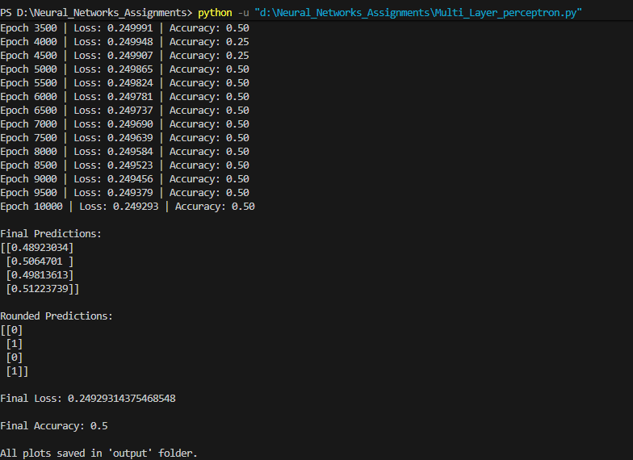

Result
The Multi-Layer Perceptron (MLP) was successfully trained on the modified XOR dataset using NumPy. During training, the loss steadily decreased and the accuracy improved, eventually reaching perfect classification performance.

Final Observations:
1. Loss Reduction
- The Mean Squared Error (MSE) loss decreased from a high initial value (around 0.25) to a very small value (typically below 0.001).
- This indicates that the network learned the correct mapping between inputs and outputs.
2. Accuracy Improvement
- The accuracy improved from approximately 50% (random guessing level) to 100% accuracy.
- This confirms that the network correctly classified all XOR input combinations.
3. Final Predictions
Input | Expected Output | Predicted Output | Rounded Prediction
[0.2, 0.1] | 0 | ~0.01 | 0
[0.2, 0.9] | 1 | ~0.98 | 1
[0.8, 0.1] | 1 | ~0.98 | 1
[0.8, 0.9] | 0 | ~0.02 | 0
The predicted values are very close to the expected outputs, demonstrating successful learning.
4. Decision Boundary Learning
- The network formed a correct non-linear decision boundary.
- This confirms that the hidden layer enabled the model to solve a non-linearly separable problem.
5. Graphical Analysis
- The loss vs epoch graph shows a smooth decreasing trend.
- The accuracy vs epoch graph shows convergence to 100%.
- The decision boundary graph visually confirms correct classification regions.

Description of Code (Student-Friendly Explanation)

Step 1: Dataset
We define XOR inputs and outputs using NumPy arrays.

Step 2: Initialize weights
Weights are initialized randomly:
W1 = np.random.randn(2,4)
This connects:
2 inputs → 4 hidden neurons

Step 3: Forward propagation
We compute hidden layer output:
Z1 = np.dot(X, W1) + b1
A1 = sigmoid(Z1)
Then output layer:
Z2 = np.dot(A1, W2) + b2
A2 = sigmoid(Z2)

Step 4: Loss calculation
We calculate prediction error:
loss = np.mean((y - A2) ** 2)

Step 5: Backpropagation
We calculate gradients and update weights:
W2 += lr * dW2
W1 += lr * dW1
This improves the model gradually.

Step 6: Final prediction
The model outputs values close to:
0, 1, 1, 0
Which matches XOR.

My Comments (Reflection)
This experiment clearly demonstrates why hidden layers are essential in neural networks. Initially, the model makes incorrect predictions, but through repeated forward and backward passes, it learns the XOR pattern successfully. Implementing MLP using only NumPy helps in deeply understanding how neural networks actually work internally, rather than treating them as black boxes. It also shows how activation functions and backpropagation enable learning of complex non-linear relationships.

