Git : https://www.youtube.com/watch?v=AJnehyqg1u8&list=PL9ok7C7Yn9A97SmHoNC65ao1TeunDdQW6&index=2

Git init :If normal folder has file it can’t be versioned, SO to track it’s version we use git init

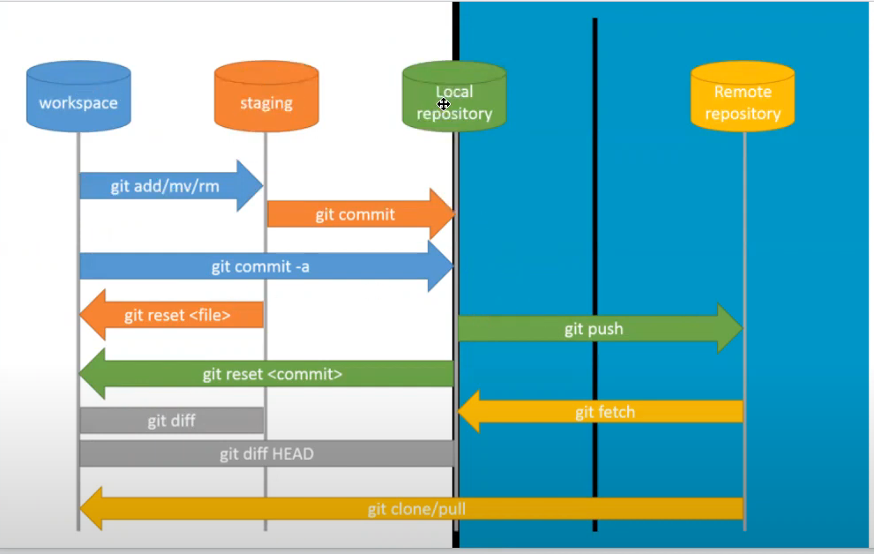

If you are creating new proj from your local and want to push it to new Repo in github.

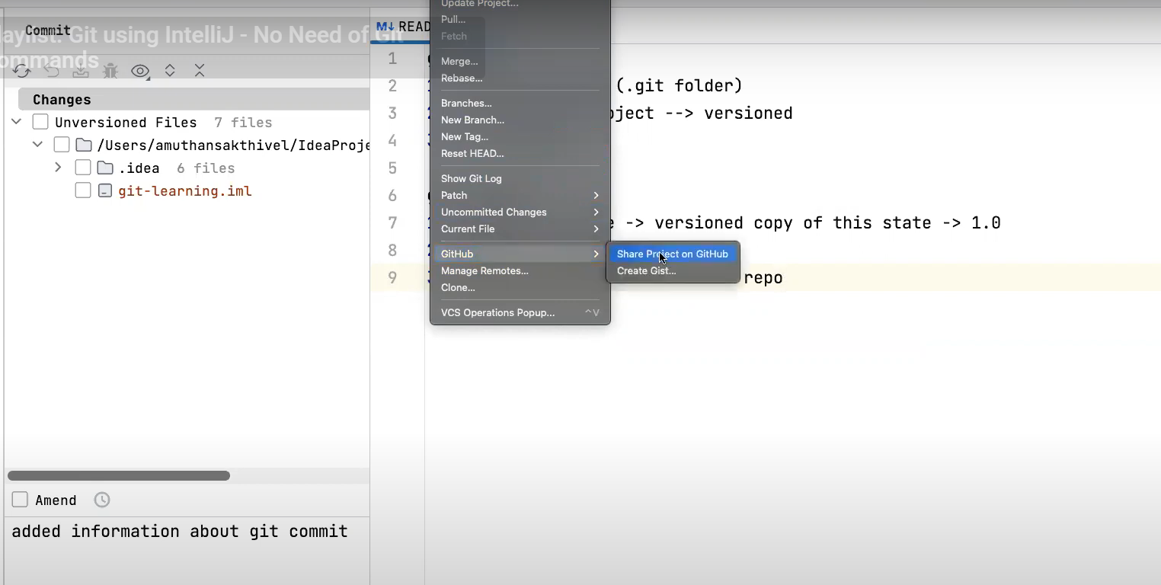

If there are multiple github accounts choose yours (Else you have option to configure new one if you have 3rd or any other)

3rd or any other below :

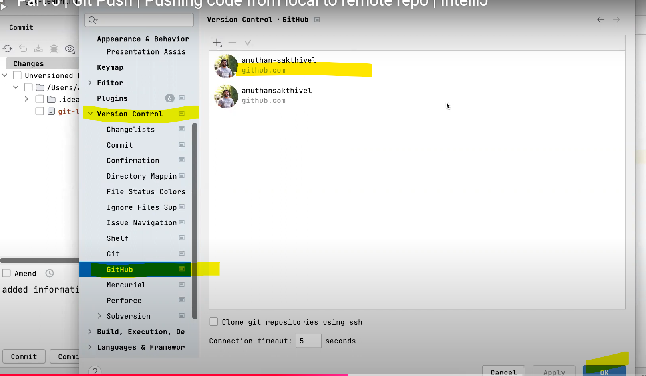

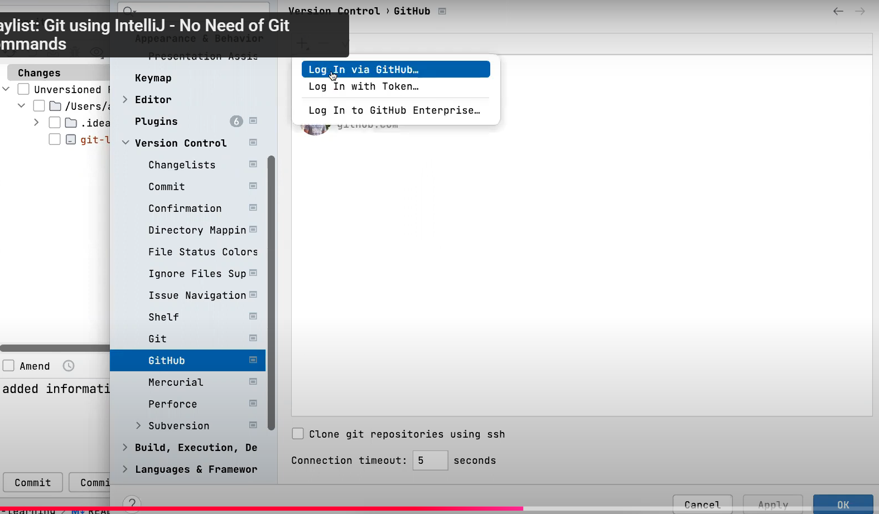

Git fetch will only pull changes to your local repo

Fetching changes from local repo to workspace is called merge

Git pull will pull changes from remote repo to your workspace

Fetch + Merge = Pull

Renaming branches :

Open branch list (3 branches)

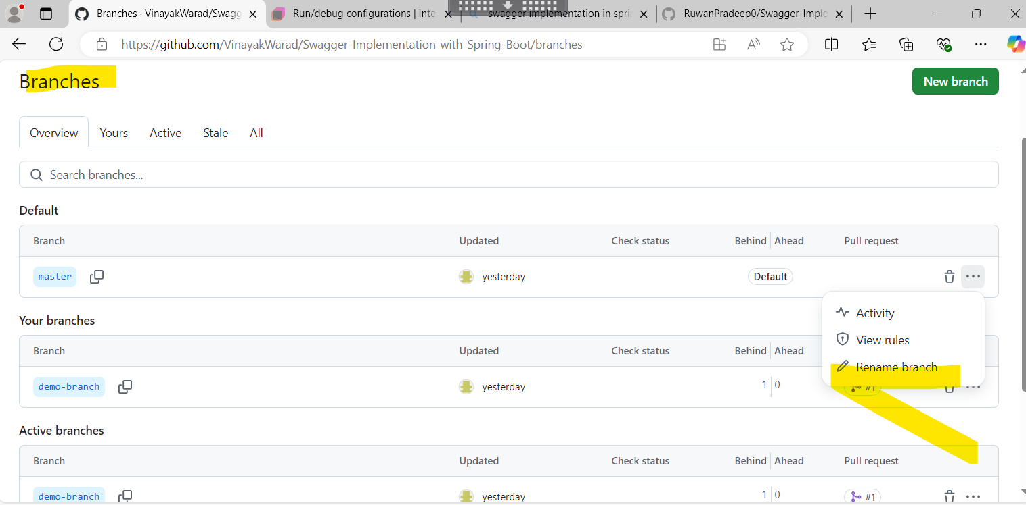



Revert commit : If you revert commit history will still be maintained, At any point you can come to that commit point and cherry pick that commit.

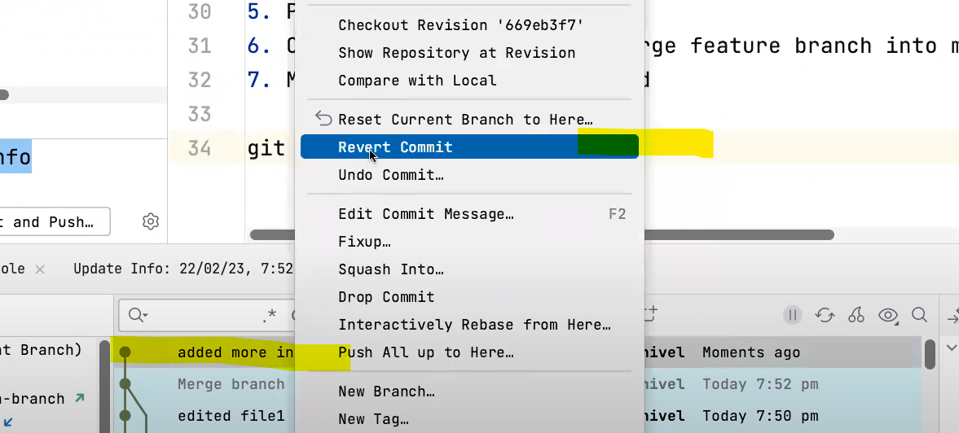

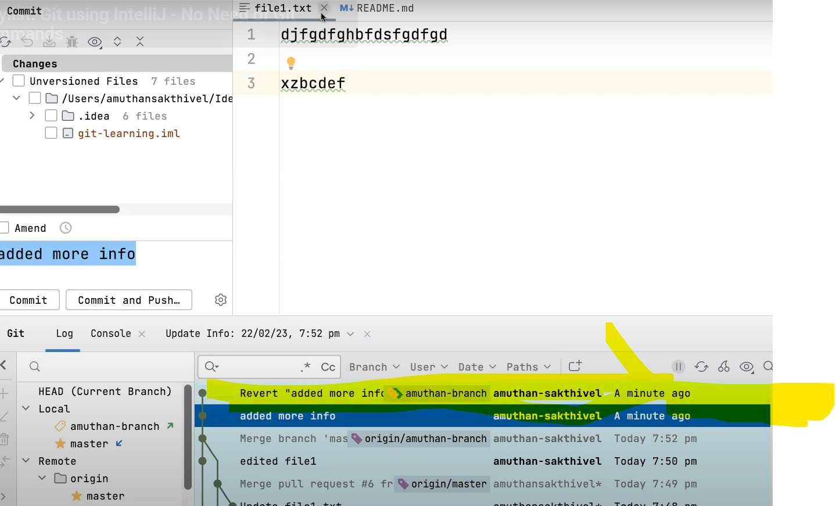

Drop Commit :

History is not maintained

Dropped commit history will not be present: (From above we dropped revert commit – Line 1 commit). Data will be irreversibly lost

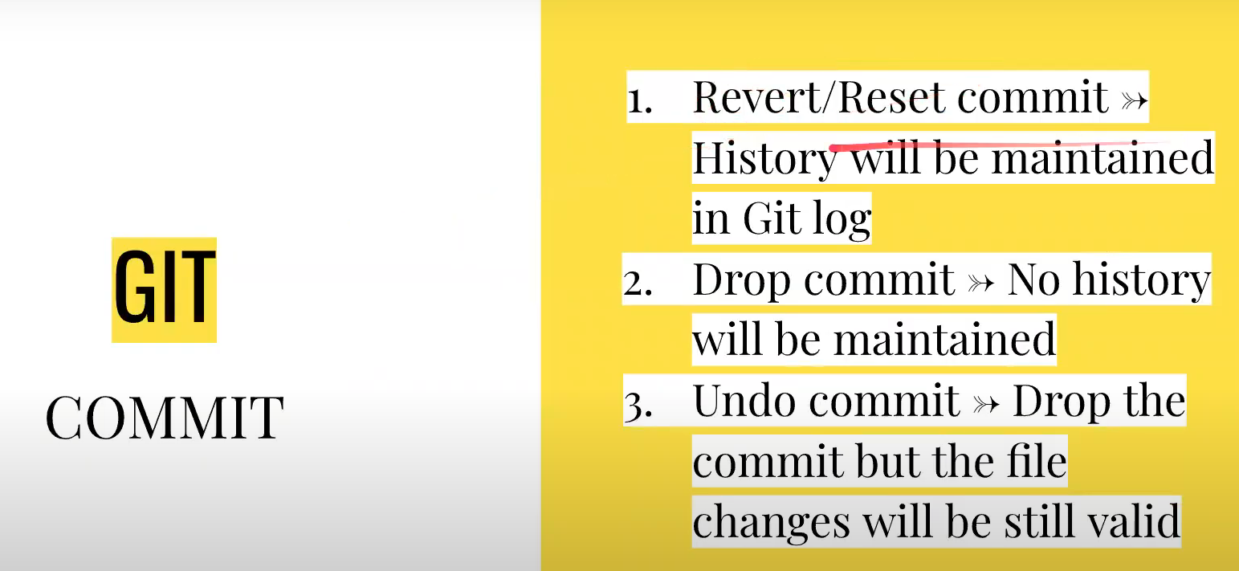

Cherrypick :

<https://www.youtube.com/watch?v=oQBwXZdEDGs&list=PL9ok7C7Yn9A97SmHoNC65ao1TeunDdQW6&index=11>



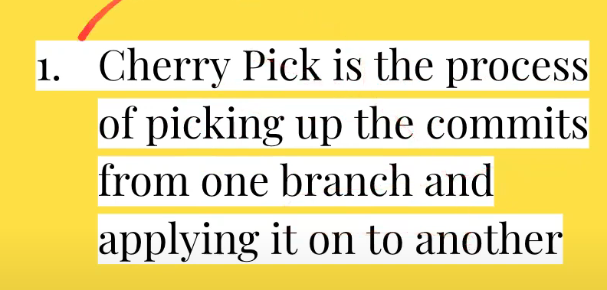

Git stash :

Consider you are on your master branch ,If you have done any changes in you workspace while you are in this branch and you have just moved them to staging and not yet committed. Then you can stash them (Now you can checkout to new branch(branch1) and work on any changes required in branch1 and also if you want the stashed changes from master branch in this branch you can still use them by unstashing here in you branch1)