Adversarial Password Cracking

Thejas S
Computer Science & Engineering
PES University
Bangalore, Karnataka, India
s.thejas99@gmail.com
Vinayaka M Hegde
Computer Science & Engineering
PES University
Bangalore, Karnataka, India
vinuvinayaka2000@gmail.com
Prof. Sushma E
Assistant Professor
Computer Science & Engineering
PES University
Bangalore, Karnataka, India sushmae@pes.edu

Abstract—Generative adversarial networks are a class of machine learning framework which is used to generate new data based on the data which it is trained on. It is unsupervised, therefore it identifies and learns if any patterns present in data. In this project, we use this model to generate passwords. There are many existing techniques to generate password guesses which include brute force, rule based generation, etc. Creating rules requires expertise and is time consuming. This model will be able to learn hidden patterns automatically and thus is easier to use. In addition, this can also be used to determine the strength of the password.

Keywords — password, generative, rule-based, machine learning, GAN

Introduction

Passwords are being used for authentication purposes for a long time. It is easy and convenient for implementing and using it. Companies need to make sure that the user’s passwords are not compromised. If compromised it can be misused which affects the user’s account which may lead to loss of money, comprise identity, etc. In the past there were many attempts to hack the databases and has also happened which is concerning. The passwords are stored in hashed form in the database. If the passwords are strong enough, it will be very difficult to crack it. There are numerous ways like dictionary attack, rule based attack, etc to crack the passwords. These methods require expertise and are time consuming tasks. The output space is also limited.

Generative adversarial networks can be used to generate passwords that humans are likely to use. We need to train the model based on a list of real passwords. This data is available as there instances in which the compromised passwords were put online. These GAN’s without the domain knowledge will be able to understand how passwords are created and once properly trained, they will generate passwords which are likely used. This approach does not require for us to input any rules, only a list of passwords are required to train the model.

Well trained models can be used to substitute or used in addition to the existing tools for password cracking. Certain patterns in passwords which might not be easy to identify by humans can be understood by this model. The output space of this model is not limited and can be used to generate many passwords.

This model can be used as a security measure where the user can check for easily crackable passwords. It can find its applications in checking password strength.

GENERATIVE ADVERSARIAL NETWORKS

Generative adversarial network is a generative model which consist of two main components called generator and discriminator. It can be used to generate data similar to the training dataset. The discriminator distinguishes between real and fake data. The generator tries to fool the discriminator.
GANs are an approach to generative modeling using deep learning. GAN is an unsupervised learning model with two sub-models : Generator and Discriminator. The generator model is trained to generate new examples, and the discriminator model is trained to classify examples as either real (from the domain) or fake (generated). The two models are trained together in a zero-sum game, adversarial, until the discriminator model is fooled about half the time, meaning the generator model is generating plausible examples.

Flowchart of working of GAN :

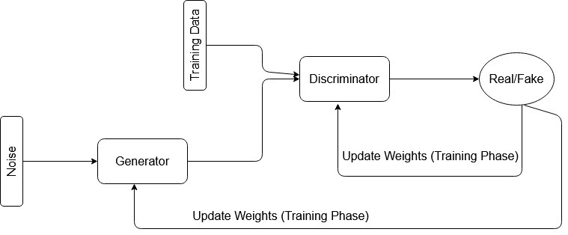

PROBLEM DEFINITION

Password generation is a very common security issue. Many users face the problem of choosing good passwords and try to make sure it is strong and not guessable. Train a generative adversarial network which has 2 components namely generator and discrimintor. Generator should generate password guesses to break a password scheme and the discriminator tries to prevent the generator from breaking the password scheme. In other words, discriminator tries to distinguish between real password and the generated password and the generator tries to generate a real looking password to fool discriminator. There should be provision to train the model based on different datasets and provision to generate the required number of passwords. There should also be provision to determine the strength of a given password based on likeness of being able to guess the password. The proposed model can be used as a security measure where the user can check for easily crackable passwords. It can find its applications in checking password strength. Compare this model with other tools like hashcat and check the strength of the password using zxcvbn.

PRIOR WORK

In this chapter, we analyse the research made and results obtained in the field of the project, by taking into account the various parameters and extent of the project.

[1]
In this paper, a generative adversarial network is trained with a generator trying to generate guesses to break a password scheme. The author has later compared the strength of this adversarial model with rule based methods such as hashcat . Later, the passwords cracked by PassGAN are compared with results of zxcvbn, to determine if the passwords cracked by PassGAN were actually hard to crack. The author suggests using a machine learning based approach for password guessing which is called PassGAN. PassGAN is a generative adversarial network where the generator tries to generate a fake password to fool the discriminator and discriminator tries to distinguish real passwords from fake passwords ( passwords generated by generator ). They both end up playing a minimax game and optimize the value function given by Equation 1. (1) min G max D V (D, G) = Ex∼pdata(x) [log(D(x))] + Ez∼pz(z) [log(1 − G(z))] The author has trained the PassGAN model on two datasets - one is RockYou and second is AshleyMadison dataset. Further, an extended version of RockYou dataset was created by including slightly modified variations of the passwords, to represent a more realistic set of passwords. The network was trained upto 70k iterations and a plot of training loss versus iterations is represented by Figure 1.

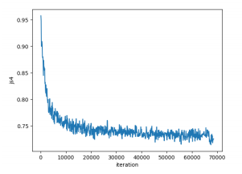
Figure 1 : Training loss v/s number of iterations

After training, the set of passwords cracked using PassGAN was evaluated using zxcvbn and the results for RockYou
and extended RockYou dataset are summarized in Table 1. From this table, we can infer that the average number of guesses for extended RockYou is high since it is a much randomized version of rockYou dataset.

[2]
In this paper, the author argues that GANs generate high quality password guesses, and can match 51 to 73 percent more passwords than the traditional rule based methods. This shows that deep learning methods can be used for password cracking. The paper begins by stating how carelessness of users can be exploited by malicious hackers in this online world. Next, the paper presents us with various kinds of attacks used by state of the art password guessing tools such as hashcat. Brute force attack generates passwords by going through a combination of characters upto a given length. Dictionary based attacks use a list of words, either from a dictionary or commonly used passwords revealed from past password leaks, and then turn them into hashes. Then, it checks these hashes against the unknown hash to crack the unknown hash. Dictionary attacks often succeed because people have a natural tendency to choose ordinary words or common passwords with little variants. Rule based attacks use a set of rules on top of the dictionary list.

For example, there could be a rule for concatenating all passwords with some numbers since these kinds of passwords are highly probable. The paper evaluated the performance of PassGAN by running the model on different datasets. The results prove that PassGAN can match 51 to 73 percent more passwords than the traditional rule based methods. Additionally, it was found that the best overall performance was achieved when PassGAN was combined with other techniques, specifically when PassGAN and HashCat were used jointly. This concludes that PassGAN was able to generate real-like passwords and when hashcat was used on these passwords, it was able to perform much better since the password list generated by PassGAN consisted of highly probable passwords.

The author concludes by stating that PassGAN can be effectively used to generate passwords that resemble real passwords since it can extract properties of passwords which could be indistinguishable to human observation. Also, PassGAN can be used without a priori knowledge of the structure of passwords. Also, PassGAN can generate passwords indefinitely whereas other tools can generate a limited number of passwords. The best overall performance was achieved when PassGAN was combined with other rule based techniques.

[3]
This paper is the first attempt to apply deep learning models like PassGAN to the password guessing problem. In this paper, the author starts by stating various kinds of rule based methods available for cracking passwords and later compares the results of using these methods with respect to that of PassGAN. Moving on to the architecture of PassGAN, this paper uses the Wassertian GANs (IWGANs) with Adam optimizer. Various hyperparameters like batch size, number of iterations, output sequence length, size of the input vector have been stated. IWGAN is implemented using ResNets since ResNets continuously reduce the training error as the number of layers increases. Residual Blocks are composed of two 1-dimensional convolutional layers, connected with one another with rectified linear units (ReLU) activation functions. PassGAN was tested on the classic RockYou dataset and linkedin leaked dataset. Figure (2) represents the number of unique passwords generated by PassGAN trained using the RockYou dataset. From the figure, we can infer that the number of passwords matched increased until 199,000 iterations. And after that, increasing the number of iterations reduced the number of passwords matched which implies the model started to overfit. So, after 199,000 iterations, the training was stopped.

When PassGAN was compared with hashcat, the results showed that it was able to match more passwords than hashcat and the most important observation was that PassGAN was able to guess passwords from a dataset different from the one it was trained on. The paper concludes by stating major advantages of PassGAN over rule based approaches and in which situations rule based methods are preferred over PassGAN. It has been observed that rule based methods were able to outperform when the number of guesses allowed to crack a password was small. However, the main downside of rule-based password guessing is that rules can generate only a finite, relatively small set of passwords. In contrast, PassGAN was able to eventually generate a large number of passwords. As a result, the best password guessing strategy is to use multiple tools since it was observed that by combining the output of PassGAN with the output of the Best64 rules, 50.8% more passwords could be matched.

[4]
The paper introduces various kinds of data breaches and the possible causes for the same. Then, it investigates how well the PassGAN model performs when trained on a large dataset. PassGAN was trained on the Russian email -based dataset and was found that PassGAN did not perform very well when trained on the dataset. After providing suitable explanations for the above mentioned result, the paper concludes by stating some key points to be remembered while training GANs on any type of data. The paper first introduces various kinds of data breaches using attacks like dictionary attack, brute force, rainbow table attack, etc. Dictionary attacks can be described as guessing passwords by using a specialized wordlist .

Brute force attack uses scripts to generate passwords systematically. But, the downside is that for every increasing character, time taken by brute force to crack password, increases exponentially. Rainbow table attacks store pre-computed hash values so that time taken to crack a password significantly reduces. Next, the paper explores various causes for data breaches. The most common is weak credentials or choosing the same passwords for multiple websites. In phishing, the attacker tries to disguise as a legitimate entity to gain access to sensitive information. Social engineering involves using manipulating tricks to get sensitive information. Ransomware is becoming increasingly popular where data of an organization is infected, and restricted until a ransom amount is paid. After the model is trained on the Russian email-based dataset, few interesting results were obtained. The most interesting result was the fact that PassGAN was able to detect passwords based on reverse translation technique, where russian words were written in english.
These words may seem gibberish to english-speaking users but they are easily recognized by russians. Analysing the results, the paper concluded that PassGAN did not perform very well when trained on this particular dataset. Table(3) represents the passwords that were not matched by PassGAN. On analysing passwords from Table(3) , it was found that since there was a lot of variation in the structure of passwords in the dataset , PassGAN could not learn a proper distribution that could represent the passwords in the dataset.

DESIGN DESCRIPTION
We aim to use generative, unsupervised model like GAN to generate more likely password guesses. The GAN model consists of two networks called Generator and Discriminator.

Generator is a network that is trained to generate passwords by learning the distribution of the input dataset. Discriminator labels the passwords generated by generator as real passwords or generated passwords.
Model is said to be trained when the discriminator is unable to label the password as real password or generated password. After training, discriminator is removed and we use generator to generate a password dataset that can be used to crack passwords. Also, discriminator can be used to evaluate the strength of a given input password.
The assumptions made are listed below :
- The training dataset quality is good and volume is high
- Fast cpu/gpu is available to train faster

The Dependencies of the project are listed below :
- The model uses some of the tensorflow and keras inbuilt libraries for implementation.

The Constraints for the project are listed below :
- The performance of the model is constrained by the amount and quality of the dataset being used to train the model.

The following diagram indicates the Master Class Diagram of the project :

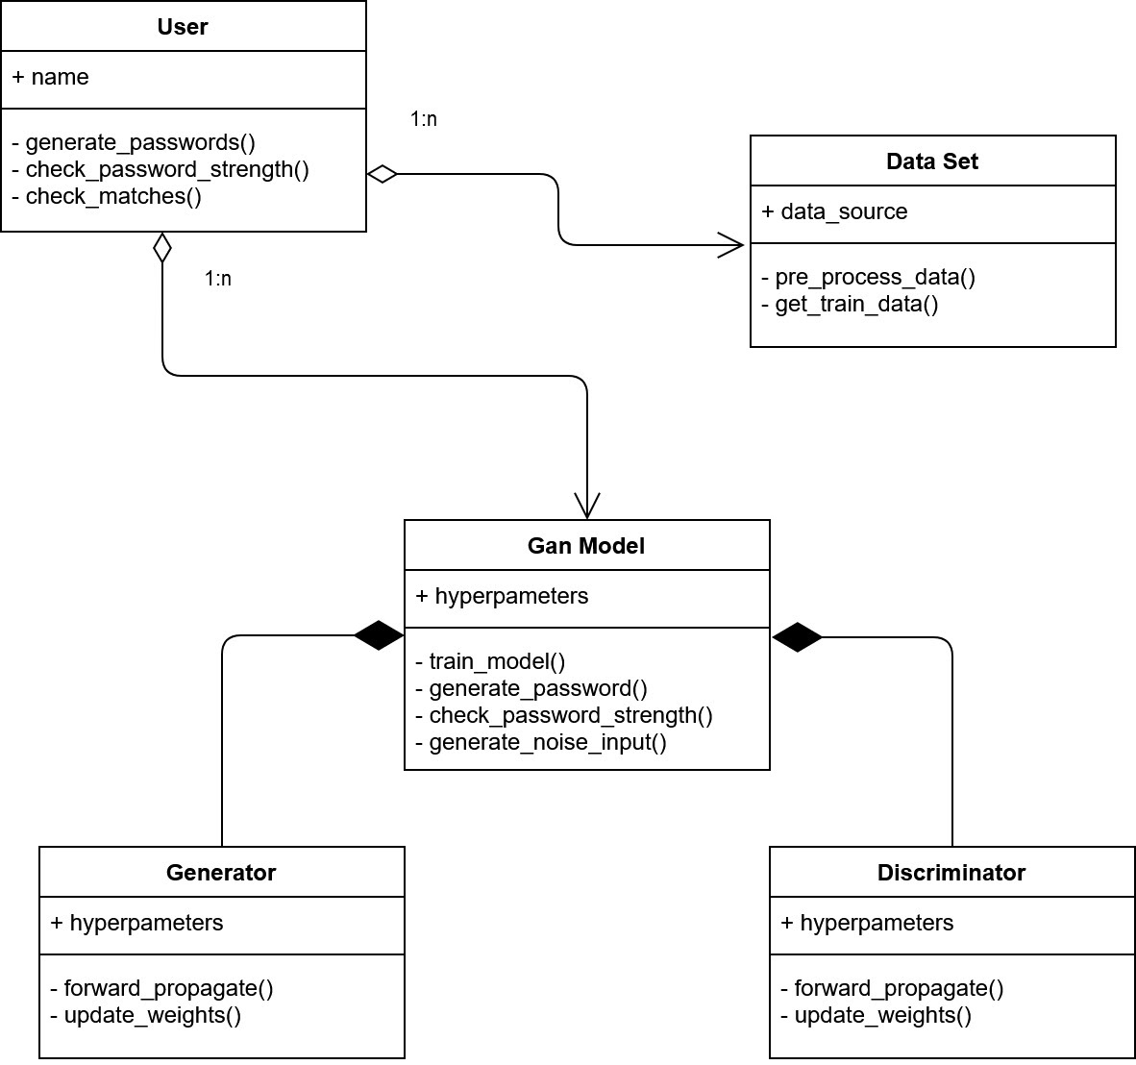
The following diagram indicates the Sequence Diagram of the project :

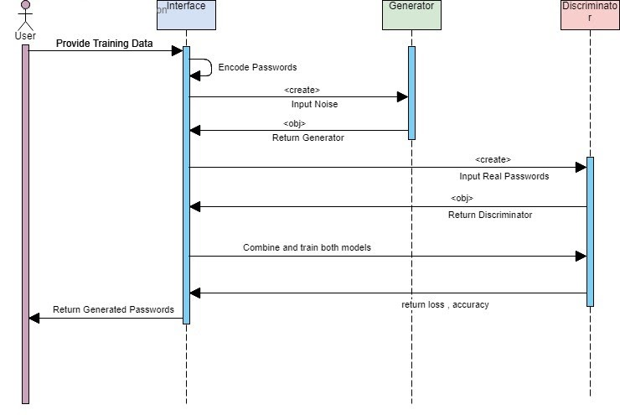

ACKNOWLEDGEMENT

We would like to express our gratitude to Prof. Sushma E, Department of Computer Science and Engineering, PES University, for her continuous guidance, assistance, and encouragement throughout the development of this entire project.

We are grateful to the project coordinators, Prof. Silviya Nancy and Prof. Sunitha R for organizing, managing, and helping with the entire process. We take this opportunity to thank Dr. Shylaja S S, Chairperson, Department of Computer Science and Engineering, PES University, for all the knowledge and support we have received from the department.

We would like to thank Dr. B.K. Keshavan, Dean of Faculty, PES University for his help. We are deeply grateful to Dr. M. R. Doreswamy, Chancellor, PES University, Prof. Jawahar Doreswamy, Pro Chancellor – PES University, Dr. Suryaprasad J, Vice-Chancellor, PES University for providing to us various opportunities and enlightenment every step of the way. Finally, this project could not have been completed without the continual support and encouragement we have received from our family and friends.

References

- Nepal, Suman, Isaac Kontomah, Ini Oguntola, and Daniel Wang. "Adversarial Password Cracking."

- Chen, Annie. "Presenting New Dangers: A Deep Learning Approach to Password Cracking."

- Hitaj, Briland, Paolo Gasti, Giuseppe Ateniese, and Fernando Perez-Cruz. "Passgan: A deep learning approach for password guessing." In International Conference on Applied Cryptography and Network Security, pp. 217-237. Springer, Cham, 2019.

- Garg, V., & Ahuja, L. (2019, October). Password Guessing Using Deep Learning. In 2019 2nd International Conference on Power Energy, Environment and Intelligent Control (PEEIC) (pp. 38-40). IEEE.

- Nam, Sungyup, Seungho Jeon, and Jongsub Moon. "Generating Optimized Guessing Candidates toward Better Password Cracking from Multi-Dictionaries Using Relativistic GAN." Applied Sciences 10, no. 20 (2020): 7306.

- Goodfellow, Ian J., Jean Pouget-Abadie, Mehdi Mirza, Bing Xu, David Warde-Farley, Sherjil Ozair, Aaron Courville, and Yoshua Bengio. "Generative adversarial networks." arXiv preprint arXiv:1406.2661 (2014).

- Malik, A. Survey Paper on Applications of Generative Adversarial Networks in the Field of Social Media. International Journal of Computer Applications, 975, 8887.

