**Assignment : Mobile World**

Design an application for mobile management. This application should read the records from Collection and display on console . There will be 2 functionalities required to be implemented.

1. Sorting of all Mobile Records based on given criteria
2. Delete mobile record based on mobile Code.
3. **Display appropriate menu**

This functionality starts with displaying "Welcome to Mobile World” :

< Display All Mobile Records from Collection Here >

Then It Should Ask the user for operation:

1. Sorting
2. Delete
3. **Sorting Records**

Display Below shown Menu for Accepting sorting criteria :

1. Mobile Name
2. Mobile Price
3. Mobile Id

Accept the choice from User :

Then Application should display the list of all mobiles based on given criteria.

Please refer to Below Screen sample :

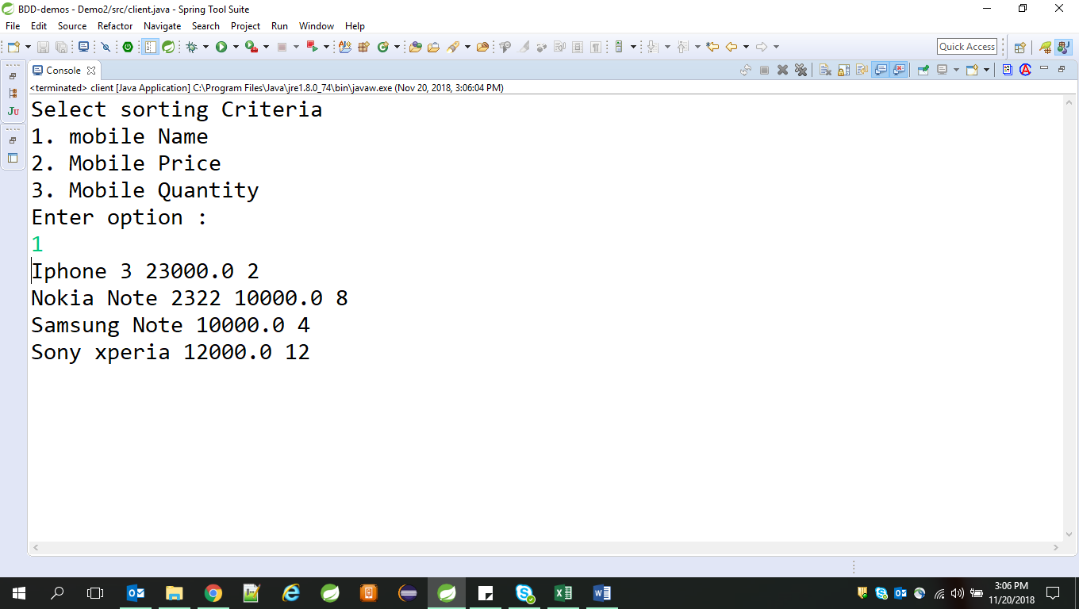

1. **Delete Mobile record :**

Accept the Mobile Id from user and delete that record from collection .

After deleting ,display all records once again.

**Classes to be created**

**com.cg.mobshop.ui** // package containing main class

class MainUI{

public static void main(// to display the menu and accept the details from user

// create object for service class and execute the respective methods

}

**com.cg.mobshop.dto** //package containing all beans

public class Mobiles{

private String mobileId

private String name;

private String price;

private String quantity;

// getter, setter,toString & constructor

}

**com.cg.mobshop.service** // package with service layer class

public interface MobileSerice {

public List<Mobiles> getMobileList();

public Mobile deleteMobile(int mobcode);

public List<Mobiles> SortList(int criteria);

public class MobileServiceImpl implements MobileService{ …….. }

**com.cg.mobshop.dao -**// package containing data access class to perform database operations.

public interface MobileDAO {

}

public class MobileDAOImpl implements MobileDAO{

……………

}

**com.cg.mobshop.util -**// package containing data access class to perform utilityoperations

public class Util{

private static Map<Integer, Mobiles> mobileEntries=new HashMap<Integer,Mobiles>();

public static Map<Integer,Mobiles> getMobileEntries(){

mobileEntries.put(101, new Mobiles(101, "Sony xperia", 12, 12000));

mobileEntries.put(102, new Mobiles(102, "Samsung Note", 4, 10000));

mobileEntries.put(103, new Mobiles(103, "Iphone 3", 2, 23000));

mobileEntries.put(104, new Mobiles(104, "Nokia Note 2322", 8, 10000));

return mobileEntries;

}

}

Add appropriate user defined exception classes required.