Fine-Tuning Stable Diffusion for Synthetic Generation of Nuclear Fuel Bundle Images

Vinayak Goyal
August 12, 2024

Contents
1.0 Statement of Problem 3
2.0 Project Objectives 3
3.0 Scope of Work 3
4.0 Method and Assumptions 3
4.1 Use of Software 3
4.2 Dataset 4
4.3 Approach 4
4.3.1 Data Preparation 4
4.3.2 Initial Training 4
4.3.3 Data Refinement and Re-lableing 4
4.3.4 Focused Training 5
5.0 Conclusion 7

Statement of Problem
Generating realistic synthetic images of nuclear fuel bundles is a challenging task due to the complexity and diversity of their designs. Traditional approaches to obtaining images are constrained by the sensitive nature of the material and the environment in which the images must be captured. These constraints create a need for an alternative method to produce high-quality images that accurately represent nuclear fuel bundles.
The objective is to develop a generative model capable of producing synthetic images of nuclear fuel bundles. However, given the variations in fuel bundle designs, training a model that can generate distinct and realistic images is difficult. A major challenge lies in ensuring the model does not overfit, which could lead to the production of less diverse and less accurate images.

Project Objectives
The project aims to fine-tune a Stable Diffusion model to generate high-quality synthetic images of nuclear fuel bundles. The goal is to create a model that can produce images with sufficient realism and diversity, representing various possible designs of nuclear fuel bundles. The deliverables from this project should demonstrate the model's capability to generate clear, distinct images, avoiding issues such as overfitting, which could compromise the quality of the outputs.

Scope of Work
This project involves fine-tuning a stable diffusion model on a nuclear fuel bundle dataset. The aim is to train a model to generate synthetic images of nuclear fuel bundles. The fine-tuning process will be conducted using Google Colab, leveraging GPUs to accelerate the training process.

Method and Assumptions
The project's method and assumptions are detailed as follows, ensuring compliance with applicable codes, standards, and best practices:

Use of Software
The following software and dependencies were utilized for this project:
- Python Version: 3.10.12
- Datasets: 2.20.0
- Pytorch: 2.4.0
- Diffusers: 0.30.0
- Bitsandbytes: 0.43.3
The training was performed in a Google Colab environment, using an Ubuntu 18.04 operating system. The stable diffusion v1.4 model from Huggingface was chosen for its pre-existing capabilities in segmentation tasks.

Dataset
The dataset collected by the team manually includes 307 images. The images are split and labeled into 3 categories by shape which are cylinder, rectangular and octagon. There are 144 for cylinder, 77 for rectangular and 55 for octagon. A metadata csv is also created to map each image with a description for training.

Figure 1: Example image from each category
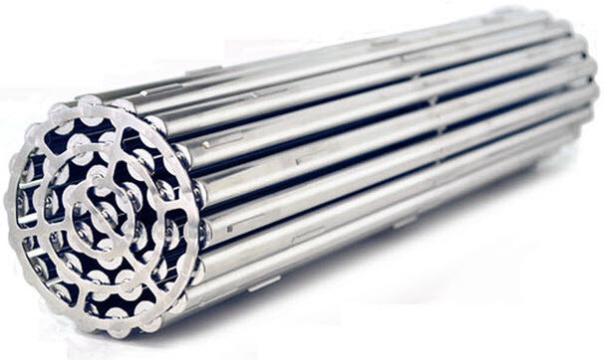

Approach

Data Preparation
The first step involved creating a metadata CSV file that served as the foundation for training the Stable Diffusion model. Initially, all images in the dataset were labeled with a general description, "nuclear fuel bundle." This uniform labeling was intended to guide the model in learning the core features of nuclear fuel bundles during the training phase.

Initial Training
We began by training two versions of the Stable Diffusion model: v1.2 and v1.4 by CompVis from Huggingface. Each version was trained for 1000 and 2000 epochs, respectively. All training is run in Google Colab with T4 Gpu. The training was carried out on the dataset with the general "nuclear fuel bundle" label. Despite the extended training periods, the generated images were often chaotic and unstructured. The models appeared to blend features from different types of fuel bundles, resulting in images that lacked clear and distinct characteristics

Data Refinement and Re-lableing
To address the issue of mixed features, the dataset was restructured into three distinct categories based on the shape of the fuel bundles:
- Cylinder-shaped Nuclear Fuel Bundles
- Rectangular-shaped Nuclear Fuel Bundles
- Octagon-shaped Nuclear Fuel Bundles
Each image was then re-labeled with a description that combined the shape and the term "nuclear fuel bundle." This refinement aimed to help the model differentiate between the varying shapes and features associated with each type of fuel bundle.

Focused Training
With the refined dataset, we focused on retraining the Stable Diffusion v1.4 model. The initial retraining was conducted for 1000 epochs, yielding noticeably improved results. Encouraged by this progress, the model was further trained for 2000, 3000, and 5000 epochs, which took 53 minutes, 1 hour and 20 minutes, and 2 hours and 13 minutes, respectively. After 2000 epochs, the generated images showed clear differentiation: cylinder-shaped images were good, reflecting the model's ability to learn and replicate the cylindrical structures; rectangular-shaped images were less accurate but still showed improvement compared to earlier epochs; and octagon-shaped images remained very messy and unstructured, likely due to the smaller number of octagon images in the dataset. These results were expected, given the distribution of images in the dataset, with more images of cylinders followed by rectangular shapes. This observation led to the decision to continue training the model.
Figure 2: generated images for 2000 epochs
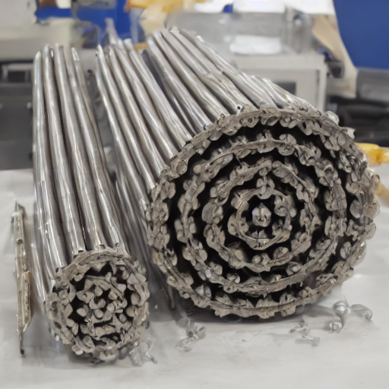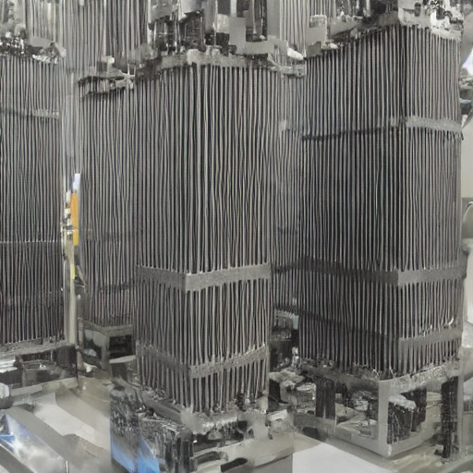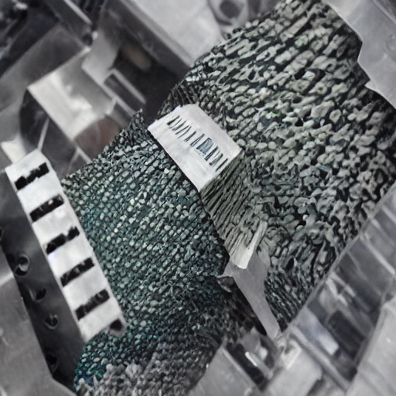
Figure 3: generated images for 3000 epochs
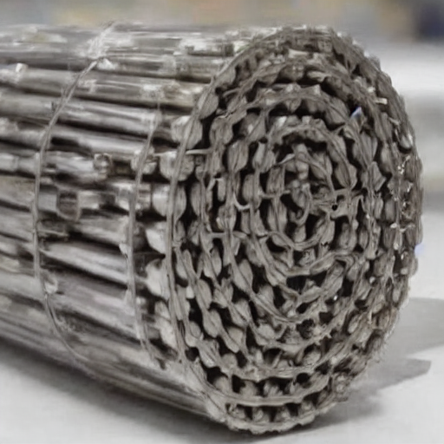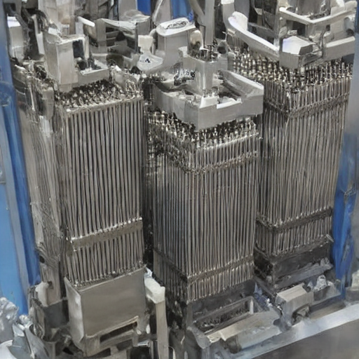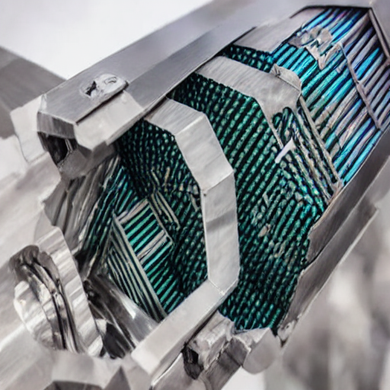

Result and Evaluation
During the 5000-epoch training phase, signs of overtraining began to emerge. The generated images started to exhibit a high degree of similarity in both color and shape, indicating that the model was overfitting to specific features. Given these observations, training was halted to prevent further degradation of image diversity.

To evaluate the model's performance, a 100 images for each of the three categories (cylinder, rectangular, and octagon) for every model are generated. The Fréchet Inception Distance (FID) and Inception Score (IS) as used as evaluation metrics. The FID score measures the similarity between the generated images and real images, with lower scores indicating better quality. The Inception Score evaluates the quality and diversity of the generated images, with higher scores being more desirable.
Figure 4: FID and IS over epochs
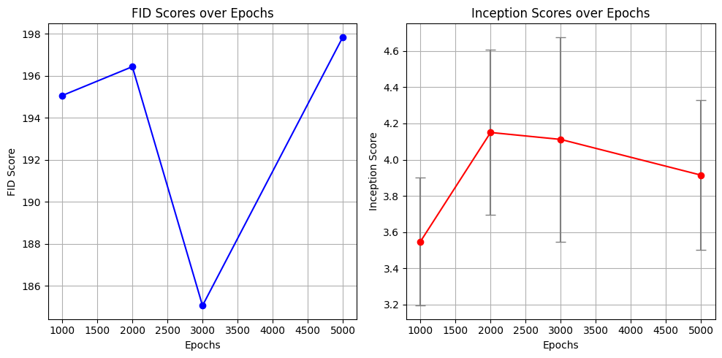
Overall, the FID and IS scores revealed a trend where the model's performance initially improved with continued training, particularly up to 3000 epochs. At 1000 epochs, the model began to learn key features of the nuclear fuel bundles but had not yet reached optimal performance. By 2000 epochs, the model showed improvements in image quality and diversity, especially for the more common cylinder-shaped fuel bundles. The best overall performance was observed at 3000 epochs, where the FID score decreased, indicating closer resemblance to real images, while the IS remained strong, suggesting high-quality and diverse outputs.
However, by 5000 epochs, signs of overtraining emerged, with the FID score increasing and the IS slightly declining. This indicated that the model was starting to generate images that were too similar to each other, losing some of the diversity and quality that had been achieved at earlier stages.
In conclusion, the model trained for 3000 epochs on the Stable Diffusion v1.4 dataset emerged as the best-performing model. It struck a balance between similarity to real images and the diversity and quality of the generated outputs. The evaluation metrics highlighted the importance of carefully monitoring training duration to avoid overfitting and ensure that the generated images maintain high diversity and realism.

Conclusion
In this project, we successfully fine-tuned a Stable Diffusion model to generate synthetic images of nuclear fuel bundles. Through iterative training and careful refinement of the dataset, we were able to produce high-quality images that accurately represent different types of fuel bundles. The approach of categorizing the data by shape and adjusting the training descriptions played a crucial role in enhancing the model's ability to generate distinct and realistic images.

This project demonstrates the potential of using advanced generative models like Stable Diffusion for creating synthetic datasets in complex domains. By leveraging techniques such as data categorization and targeted labeling, we can guide these models to produce more accurate and useful outputs. The insights gained from this work can inform future efforts to apply generative models to other specialized fields, with the goal of improving model performance and reducing the risk of overfitting.

