**Albus Security**

**Networking Assignment Challenge – 1**

**Approach:** NVRAM act as the RAM of networking device and Running-Config is a system config file that is found in the networking device's memory that acts like RAM and store all details of system. So, all process will be deleted if the device loses their power, but the present login details are available in NVRAM and we can see the admin login detail file by saving the Admin-running-config.txt file from Config section of Switch.

**Solution:** 1. After saving Admin-running-config.txt file in system I get the detail of hostname, some encrypted secret, username and password, Fast Ethernet Interface, Vlan1 Interface IP Address and Banner. Following is the Username and Password of Switch:

username net privilege 1 password 0 game

And after some attempts I get the

**username: net password: game**

2. After entering the username and password, I get logged-in to switch. Then to change the configuration, I type the **enable** command to enter in enable mode of switch.

3. To prevent loss of configuration in case of power failure, I saved the running configuration to the startup configuration using the **copy running-config startup-config** command.

4. **running-config** is stored in RAM and will be lost on reboot unless saved to the **startup-config** in NVRAM.

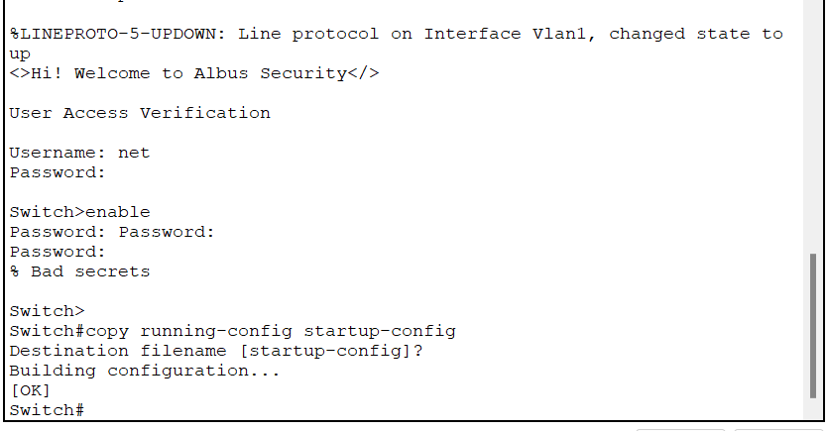

By – Vinayak

Batch - 2