**Albus Security**

**Networking Assignment Challenge – 3**

**Approach:** Understanding the VLANs that allow multiple broadcast domains on a single switch. Checking is all VLANs are configured correctly by reviewing configurations. Troubleshooting by examining the configuration of individual VLANs.

**Solution:** 1. Checking the connectivity of network.

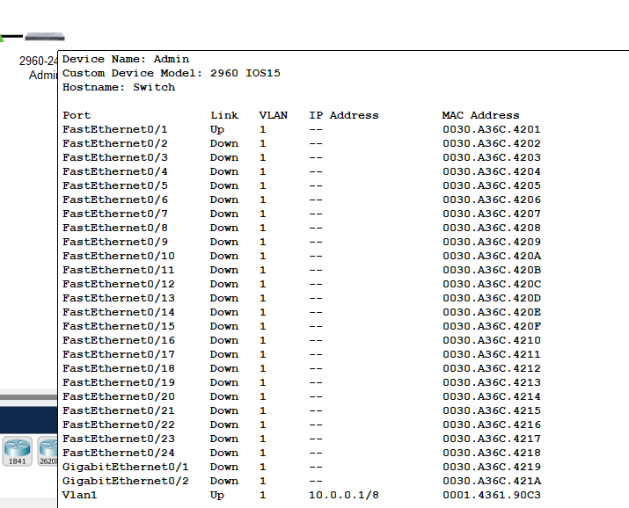

2. For checking or changing the configuration I entered in enable mode by **enable** command.

3. Checking Vlan Interface by using **show** **vlan** command.

4. After that I checked the IP Address interface by using **show ip interface** command.

5. Finally, I found that the VLAN is configured properly.

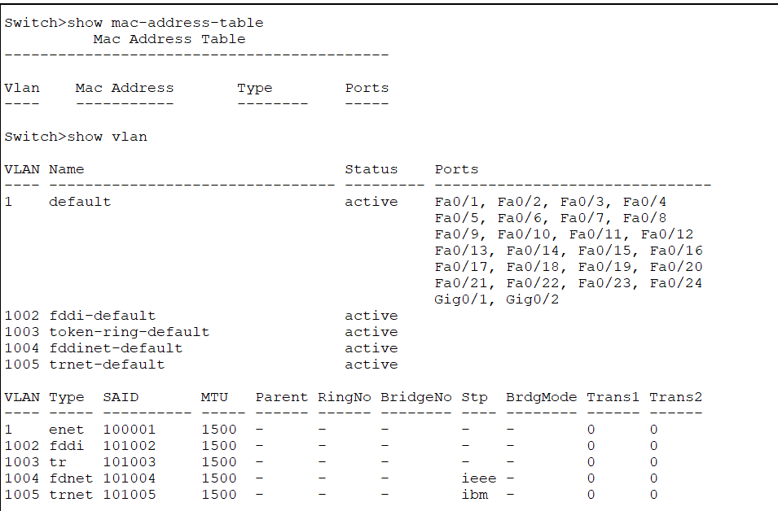

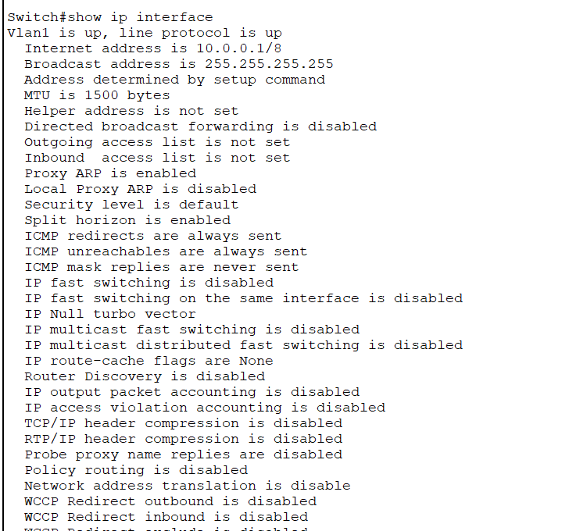

4. Finally the VLAN is configured and working properly.

By – Vinayak

Batch - 2