**Albus Security**

**Networking Assignment Challenge – 4**

**Approach:** SSH Configure the IP address of the switch’s virtual interface (VLAN1 by default) and the PC. Hostname, Domain name, RSA Key and User Account is required for a secure shell. We have to provide all the necessary details required for a secure ssh.

**Solution:** 1. Protocol configuration is implemented in configuration mode, **conf t** command is used to switch to the configuration mode.

2. Following commands are used to configure SSH:

* Assign a hostname to the switch using the command **hostname vinayak**.
* Set the domain name with **ip domain-name vinayak.com**.
* Generate the encryption keys with **crypto key generate rsa**.
* Set up a username and password with **username vinayak secret 123**.
* Saving the configuration by **no shutdown** command and then **exit**.

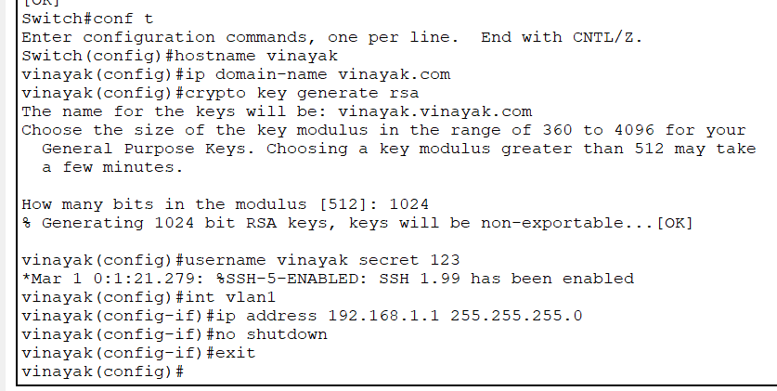

3. Checking the SSH working by **ssh -l vinayak 192.168.1.1** command on the connected device.

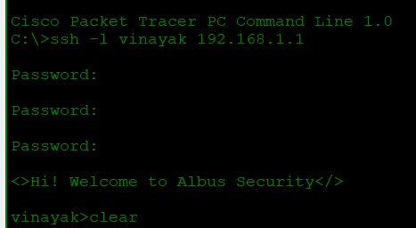

4. Finally, SSH is configured properly on the network.

By – Vinayak

Batch -2