**Albus Security**

**Networking Assignment Challenge – 5**

**Approach:** Interface problem like – administratively down, duplex is present in Admin Switch, Junior Switch, Jack Pc and BOB Pc. By changing the interface, I troubleshoot the problems and network is working properly.

**Solution:** 1. In Junior Switch, Jack Pc is connected with **interface fa0/3** and its administratively down.

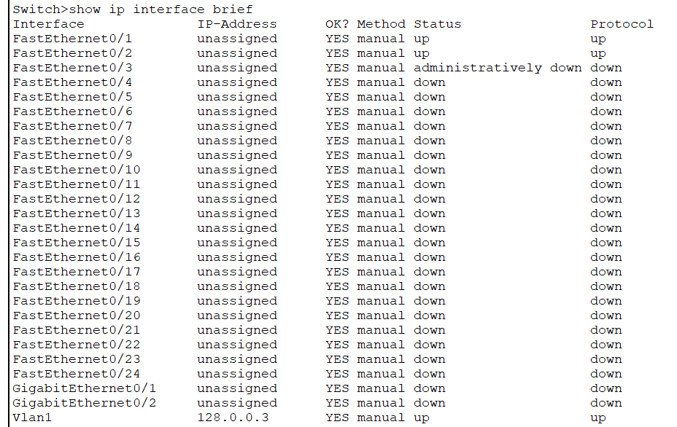Junior switch

2. I changed the state to up by **interface fa0/3** and **no shutdown** command in **configuration mode.**

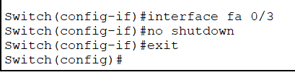Junior Switch

3. As a result, the status is changed to up.

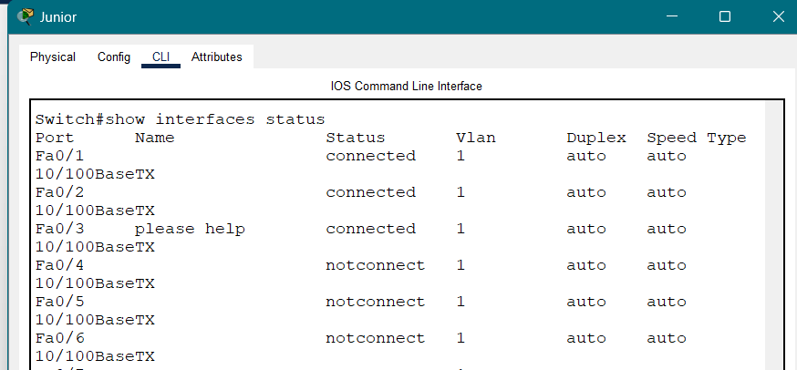

4. In Admin Switch, Bob Pc is connected with interface fa0/3 but there is problem with duplex. Bob Pc is set to **Half Duplex.** Then I changed the duplex to full by **interface fa0/3** and **duplex full** in configuration mode.

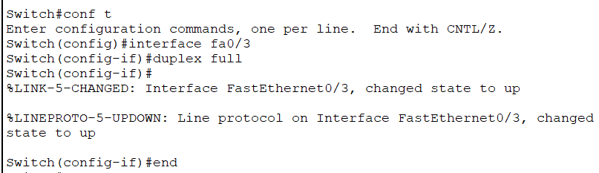 Admin Switch

5. As a result, the duplex is changed to full and working properly.

By – Vinayak

Batch – 2