Smart Retail Store System
A SDS for
Minor Project
BACHELOR OF SCIENCE in COMPUTER SCIENCE
BY
Alfez Mansuri
University Roll No: SC23CS302005
Prince Bairagi
University Roll No: SC23CS302030
Under the Guidance
of
Dr.Rohit Gupta
Prof. Shrikant Telang

Department of Computer Science &
Faculty of Science
MEDICAPS UNIVERSITY, INDORE- 453331
FEBRUARY 2026

Table of Contents
1. Introduction
1.1 Purpose
1.2 Document Conventions
1.3 Intended Audience and Reading Suggestions
1.4 References

Analysis Model
  - Methodology Used (If Object Oriented)
  - Use Case Diagrams (Also include use case specifications)
  - Activity Diagram
  - Sequence Diagram
  - Class Diagram

Design Model
  - Architectural Design
    - System Architecture Diagram
    - Description Of Architectural Design
  - Database Design
    - Data Dictionary
    - Normalization
  - Component Design
    - Package diagram
    - Component Diagram
    - Deployment Diagram
  - Interface Design
    - Screenshots

Appendix C1 : Glossary

Appendix C2 : To Be Determined List

Introduction

Purpose
This Software Design Specification (SDS) document describes the design and architecture of the Smart Retail Store System, a comprehensive web-based business intelligence platform designed for small and medium-scale retail enterprises. The system provides automated data analytics and actionable business insights through an intuitive dashboard interface. This document covers the complete system including the frontend user interface built with React 18 and TypeScript, the backend REST API built with Python FastAPI, the ETL data processing pipeline, the analytics engine, and the SQLite database layer. The document is intended for developers, testers, and project stakeholders involved in the development, maintenance, and deployment of the system.

Document Conventions
The following conventions are used throughout this document: (1) Requirement identifiers follow the format SDS-XX where XX is a sequential number. (2) UML diagrams conform to UML 2.5 specification standards. (3) All database table names are in uppercase (e.g., TRANSACTIONS) and column names use snake_case. (4) Python code follows PEP 8 style guidelines. (5) API endpoints use RESTful naming conventions with HTTP methods (GET, POST) to indicate operations. (6) Front-end components use PascalCase naming (e.g., DashboardPage) and hooks use camelCase. (7) Terms in bold indicate glossary entries on first use. (8) Priority levels are High, Medium, and Low, with High priority requirements being essential for system operation.
  - Intended Audience and Reading Suggestions
This document is intended for the following audiences: (1) Software Developers: who will implement, extend, and maintain the system. They should read the full document, paying particular attention to the Analysis Model (Section 2) for use cases and class diagrams, and the Design Model (Section 3) for architecture and component design. (2) Quality Assurance Testers: who will design test cases based on the use case specifications and verify system functionality against the design. (3) Project Managers: who need an overview of system scope and architecture for planning purposes. They should focus on Sections 1 and 3.1. (4) System Administrators: who will deploy and maintain the system in production environments. They should read Sections 3.1, 3.2, and 3.3 for deployment and database configuration. (5) End Users (Retail Store Owners): who will operate the system should review Section 3.4 for interface screenshots and Appendix C1 for terminology.
  - References
The following documents and references were consulted during the development of this SDS: [1] Smart Retail Store System Software Requirements Specification (SRS), Medi-Caps University, April 2026. [2] UML 2.5 Specification, Object Management Group (OMG), 2015. [3] Python 3.10 Documentation, Python Software Foundation, https://docs.python.org/3.10/. [4] FastAPI 0.100+ Documentation, https://fastapi.tiangolo.com, Accessed March 2026. [5] React 18 Documentation, Meta Platforms Inc., https://react.dev, Accessed March 2026. [6] TypeScript 5.0 Documentation, Microsoft Corporation, https://www.typescriptlang.org, Accessed March 2026. [7] Chen, H., Chiang, R.H., and Storey, V.C., "Business Intelligence and Analytics: From Big Data to Big Impact," MIS Quarterly, vol. 36, no. 4, pp. 1165-1188, 2012. [8] Few, S., Information Dashboard Design, O'Reilly Media, 2009. [9] SQLite Documentation, https://www.sqlite.org/docs.html, Accessed March 2026. [10] Pandas Documentation, https://pandas.pydata.org/docs/, Accessed March 2026.
2. Analysis Model
2.1 Methodology used
The Smart Retail Store System is developed using an Object-Oriented Programming (OOP) approach. The backend is implemented in Python 3.10+, leveraging object-oriented principles such as encapsulation, inheritance, and polymorphism. The core architecture centers around the AnalyticsEngine class which serves as the central controller, with specialized classes including DataProcessor, SalesAnalyzer, TrendAnalyzer, InventoryManager, and ReportGenerator composed within it. The frontend is built with React 18 and TypeScript using a component-based architecture where UI elements are organized as reusable class-like components with props and state management. The Software Process model adopted is the Iterative Development Model with five phases: (1) Setup and Design involving technology selection and architecture definition; (2) Backend Development implementing API endpoints, data processing, and analytics engine; (3) Frontend Development building UI components and data visualization; (4) Integration and Testing connecting frontend and backend and validating functionality; and (5) Documentation preparing technical reports and user guides. This iterative approach allows for continuous refinement and early detection of design issues.
2.2 Use Case diagram
The use case diagram for the Smart Retail Store System identifies two primary actors interacting with the system: the User (Customer) and the Retail Manager. The User actor participates in use cases including Browse Products and Purchase Items. The Retail Manager, who represents the store owner or administrator, participates in use cases including Generate Reports, View Insights, Track Inventory, and Analyze Trends. These use cases collectively represent the core functionality of the Smart Retail Store System, providing a comprehensive retail analytics platform.
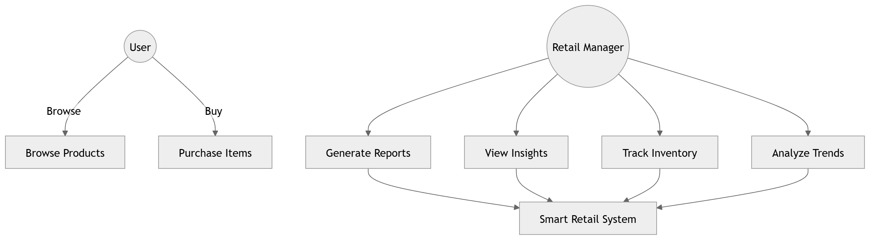
Figure 2.1: Use Case Diagram for Smart Retail Store System
Analyze Sales Trends
Retail Manager
Use Case Specification
Name Of Use Case | The retail manager must be logged into the system and have uploaded valid sales transaction data (CSV, XLS, or XLSX format) containing date, product name, category, cost price, selling price, and quantity columns.
Actor | 1. Retail Manager navigates to the Dashboard page. 2. System displays KPI summary cards (Total Revenue, Total Profit, Unique Products, Avg Profit Margin). 3. System renders Sales Trend line chart showing revenue and profit over time. 4. Retail Manager can hover over chart points to see detailed values. 5. System identifies and displays top-performing and low-performing products. 6. Retail Manager reviews automated insights for actionable recommendations.
Pre Condition | The retail manager has successfully viewed the sales trend analysis with KPI summaries, trend charts, and actionable insights. The data remains stored in the database for future analysis.
Primary Flow of Events | The use case terminates when the retail manager navigates away from the Dashboard page or closes the application.
Alternate Folw Of Events | Alternate Flow 1: If no data has been uploaded, the system displays a message prompting the user to upload sales data first.
 | Alternate Flow 2: If uploaded data contains invalid or missing values, the system displays cleaning warnings but proceeds with analysis using imputed values.
Post Condition
Use Case termination

2.3 Activity Diagram
The activity diagram models the workflow of the data processing pipeline in the Smart Retail Store System. The process begins with the user uploading a sales data file (CSV, XLS, or XLSX). The system then validates the file format, cleans the data by normalizing headers and imputing missing values, validates the cleaned data, transforms it through the ETL pipeline, analyzes the data to compute KPIs and trends, generates reports with visualizations and insights, and finally displays the results on the dashboard. Decision points include validation checks that loop back to data cleaning if issues are found.
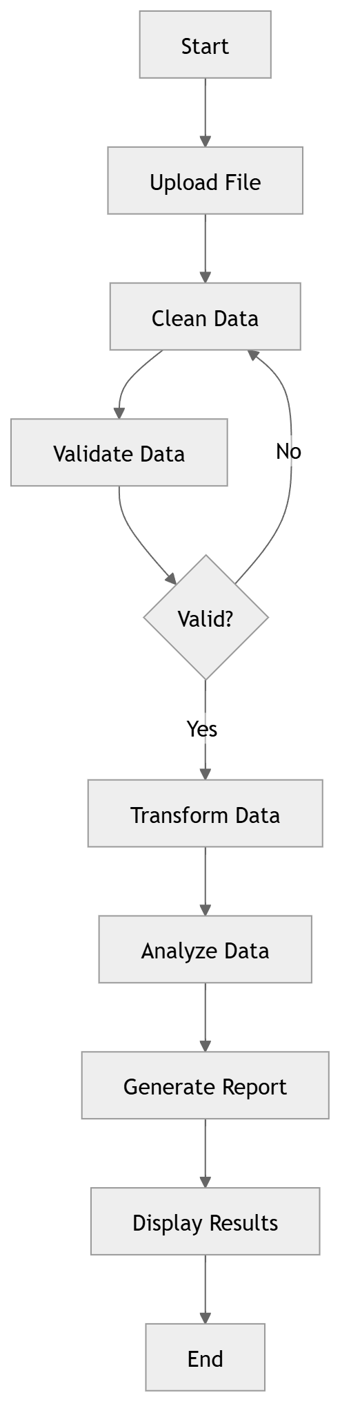
Figure 2.2: Activity Diagram - Data Processing Workflow
2.4 Sequence Diagram
The sequence diagram illustrates the dynamic interaction between system components during a typical analytics session. The User initiates the process by uploading a file through the UI. The Streamlit UI component forwards the file to the DataProcessor via the acquire_data() method. The DataProcessor performs data cleaning as a self-call operation (clean_data()), then sends the cleaned data to the AnalyticsEngine. The AnalyticsEngine performs analysis via self-calls (analyze trends and profit), then calls generate_report() to produce visualization output. The result flows back through display_report() to the User via the PowerBI/Visualization component.
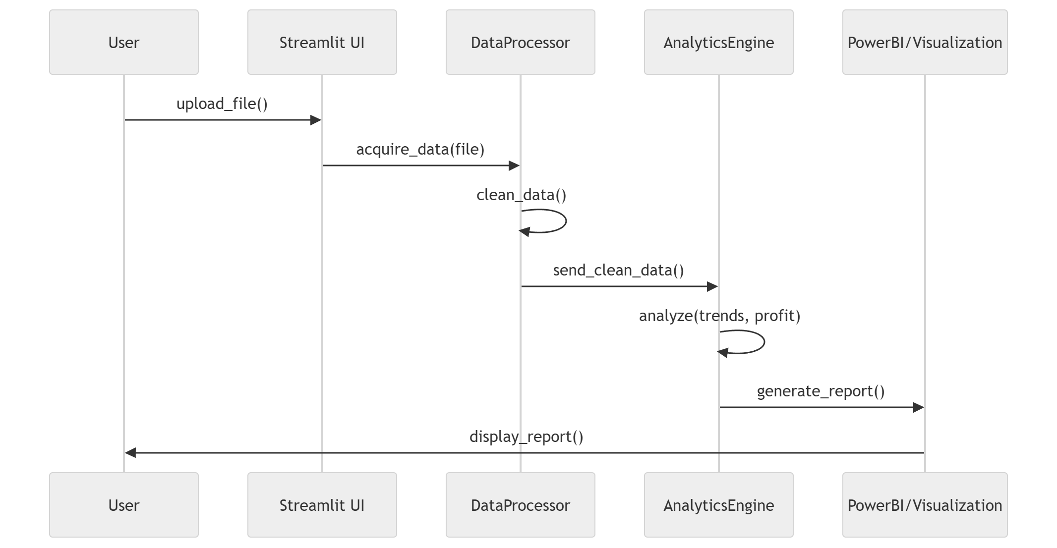
Figure 2.3: Sequence Diagram - Analytics Session
2.5 Class Diagram
The class diagram illustrates the static structure of the Smart Retail Store System backend. The AnalyticsEngine class serves as the central controller with attributes including a Pandas DataFrame for data storage and methods for load_data(), clean_data(), analyze_data(), and generate_report(). It has composition relationships with five specialized classes: DataProcessor handles file reading and data normalization through read_excel() and normalize_data() methods; SalesAnalyzer computes revenue calculations and identifies top products via calculate_revenue() and get_top_products(); TrendAnalyzer analyzes temporal patterns and forecasts trends through analyze_trends() and forecast_sales(); InventoryManager detects dead stock and finds low-margin items through detect_dead_stock() and find_low_margin_items(); and ReportGenerator creates summaries, visualizations, and recommendations through generate_summary(), create_visuals(), and generate_recommendations().
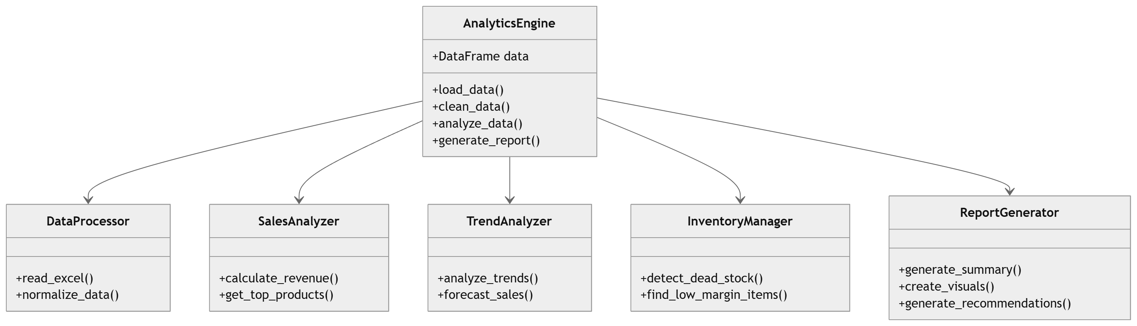
Figure 2.4: Class Diagram - System Backend Structure
3. Design Model
3.1 Architectural Design
3.1.1 System Architectural Diagram
The Smart Retail Store System adopts a modern three-tier architecture pattern with clear separation of concerns between the presentation layer, application logic layer, and data persistence layer. The frontend application is built with React 18 and TypeScript, communicating with the backend via RESTful API calls. The backend is implemented using Python FastAPI with modular components including the Backend API router, Data Processor for ETL operations, Analytics Engine for computation, ML Model for predictions, and Report Generator for output formatting. The Database layer uses SQLite for lightweight, zero-configuration data storage.
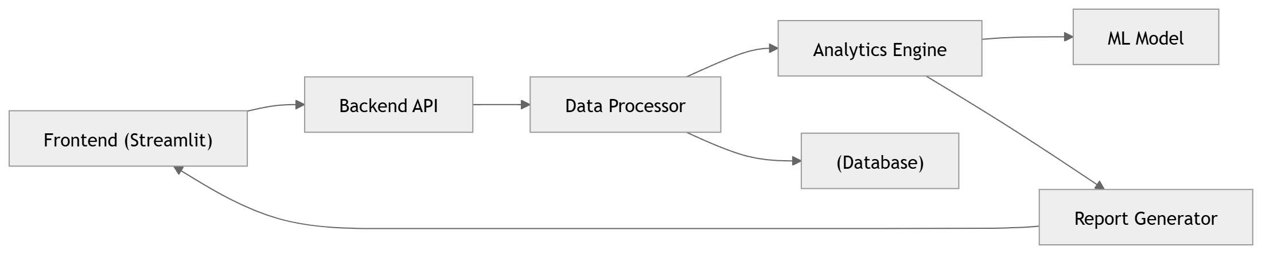
Figure 3.1: System Architecture Diagram
3.1.2 Description of Architectural Diagram
The system architecture consists of the following interconnected components: (1) Frontend (Streamlit/React): The presentation layer that provides the user interface for file upload, dashboard visualization, and report viewing. It communicates with the backend via HTTP REST API calls. (2) Backend API (FastAPI): Serves as the entry point for all client requests, handling routing, request validation, and response formatting. It exposes endpoints for file upload (/upload), dashboard analytics (/dashboard), report generation (/report), and health monitoring (/health). (3) Data Processor: Handles ETL operations including file reading (CSV, XLS, XLSX), data cleaning (header normalization, missing value imputation, type coercion), and data validation. (4) Analytics Engine: Performs all computational operations including KPI calculation, sales trend analysis, product performance ranking, category distribution analysis, and dead stock detection. (5) ML Model: Provides machine learning capabilities for sales forecasting and demand prediction. (6) Report Generator: Aggregates analytics data and formats it for export in CSV and PDF formats. (7) Database (SQLite): Provides persistent storage for cleaned transaction data with indices on date and product_name columns for optimized queries.
3.2 Database Design
3.2.1 Data Dictionary
The Data Dictionary for the Smart Retail Store System defines all data elements used in the SQLite database. The system uses a single transactions table with the following data elements:
Table 3.1: Data Dictionary - Transactions Table
- Name- the primary name of data and control item, the data store or an external entity.
- Alias- other names used for the first entry.
- Where used / how used – a listing of processes that uses the data or control item and how it is used.
- Content description – a notation for representing content.
- Supplementary information – other information about data types, preset values, restriction or limitations, etc.
The Entity-Relationship diagram models the database schema for the retail analytics system. The database schema consists of five entities: CUSTOMER (customer_id, customer_name), CATEGORY (category_id, category_name), PRODUCT (product_id, product_name, cost_price, selling_price), SALES (sale_id, sale_date, total_amount), and SALES_ITEM (sale_item_id, quantity, unit_price, total_price). The relationships are: a CUSTOMER has a one-to-many relationship with SALES; a SALE contains one-to-many SALES_ITEM records; each SALES_ITEM references one PRODUCT; and each PRODUCT belongs to one CATEGORY.
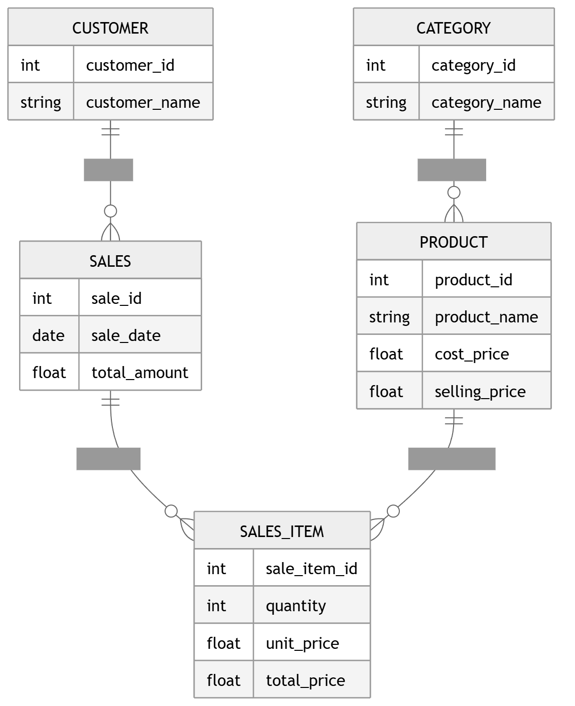
Figure 3.5: ER Diagram - Database Schema
3.2.1 Normalization
The Smart Retail Store System database follows Third Normal Form (3NF) to minimize redundancy and ensure data integrity. First Normal Form (1NF): The transactions table has atomic values in all columns - each cell contains a single value, and there are no repeating groups. All columns (date, product_name, category, cost_price, selling_price, quantity, revenue, profit, profit_margin) contain indivisible values. Second Normal Form (2NF): The table is in 1NF and all non-key attributes are fully functionally dependent on the primary key (id). Since the primary key is a single-column surrogate key, there are no partial dependencies. Third Normal Form (3NF): The table is in 2NF and contains no transitive dependencies. The computed fields (revenue, profit, profit_margin) are functionally dependent on the primary key and not on other non-key attributes. While these computed fields could theoretically be calculated on-the-fly, they are denormalized and stored alongside raw fields to optimize read performance for dashboard queries, which is an acceptable denormalization trade-off for a read-heavy analytics system.
Apply the normalization process on the tables of your database and also explain the normal form that has been applied on the database>
3.3 Component Design
3.3.1 Package Diagram
The package diagram depicts the high-level module structure of the Smart Retail Store System. The UI Package contains the Streamlit/React frontend components for user interaction. The Processing Package encapsulates the DataProcessor and AnalyticsEngine classes responsible for ETL operations and analytics computation. The Database Package manages SQLite persistence and data access. The Reporting Package contains the ReportGenerator for formatting and exporting reports. The Analysis Package includes specialized analyzers: SalesAnalyzer for revenue calculations, TrendAnalyzer for temporal pattern analysis, and InventoryManager for stock management.
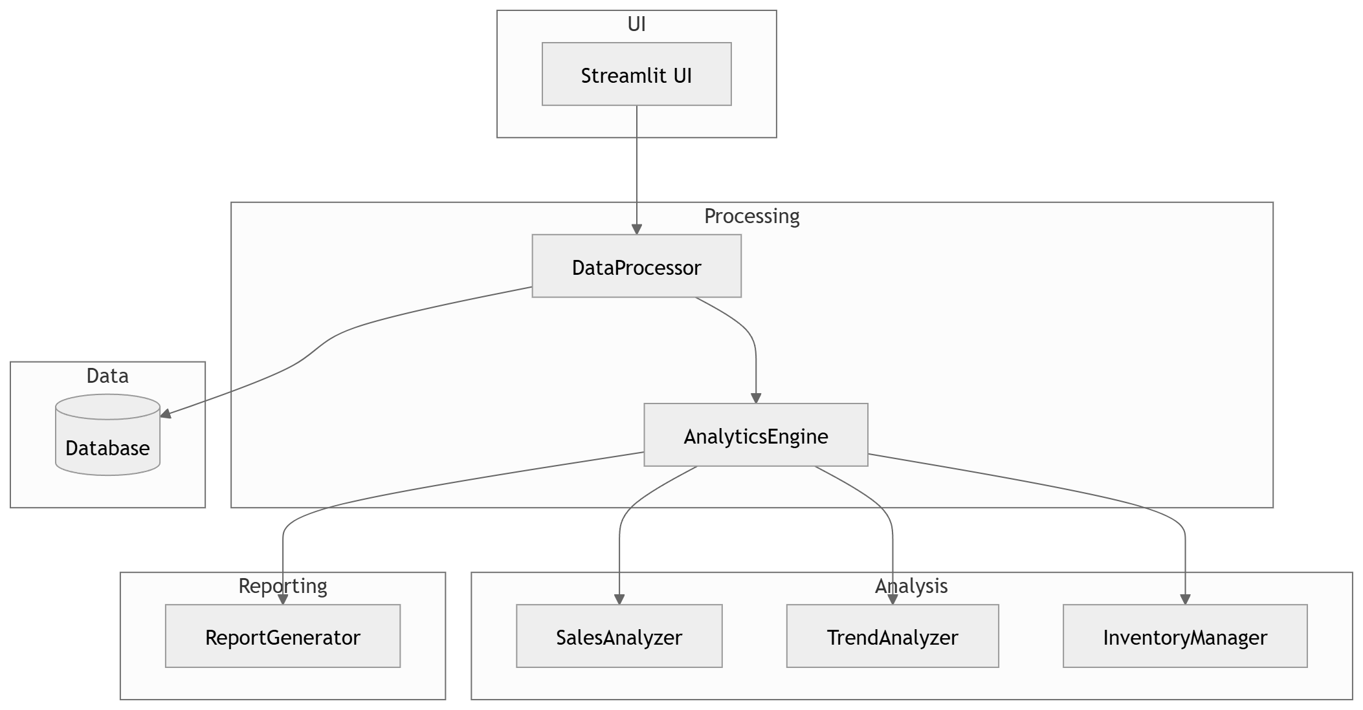
Figure 3.2: Package Diagram - System Module Structure
3.3.2 Component Diagram
The component diagram illustrates how software components are wired together in the Smart Retail Store System. The User interacts with the Frontend component (Streamlit UI). The Frontend communicates with the Backend API component (FastAPI) via HTTP requests. The Backend API delegates to the Data Processor component for file handling and data cleaning, which stores cleaned data in the Database (SQLite). The Analytics Engine component performs computations using the ML Model for predictions. The Report Generator component produces exportable reports that flow back to the Frontend for display.
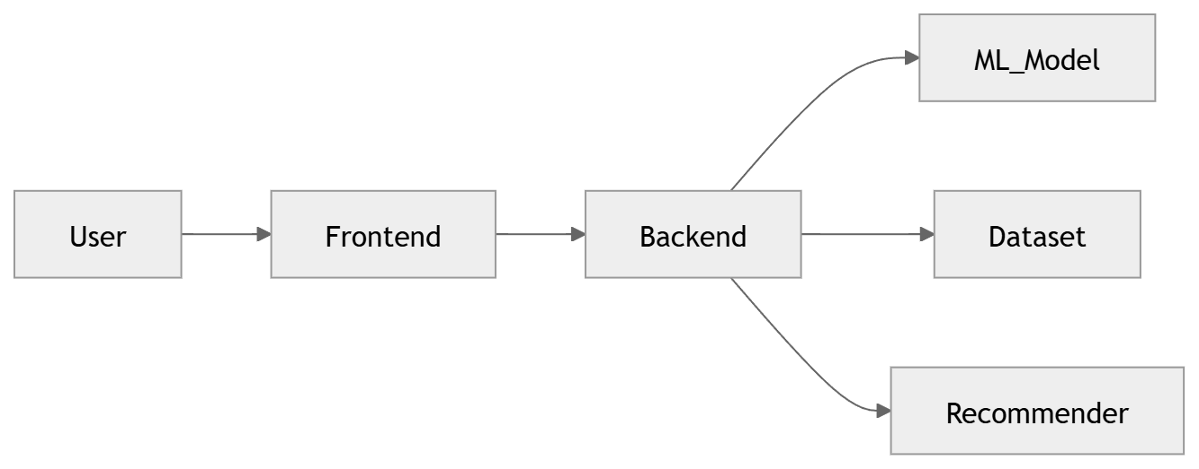
Figure 3.3: Component Diagram - Component Interactions
System Workflow Flowchart
The system workflow flowchart illustrates the sequential processing from data input to insight delivery. The process begins with data entry where the user uploads a sales transaction file. The Send API step transmits the file to the backend. The Predict Price step computes selling price analytics. The Check Trend step analyzes sales patterns over time. The Recommend Stock step generates inventory recommendations based on dead stock detection and demand analysis. The Display Result step renders the dashboard with all computed analytics.
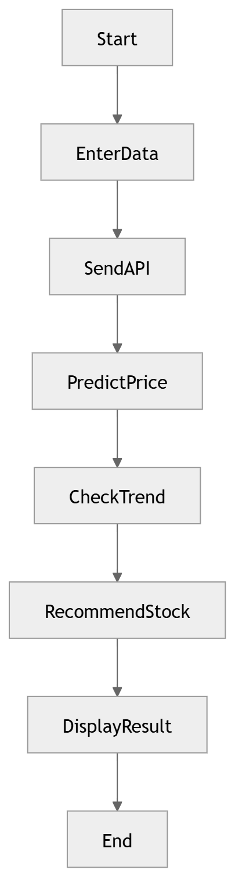
Figure 3.3a: System Workflow Flowchart
3.3.2 Deployment Diagram
The deployment diagram models the physical deployment of the Smart Retail Store System. The system is deployed on a Web Server (Node.js/Uvicorn) that hosts both the React frontend (as static files) and the Python FastAPI backend. The web server runs on standard hardware with a dual-core CPU and 4GB RAM minimum. The SQLite database file is stored locally on the DB Server, which can be the same physical machine as the web server for small deployments. The client device (User Device) accesses the system through a standard web browser supporting JavaScript ES6+, connecting to the Web Server via HTTP/HTTPS.
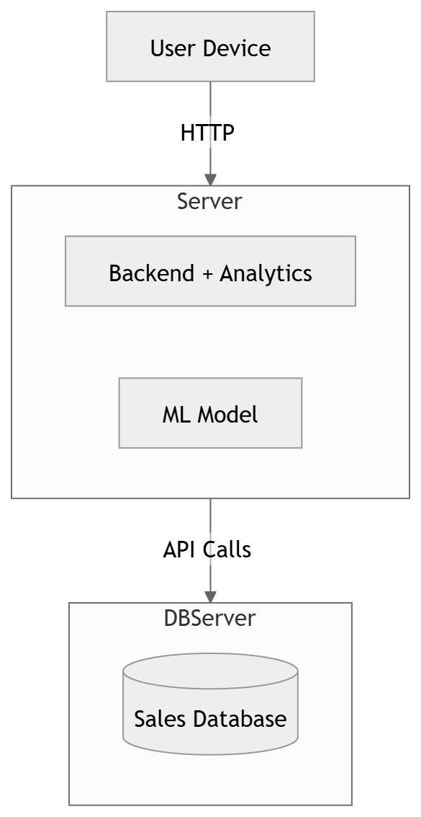
Figure 3.4: Deployment Diagram - Physical Deployment
3.4 Interface Design
3.4.1 Screen Shots
The following screenshots demonstrate the key user interface screens of the Smart Retail Store System:
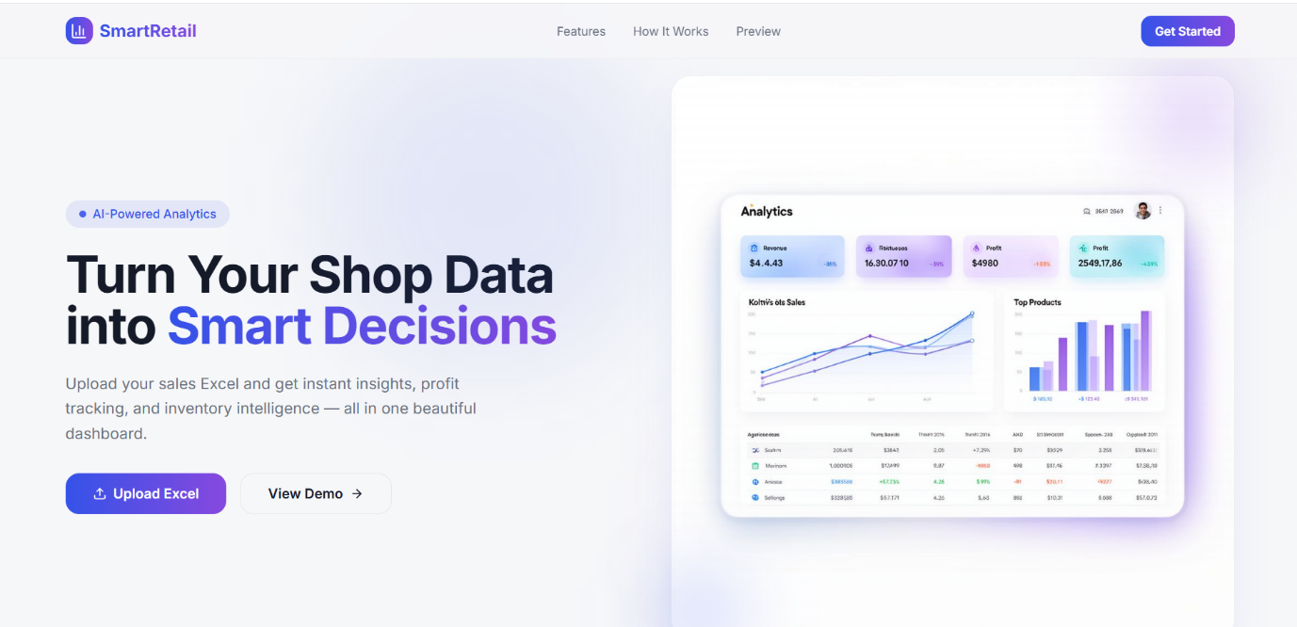
Figure 3.5: Landing Page
The landing page serves as the entry point with a hero section describing the product, feature highlights for Data Upload, Smart Analytics, Business Insights, and Export Reports, and a step-by-step guide showing how the system works.
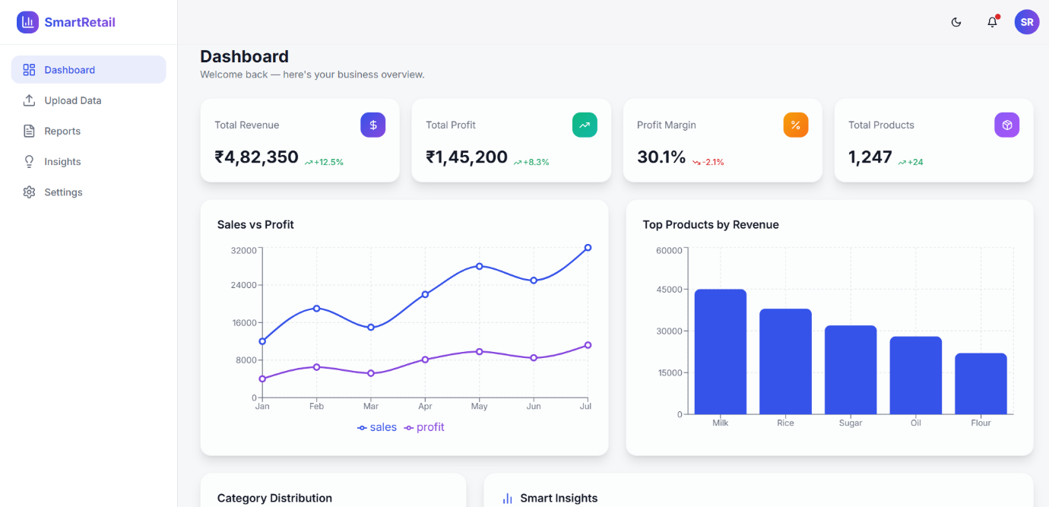
Figure 3.6: Dashboard Interface
The dashboard page presents the main analytics interface with KPI summary cards showing Total Revenue, Total Profit, Unique Products, and Average Profit Margin. Below the KPIs, the dashboard displays interactive charts including sales trend line graphs and category distribution analysis.
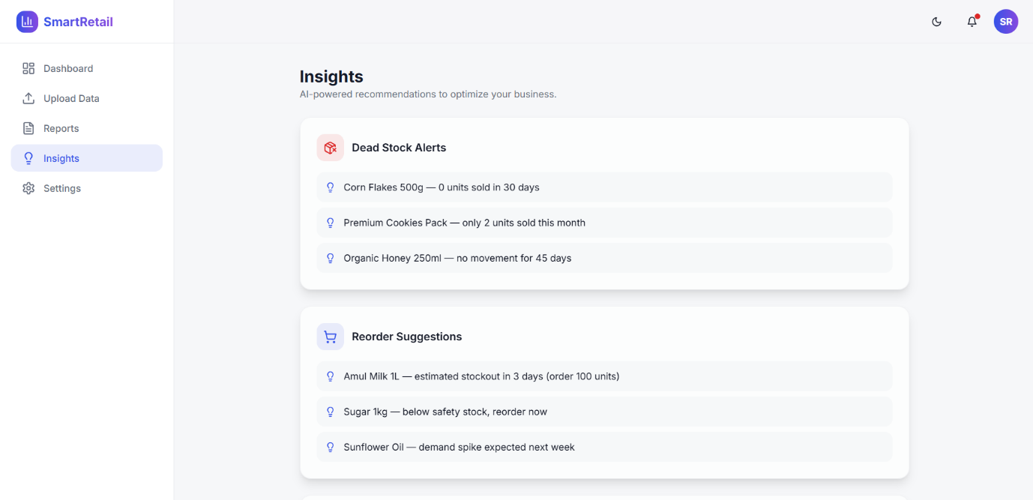
Figure 3.7: Insights Page
The insights page displays automated business recommendations generated by the system, including warnings for dead stock products, trend statements for profitable categories, alerts for low-performing products, and demand spike indicators.
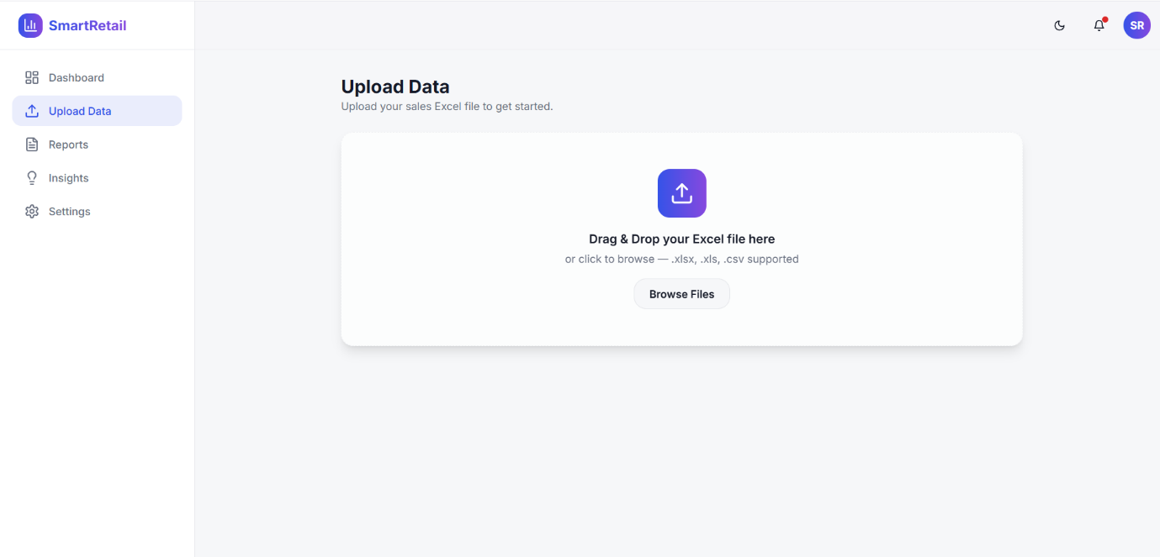
Figure 3.8: Excel File Upload Page
The reports page allows users to download analytics data in CSV and PDF formats. It displays a summary of available reports with options to export data for further analysis or presentation purposes.
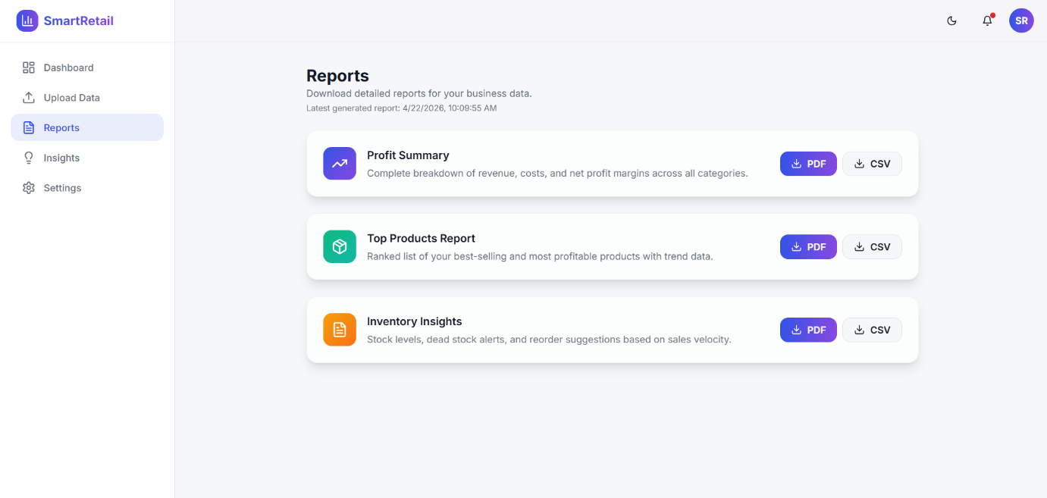
Figure 3.9: Reports Page
State Transition Diagram
The state transition diagram describes all the states that the Smart Retail Store System can have during a typical user session. The system starts in the Idle state. When a user uploads a file, it transitions to the Uploading state. Upon successful upload, it moves to the Processing state for data cleaning and transformation. After processing, the system enters the Validating state to check data quality. If validation passes, it transitions to the Analyzing state for analytics computation, then to the Reporting state for report generation, and finally to the Displaying state where results are shown on the dashboard. From any state, the system can return to Idle if the session is terminated.
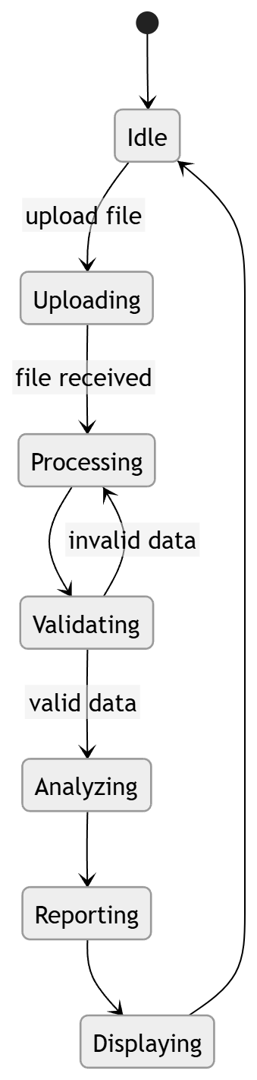
Figure 3.9: State Transition Diagram - System States
Appendix C1: Glossary
The following terms and abbreviations are used throughout this SDS: API (Application Programming Interface): A set of protocols for building software applications that communicate with each other. ETL (Extract, Transform, Load): A data processing pipeline that extracts data from sources, transforms it into a suitable format, and loads it into a destination database. KPI (Key Performance Indicator): A measurable value that demonstrates how effectively a company is achieving key business objectives. Dead Stock: Products that have not had sales activity for a specified period (default 30 days). FastAPI: A modern, high-performance Python web framework for building APIs. React: A JavaScript library for building user interfaces. SQLite: A serverless, self-contained SQL database engine. TypeScript: A typed superset of JavaScript that compiles to plain JavaScript. UML (Unified Modeling Language): A standardized visual modeling language for specifying, visualizing, constructing, and documenting software systems. Profit Margin: The ratio of profit to revenue, calculated as (selling_price - cost_price) / selling_price * 100. Data Imputation: The process of replacing missing data with substituted values. Normalization: The process of organizing database tables to minimize redundancy and dependency.
Appendix C2: To Be Determined List
The following items remain to be determined and will be addressed in future iterations: TBD-01: Integration of real-time data streaming for live dashboard updates. TBD-02: Implementation of user authentication and role-based access control (RBAC). TBD-03: Migration from SQLite to PostgreSQL for production deployment. TBD-04: Development of mobile application (iOS/Android) for on-the-go analytics access. TBD-05: Implementation of predictive analytics using machine learning models for sales forecasting. TBD-06: Multi-tenant support for serving multiple retail stores from a single deployment. TBD-07: Email and SMS notification system for critical business alerts.

