UML Diagrams - Smart Retail System

Data Flow Diagram
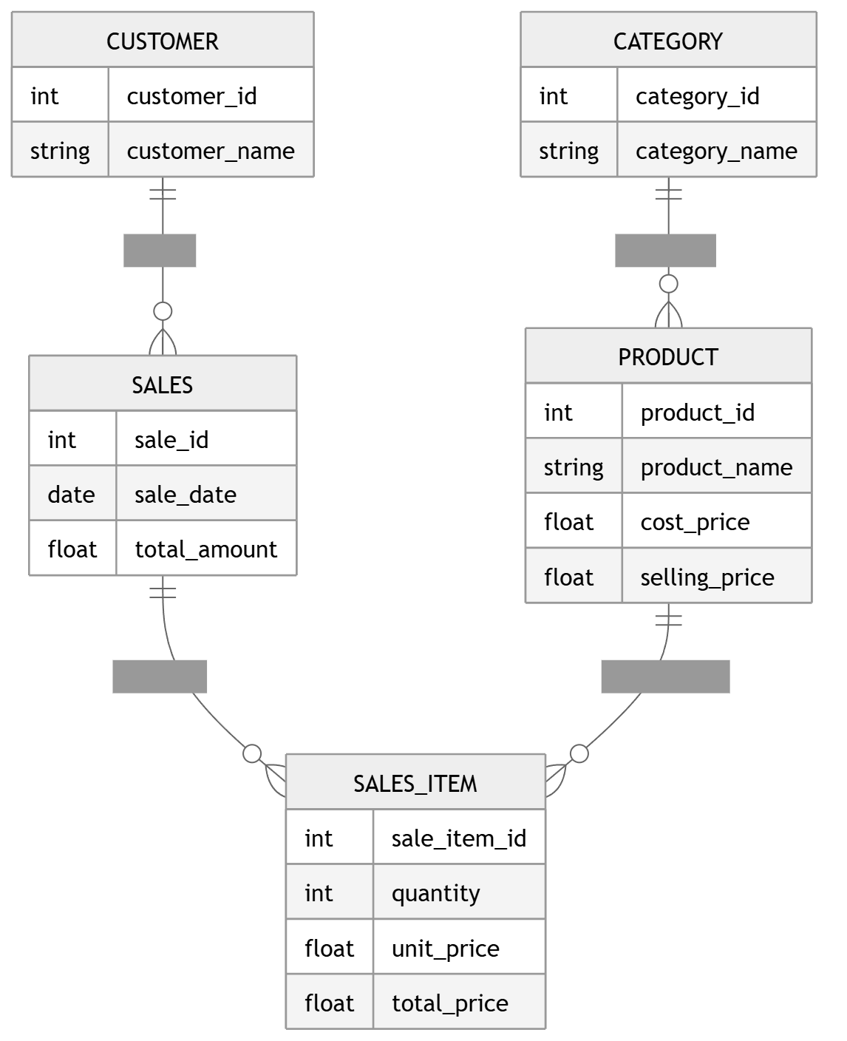
Shows how data flows from user upload through cleaning, processing, analytics, and visualization.

Class Diagram
Represents system classes like AnalyticsEngine and DataProcessor and their relationships.

Sequence Diagram
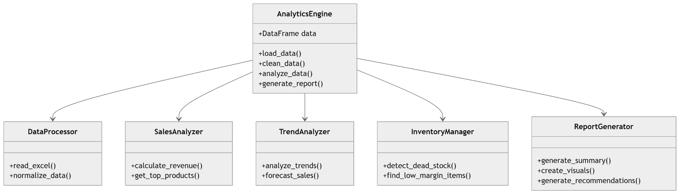
Illustrates step-by-step interaction between user, UI, processing, and analytics components.

Use Case Diagram
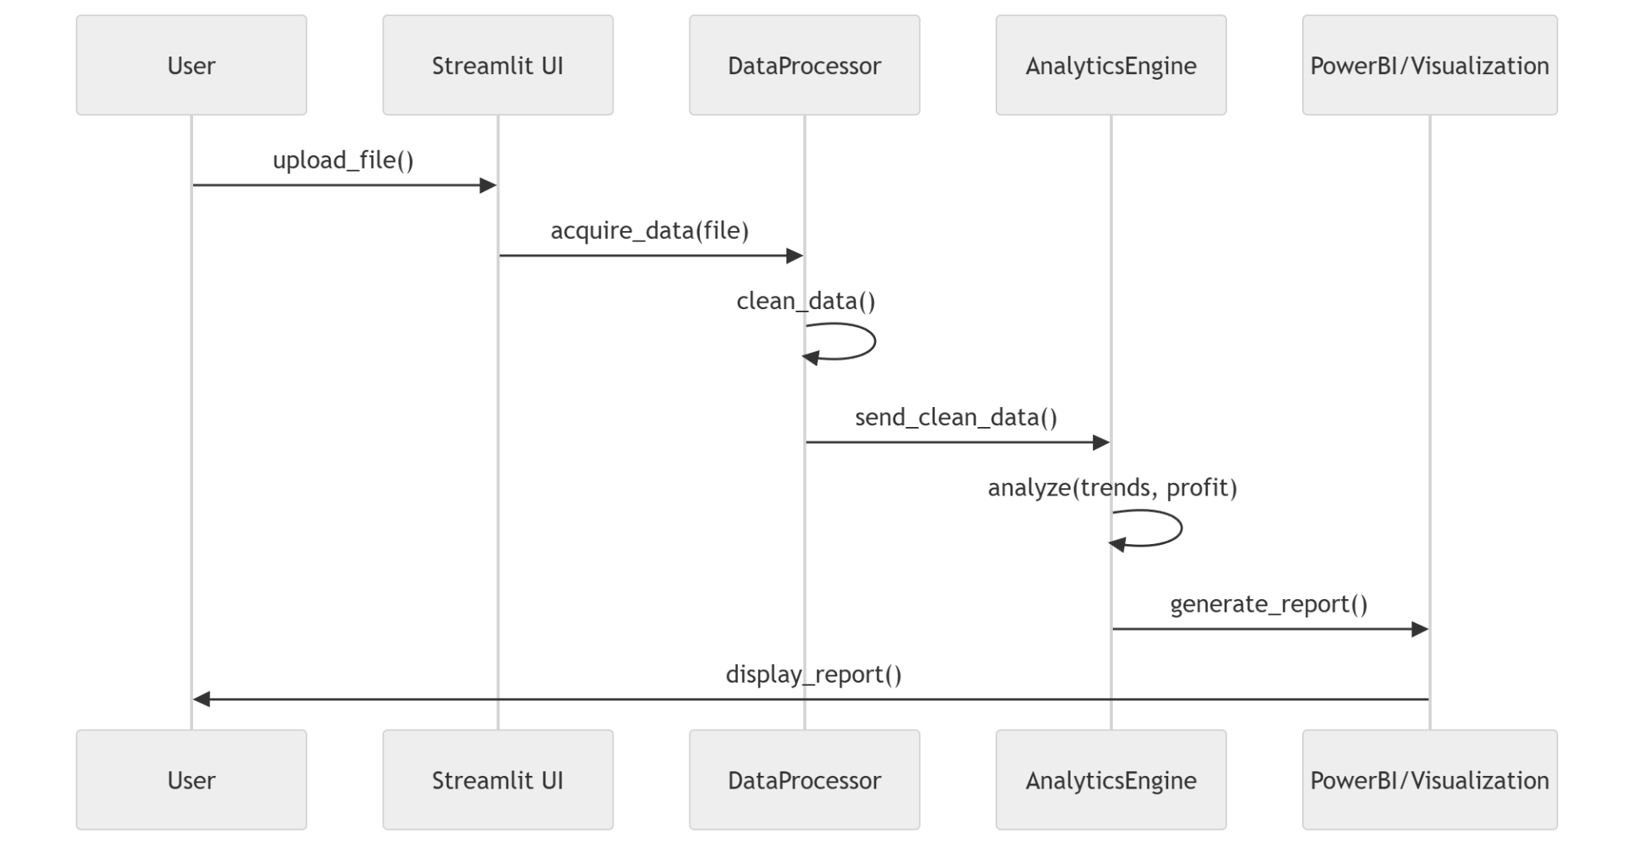
Defines interactions between users (Customer, Retail Manager) and system functionalities.

Activity Diagram
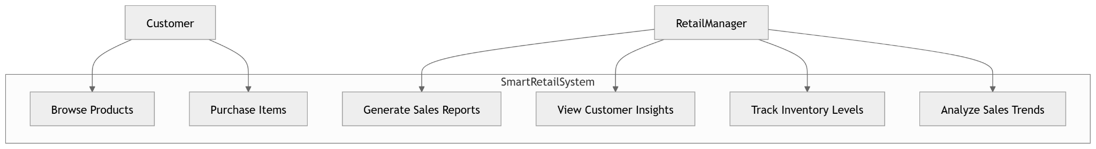
Describes workflow of user actions and system responses across different features.

ER Diagram
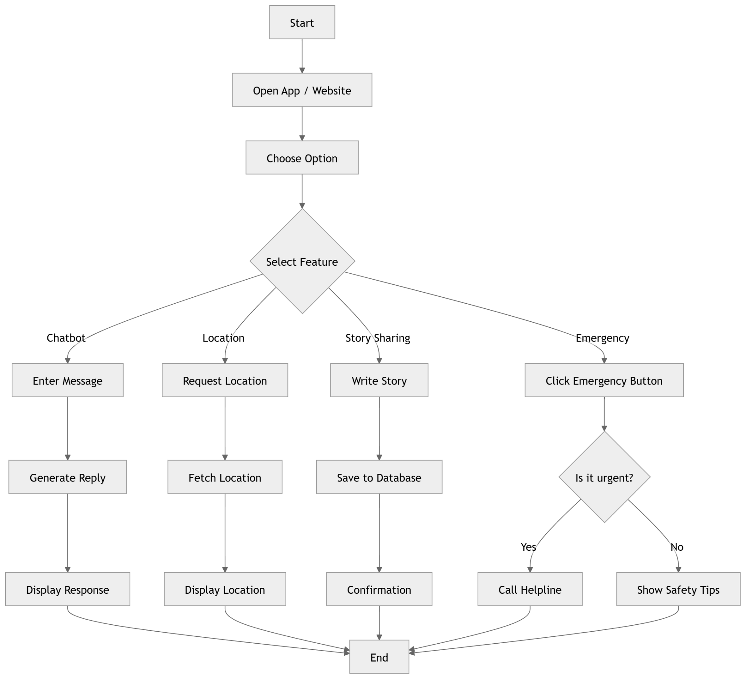
Shows database entities like Customer, Product, Sales and their relationships.

