**Task:**

* Create local git repo & checkout dev branch
* Under dev branch add 2 new files
* Once files are added instead of merge & rebase lets try to pick one specific commit from dev
* We will use cherry pick command & get that commit on your main branch.

**Solution:**

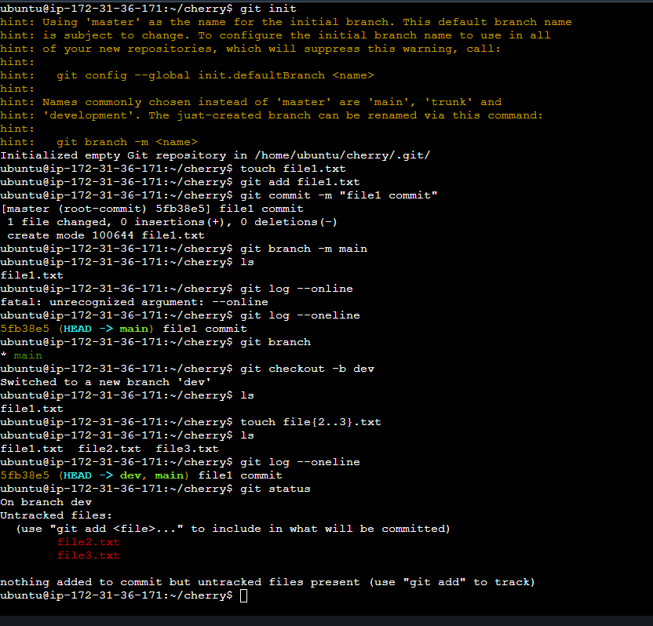

Lets add each file separately on dev branch,

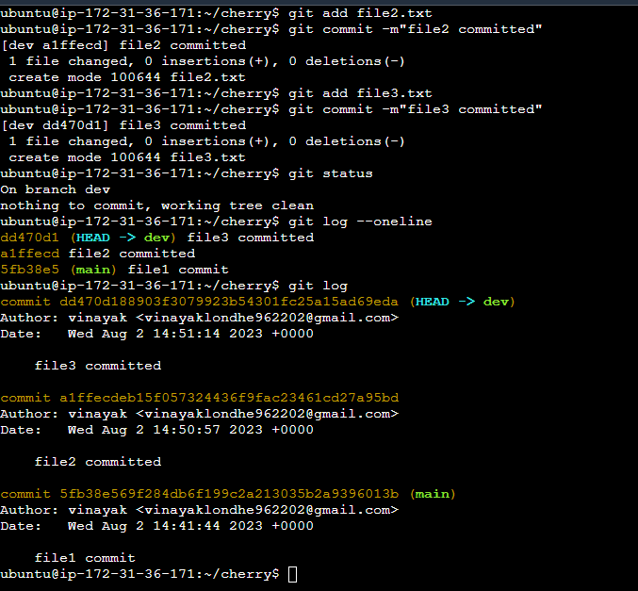

Now I want only file2 commit to be present on main branch,

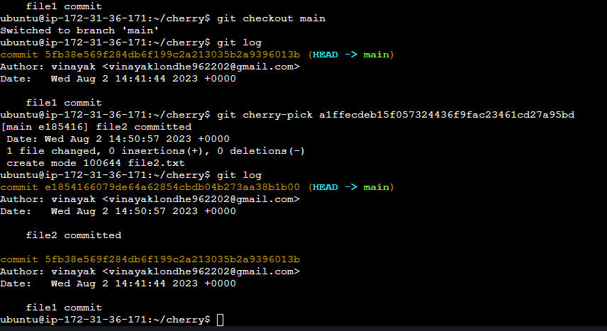

Now check git status,

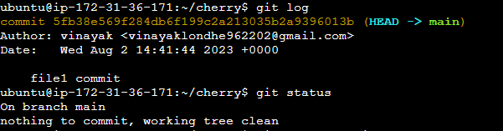

There is nothing to commit !!!

**Hope this helps!**