**Task:**

* Create github repo & clone on local git
* Add one file & some content in it
* Lets same file & check on github repo
* Now lets do some changes to file on one of the line on local git & try to pull our github repo (pull scenario)
* Also lets check push scenario in git merge.

**Solution:**

Hope you all know how to create github repo & clone it on local git. I am in my local git lets get started!!!

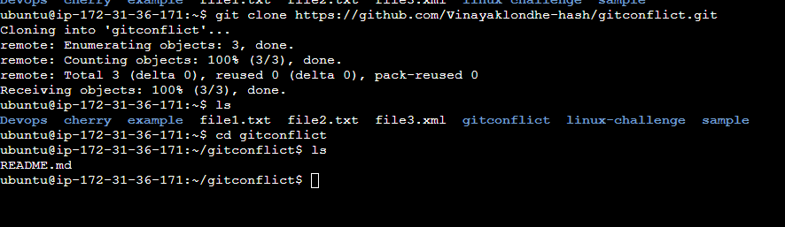

Lets create a file with some content,

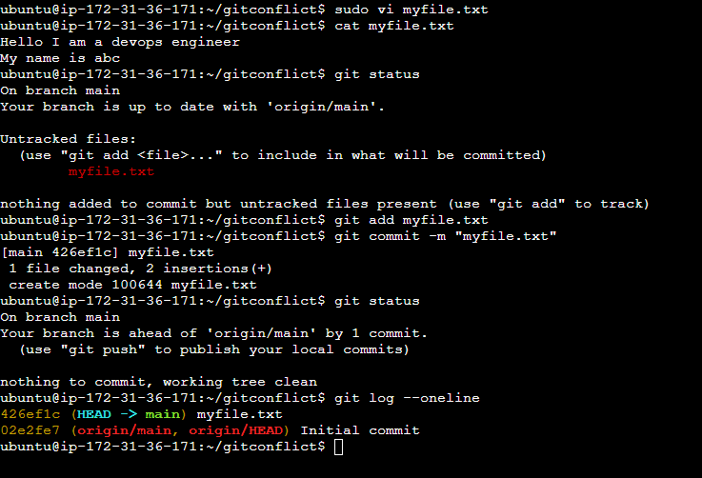

We can see that our origin/main is lagging behind by 1 commit. Lets push our local main branch commit to origin/main github repo.

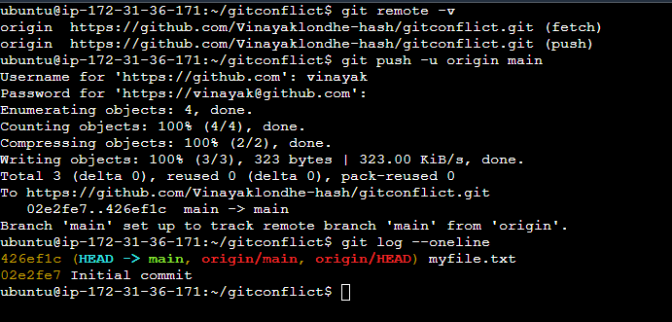

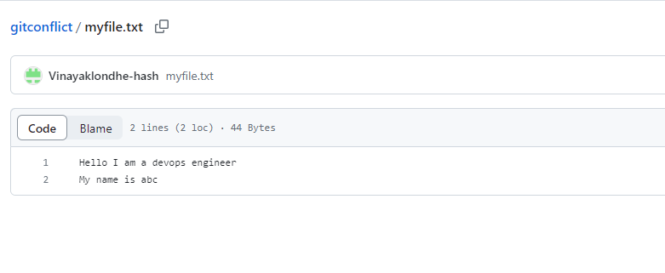

Now to create pull conflict:

Now lets make some change to line 2 in github file. “My name is xyz” and try to pull changes on our local repo.

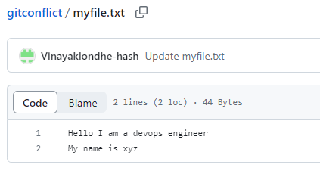

When we did git pull it worked with no issue.

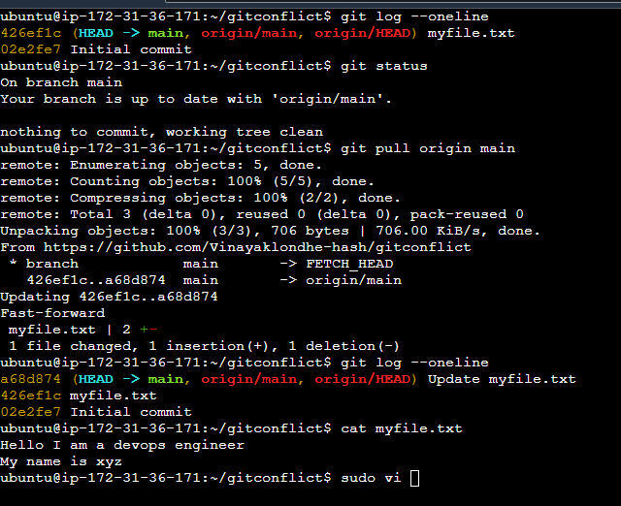

Now lets create a conflict,

Suppose I do changes to 2nd line that “My name is def” , add & commit it .But don’t push the change to github . Now suppose someone did change on github repo on same line. Lets try to pull the change on local git and here is your conflict….

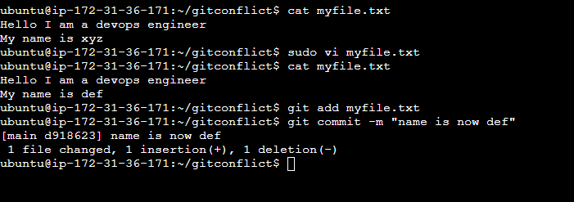

Did changes on github 2nd line is “My name is”

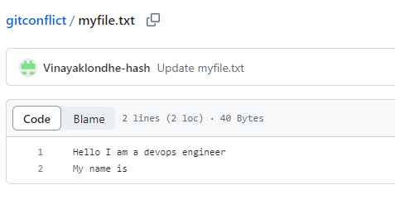

Now pull our repo & see that conflict has been occurred.

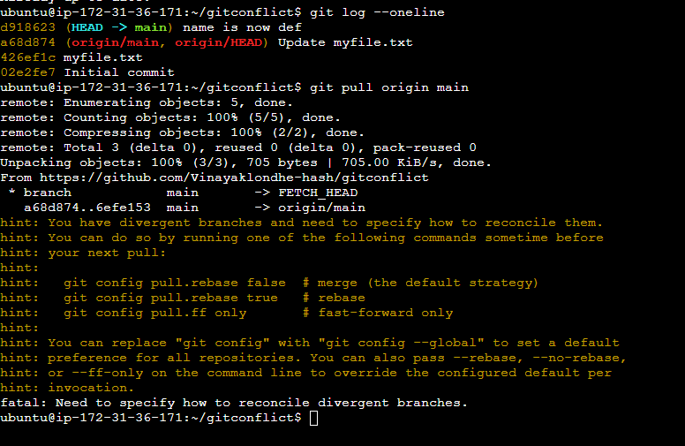

Now we have to use - - ff (fast-forward) will pulling our github repo. So it will allow you to decide what changes needs to be keep.

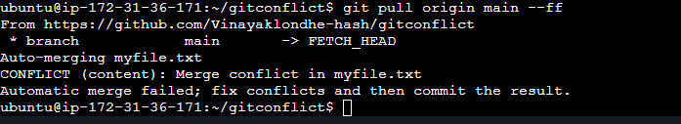

Now check myfile and see discrepancy….Resolve it like what needs to be saved and discard. Push changes to github repo.

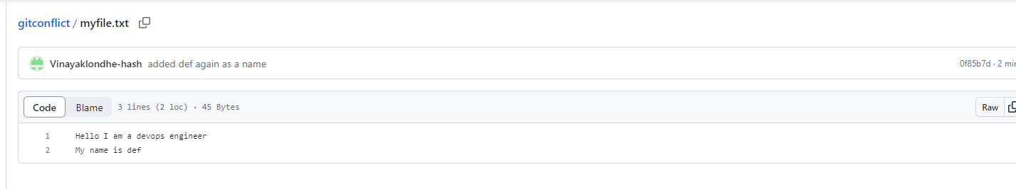

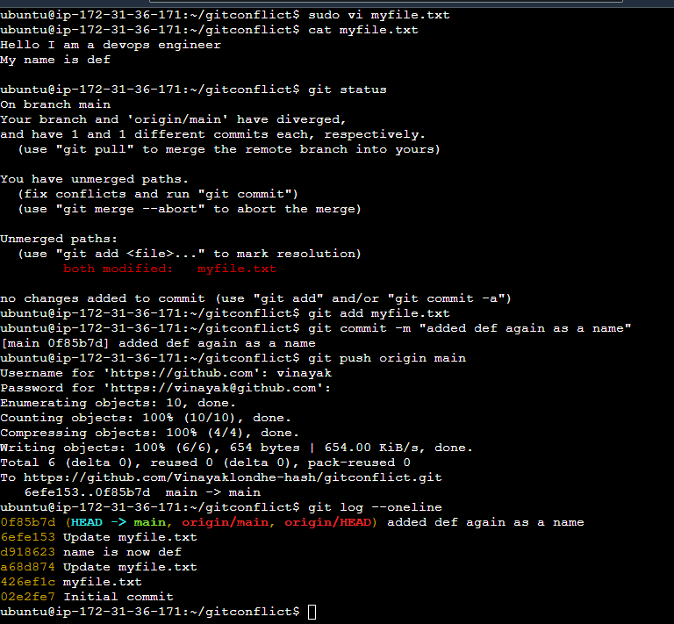

Now lets see push conflict:

Lets add one more line on local git file & do change on same line on github repo.

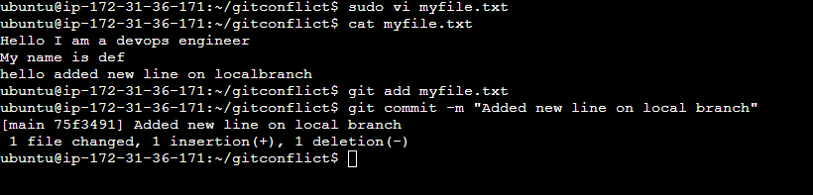

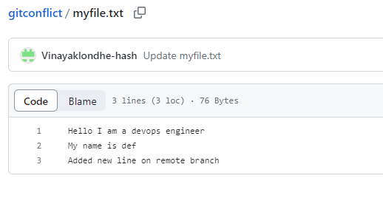

See line 3 on local & remote branch they are different.

Now lets try to push our local git changes to remote repo you will get conflict.

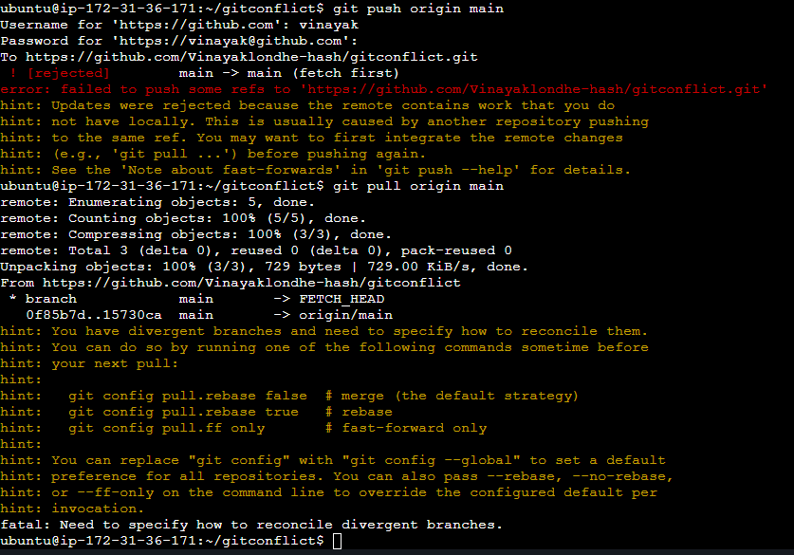

Now pull changes using fastforward and do changes and push to github repo.

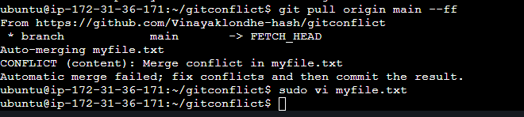

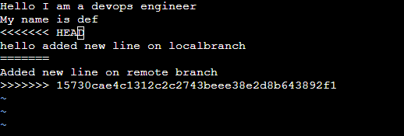

Keep necessary changes & push changes. We are keeping local changes !!

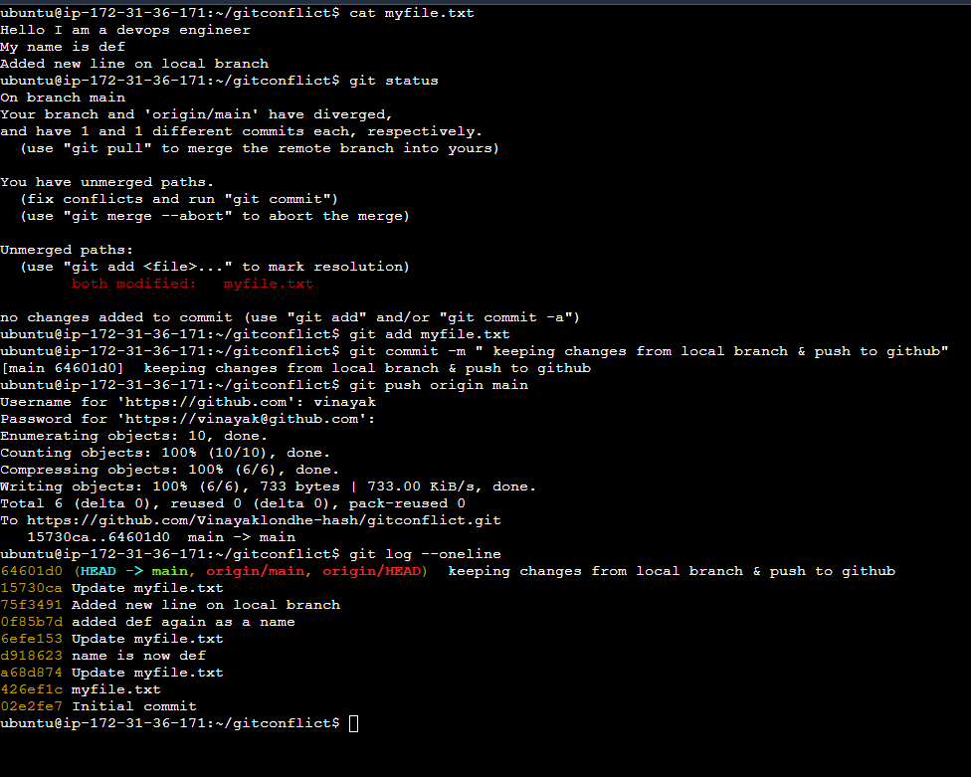

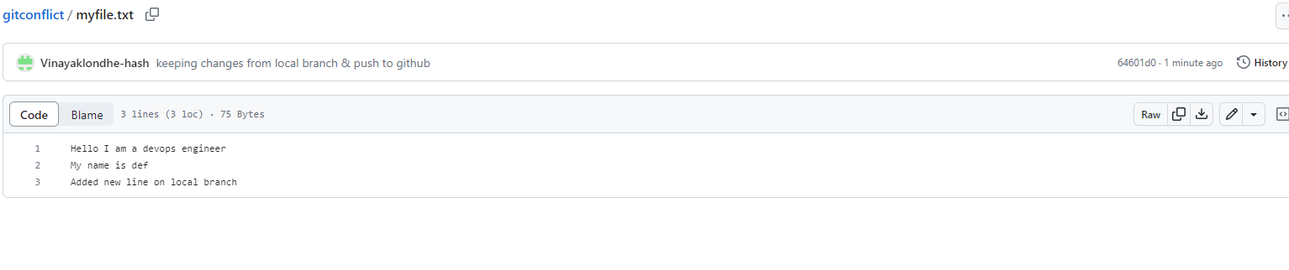

**Hope this helps!!!!**