**Task:**

* Demonstrate the concept of branches with 2 or more branches with screenshot.
* add some changes to dev branch and merge that branch in master
* as a practice try git rebase too, see what difference you get.

**Solution:**

**Git Rebase:**

Create a github repo as git-rebase

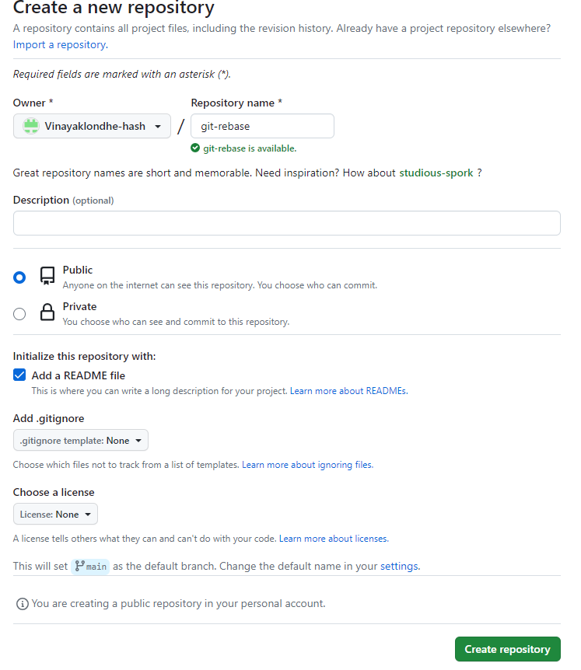

Once repo is created , we can see that default branch for github will be main

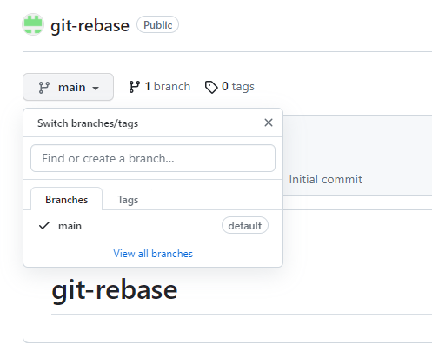

Go to local git and clone github repo and get inside repo..

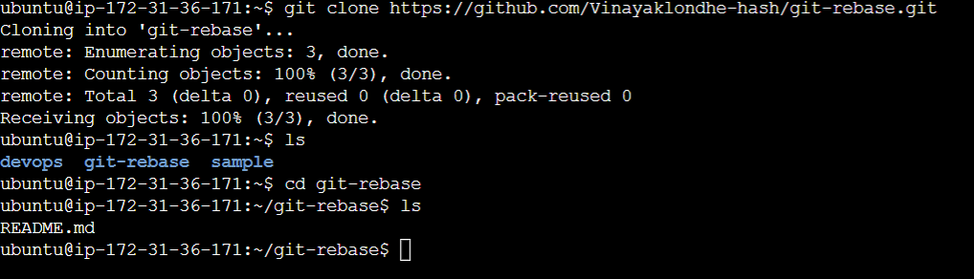

Now checkout feature branch , for that we need to have a branch. Now we can achieve it using git checkout -b branch <branchname>

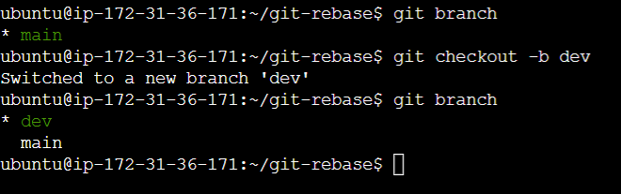

Now lets create 2 files in dev branch and commit it.

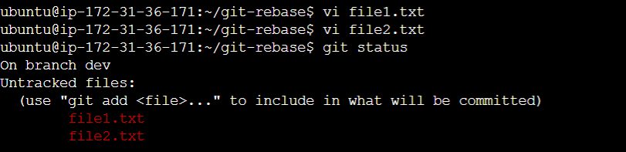

Lets add these files & commit one by one for getting 2 commits.

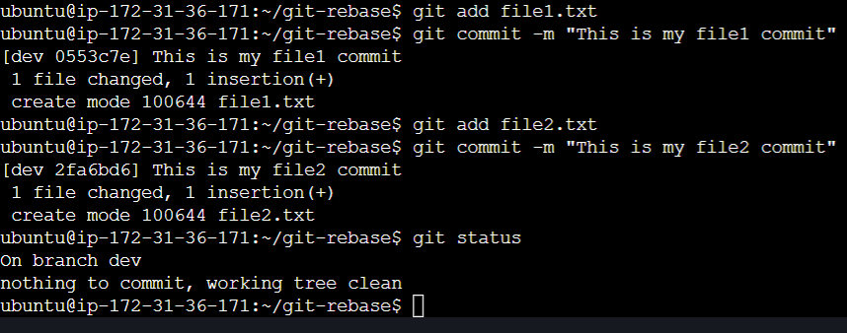

Now check logs on dev branch,we can see 2 commits

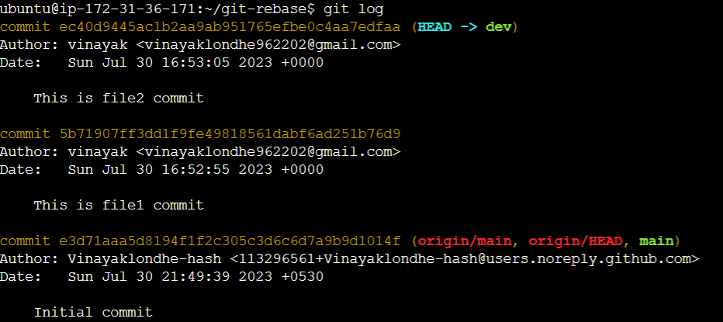

Now checkout master branch and check if any changes are available .

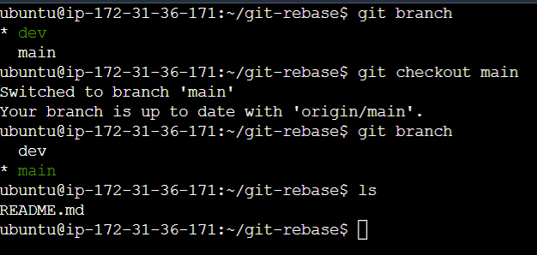

Add file3.txt under master branch & commit it. Check logs

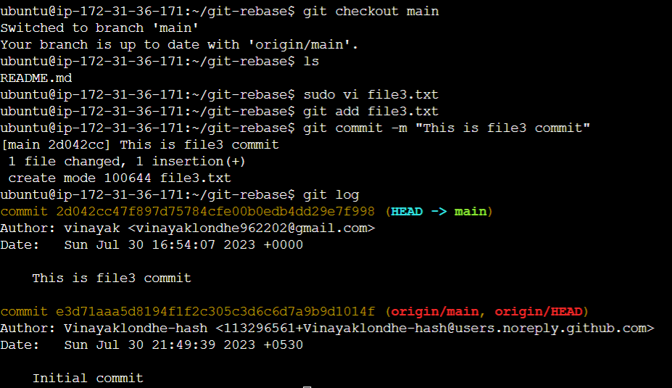

See above image we can see logs on master branch. We have commit for file3 .

Lets to git rebase,

**Expected output is to get 2 commits from dev branch before file3 commit from main branch**.

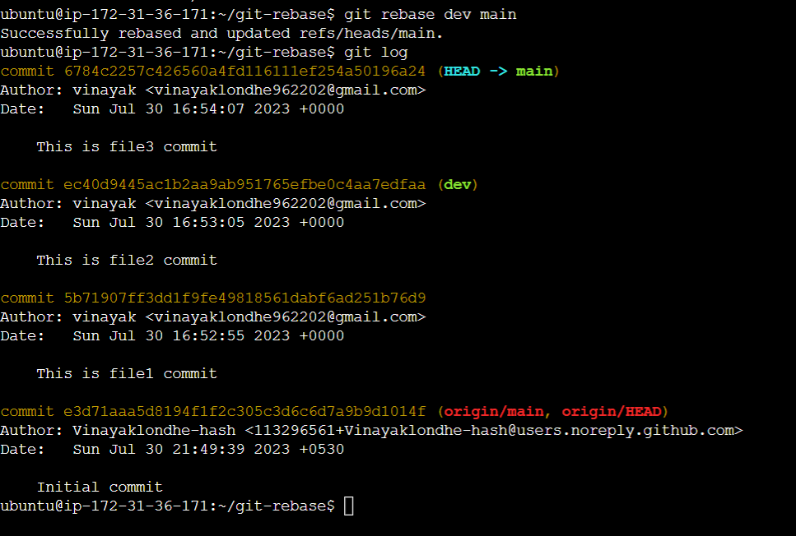

Now switch to dev branch and check logs,

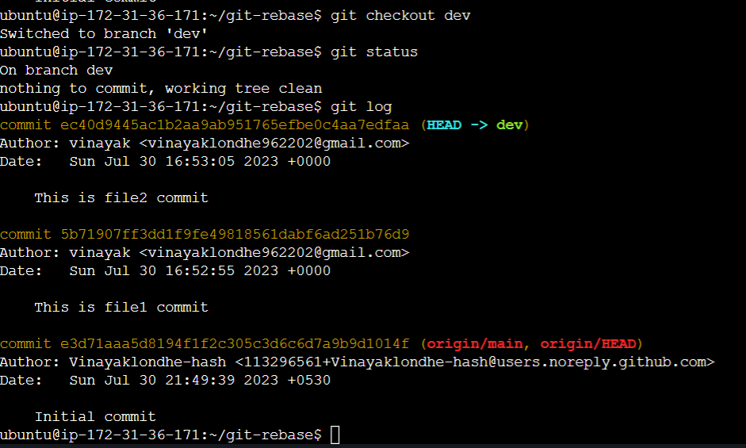

**Git Merge:**

* Create New github repo with git-merge
* Git clone repo with main branch
* Checkout new branch dev & add 2 files (file1.txt,file2.txt)

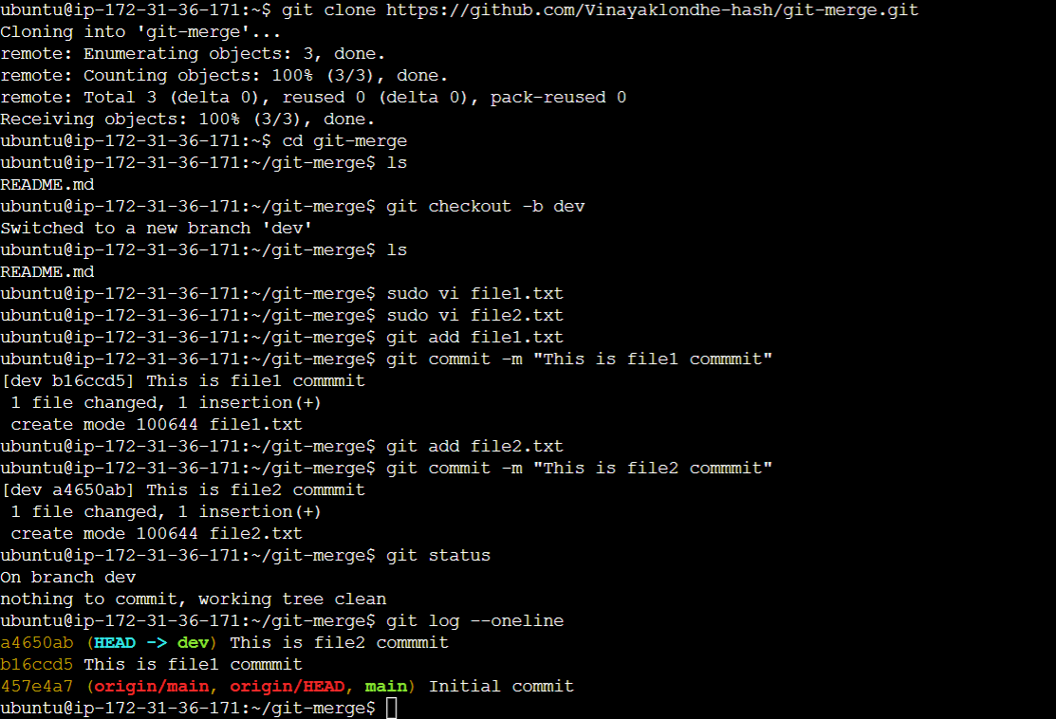

* Now checkout to main branch and add one file (file3.txt)

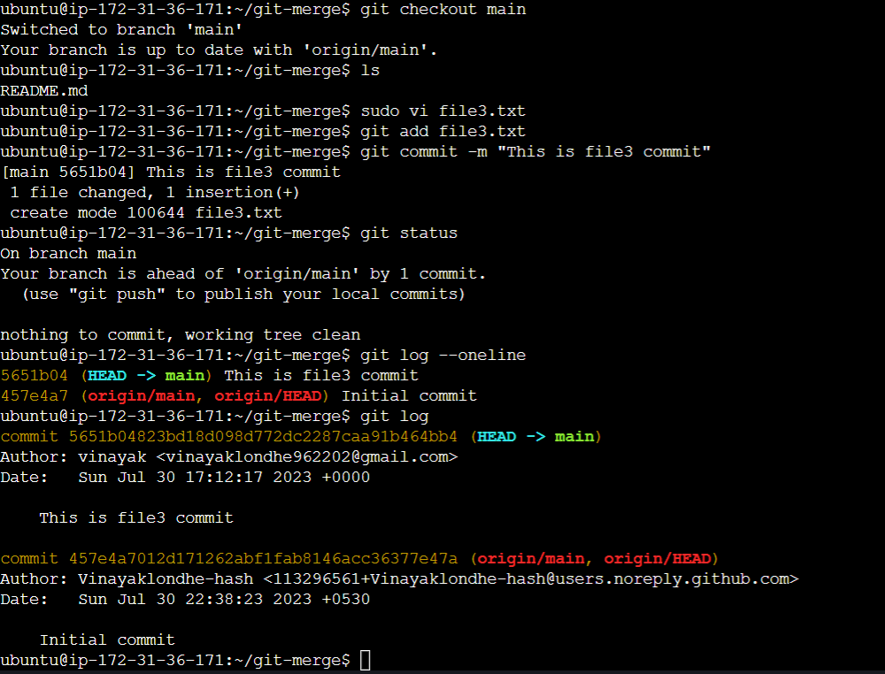

* Now do git merge dev so you will get changes from dev branch to main branch. Now check logs on main branch, we will see new merge commit is created along with file1 & file2

