**Task1:**

* Create a new branch and make some changes to it.
* Use git stash to save the changes without committing them.
* Switch to a different branch, make some changes and commit them.
* Use git stash pop to bring the changes back and apply them on top of the new commits.

**Solution:**

Create a local git repo and do git init . I have created file.txt and committed it to default branch Master & changed it named to main using git branch -m main. Also for demonstrating purpose we checkout dev branch .

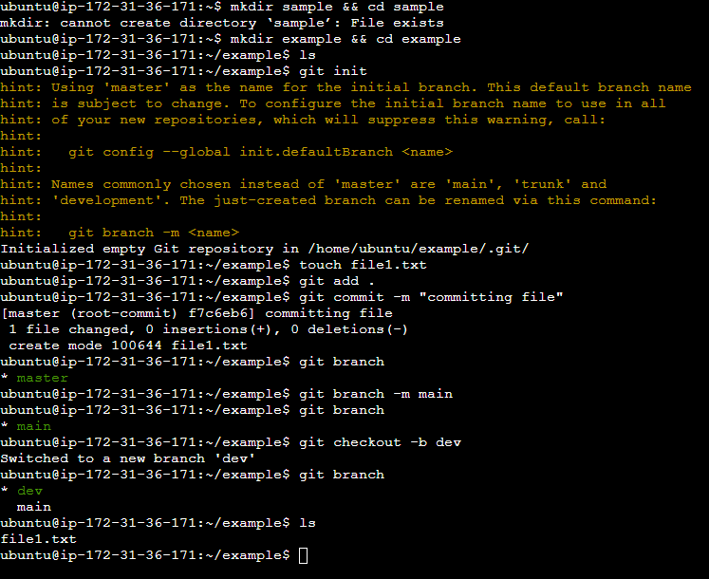

Now lets switch to main branch and add another file2.txt and add some content in it. Now when you do git status it will display file2.txt as untracked so lets do git add & do git stash with our msg. I have not checked out dev branch here , I experimented on main branch itself . Refer stash commands from blog.

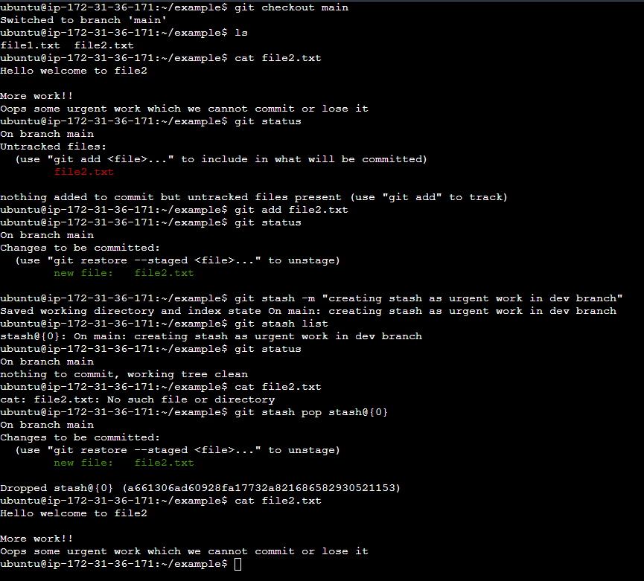

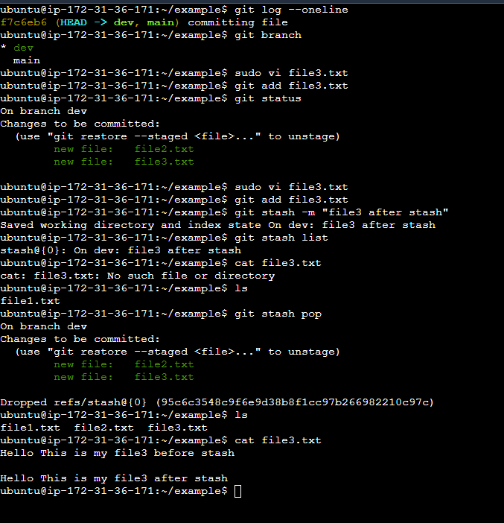

Lets switch to dev and create one file according to our task while applying stash to our main branch.

Once changes are done and committed on dev lets get back to main and check our main branch stash.

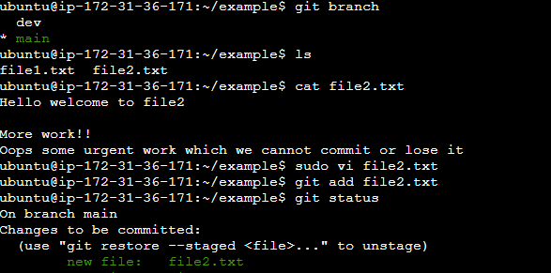

Lets commit it with 2 lines which was present & then add one more line as shown

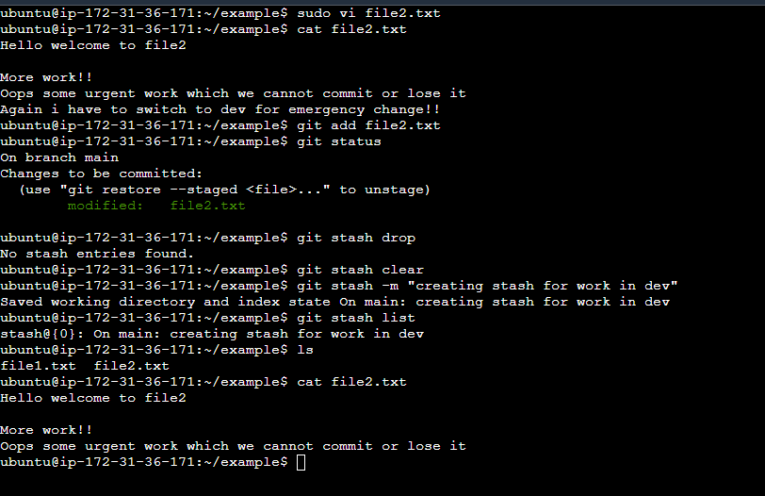

Now lets get to dev branch and add one file then after commit lets get back to main & do git stash pop we will have changes which is in stash.

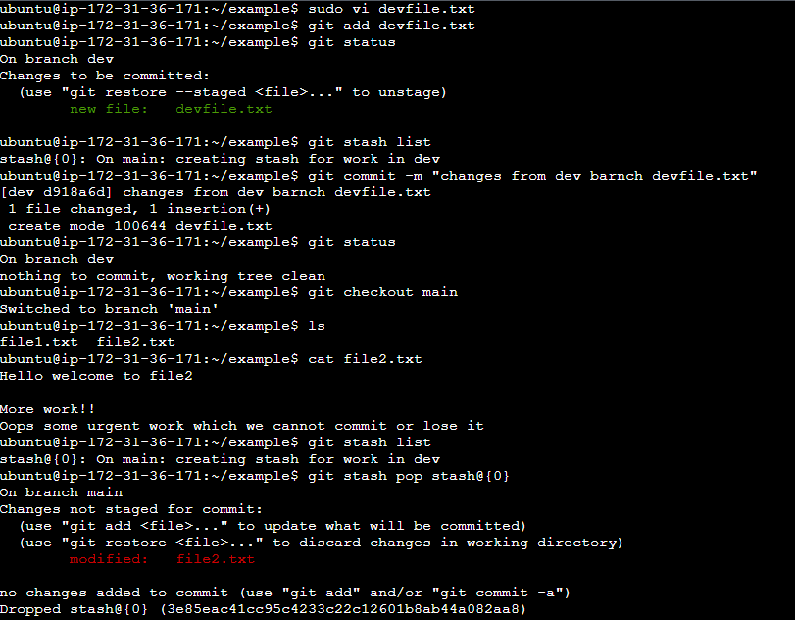

Notice that after git stash pop ,stash will be destroyed

Now do git add & commit for changes .

Hope this helps!!!