**Thread**

* A thread is a path of execution within a process.
* A process can contain multiple threads.
* A thread is also known as lightweight process.
* The idea is to achieve parallelism by dividing a process into multiple threads.
* For example, in a browser, multiple tabs can be different threads.
* MS Word uses multiple threads: one thread to format the text, another thread to process inputs, etc.
* More advantages of multithreading are discussed below

**Process vs Thread**

* The primary difference is that threads within the same process run in a shared memory space, while processes run in separate memory spaces.
* Threads are not independent of one another like processes are, and as a result threads share with other threads their code section, data section, and OS resources (like open files and signals).
* But, like process, a thread has its own program counter (PC), register set, and stack space.

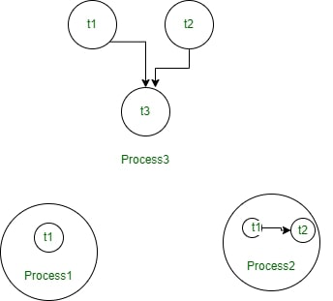

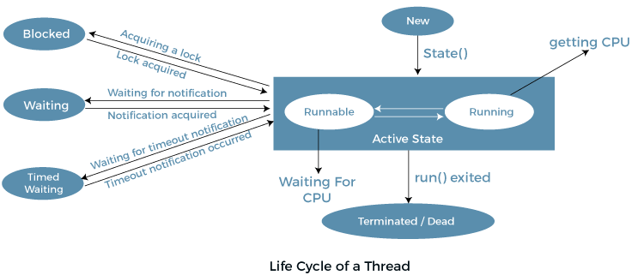

# Life cycle of a Thread (Thread States)

In Java, a thread always exists in any one of the following states. These states are:

1. New
2. Active
3. Blocked / Waiting
4. Timed Waiting
5. Terminated

## Explanation of Different Thread States

**New:** Whenever a new thread is created, it is always in the new state. For a thread in the new state, the code has not been run yet and thus has not begun its execution.

**Active:** When a thread invokes the start() method, it moves from the new state to the active state. The active state contains two states within it: one is **runnable**, and the other is **running**.

* **Runnable:** A thread, that is ready to run is then moved to the runnable state. In the runnable state, the thread may be running or may be ready to run at any given instant of time. It is the duty of the thread scheduler to provide the thread time to run, i.e., moving the thread the running state.  
  A program implementing multithreading acquires a fixed slice of time to each individual thread. Each and every thread runs for a short span of time and when that allocated time slice is over, the thread voluntarily gives up the CPU to the other thread, so that the other threads can also run for their slice of time. Whenever such a scenario occurs, all those threads that are willing to run, waiting for their turn to run, lie in the runnable state. In the runnable state, there is a queue where the threads lie.
* **Running:** When the thread gets the CPU, it moves from the runnable to the running state. Generally, the most common change in the state of a thread is from runnable to running and again back to runnable.

**Blocked or Waiting:** Whenever a thread is inactive for a span of time (not permanently) then, either the thread is in the blocked state or is in the waiting state.

For example, a thread (let's say its name is A) may want to print some data from the printer. However, at the same time, the other thread (let's say its name is B) is using the printer to print some data. Therefore, thread A has to wait for thread B to use the printer. Thus, thread A is in the blocked state. A thread in the blocked state is unable to perform any execution and thus never consume any cycle of the Central Processing Unit (CPU). Hence, we can say that thread A remains idle until the thread scheduler reactivates thread A, which is in the waiting or blocked state.

When the main thread invokes the join() method then, it is said that the main thread is in the waiting state. The main thread then waits for the child threads to complete their tasks. When the child threads complete their job, a notification is sent to the main thread, which again moves the thread from waiting to the active state.

If there are a lot of threads in the waiting or blocked state, then it is the duty of the thread scheduler to determine which thread to choose and which one to reject, and the chosen thread is then given the opportunity to run.

**Timed Waiting:** Sometimes, waiting for leads to starvation. For example, a thread (its name is A) has entered the critical section of a code and is not willing to leave that critical section. In such a scenario, another thread (its name is B) has to wait forever, which leads to starvation. To avoid such scenario, a timed waiting state is given to thread B. Thus, thread lies in the waiting state for a specific span of time, and not forever. A real example of timed waiting is when we invoke the sleep() method on a specific thread. The sleep() method puts the thread in the timed wait state. After the time runs out, the thread wakes up and start its execution from when it has left earlier.

**Terminated:** A thread reaches the termination state because of the following reasons:

* When a thread has finished its job, then it exists or terminates normally.
* **Abnormal termination:** It occurs when some unusual events such as an unhandled exception or segmentation fault.

A terminated thread means the thread is no more in the system. In other words, the thread is dead, and there is no way one can respawn (active after kill) the dead thread.

The following diagram shows the different states involved in the life cycle of a thread.

**How to Create Threads using Java Programming Language?**

We can create Threads in java using two ways, namely :

1. By extending Thread Class
2. By Implementing a Runnable interface

# Synchronization in Java

Synchronization in Java is the capability to control the access of multiple threads to any shared resource.

Java Synchronization is better option where we want to allow only one thread to access the shared resource.

### Types of Synchronization

There are two types of synchronization

1. By Using Synchronized Method
2. By Using Synchronized Block
3. By Using Static Synchronization