**NAME: VINAYAKUMAR WALAKE**

**DATE: 19/4/2025**

**TASK: Q no-2**

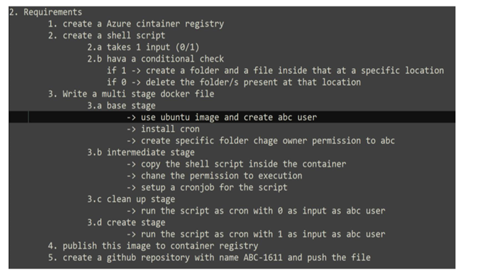

**Step:1**

**-First we created ACR with name of vinayakumar**

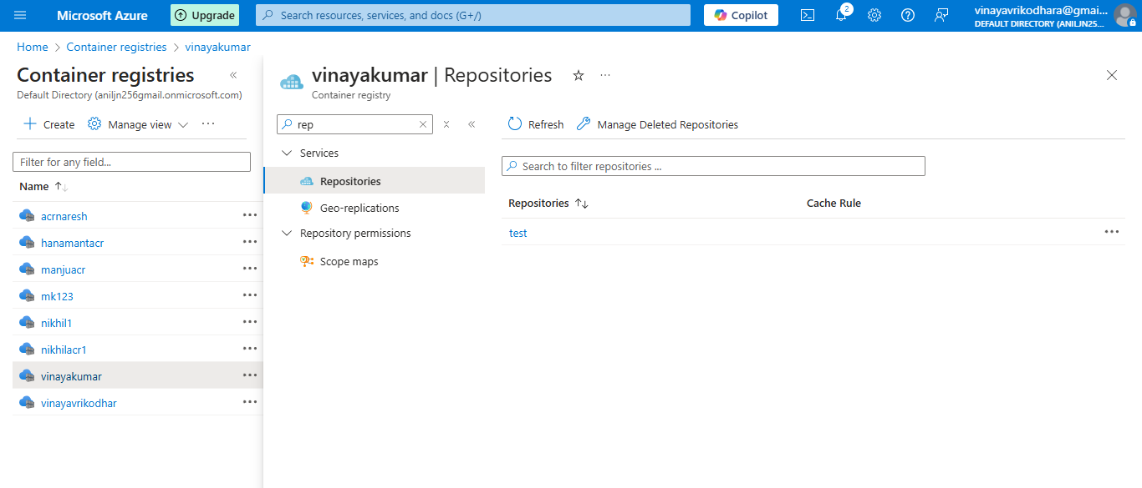

**Step:2**

**- we created shell script with name of Script.sh**

**- we created multi-stage Dockerfile with name of Dockerfile**

**- building the image using the Dockerfile**

**cmd: docker build -t test .**

**- creating the container using build image name-test**

**cmd: docker run -it -d --name test test:1.0 /bin/bash**

**script.sh**

#!/bin/bash

#Author: Vinay

#Desc: script

#Date: 19/4/2025

INPUT=$1

TARGET_DIR="/tmp/target"

if [ "$INPUT" = "1" ]; then

echo "Creating folder and file..."

mkdir -p "$TARGET_DIR"

touch "$TARGET_DIR/file.txt"

echo "File created at $TARGET_DIR/file.txt"

elif [ "$INPUT" = "0" ]; then

echo "Deleting folder..."

rm -rf "$TARGET_DIR"

echo "Deleted $TARGET_DIR"

else

echo "Invalid input! Use 1 (create) or 0 (delete)."

fi

**Dockerfile**

# Base Stage

FROM ubuntu:latest AS base

RUN apt-get update && apt-get install -y cron

RUN useradd -ms /bin/bash abc

RUN mkdir -p /target && chown abc:abc /target

# Intermediate Stage

FROM base AS intermediate

COPY script.sh /home/abc/script.sh

RUN chmod +x /home/abc/script.sh

RUN echo "*/5 * * * * abc /home/abc/script.sh 1" > /etc/cron.d/mycron

RUN crontab /etc/cron.d/mycron

RUN service cron start # Ensures cron runs

# Cleanup Stage

FROM intermediate AS cleanup

USER abc

CMD ["/home/abc/script.sh", "0"]

# Create Stage

FROM intermediate AS create

USER abc

CMD ["/home/abc/script.sh", "1"]

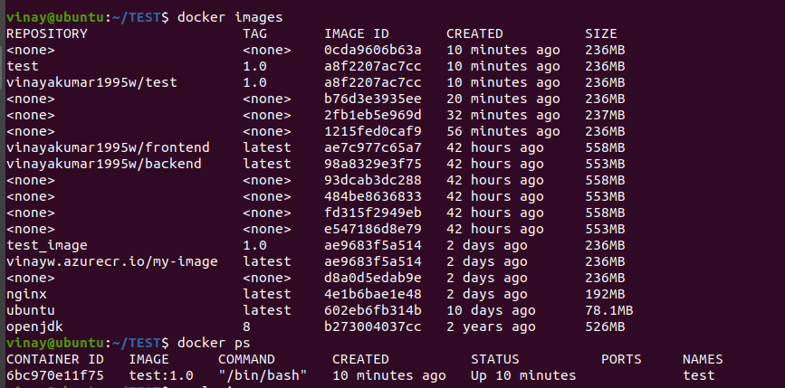

**Step:3**

**- creating tag using the image**

**cmd : docker tag test:latest vinayakumar.azurecr.io/test**

**- pushing the image to ACR**

**cmd: az login**

**cmd: az acr --name vinayakumar**

**cmd: docker push vinayakumar.azurecr.io/test**

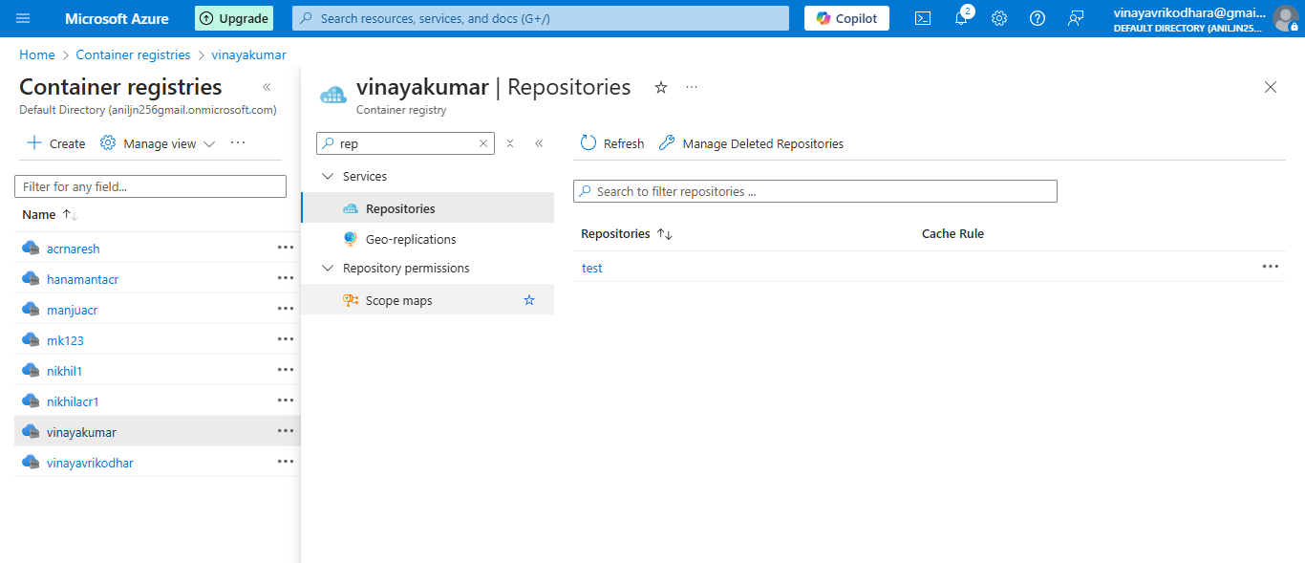

**Step:4**

**-creating the github repository with name of ABC-1611**

**- pushing the all file to git repo**

**cmd : git init**

**cmd : git add .**

**cmd : git commit -m "pushing"**

**cmd : git push origin -u master**

**url: https://github.com/Vinayakumarw/ABC-1611.git**

