**Creating Instance Templates:**

Create a ServiceAccount which can be used for OSLOGIN.

To create an instance template we need to create a custom image first. Create a ubuntu 18.04 and install eventing mentioned in repo on branch gcp-autoscaling. Also make sure OSLOGIN SA is also attached.

<https://github.com/mavrick202/ansibletemplatetesting>

Stop the instance and create the Instance Template using the boot disk of the servers. In the management , give the following as the boot script.

#!/bin/bash

ansible-playbook /myrepo/playbook.yaml

Launch an instance from the Instance Template which we have created and following should be visible.

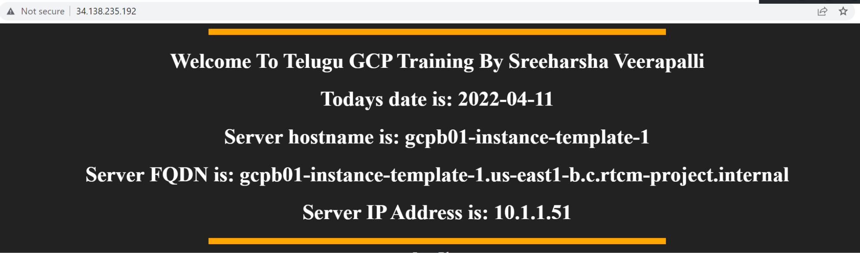

## **How stateful workloads are different from stateless workloads**

